AI-POWERED EMAIL ASSISTANT
Technical Documentation

An intelligent robotic process automation solution that monitors Outlook, extracts action items using a large language model, and creates calendar events, tasks, draft replies, and a categorised document library.

Built with UiPath Studio 2026 and Google Gemini
Version 1.0.0 · August 2026

Contents
Contents 2
1. Overview 4
1.1 Capability summary 4
2. Solution Architecture 5
2.1 Design principles 5
2.2 Component responsibilities 5
2.3 Email processing pipeline 6
2.4 Document intake pipeline 6
3. Technology Stack 9
4. Repository Structure 10
5. Workflow Reference 11
6. Configuration 12
6.1 Mailbox and scheduling 12
6.2 Language model 12
6.3 Extraction behaviour 13
6.4 Documents and reporting 13
7. The AI Extraction Contract 14
7.1 Response structure 14
7.2 Extraction rules 14
8. Design Decisions 16
8.1 Outlook COM automation instead of Microsoft Graph 16
8.2 Declining the standard framework template 16
8.3 Append-only CSV for the audit log 16
8.4 Semantic embeddings for duplicate detection 16
8.5 Three priority levels, collapsed only at the point of writing 17
8.6 Email as instruction, attachments as context 17
9. Reliability and Error Handling 18
9.1 Failure isolation 18
9.2 Retry policy 18
9.3 Idempotency 18
9.4 Input guards 18
10. Results and Validation 19
10.1 Test matrix 19
10.2 Extraction and output 19
10.3 Attachment processing 20
10.4 Document library 21
10.5 Reporting and audit 23
11. Deployment 25
12. Limitations 27
13. Future Work 28
14. Setup Guide 29
14.1 Prerequisites 29
14.2 Installation 29
14.3 Operational notes 29

1. Overview
Professionals lose a measurable amount of time each day performing the same mechanical loop: opening an email, reading it, deciding what it requires, and then manually transcribing that decision into a calendar entry or a task list. The work is low value but not optional, and it scales linearly with inbox volume.
This solution automates that loop end to end. It monitors an Outlook mailbox, sends each new message together with its attachments to a large language model, and converts the model's structured response into real artefacts inside Microsoft 365: calendar appointments, prioritised tasks, and draft replies awaiting the user's approval. A parallel intake path applies the same intelligence to documents dropped into a watched folder, filing each one into a categorised library alongside an automatically generated summary.
The system is built entirely from freely available components. It requires no API registration, no administrative approval, and no paid licence.

1.1 Capability summary
Capability | Description
Continuous monitoring | Polls a configured Outlook folder on a fixed interval and processes newly arrived messages automatically.
AI extraction | Sends message body and attachment text to Gemini, receiving a schema-validated JSON response.
Calendar events | Creates Outlook appointments with location and configurable reminder lead time.
Prioritised tasks | Creates Outlook tasks that synchronise to Microsoft To Do, colour-coded by priority.
Draft replies | Composes a contextual reply and saves it to Drafts. Nothing is ever sent automatically.
Attachment intelligence | Extracts text from PDF, Word, Excel, and plain-text attachments and supplies it to the model as context.
Document library | Classifies, renames, and files documents into category folders with a generated summary alongside each.
Folder intake | Applies the full pipeline to documents that arrive outside email, via a watched folder.
Duplicate suppression | Uses semantic embeddings to recognise re-sent or restated tasks and avoid creating them twice.
Bilingual operation | Processes Arabic and English messages, replying in the language of the original.
Audit logging | Appends a structured record of every processed item to a CSV log.
Weekly reporting | Generates and emails a formatted activity report with an AI-written narrative summary.

Design intent
Every automated action either creates something reversible or leaves a record. Nothing is sent, deleted, or transmitted outside the user's own mailbox without explicit human action. This constraint shaped several of the decisions documented in Section 8.

2. Solution Architecture
The architecture is deliberately flat. A single orchestrating workflow drives a set of narrowly scoped child workflows, each responsible for one external system or one transformation. There is no queue, no message broker, and no persistent database.
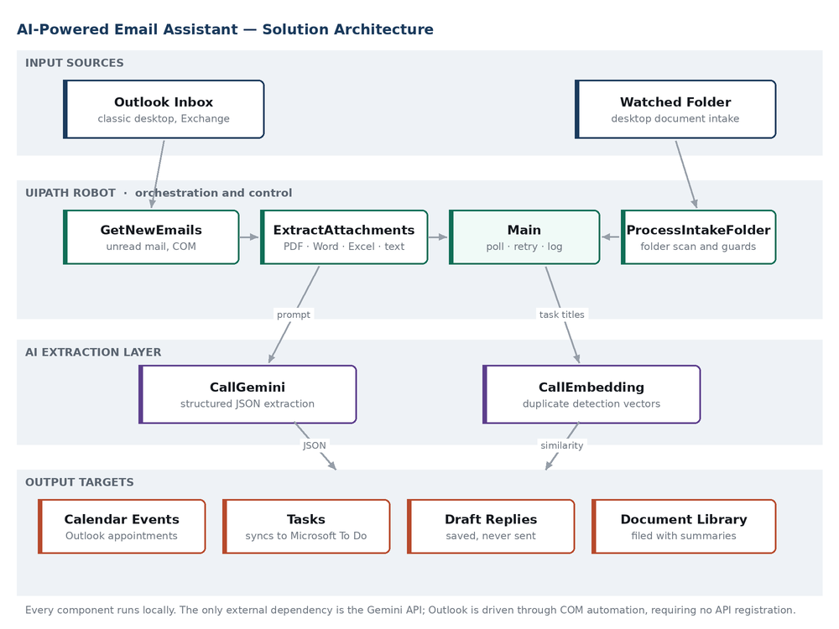
Figure 1. End-to-end solution architecture. Two input paths converge on a shared extraction and output pipeline.

2.1 Design principles
- Local execution. Every component runs on the user's own machine. The single external call is to the Gemini API.
- Inherited identity. Outlook is driven through COM automation, so the robot operates as the signed-in user with no credentials of its own.
- Single responsibility per workflow. Each .xaml file addresses one concern and can be tested in isolation.
- Configuration over code. All operational parameters live in a single JSON file; behavioural changes require no rebuild.
- Fail forward. A failure on one item never halts the run; the item is logged and retried on the next cycle.

2.2 Component responsibilities
Layer | Component | Responsibility
Input | Outlook Inbox | Source of incoming messages and attachments.
Input | Watched folder | Source of documents arriving outside email.
Robot | Main | Polling loop, cycle-level error handling, scheduling of the weekly report.
Robot | GetNewEmails | Retrieves unread messages from the configured folder.
Robot | ExtractAttachments | Saves attachments to disk and extracts their text.
Robot | ProcessIntakeFolder | Scans the watched folder and drives the document pipeline.
AI | CallGemini | Issues the extraction request and returns the model response.
AI | CallEmbedding | Converts task titles into vectors for similarity comparison.
Output | CreateOutlookItems | Creates appointments and tasks through COM.
Output | CreateReplyDraft | Composes and saves an unsent reply.
Output | FileToLibrary | Renames, files, and summarises processed documents.
Output | WriteAuditLog | Appends a structured record of the outcome.

2.3 Email processing pipeline
- The polling loop retrieves unread messages from the configured Outlook folder, capped at a configurable batch size.
- For each message, attachments are saved to a temporary directory and their text extracted according to file type.
- A prompt is assembled from a template, injecting the current date, timezone, sender, subject, body, and extracted attachment text.
- The prompt is sent to Gemini with a response schema that constrains the reply to a fixed JSON structure.
- Each extracted task title is embedded and compared against previously created tasks; near-duplicates are skipped.
- Surviving tasks, meetings, and the reply draft are written to Outlook.
- Any attachments are classified, renamed, and filed into the document library with a generated summary.
- The outcome is appended to the audit log, the message is categorised, and it is moved to the processed folder.

Steps two through eight execute inside a per-message error boundary. A failure at any point leaves the message unprocessed and in place, so the next cycle retries it while the remainder of the batch proceeds unaffected.

2.4 Document intake pipeline
The intake path reuses the extraction, output, and logging components without modification. Only the input acquisition and the prompt template differ: there is no sender, no subject, and no reply to compose, so the intake template instructs the model to return an empty reply draft and to treat the document itself as the complete input.
Three guards protect the watched folder from partially written files: an extension filter, a minimum age threshold, and an exclusive-lock test. A per-cycle file cap prevents a large drop from exhausting the API quota in a single pass.
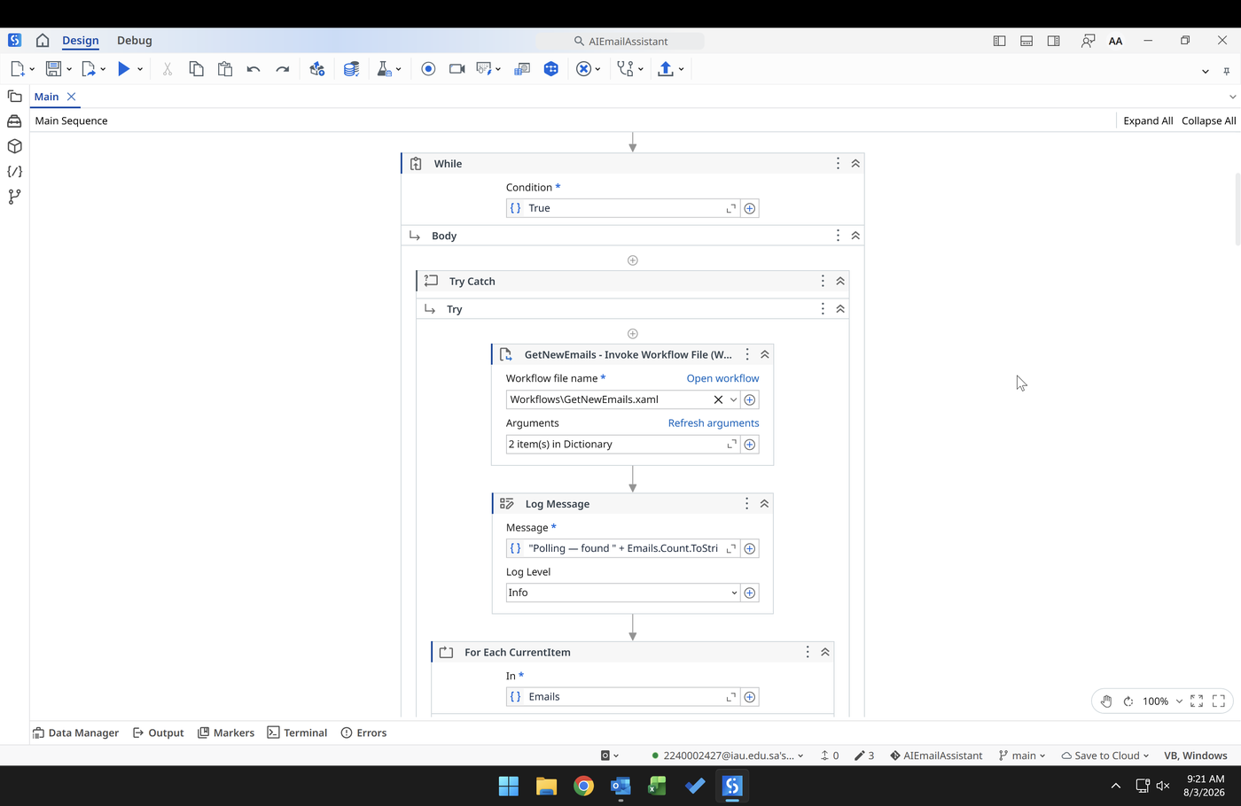
Figure 2. The orchestrating workflow. A perpetual loop wraps a try/catch boundary, with the delay placed in the finally block so the interval is honoured whether the cycle succeeded or failed.
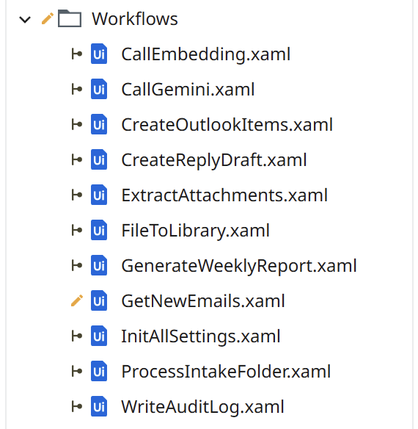
Figure 3. Workflow inventory. Eleven single-purpose files, each independently testable.

3. Technology Stack
Each element of the stack was selected against three constraints: it had to be free, it had to run without administrative privileges, and it had to avoid any dependency on organisational approval.
Component | Selection | Rationale
Automation platform | UiPath Studio 2026 Community Edition | Free for individual use. Native Windows COM interoperability. Visual workflows that a reviewer can follow without reading code.
Language model | Google Gemini (Flash-Lite tier) | Free tier sufficient for the workload. Native support for response schemas, which removes an entire class of parsing failure.
Embedding model | gemini-embedding-001 | Free, multilingual, and configurable output dimensionality. Shares authentication with the extraction model.
Mail, calendar, tasks | Outlook desktop via COM | Already authenticated as the user. No API registration required.
Task synchronisation | Outlook Tasks | Tasks created against an Exchange mailbox propagate to Microsoft To Do automatically, with no additional integration.
Document extraction | UiPath PDF activities; Word and Excel COM | Reuses software already installed. No third-party parsing libraries.
Configuration | JSON | Human-readable, trivially parsed, and free of the file-locking behaviour that affects spreadsheet formats.
Audit storage | CSV, append-only | Constant-time appends, resilient to concurrent reads, and openable in any spreadsheet application.
Version control | Git and GitHub | Standard practice. Secrets excluded through .gitignore with a committed configuration template.

4. Repository Structure
AIEmailAssistant/
├── Main.xaml Orchestrating polling loop
├── project.json UiPath project manifest
├── README.md
├── .gitignore
│
├── Config/
│ ├── Config.json Runtime settings (git-ignored)
│ ├── Config.template.json Published template, key redacted
│ ├── PromptTemplate.txt Email extraction prompt
│ ├── IntakePromptTemplate.txt Document extraction prompt
│ ├── GeminiRequest.json Request body with response schema
│ ├── GeminiRequestPlain.json Request body without schema
│ └── GeminiEmbedRequest.json Embedding request body
│
├── Workflows/
│ ├── InitAllSettings.xaml Configuration loader
│ ├── GetNewEmails.xaml Mailbox reader
│ ├── ExtractAttachments.xaml Attachment text extraction
│ ├── CallGemini.xaml Extraction API client
│ ├── CallEmbedding.xaml Embedding API client
│ ├── CreateOutlookItems.xaml Tasks and appointments
│ ├── CreateReplyDraft.xaml Reply composition
│ ├── FileToLibrary.xaml Document classification and filing
│ ├── ProcessIntakeFolder.xaml Watched-folder pipeline
│ ├── WriteAuditLog.xaml Structured logging
│ └── GenerateWeeklyReport.xaml Aggregation and reporting
│
└── Documentation/ Generated artefacts (git-ignored)
Runtime artefacts are excluded from version control. The audit log and the vector cache contain real sender addresses, subject lines, and document content; the temporary and library directories contain the documents themselves. Only the redacted configuration template is published.

5. Workflow Reference
Workflow | Inputs | Outputs | Notes
InitAllSettings | — | Configuration dictionary | Parses the JSON file and expands environment variables in every value.
GetNewEmails | Config | Message list | Reads unread mail. Does not mark as read; state is tracked by category and folder.
ExtractAttachments | Message, Config | Combined text, file paths | Dispatches by file extension. Office formats are read through COM with guaranteed process cleanup.
CallGemini | Config, prompt, schema flag | Raw response | Truncates oversized prompts, retries transient failures, and distinguishes them from permanent errors.
CallEmbedding | Config, text | Vector | Returns a 768-dimension embedding as a JSON array.
CreateOutlookItems | Extraction, Config | — | Creates tasks and appointments. Performs duplicate checking before each task.
CreateReplyDraft | Address, subject, body | — | Creates an unsent draft. Suppressed for empty bodies and no-reply senders.
FileToLibrary | Extraction, files, Config | — | Moves each document into its category folder and writes a summary file alongside.
ProcessIntakeFolder | Config | — | Scans the watched folder and drives the full pipeline for each qualifying file.
WriteAuditLog | Path, sender, subject, extraction, status | — | Appends a quoted CSV row. Writes a byte-order mark so non-Latin text renders correctly.
GenerateWeeklyReport | Config | Statistics | Aggregates the audit log, requests a narrative, writes a formatted report, and emails it.

6. Configuration
All operational parameters are held in a single JSON file loaded once at startup. Values may contain Windows environment variables, which are expanded during loading so that paths remain portable across machines and user accounts.
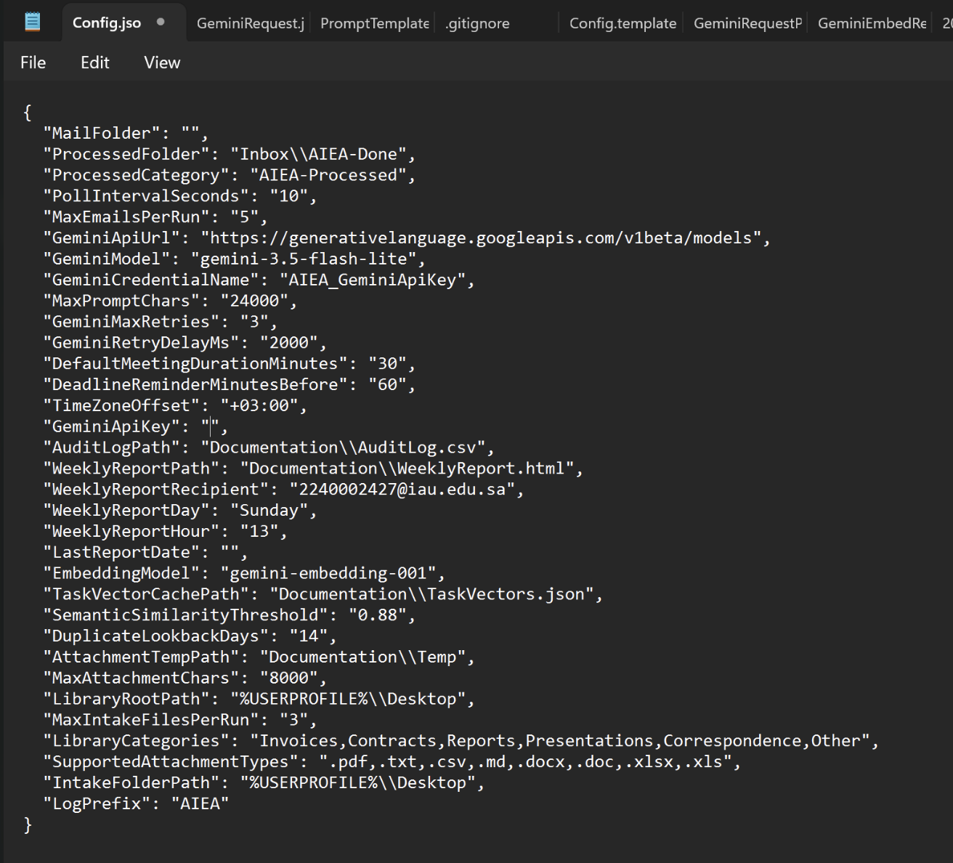
Figure 4. The complete configuration file. Thirty-three settings govern behaviour without requiring any change to the workflows.

6.1 Mailbox and scheduling
Setting | Purpose
MailFolder | Folder to monitor, relative to the mailbox root. An empty value denotes the Inbox itself.
ProcessedFolder | Destination for successfully processed messages.
ProcessedCategory | Outlook category applied before the message is moved.
PollIntervalSeconds | Delay between cycles.
MaxEmailsPerRun | Upper bound on messages handled in a single cycle.
TimeZoneOffset | Supplied to the model so relative dates resolve correctly.

6.2 Language model
Setting | Purpose
GeminiApiUrl | Base endpoint for both extraction and embedding.
GeminiModel | Extraction model identifier.
EmbeddingModel | Embedding model identifier.
GeminiApiKey | API credential. Excluded from version control.
MaxPromptChars | Prompt ceiling; longer prompts are truncated with an explicit marker.
GeminiMaxRetries | Retry attempts for transient failures.
GeminiRetryDelayMs | Interval between retry attempts.

6.3 Extraction behaviour
Setting | Purpose
DefaultMeetingDurationMinutes | Applied when a meeting has no stated end time.
DeadlineReminderMinutesBefore | Reminder lead time on created appointments.
SemanticSimilarityThreshold | Cosine similarity above which a task is treated as a duplicate.
DuplicateLookbackDays | Age beyond which cached task vectors are discarded.
TaskVectorCachePath | Location of the vector cache.

6.4 Documents and reporting
Setting | Purpose
SupportedAttachmentTypes | Extensions eligible for extraction and filing.
AttachmentTempPath | Staging directory for saved attachments.
MaxAttachmentChars | Ceiling on combined attachment text per message.
LibraryRootPath | Root of the categorised document library.
LibraryCategories | Permitted classification values.
IntakeFolderPath | Watched folder for documents arriving outside email.
MaxIntakeFilesPerRun | Upper bound on files handled in a single cycle.
AuditLogPath | Location of the audit log.
WeeklyReportPath | Output path for the generated report.
WeeklyReportRecipient | Address the report is sent to.
WeeklyReportDay | Weekday on which the report is generated.
WeeklyReportHour | Hour after which generation may occur.

7. The AI Extraction Contract
The interface between the robot and the language model is a strict schema rather than free prose. Gemini accepts a response schema alongside the prompt and guarantees conformance, which eliminates markdown fences, preamble, and structural drift as failure modes. The robot can therefore parse the response with confidence instead of defensively.

7.1 Response structure
{
"email_type": "actionable" | "informational",
"summary": string, one sentence, under 25 words
"priority": "High" | "Normal" | "Low",
"reply_draft": string, empty when no reply is warranted

"tasks": [ {
"title": string,
"due_date": string, ISO 8601, or empty
"notes": string,
"priority": "High" | "Normal" | "Low"
} ],

"meetings": [ {
"title": string,
"start": string, ISO 8601
"end": string, ISO 8601
"location": string
} ],

"documents": [ {
"filename": string,
"category": one of the configured categories,
"suggested_name": string, descriptive, no extension
"summary": string, two to three sentences
"key_dates": string labelled, comma separated
} ]
}

7.2 Extraction rules
The prompt encodes twenty numbered rules. The following carry the most weight in practice, each having been added in response to an observed failure.
Concern | Rule | Failure it prevents
Ownership | Extract only actions the recipient must personally perform. | Tasks generated from work explicitly assigned to other people.
Source hierarchy | The email body is the instruction; attachments are context only. | A contract's own clauses becoming tasks on the reader's list.
Date grounding | Resolve relative dates against today's date; never output a past date. | Weekday names resolving backwards into the previous week.
Meeting certainty | Create a meeting only for one unambiguous slot; otherwise create a scheduling task. | The model inventing a specific time from a range of options.
Priority independence | Judge each task's priority separately from the message's overall priority. | Every task inheriting the urgency of the most urgent one.
Actionable dating | High-priority tasks always receive a due date. | Urgent items sinking to the bottom of an undated task list.
Language parity | Reply in the language of the original; normalise numerals. | Arabic messages producing English tasks.
Graceful degradation | If attachment text is missing or unreadable, work from the body alone. | The model reporting extraction errors as user-facing content.

Determinism
The extraction request sets temperature to zero. Identical input therefore produces identical output, which makes both duplicate detection and demonstration behaviour predictable. The weekly narrative uses a higher temperature, since prose benefits from variation where structured extraction does not.
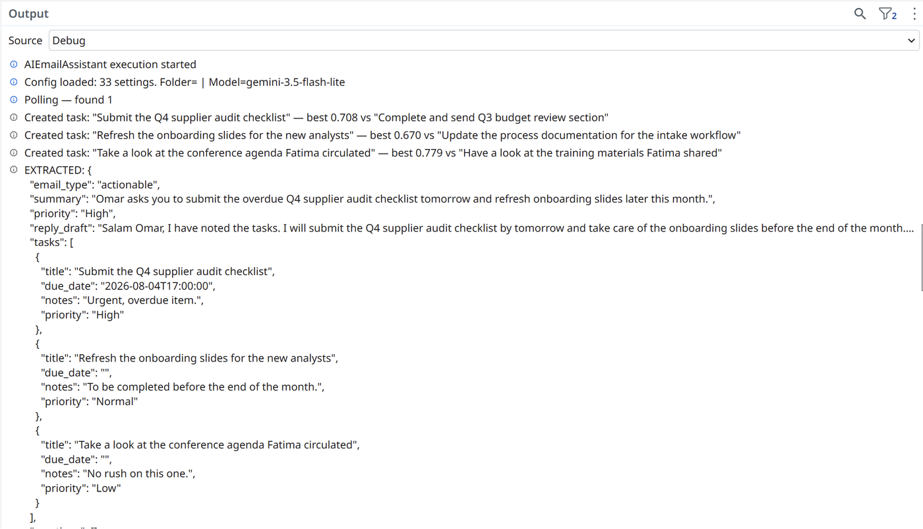
Figure 5. A single message yielding three tasks at distinct priorities, with due dates resolved from natural language. Similarity scores against previously created tasks are shown above the extraction.

8. Design Decisions
The following decisions shaped the solution more than any individual feature. Each is recorded with the constraint that produced it and the cost that was accepted.

8.1 Outlook COM automation instead of Microsoft Graph
Context. Microsoft Graph is the conventional route to Outlook mail, calendar, and tasks. It requires an application registration in Azure Active Directory, which was not available.
Decision. Drive the installed Outlook desktop application directly through COM automation.
Rationale. Outlook is already authenticated as the signed-in user, so the robot inherits that identity without holding any credential of its own. This removed the registration dependency entirely. It also unlocked the task requirement: tasks created against an Exchange mailbox propagate to Microsoft To Do automatically, so no separate integration was needed.
Trade-off. The solution is bound to Windows with classic Outlook installed and running. It cannot execute headless or on a server without a mail profile.

8.2 Declining the standard framework template
Context. UiPath's Robotic Enterprise Framework is the conventional starting point for production automation and would have been the expected choice.
Decision. Build a modular sequence project instead, with a configuration file, one workflow per responsibility, and explicit error boundaries.
Rationale. That framework exists to consume Orchestrator queues transactionally. This solution has no queue: its work arrives as mail and files, and its state lives in Outlook. Adopting the template would have added several layers of state-machine ceremony around logic that does not need them, at a cost in both build time and reviewer comprehension.
Trade-off. The project cannot be dropped into a queue-based orchestration model without restructuring. Given that unattended execution is outside the current scope, this cost is deferred rather than incurred.

8.3 Append-only CSV for the audit log
Context. The audit log is written on every processed item while the robot runs continuously, and it is read by the weekly report.
Decision. Write the log as an append-only CSV with explicit quoting and a byte-order mark, and generate the formatted report as HTML.
Rationale. A spreadsheet write requires opening, reading, and rewriting the entire workbook on every append, and fails outright if the file is open for inspection. A CSV append is a constant-time operation that tolerates concurrent reads. Separating capture from presentation means the log stays robust while the report stays readable.
Trade-off. The log carries no formatting or formulas. This is addressed by the reporting layer rather than the capture layer.

8.4 Semantic embeddings for duplicate detection
Context. Re-sent or restated messages produce tasks with the same meaning but different wording. A first implementation compared word overlap between task titles.
Decision. Replace lexical comparison with cosine similarity over sentence embeddings, cached locally so that only new tasks require an API call.
Rationale. Word overlap compares spelling, not meaning. It missed genuine duplicates phrased differently, and it flagged distinct tasks that shared a noun phrase: "update the deck" and "review the deck" scored above the duplicate threshold despite being different work. Embeddings capture semantic distance, which is the property the question actually depends on. The multilingual model additionally makes detection work across languages at no extra cost.
Trade-off. One additional API call per new task. The threshold is tuned conservatively because the two error types are not symmetric: a false positive silently suppresses a real task, whereas a false negative produces a visible duplicate that takes seconds to dismiss.

8.5 Three priority levels, collapsed only at the point of writing
Context. Microsoft To Do renders importance as a binary flag, so a three-level classification cannot be displayed directly.
Decision. Retain three levels throughout extraction, logging, and reporting; collapse to binary only in the Outlook write. Low-priority tasks are additionally left undated so they sort naturally to the bottom of the list.
Rationale. Collapsing early would have destroyed a distinction the audit log and weekly report both use. Collapsing late costs nothing and preserves the richer signal for every consumer that can represent it.
Trade-off. The Low and Normal distinction is not visible in the task interface itself, and is conveyed indirectly through the presence or absence of a due date.

8.6 Email as instruction, attachments as context
Context. Once attachment text was supplied to the model, a document's own contents became eligible for extraction. A contract states obligations in imperative language throughout, almost none of which belong to the reader.
Decision. Establish an explicit hierarchy in the prompt: the message body is the instruction, and attachments may only inform the detail of tasks the body already implies.
Rationale. Without this rule the system extracted supplier obligations from contract clauses and produced them as personal tasks. The hierarchy converts the attachment from a second source of instructions into a source of supporting detail, which is what makes attachment processing safe rather than merely capable.
Trade-off. Genuinely actionable items that appear only inside an attachment, with no corresponding request in the message body, will not be extracted.

9. Reliability and Error Handling

9.1 Failure isolation
Error handling operates at two levels. A per-item boundary surrounds the processing of each individual message or document; a per-cycle boundary surrounds the batch. A failure inside the inner boundary is logged, the item is left in place, and processing continues with the next item. A failure that escapes to the outer boundary is logged and the loop proceeds to the next cycle.
Because a failed message is neither categorised nor moved, it is retried automatically on the following cycle. Persistent failures therefore appear as repeated entries for the same subject in the audit log, which is the intended signal for human investigation.

9.2 Retry policy
The extraction call distinguishes transient failures from permanent ones. Rate limiting and server-side errors are raised as exceptions inside a retry scope and reattempted with a fixed delay. Authentication failures and malformed requests are logged and allowed to fail immediately, since no number of retries will resolve them. This distinction avoids consuming the retry budget on conditions that cannot improve.

9.3 Idempotency
Two independent mechanisms prevent repeated work. At the message level, successful processing applies a category and moves the message out of the monitored folder, so it cannot be selected again. At the task level, semantic comparison against recently created tasks suppresses near-duplicates even when they arrive from a different message.

9.4 Input guards
Guard | Protects against
Prompt truncation with an explicit marker | Oversized input exceeding model limits, and the model summarising content it only partially received.
Separate attachment text ceiling | A long document displacing the message body from the prompt.
Batch size caps on both input paths | A large backlog exhausting the API quota in a single cycle.
Extension allow-list | Unsupported binary formats reaching the extraction stage.
Minimum file age and exclusive-lock test | Files still being written or copied being read prematurely.
Guaranteed COM process termination | Orphaned Word and Excel processes accumulating over long runs.
No-reply sender detection | Draft replies addressed to unmonitored automated senders.

10. Results and Validation
Validation used a fixed set of messages, each constructed to exercise a specific behaviour, together with two representative documents: a one-page operational status report and a one-page managed services agreement.

10.1 Test matrix
Scenario | Expected behaviour | Result
Single action with a hard deadline | One task, deadline resolved from natural language | Pass
Meeting with an explicit weekday and time | One appointment; no task | Pass
Purely informational newsletter | No task, no appointment, no draft reply | Pass
Multiple actions of mixed urgency | Three tasks at distinct priorities; work assigned to a third party excluded | Pass
Ambiguous proposed timing | No appointment; a scheduling task instead | Pass
Arabic message | Task and reply produced in Arabic; numerals normalised | Pass
Message with a report attached | Task derived from the request, informed by document content | Pass
Message with a contract attached | Signature task only; supplier obligations excluded | Pass
Document dropped into the watched folder | Full pipeline applied; document filed with summary | Pass
Repeated message | Near-duplicate tasks suppressed | Pass
Invalid API credential | Failure classified as permanent; retries not consumed | Pass
Scheduled weekly report | Generated once, then suppressed for the remainder of the day | Pass

10.2 Extraction and output
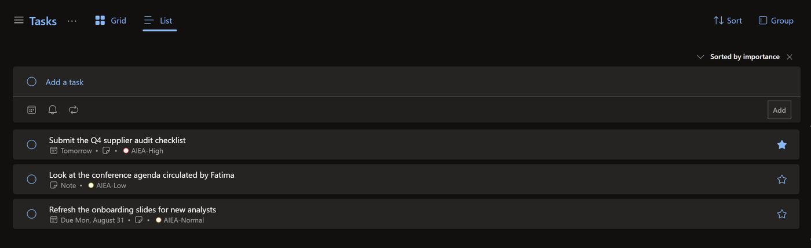
Figure 6. Extracted tasks in Microsoft To Do. Three priorities are distinguished by category colour; only the high-priority item is flagged, and the low-priority item is deliberately undated.
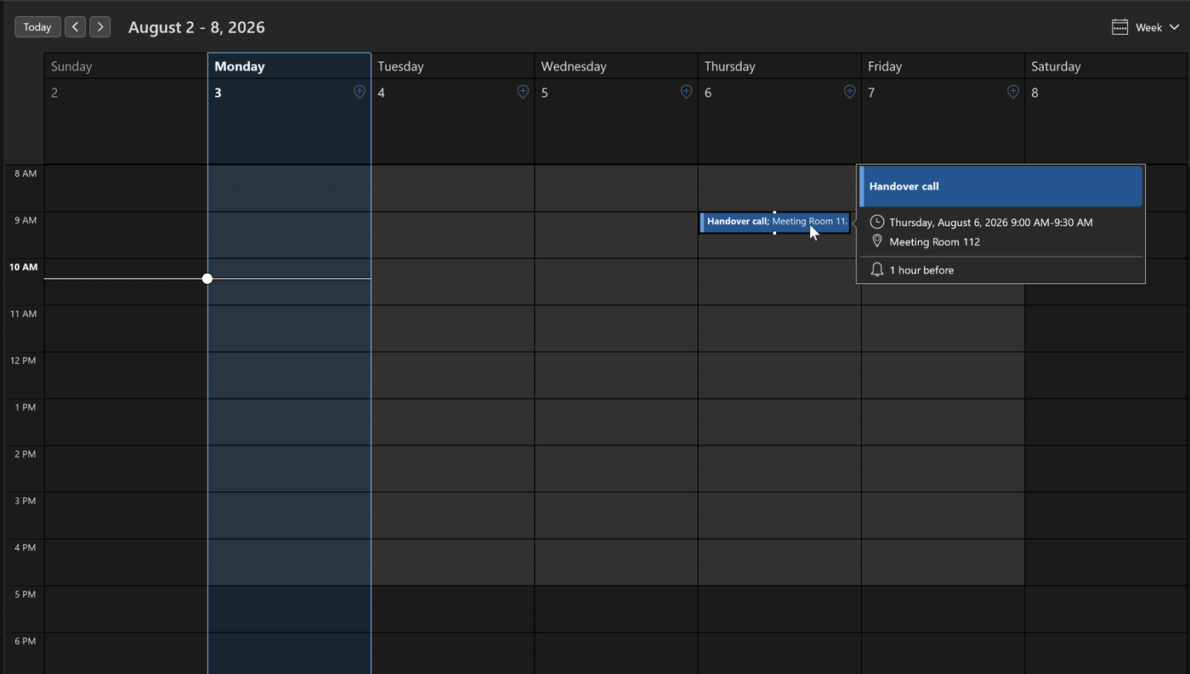
Figure 7. An appointment created from a weekday and time stated in natural language, with location and reminder applied from configuration.
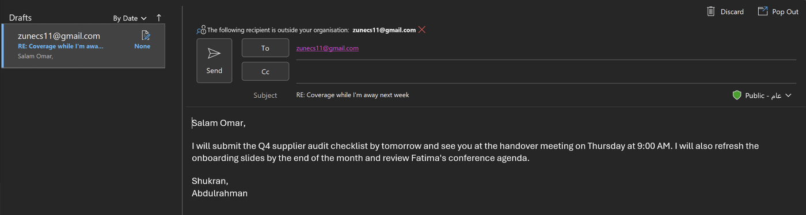
Figure 8. A generated reply saved to Drafts. The draft commits only to actions stated in the original message and is never sent automatically.

10.3 Attachment processing
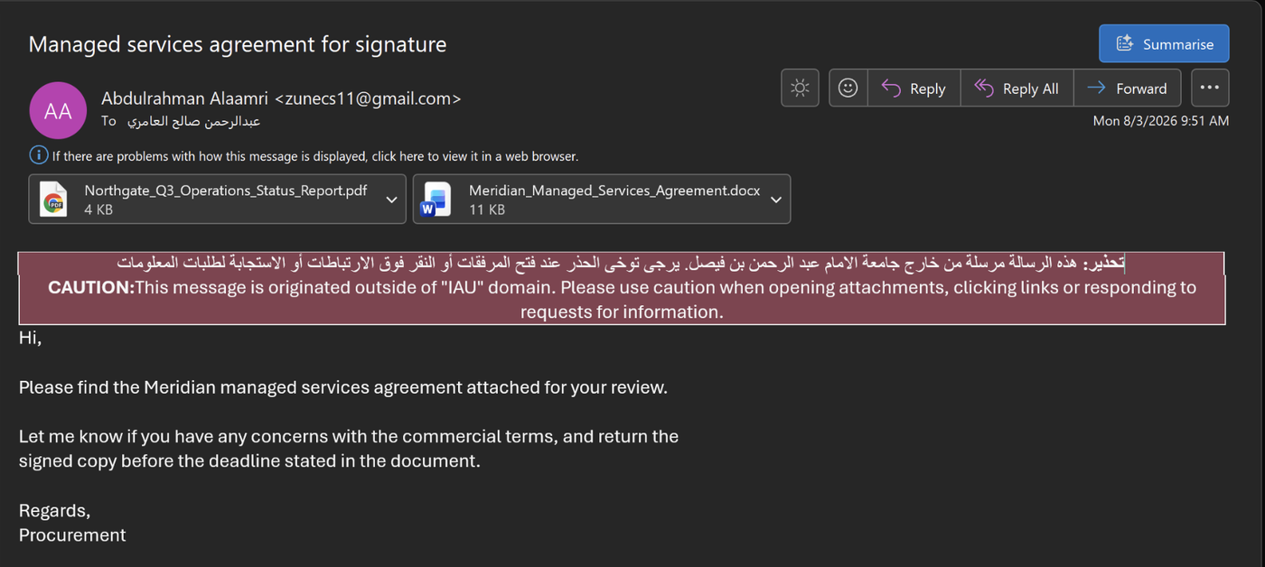
Figure 9. Input message carrying two attachments in different formats, exercising both the PDF and the Word extraction paths in a single run.
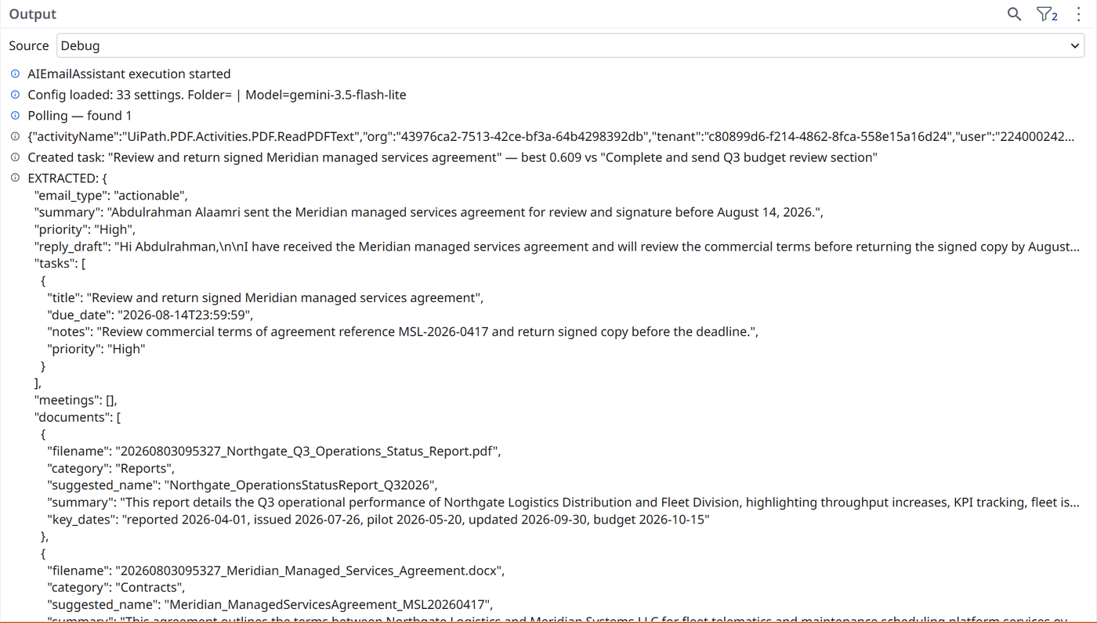
Figure 10. The corresponding extraction. A single task derives from the message's own request; the contract's internal obligations are correctly excluded. Both documents are classified independently with generated names, summaries, and key dates.

10.4 Document library
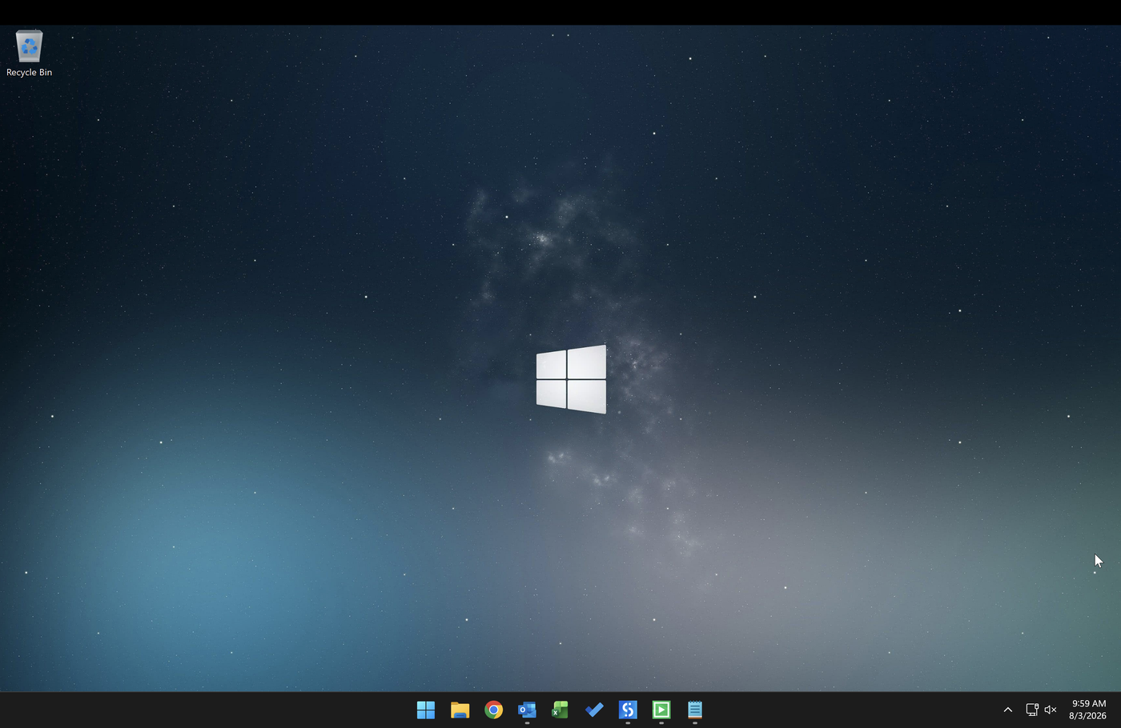
Figure 11. Watched folder before processing.
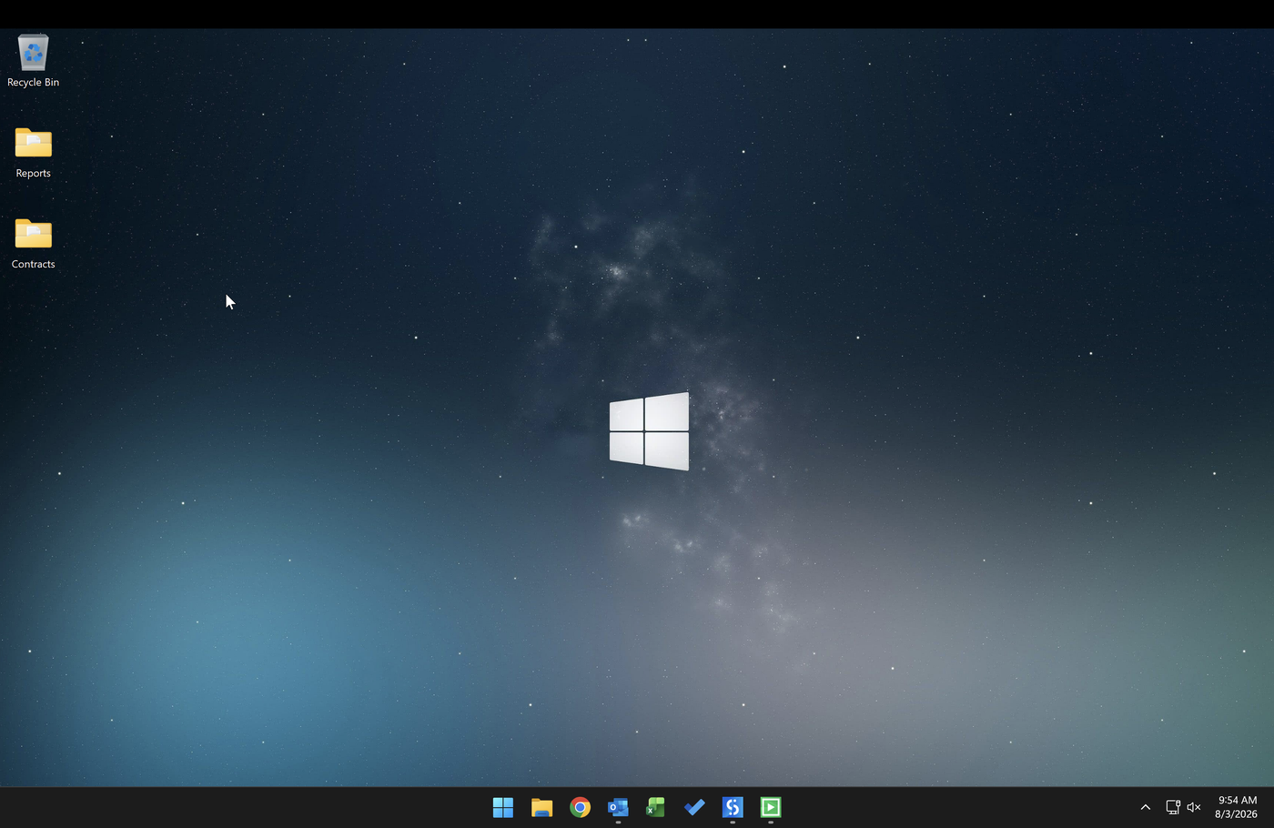
Figure 12. After processing. Category folders have been created and the source files moved into them.
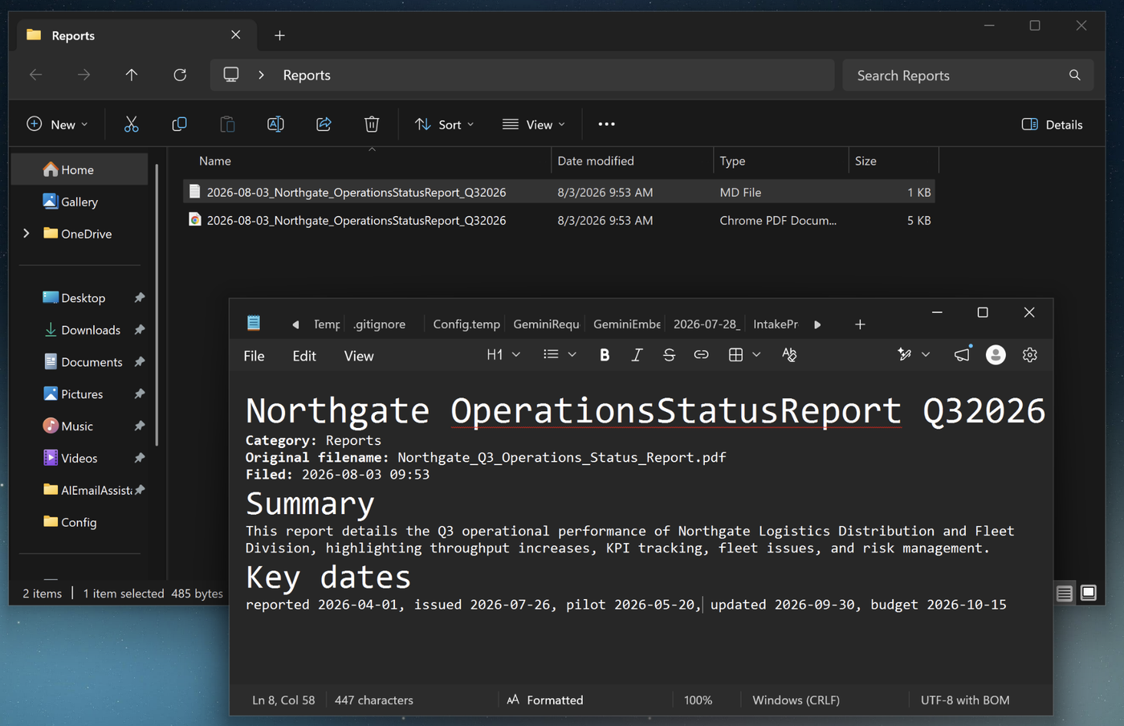
Figure 13. A filed report with its generated summary. Dates have been extracted from within the document body, not from the message that carried it.
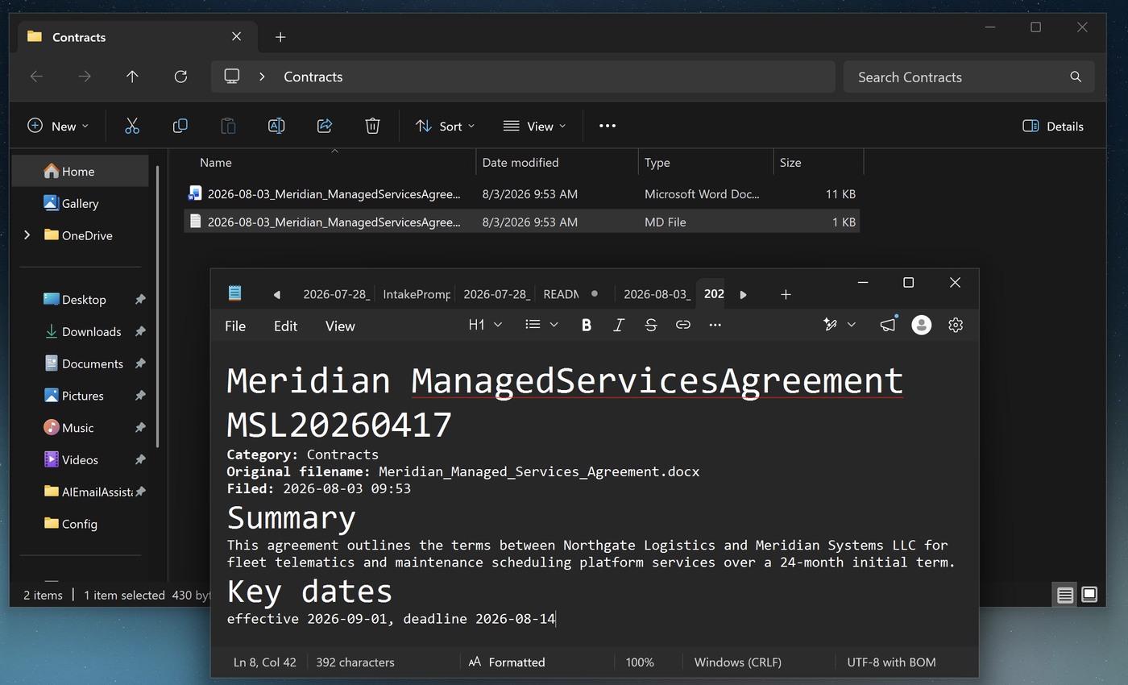
Figure 14. A filed agreement. The effective date and the signature deadline were both recovered from the document's own contents.

10.5 Reporting and audit
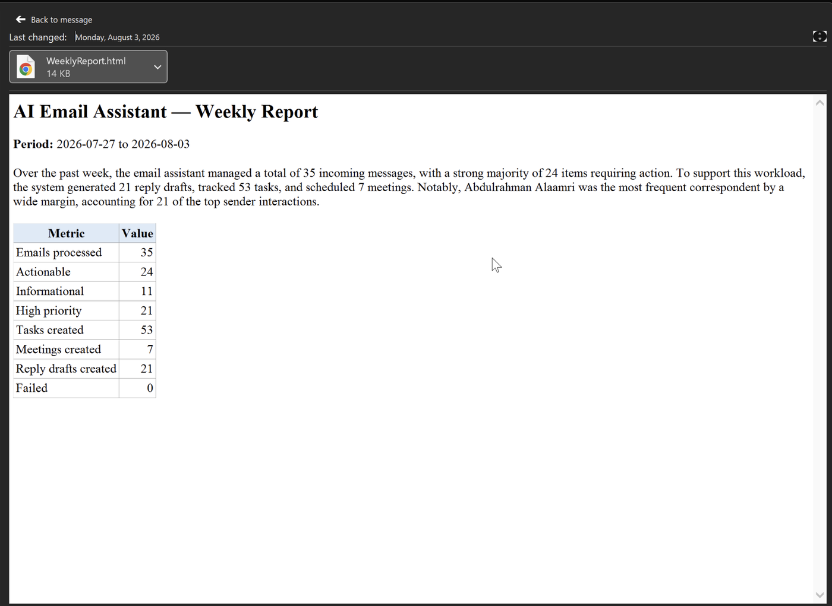
Figure 15. The generated weekly report. Figures are computed from the audit log; the narrative paragraph is written by the model from those figures alone.
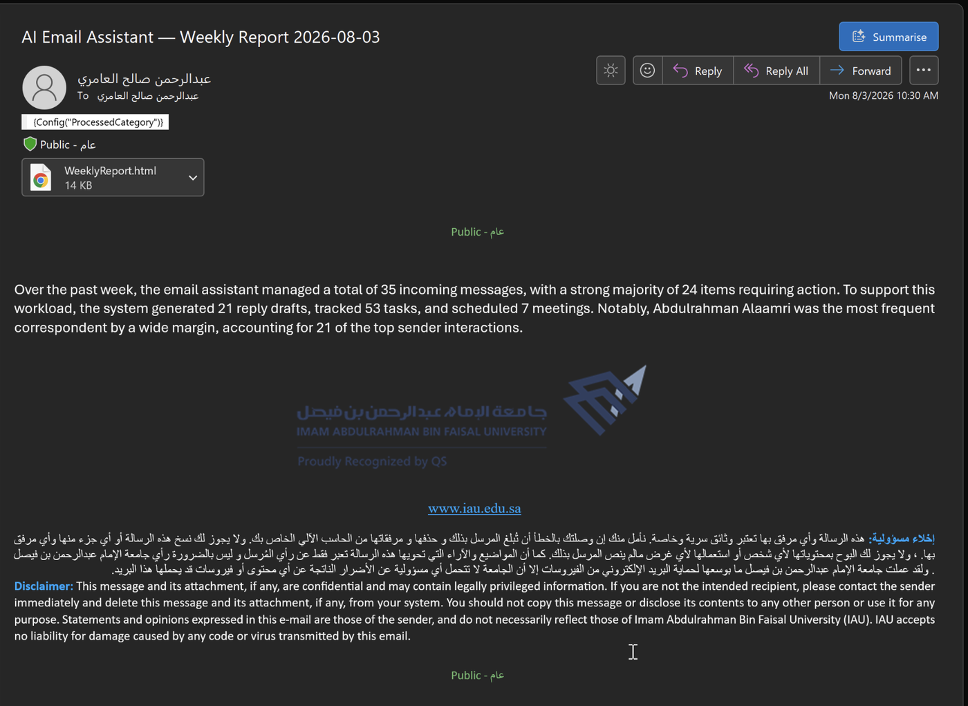
Figure 16. The report delivered as an email attachment.
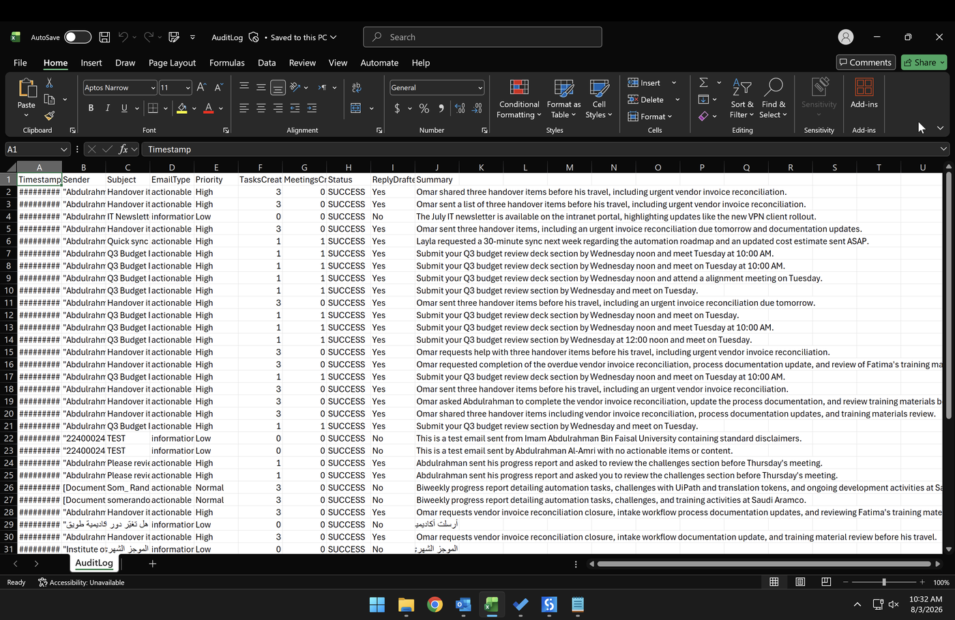
Figure 17. The audit log. Every processed item is recorded with its classification, counts, outcome, and summary. Arabic entries render correctly owing to the byte-order mark written on each append.

11. Deployment
The solution is published as a versioned package to a personal workspace and runs from UiPath Assistant, independently of the development environment. Configuration travels with the package, so the deployed instance is self-contained.
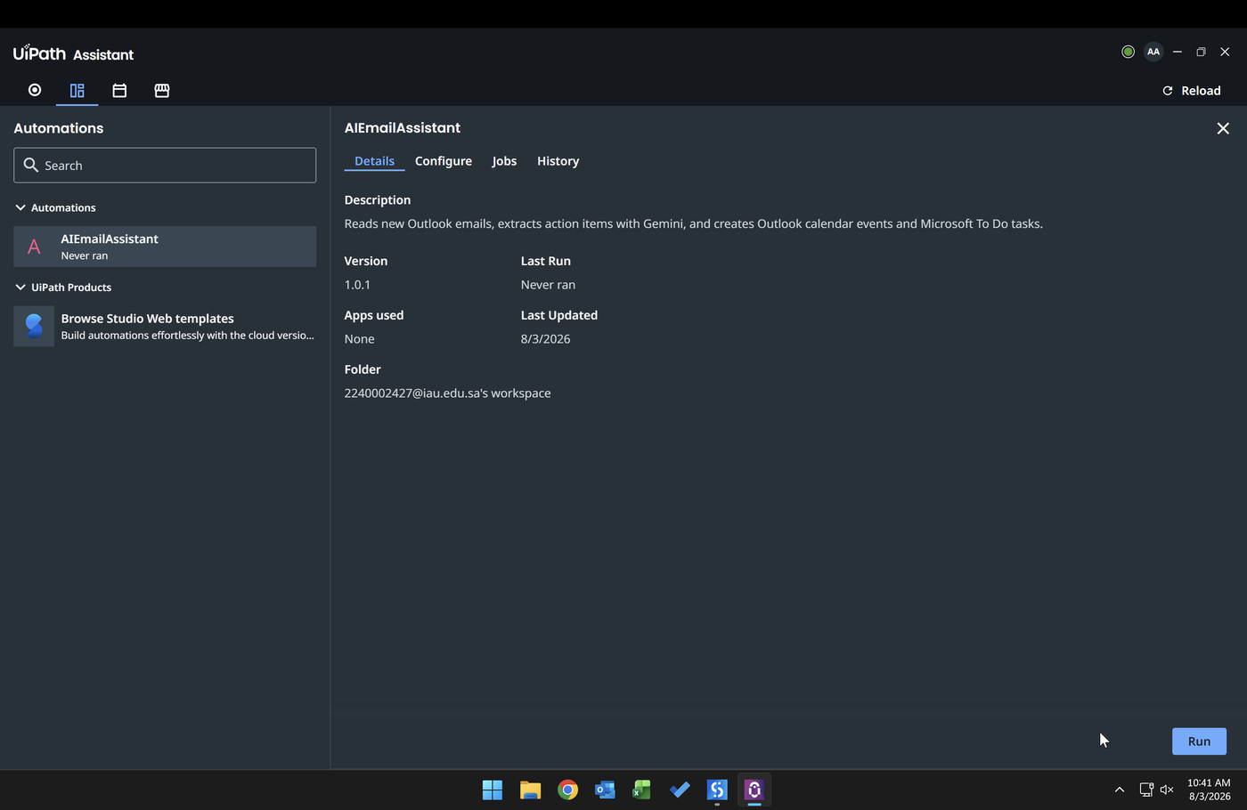
Figure 18. The published automation available for execution outside the development environment.
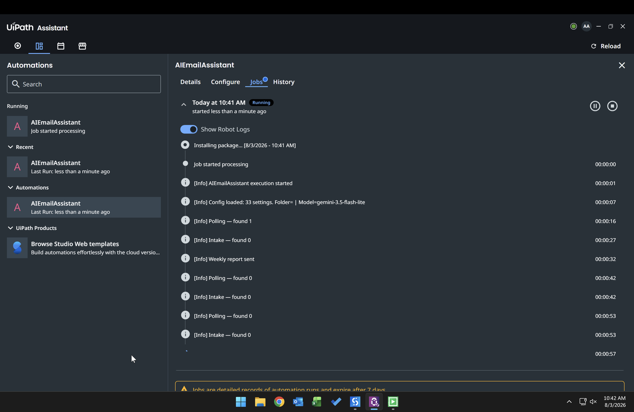
Figure 19. A live run. Robot logs show configuration loading, polling cycles, folder intake, and scheduled report generation.
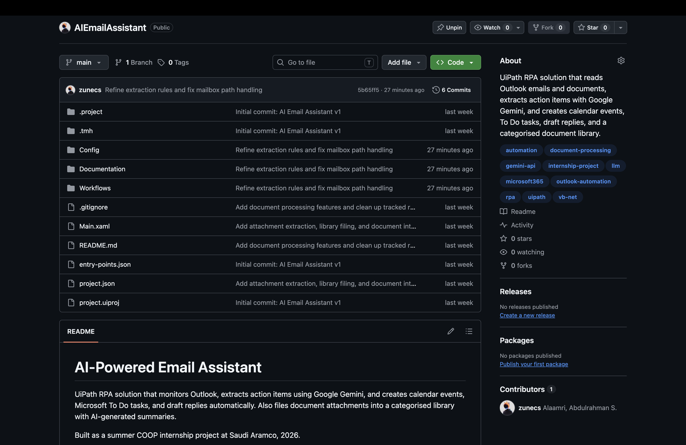
Figure 20. The public repository. Configuration secrets and generated runtime data are excluded through .gitignore; a redacted template documents the required settings.

12. Limitations
The following constraints are known and accepted at this version. Each is a consequence of a documented decision rather than an oversight.
Limitation | Cause and consequence
Windows-only execution | COM automation binds the solution to Windows with classic Outlook installed, signed in, and running. It cannot run headless.
Attended operation | Unattended scheduling requires a licensed orchestration tier. The process runs under a signed-in session, started manually or by the operating system scheduler.
Vector cache reflects creation, not existence | Duplicate detection compares against tasks the robot created. A task deleted manually will not be recreated until its cache entry ages out.
Report state is not persisted | The last-report marker is held in memory. A restart on the report day after the trigger hour would produce a second report.
Replies are not threaded | The mail object does not expose the identifier required for a true threaded reply, so drafts are composed as new messages with a conventional subject prefix.
Scanned documents are not read | Image-based PDFs yield no text and are processed as though empty, without an error.
Shared attachment budget | The text ceiling applies to all attachments combined, so a long first document can crowd out a shorter later one.
Free-tier quotas | Request rates are subject to provider limits. Batch caps mitigate this but do not remove it.

13. Future Work
Enhancement | Value
Confidence-driven human review | Route low-confidence extractions to a review task rather than creating a calendar entry directly, making the system's own uncertainty visible to the user.
Conversation-thread awareness | Read earlier messages in a thread before extracting, so that follow-ups are interpreted against what was already agreed.
Direct task-store comparison | Query existing tasks rather than a local cache, removing the divergence between what the robot created and what currently exists.
Persistent report state | Write the last-report marker back to configuration so that scheduling survives a restart.
Commitment tracking | Apply the same extraction to sent mail, capturing promises the user made rather than requests they received.
Optical character recognition | Extend document intake to scanned material.
Unattended orchestration | Move to a licensed tier for continuous server-side execution independent of a signed-in session.

14. Setup Guide

14.1 Prerequisites
- Windows with UiPath Studio 2026 Community Edition installed.
- Classic Outlook desktop, signed in to a Microsoft Exchange account and running.
- Microsoft Word and Excel, required for Office attachment extraction.
- A Gemini API key, obtainable without charge from Google AI Studio.

14.2 Installation
- Clone the repository and open project.json in UiPath Studio.
- Copy Config/Config.template.json to Config/Config.json.
- Enter the API key and the report recipient address in the new file.
- Adjust the monitored folder, poll interval, and library paths as required.
- In Outlook, create the three priority categories named AIEA-High, AIEA-Normal, and AIEA-Low, and create the processed-mail folder named in the configuration.
- Run from Studio to verify, then publish and run from UiPath Assistant.

14.3 Operational notes
Situation | Action
Outlook is closed | Automation will start it, but the first cycle may be slow. Keeping Outlook open is recommended.
Tasks are not appearing | Confirm the account type is Exchange. Tasks on a local-only store do not synchronise to Microsoft To Do.
Categories appear without colour | The category does not yet exist in the mailbox. Create it once in Outlook.
A task is not recreated after deletion | Its entry remains in the vector cache. Delete the cache file to reset.
Repeated failures for one message | Inspect the audit log entries for that subject; the message remains in the monitored folder.

This document describes version 1.0 of the solution. All company names, personal names, and document contents shown in figures are fictional and were created for demonstration purposes.

