**Project Management!**



**We used the projects tab in Git hub for project management and organization.**

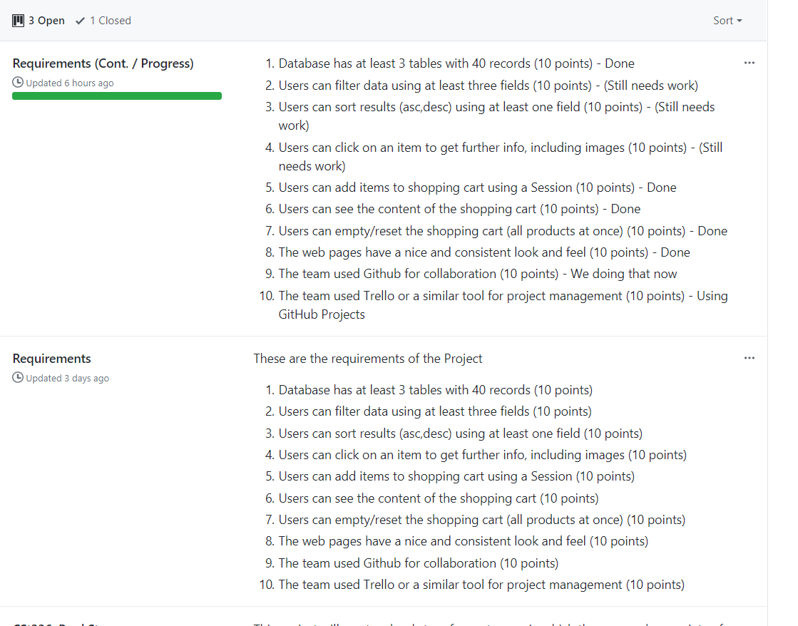

**We created Requirements tabs that were based off of the rubric to keep count of what was completed and what needed work.**

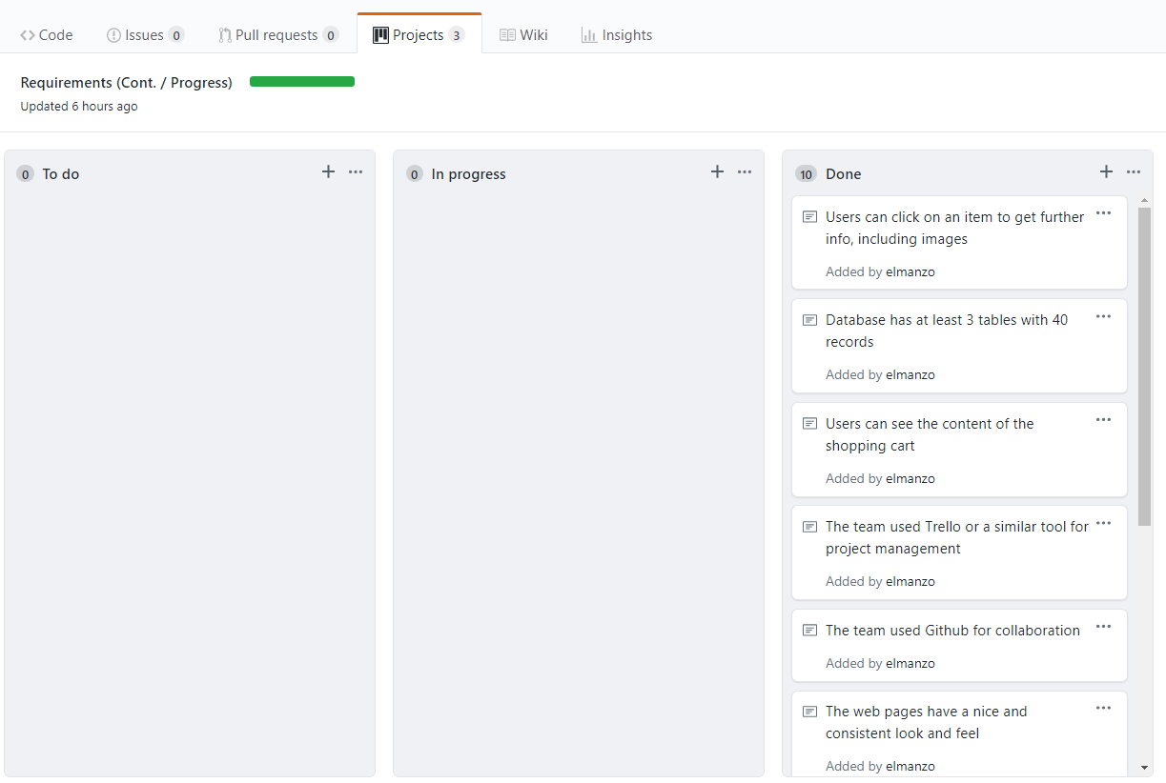

**We also used the progress application in Github. This made it easier for us to know what was started, what was being worked on, and what was has been completed.**

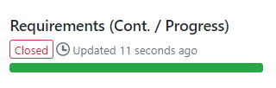

**Towards the end. We closed the project when we finished the application created.**