|  |
| --- |
| **Department of Computer & Software Engineering- ITU** |
| **CE302L: Database Management Systems Lab** |

|  |  |
| --- | --- |
| **Course Instructor: Hamza Shoukat** | **Dated:** |
| **Lab Engineer: Muhammad Usama Riaz** | **Semester: Spring 2025** |
| **Session: 2023-2027** | **Batch: BSSE2023** |

# **Lab 13. Open Ended Lab: Building a Web-Based Database Application**

|  |  |  |  |
| --- | --- | --- | --- |
| **Name** | **Roll number** | **Group No.** | **Obtained Marks / 100** |
|  |  |  |  |

Checked on: ____________________________

Signature: ____________________________

## **Objective**

The objective of this open-ended lab is to provide students with the opportunity to apply their knowledge of HTML, CSS, JavaScript, PHP, and MySQL to design and implement a web-based database application. Students will create a functional web application that interacts with a MySQL database, allowing users to perform CRUD (Create, Read, Update, Delete) operations on data.

## **Equipment and Material Required**

* Computers with internet access and development environments (e.g., XAMPP, WAMP, or a web hosting server with PHP and MySQL support).
* Text editors or integrated development environments (IDEs) for coding.
* MySQL database server.
* Sample database or dataset (e.g., a list of books, students, products).

## **Conduct of Lab**

* Duration: 2 weeks
* The lab will be conducted in a group of 3 students.

## **Lab Tasks**

**Week 1: Planning and Database Design**

1. Select a project idea or choose from predefined options (e.g., a library management system, e-commerce website, student registration system).
2. Define the requirements and features of the web application.
3. Design the database schema:
   1. Identify tables and their relationships.
   2. Create an Entity-Relationship Diagram (ERD).
   3. Define attributes and data types.

**Week 1: Front-End Development**

1. Design the user interface (UI) using HTML and CSS.
2. Create web pages for different functionalities (e.g., listing, adding, editing, deleting records).
3. Implement responsive design principles for mobile and desktop.
4. Implement JavaScript for client-side validation and interactivity.

**Week 2: Back-End Development and Database Integration**

1. Develop the PHP scripts for the back end:
   1. Create PHP scripts to handle user input, process requests, and interact with the database.
   2. Implement CRUD operations (Create, Read, Update, Delete) using PHP and MySQL queries.
2. Connect the web application to the MySQL database:
   1. Configure database connection settings.
   2. Create functions or methods to interact with the database (e.g., insert, retrieve, update, delete records) using PHP or any latest PHP framework of your choice.
3. Test the application:
   1. Verify that data is being stored and retrieved accurately.
   2. Handle potential errors.

**Week 2: Testing, Debugging, and Refinement**

1. Thoroughly test the web application, including all CRUD operations.
2. Debug and fix any issues or errors.
3. Add additional features or improvements based on feedback or creativity (e.g., search functionality, user authentication).
4. Optimize the code for performance.

**Week 3: Documentation and Presentation**

1. Prepare documentation for the web application, including a user manual, database schema documentation, and code documentation.
2. Share and discuss the challenges faced during the development process and the solutions implemented

**Project description:**

**1. Introduction**

SkillConnect is a comprehensive web-based platform designed to bridge the gap between individuals seeking to enhance their skills and those looking for talent, alongside offering educational opportunities and administrative tools. It aims to be a central hub for learning, professional development, and career advancement by providing features for online courses, tutoring sessions, job listings, and application management. The platform is built with a focus on user experience, robust functionality, and efficient administration.

# 2. Project Goals & Objectives

The primary goals of SkillConnect are:

* • Empower Skill Development
* • Facilitate Career Advancement
* • Streamline Administration
* • Enhance Communication
* • Provide Insightful Reporting

# 3. Key Features

SkillConnect is structured around several core modules:

## 3.1 User Management

* Employee Management
* Tutor Management
* Admin Management (Backend)

## 3.2 Learning & Development

* Course Management
* Tutoring Sessions

## 3.3 Job & Application Management

* Job Listings
* Applications

## 3.4 Communication & Reporting

* Messaging System
* Reports

## 3.5 System Settings (Admin Panel)

* Centralized control panel for core platform configurations

# 4. Technology Stack

Frontend: HTML5, CSS3, Bootstrap 5.3, Bootstrap Icons, Font Awesome, JavaScript

Backend: PHP, PDO (PHP Data Objects)

Database: MySQL/MariaDB

# 5. Architecture

SkillConnect follows a client-server architecture with separation of concerns:

• Frontend: HTML, CSS, JavaScript

• Backend: PHP with PDO

• Database: MySQL/MariaDB

# 6. Security Considerations

* Password Hashing using password_hash()
* Prepared Statements using PDO
* Input Validation using htmlspecialchars and trim
* Access Control (Future Enhancement)
* Error Logging using error_log
* HTTPS recommended for production

# 7. Development Environment

• Web Server: Apache/Nginx (via XAMPP/WAMP)

• PHP Version: 7.4+

• Database Server: MySQL/MariaDB

• Browser: Modern browsers

• Text Editor/IDE: VS Code, PHPStorm

# 8. Future Enhancements

* User Roles & Permissions
* User Dashboards
* Notification System
* Payment Gateway Integration
* File Uploads
* Review and Rating System
* Analytics Dashboard
* API Documentation
* Automated Testing
* Password Reset Functionality

**Landing page:**

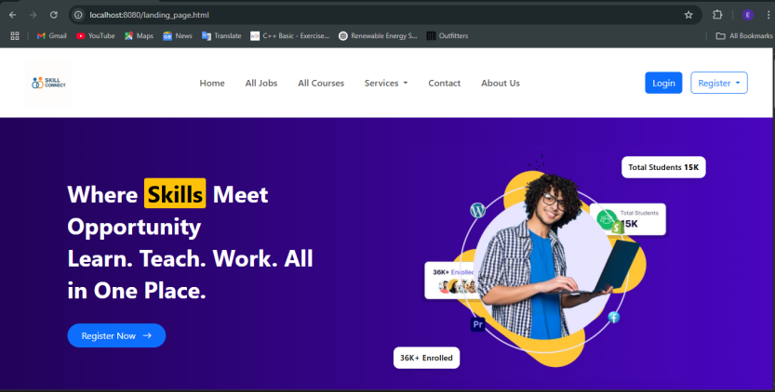

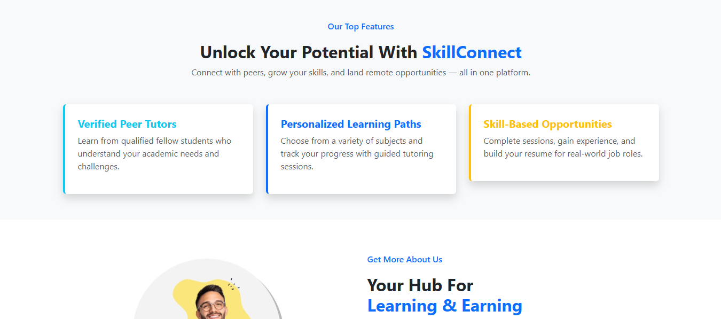

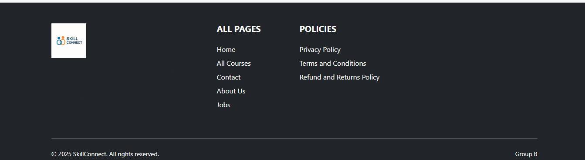

**Login page:**

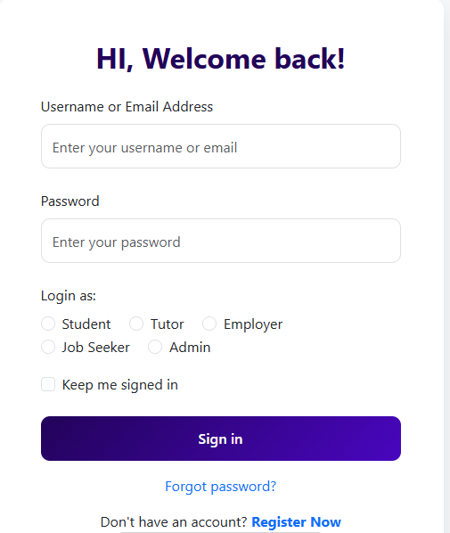

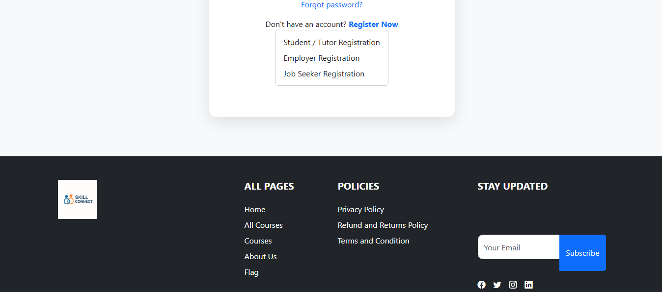

**Register page:**



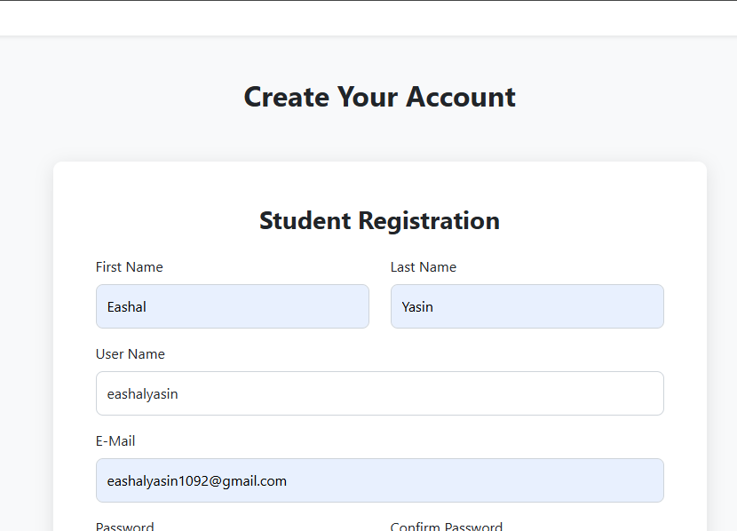

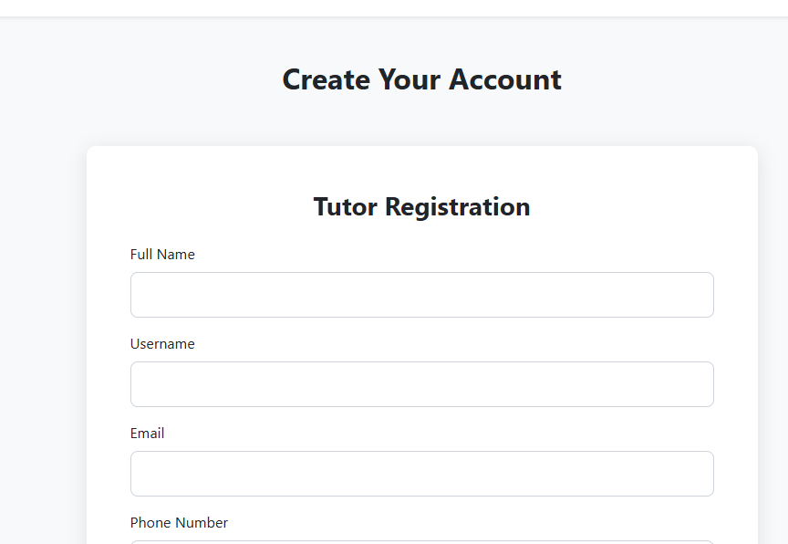

**DataBase:**

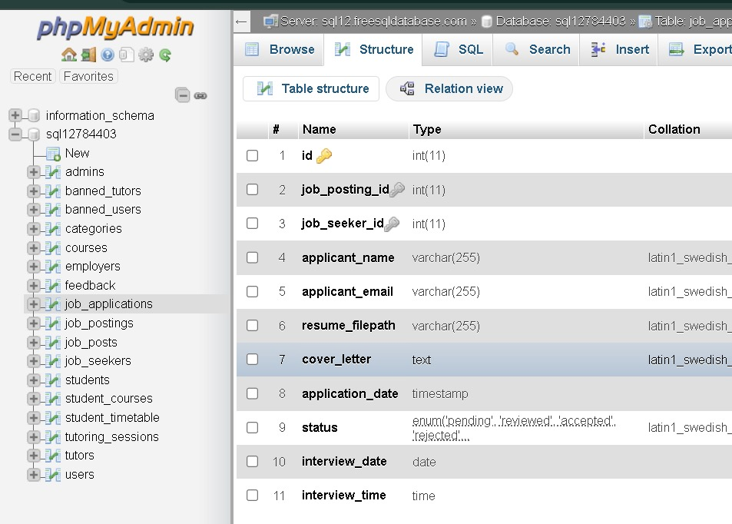

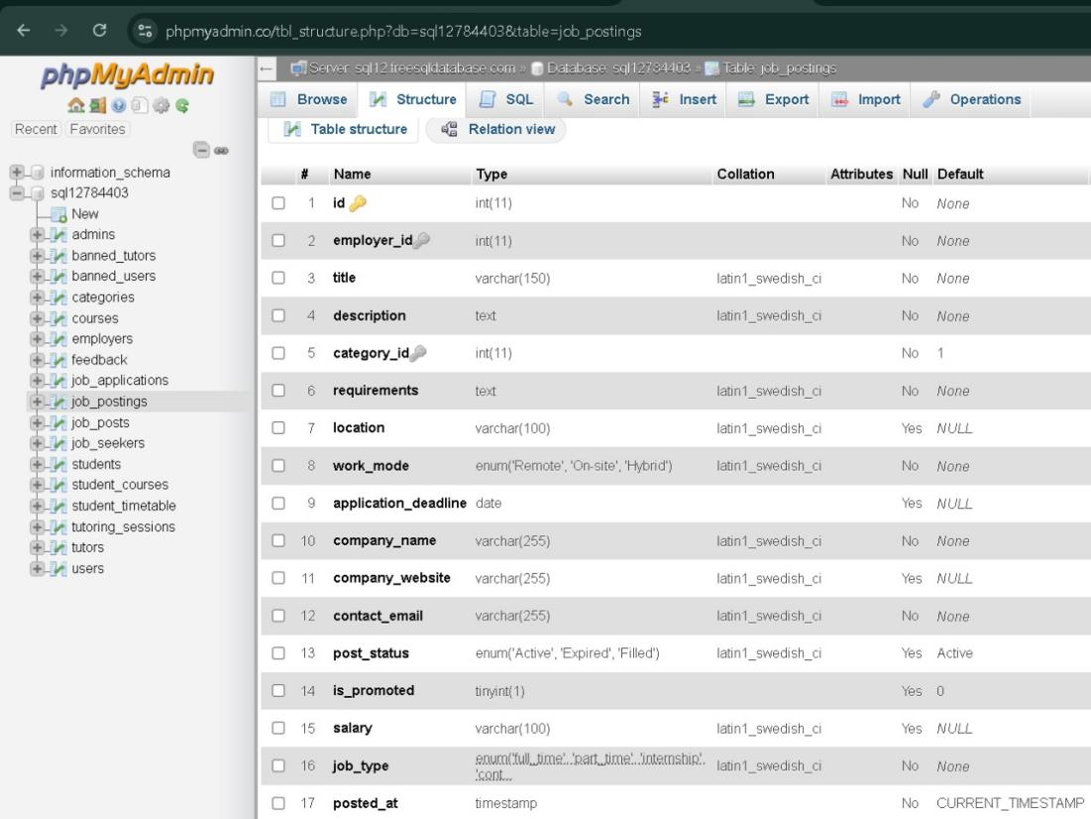

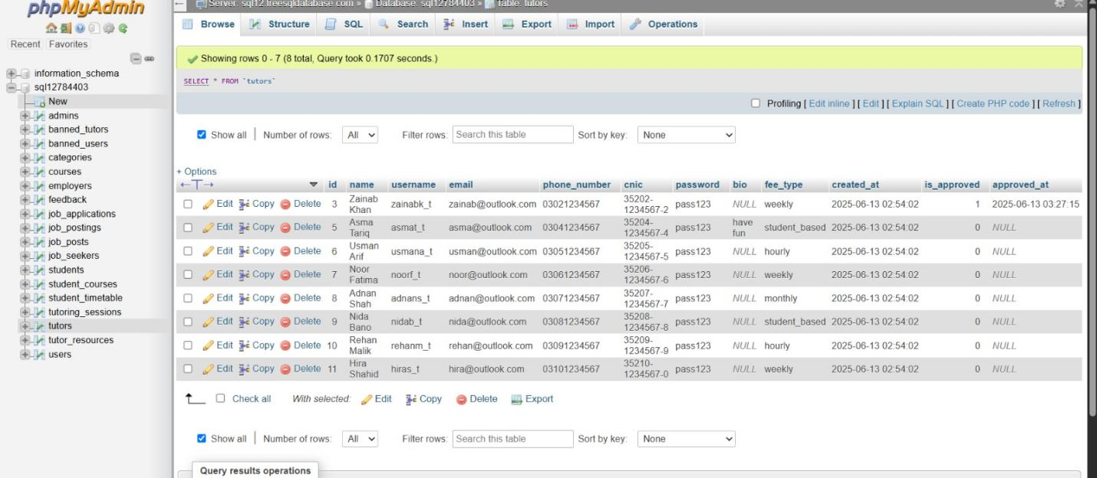

**Jobseeker page:**

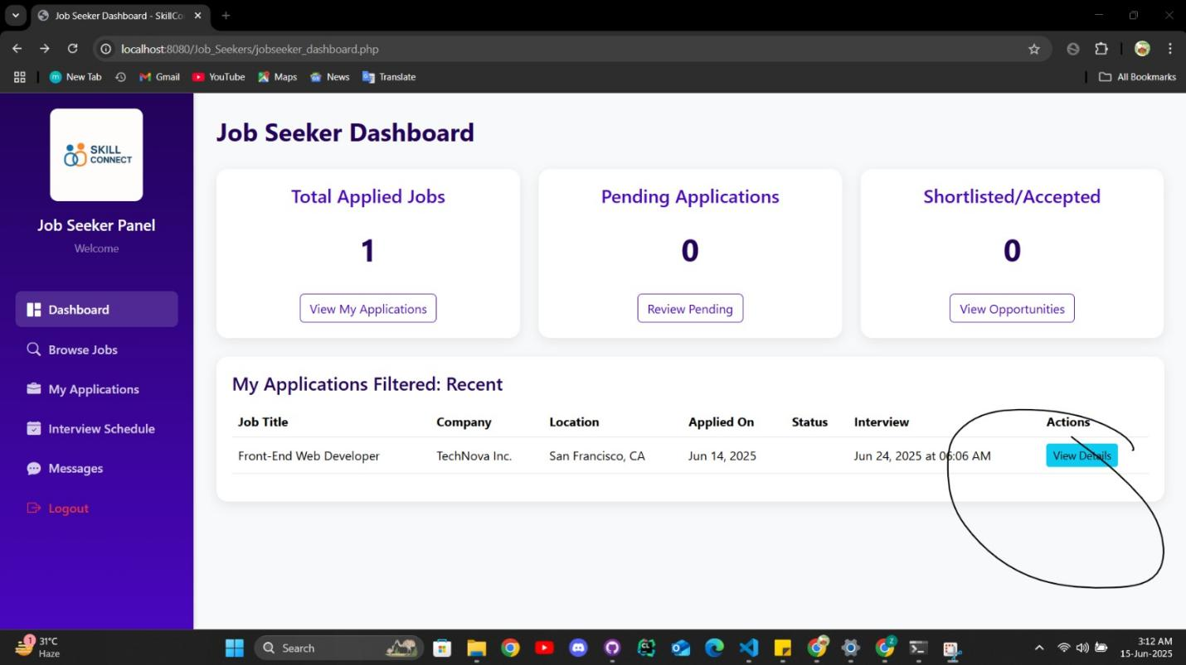

**Employee Dashboard:**

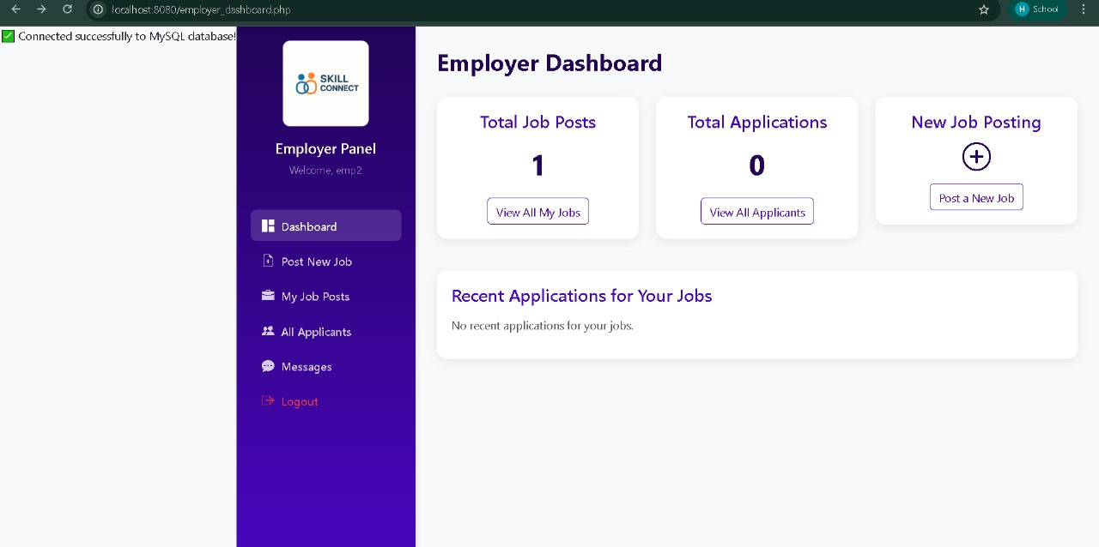

**Tutor Dashboard:**

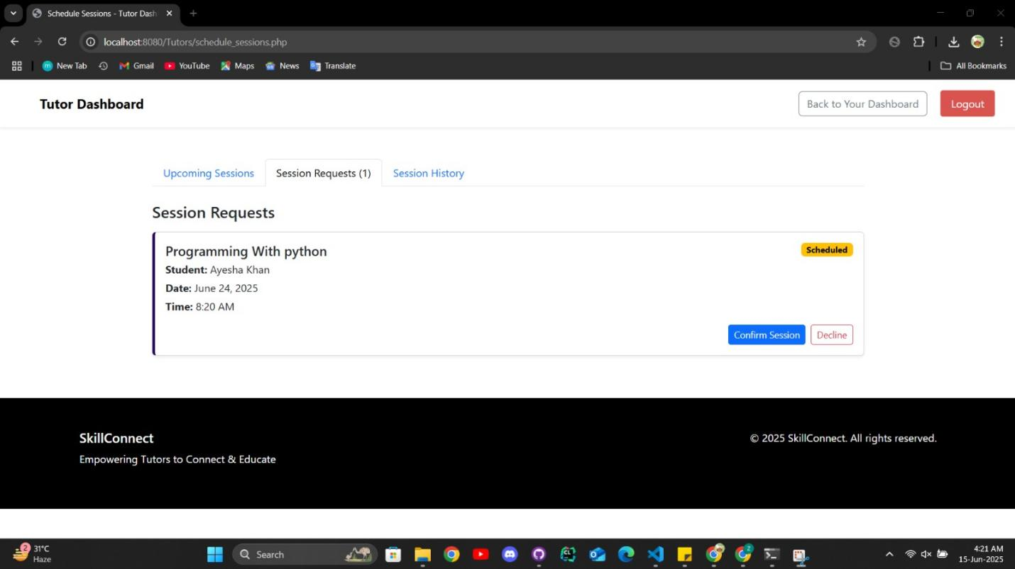

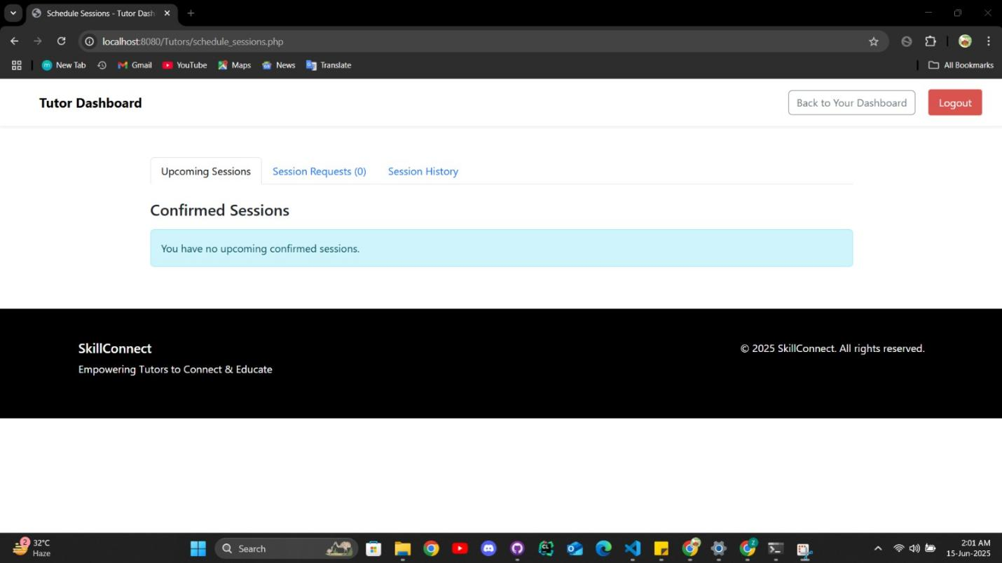

**Courses:**

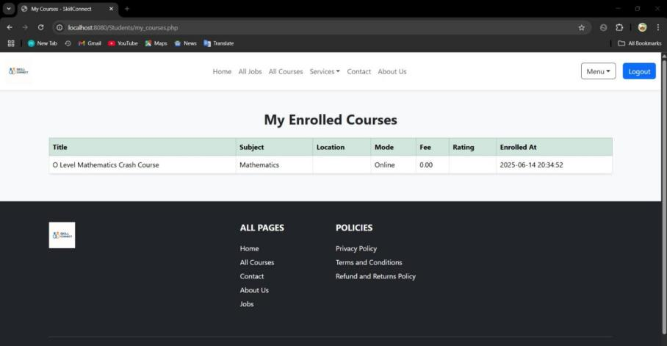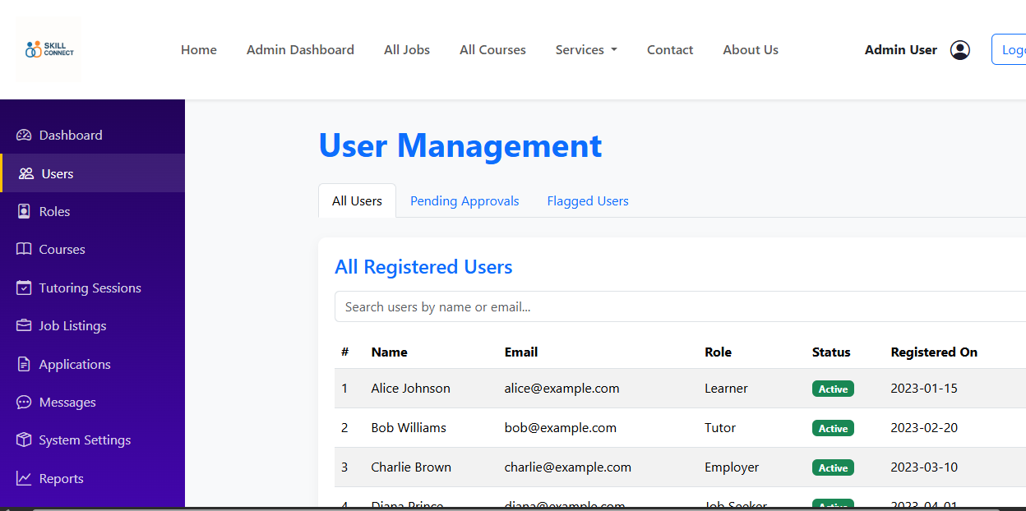

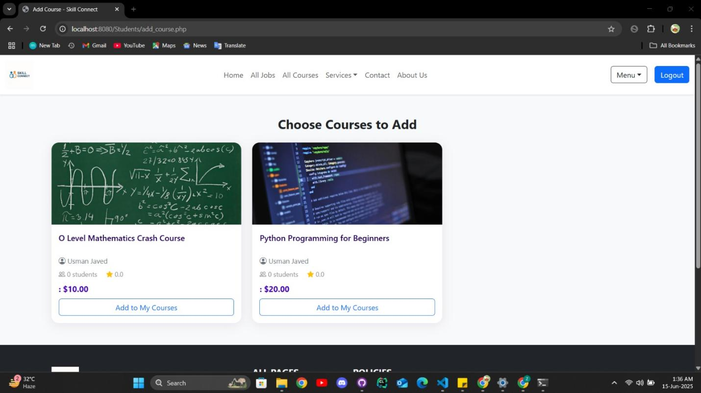

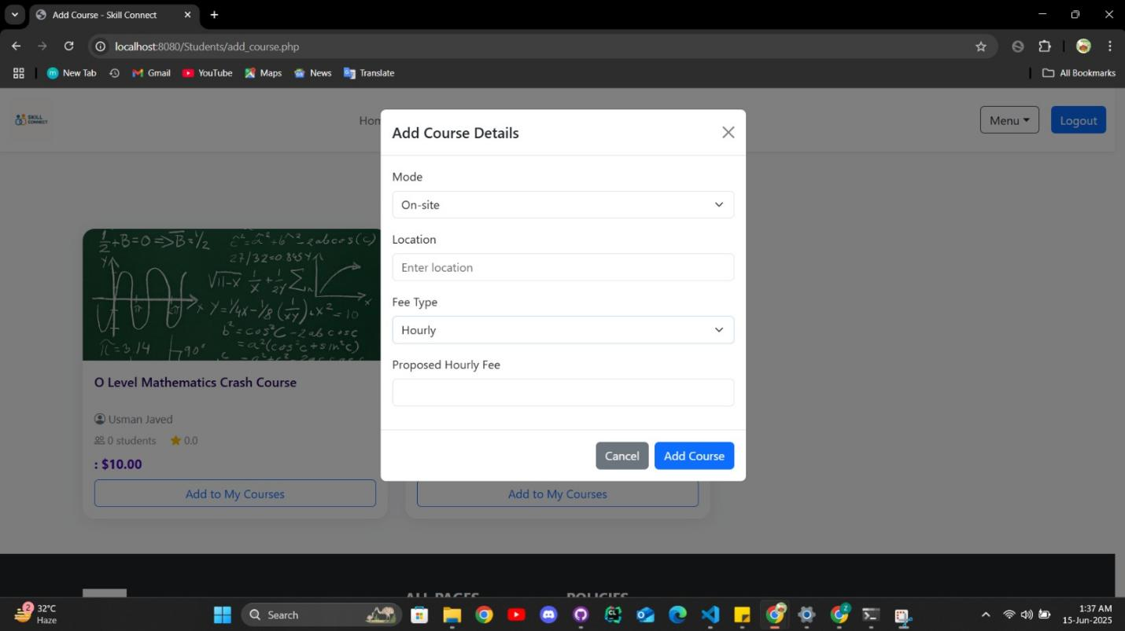

**Admin page:(ban users)**

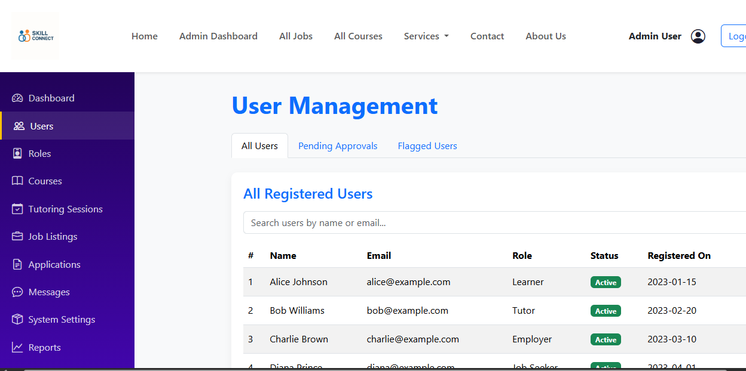

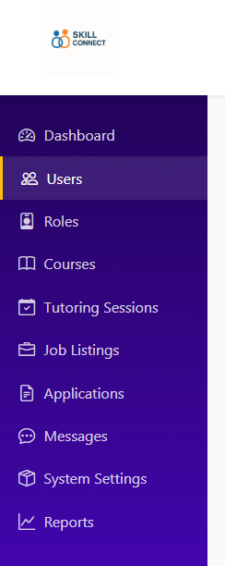

**Files and code:**

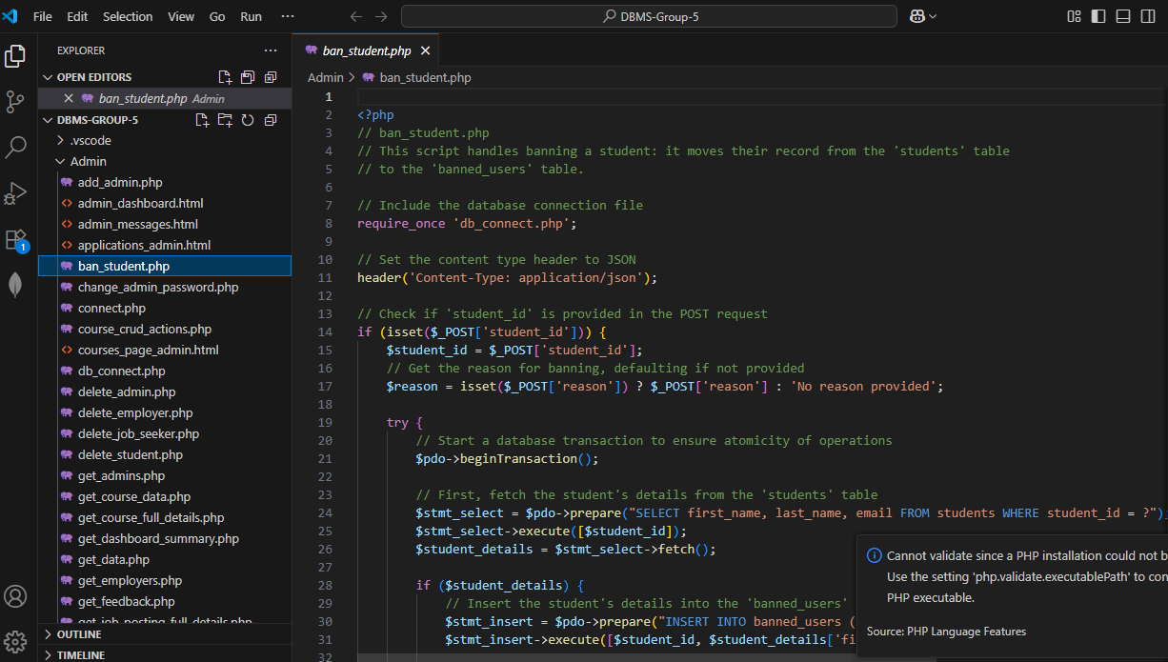

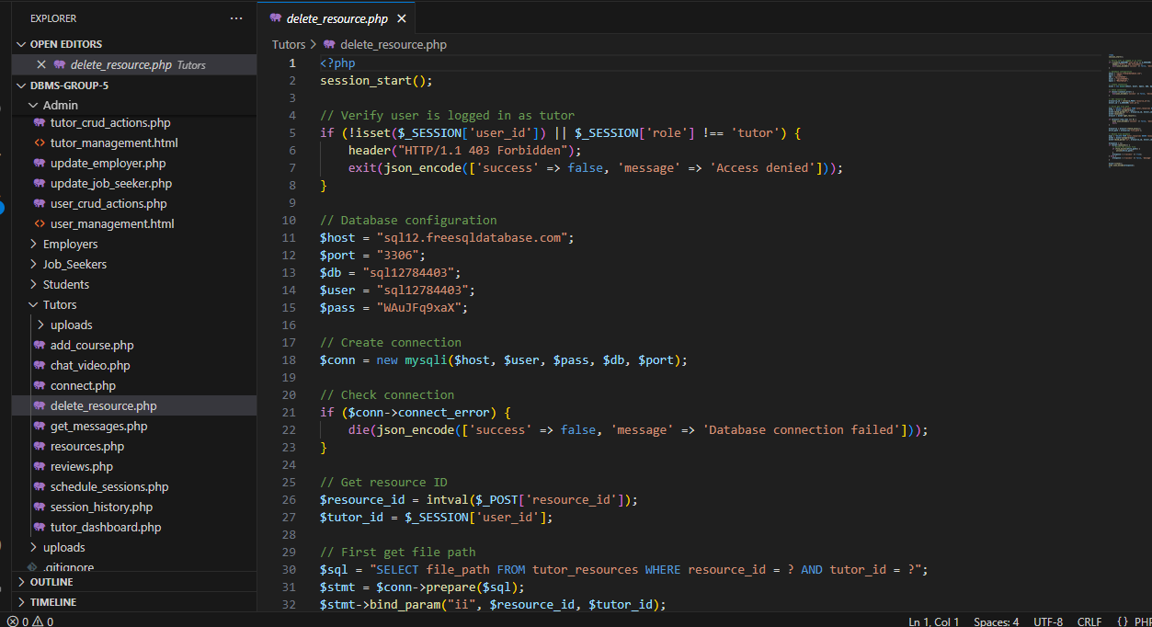

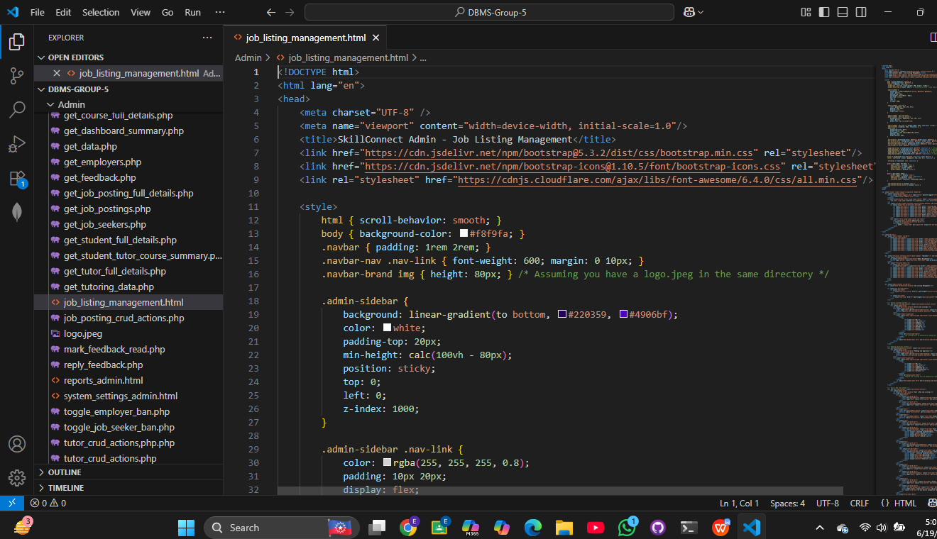

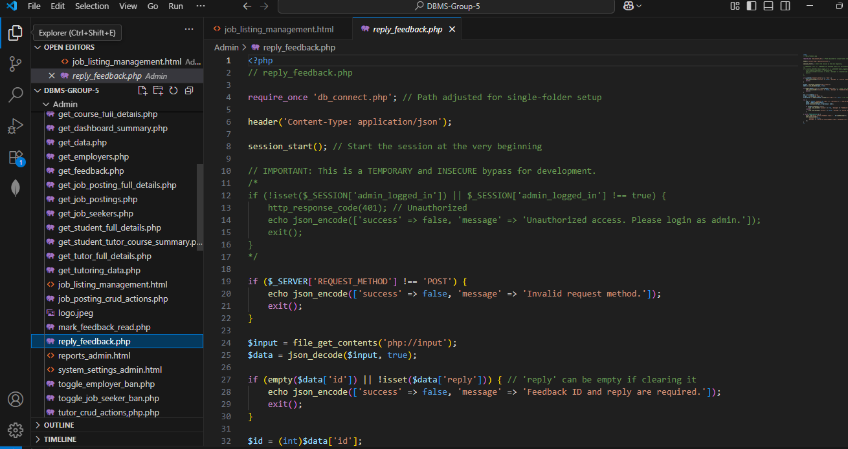

**Assessment Rubrics for the Open-Ended Lab**

|  |  |  |  |  |
| --- | --- | --- | --- | --- |
| **Category** | **CLO** | **Scoring Criteria** | **Total Points** | **Score** |
| **Design and Development of a Database Management System** | 1 | **Database Design:** Comprehensive ERD with clear identification of tables, relationships, and attributes, following relational theory. | 10 |  |
| **User Interface Design:** Well-designed and responsive UI that meets all requirements. | 10 |  |
| **Back-End Development:** PHP scripts are well-organized, efficient, and correctly implement CRUD operations. | 10 |  |
| **Utilization of Modern Tools** | 2 | **Development Environment:** Effective use of modern tools (e.g., VS Code, other IDEs) with clear organization of project files. | 10 |  |
| **Documentation:** Well-documented user manual covering all aspects of the application. | 10 |  |
| **Collaboration and Individual Work** | 3 | **Collaboration:** Effective collaboration within the team, contributing ideas and actively participating in group discussions. | 10 |  |
| **Individual Work:** Successfully completing individual tasks, demonstrating a high level of independence and adherence to guidelines. | 10 |  |
| **Presentation/Demonstration:** Engaging and clear presentation or demonstration of the web application, effectively highlighting its features and functionality. | 10 |  |
| **Independence and Adherence to Guidelines** | 4 | **Problem Solving:** Effectively applying theoretical knowledge to solve problems and overcome challenges. | 10 |  |
| **Adherence to Guidelines:** Strict adherence to guidelines and specifications, delivering a solution that meets all requirements. | 10 |  |
| **Total Points** | | | **100** |  |