NAME:ZUNAIRA IMRAN

REG (FA24_BSE_055)

SUBMITTED TO : MISS AMBREEN GULL

LAB TASK

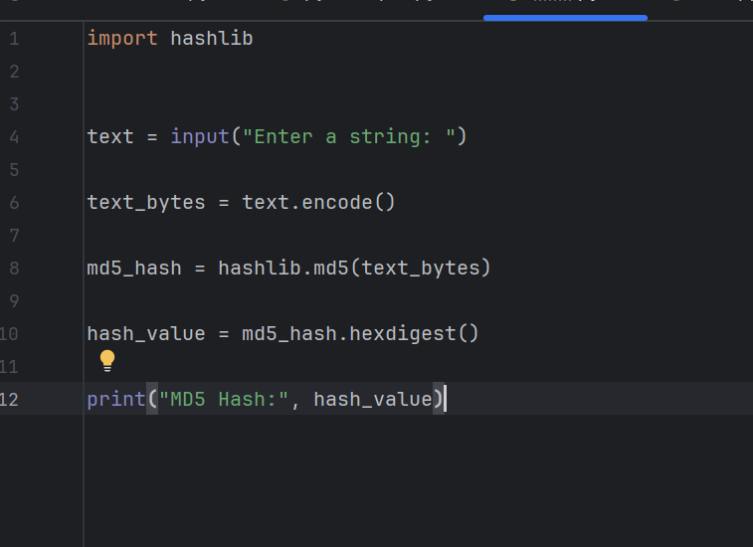

OUTPUT:
