OASIS INFOBYTE — SUMMER INTERNSHIP PROGRAM
CYBERSECURITY INTERNSHIP — TASK 2

WEB APPLICATION SECURITY
ASSESSMENT USING BURP SUITE

A Security Assessment Report on HTTP Response Configuration and
Information Disclosure Testing of a Web Application
FIELD | DETAILS
Prepared By | Akshita Kaul
University | Amity University Mumbai
Program | B.Tech, Computer Science Engineering  (Cybersecurity and Cloud Computing Specialization)
Internship Track | Cybersecurity Internship — Oasis Infobyte (OIBSIP)
Task | Task 2 — Web Application Security Assessment
Target of Assessment | https://example.com (authorized public documentation/reference domain)
Tool Used | Burp Suite Community Edition v2026.4.3
Report Date | 1 July 2026
Classification | Internal / Academic Submission

1. Executive Summary
This report documents a web application security assessment carried out as Task 2 of the Oasis Infobyte Cybersecurity Internship Program (OIBSIP). The objective of the assessment was to evaluate the HTTP-level security posture of a publicly accessible, authorized reference domain (https://example.com) using Burp Suite Community Edition as the primary interception and analysis tool.
The assessment focused on passive and manual analysis of a single HTTP GET request and its corresponding response, examining the presence and configuration of security-relevant response headers, cookie handling, and technology fingerprinting information. This scope was intentionally limited and non-intrusive, consistent with the authorization boundaries of the target and the introductory nature of the exercise.
Four findings were identified during the assessment. None represent an active, exploitable vulnerability against the target as tested; the findings instead relate to the absence of recommended browser-enforced security headers, which is a common and generally low-to-medium risk configuration gap on production web servers. A summary of all findings, together with their associated risk ratings and recommendations, is provided in Section 10.
This exercise was performed to build practical, hands-on proficiency with HTTP traffic interception, header-level security analysis, and structured vulnerability reporting — core competencies expected of an application security analyst.

2. Introduction to Web Application Security
Web application security is the practice of identifying, understanding, and mitigating weaknesses in how a web application is designed, configured, and deployed, so that it cannot be misused to compromise confidentiality, integrity, or availability of data and services. Because the web is the primary interface between organizations and their users, even small misconfigurations at the HTTP layer can have a disproportionate impact on an organization's overall security posture.
A meaningful proportion of real-world web security issues do not stem from complex logic flaws but from missing or misconfigured HTTP response headers, weak session and cookie handling, and unnecessary disclosure of backend technology details. These issues are attractive to attackers because they are cheap to discover — often visible in a single response — and they frequently act as force-multipliers for other attacks such as cross-site scripting (XSS) and clickjacking, rather than being exploitable vulnerabilities in isolation.
This assessment applies a structured, header-and-configuration-focused methodology to a single target in order to demonstrate how such a review is conducted in practice, from initial reconnaissance through to a risk-rated set of findings and recommendations.

3. Objectives
- To gain hands-on experience with Burp Suite Community Edition as an HTTP interception and analysis proxy.
- To perform reconnaissance on a target web application and interpret core HTTP response metadata.
- To assess the presence and configuration of key browser-enforced security headers.
- To evaluate cookie issuance and session-handling practices at the HTTP level.
- To identify any unnecessary disclosure of backend technology information.
- To document findings in a structured, industry-style security assessment report, including risk ratings and remediation guidance.

4. Tools and Technologies
TOOL / TECHNOLOGY | PURPOSE IN THIS ASSESSMENT
Burp Suite Community Edition v2026.4.3 | Intercepting proxy used to capture, inspect and analyze the HTTP request/response pair exchanged with the target
Chromium-based Web Browser | Configured to route traffic through the Burp Suite proxy (127.0.0.1:8080) to generate live traffic for capture
Burp Suite HTTP History / Proxy Module | Used to review captured requests and responses in the Pretty, Raw and Render views
Burp Suite Response Search | Used to search response headers for specific security-relevant header names (e.g. Strict-Transport-Security, X-Frame-Options, Set-Cookie, X-Powered-By)

5. Scope of Assessment
Target: https://example.com — a domain reserved by IANA for use in documentation and illustrative examples, chosen specifically because it permits inspection without requiring separate written authorization.
Scope boundary: Passive/manual review of a single unauthenticated GET request to the target's root path ('/') and analysis of the resulting HTTP response. No authenticated areas, forms, APIs, or third-party-linked resources were tested.
Out of scope: Active exploitation, automated scanning, fuzzing, denial-of-service testing, and any interaction beyond a standard browser page load were explicitly excluded from this assessment.
Testing was performed strictly against the authorized educational/reference target described above and for learning purposes only, in line with the intended use of the domain. No production systems, customer data, or third-party infrastructure outside this scope were accessed at any point during the exercise.

6. Methodology
The assessment followed a condensed version of a standard web application penetration testing workflow, scaled appropriately to the size and scope of the target:

6.1 Reconnaissance
- Identify basic target information exposed by the web server (protocol version, hosting/CDN provider, response status).
- Analyze the raw HTTP response returned for the root path.
- Record server and application-level details visible in the response headers.

6.2 HTTP Traffic Analysis
- Route browser traffic through Burp Suite's intercepting proxy (listening on 127.0.0.1:8080).
- Capture the request and response pair in the Proxy → HTTP History tab.
- Review the HTTP method, request headers, response status code, and response headers in the Pretty view.

6.3 Security Configuration Analysis
- Search the response for security headers: Content-Security-Policy, X-Frame-Options, Strict-Transport-Security.
- Search the response for a Set-Cookie header to assess session/cookie handling.
- Search the response for an X-Powered-By header to assess technology disclosure.

6.4 Risk Analysis
Each observation was evaluated against four criteria: the observation itself, the associated security impact, an assigned risk level (Informational, Low, Medium, or High), and a corresponding, actionable recommendation. This structure mirrors the format used in professional vulnerability assessment reports and is applied consistently to every finding in Section 10.

7. HTTP Communication Explanation
Hypertext Transfer Protocol (HTTP) is the application-layer protocol underlying nearly all web communication. A client (browser) issues a request specifying a method (such as GET), a target resource, and a set of headers describing the client and its capabilities. The server responds with a status code indicating the outcome of the request, a set of response headers describing the resource and how it should be handled, and, typically, a response body.
For this assessment, the request observed was a simple GET request to the root path of the target over HTTP/2, using TLS (HTTPS). The server responded with a 200 OK status, indicating the request succeeded and the requested resource — the site's HTML page — was returned successfully.
Response headers are of particular interest in a security assessment because, beyond describing the content itself (such as Content-Type), many of them instruct the browser to enforce specific protective behaviors — for example, restricting where a page can be framed, or forcing all future connections to use HTTPS. The remainder of this report focuses on this category of headers, as they are directly observable from a single response and are a standard first checkpoint in any web application security review.

8. Assessment Results
The table below summarizes the raw metadata captured from the target's HTTP response, which formed the basis for the reconnaissance finding discussed in Section 9.1.
PARAMETER | OBSERVED VALUE
Request Method | GET /
Protocol | HTTP/2
Response Status | 200 OK
Content-Type | text/html
Server | cloudflare
Cf-Cache-Status | HIT (response served from CDN edge cache)
Last-Modified | Wed, 01 Jul 2026 17:52:37 GMT
Allow | GET, HEAD

9. Security Findings

9.1 Finding 1 — Initial Website Reconnaissance
Observation: The target responded to a standard GET request over HTTP/2 with a 200 OK status. The response identified the hosting/edge provider as Cloudflare, returned a Content-Type of text/html, and included cache and modification metadata.
Reconnaissance is the foundation of any security assessment because it establishes a factual baseline of what the target is, how it responds under normal conditions, and what infrastructure sits in front of it, before any deeper analysis is attempted. Identifying that the target sits behind Cloudflare, for instance, is useful context: it indicates that certain protections (such as basic DDoS mitigation and edge caching) are likely already in place at the network layer, which shapes expectations for the remainder of the assessment. Confirming the response status, protocol version, and content type also validates that the tooling and proxy configuration are working correctly before proceeding to header-level analysis.
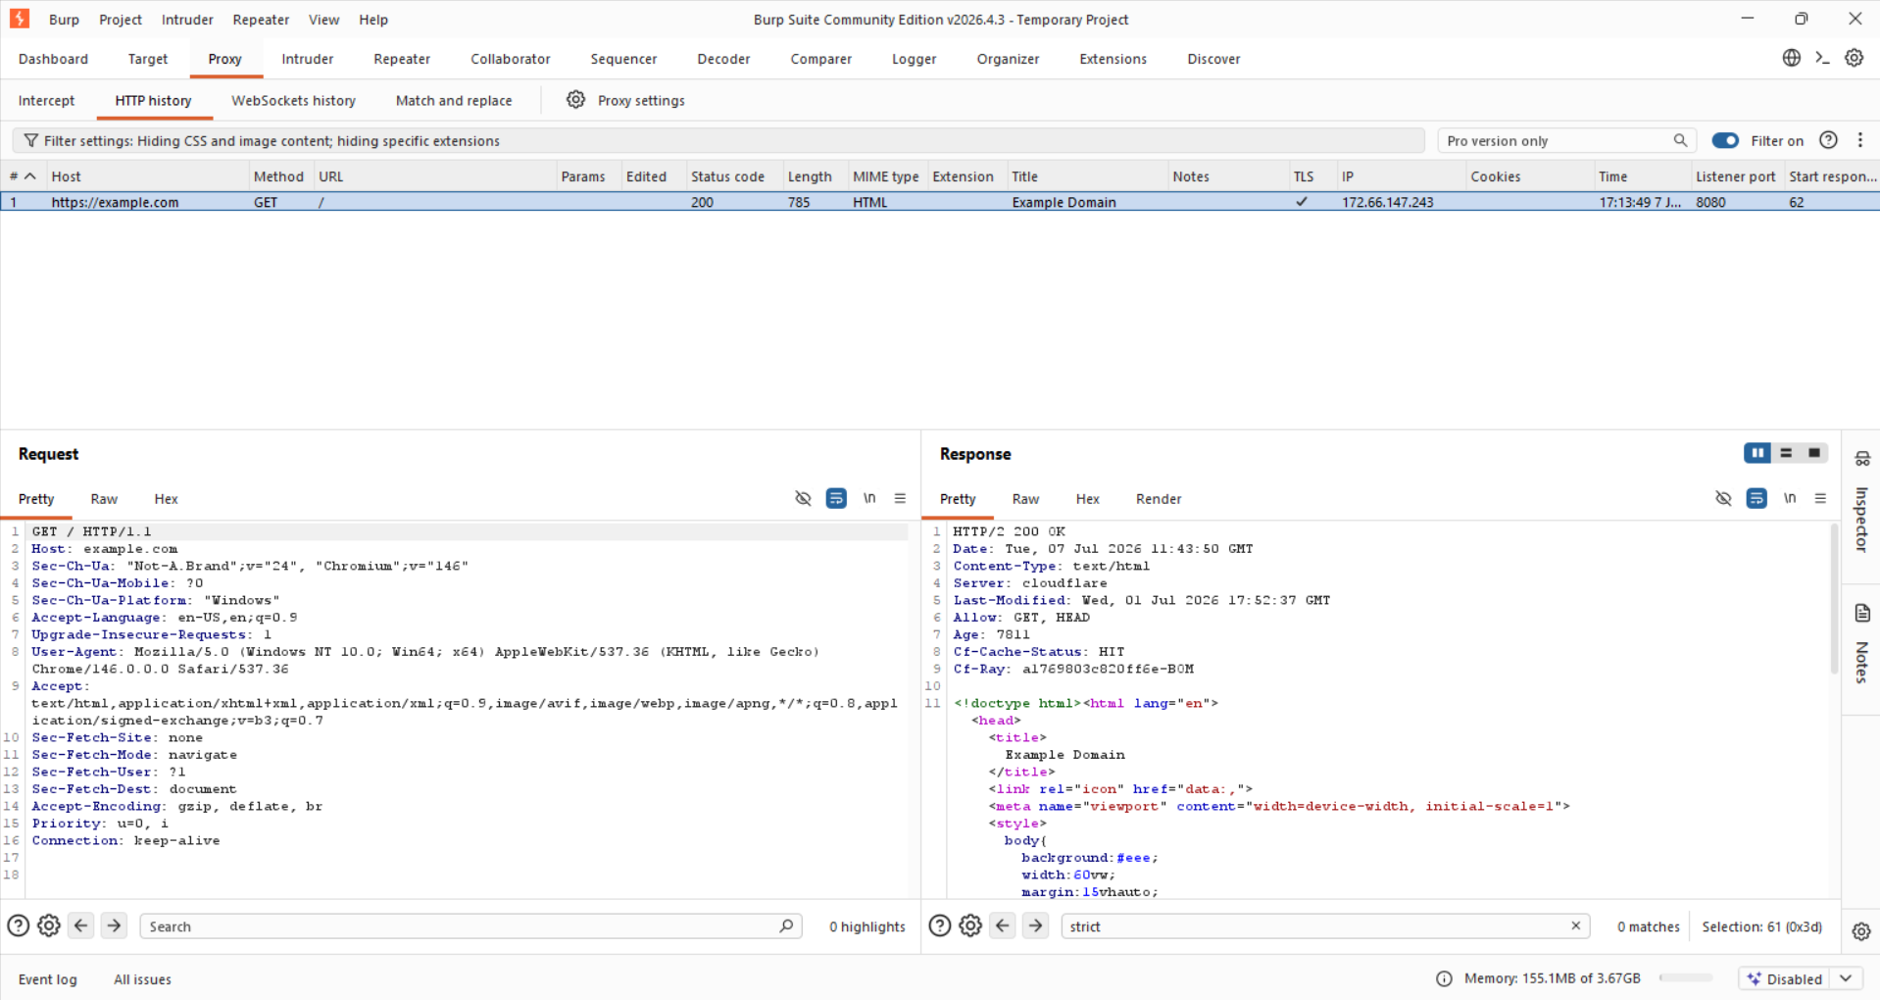
Screenshot 1 — Burp HTTP Reconnaissance: captured GET request and response in Burp Suite Proxy → HTTP History

9.2 Finding 2 — Missing Security Headers
Observation: A manual search of the response headers for Content-Security-Policy, X-Frame-Options, and Strict-Transport-Security returned no matches for any of the three headers.
These three headers are among the most commonly recommended browser-enforced security controls for any web application:
- Content-Security-Policy (CSP) restricts the sources from which a browser is permitted to load scripts, styles, images, and other resources, and is one of the most effective mitigations against cross-site scripting (XSS) and data-injection attacks.
- X-Frame-Options (or the frame-ancestors directive within CSP) controls whether a page can be rendered inside a frame on another site, and is the primary defense against clickjacking attacks.
- Strict-Transport-Security (HSTS) instructs the browser to only ever connect to the domain over HTTPS for a specified duration, preventing protocol-downgrade and certain man-in-the-middle attacks that rely on an initial unencrypted request.
The absence of these headers does not, by itself, constitute an exploitable vulnerability against this target as tested. It does, however, mean that the browser is not receiving explicit instructions to enforce these protections, which reduces defense-in-depth. On a site that renders user-controllable content or handles sensitive transactions, this gap becomes materially more significant. Because example.com is a static, non-interactive reference page with no user input or sensitive functionality, the practical impact here is limited — but the same gap on a production application would warrant prompt remediation.
Recommendation: Configure the web server or CDN edge (e.g. Cloudflare Transform Rules or an origin-level configuration) to send a restrictive Content-Security-Policy, an X-Frame-Options: DENY or SAMEORIGIN header (or equivalent frame-ancestors directive), and a Strict-Transport-Security header with an appropriate max-age and includeSubDomains directive.
Risk Level: Low to Medium
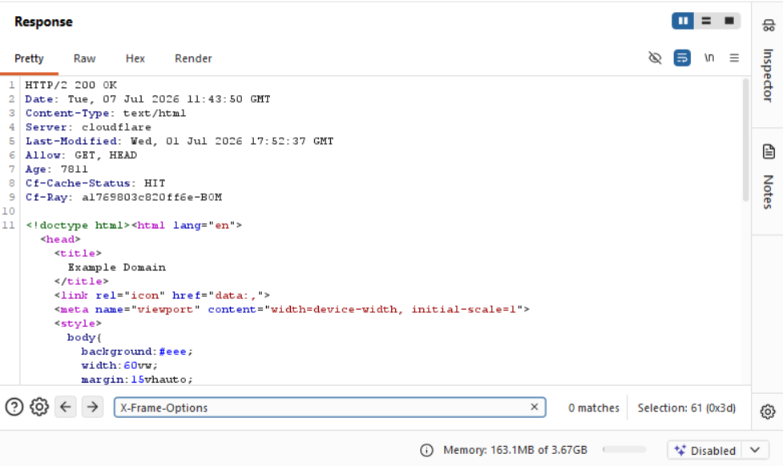
Screenshot 2 — Security Header Analysis: response search for the X-Frame-Options header returning 0 matches

9.3 Finding 3 — Cookie Security Analysis
Observation: A search of the response for a Set-Cookie header returned no matches; the target did not issue any cookie on this request.
Cookies are small pieces of data that a server instructs a browser to store and automatically re-send on subsequent requests to the same domain. They are most commonly used to maintain session state — for example, keeping a user logged in — by associating the browser with a session identifier stored server-side. Because cookies are transmitted automatically, their configuration has direct security implications, particularly for authenticated applications.
Three attributes are considered essential for any session or authentication cookie: the Secure attribute, which ensures the cookie is only ever transmitted over HTTPS; the HttpOnly attribute, which prevents the cookie from being read by client-side JavaScript and thereby limits exposure to cross-site scripting attacks; and the SameSite attribute, which restricts whether the cookie is sent on cross-site requests and helps mitigate cross-site request forgery (CSRF).
In this case, cookie security could not be meaningfully evaluated because the target did not create a session or set any cookie for this request, which is expected behaviour for a static, non-interactive reference page. This finding is therefore recorded as informational rather than a security weakness. Should authentication or session functionality be introduced to the target in future, this check should be repeated to confirm that any session cookie issued carries the Secure, HttpOnly, and SameSite attributes.
Risk Level: Informational
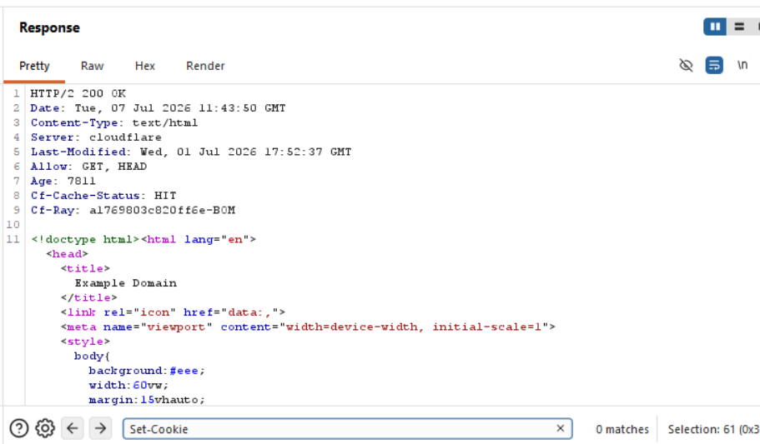
Screenshot 3 — Cookie Analysis: response search for the Set-Cookie header returning 0 matches

9.4 Finding 4 — Technology Information Disclosure Analysis
Observation: A search of the response for an X-Powered-By header returned no matches; the header was not present.
Information disclosure, in this context, refers to a server unintentionally revealing details about its underlying technology stack — such as the web framework, application server, or language runtime — through HTTP response headers. Headers such as X-Powered-By, Server (when overly specific), or framework-default headers can give an attacker a head start in reconnaissance by narrowing down which known vulnerabilities or default configurations might apply to the target.
The absence of an X-Powered-By header in this response is a positive security observation. Suppressing or removing version- and framework-revealing headers is considered good security hygiene, as it increases the effort required for an attacker to fingerprint the technology stack, even though it does not prevent fingerprinting through other means (such as response timing, error pages, or file structure).
Recommendation: No remediation required. Maintain the current server configuration that suppresses this header, and apply the same principle to any other technology-revealing headers introduced by future changes to the application stack.
Risk Level: Low (positive finding)
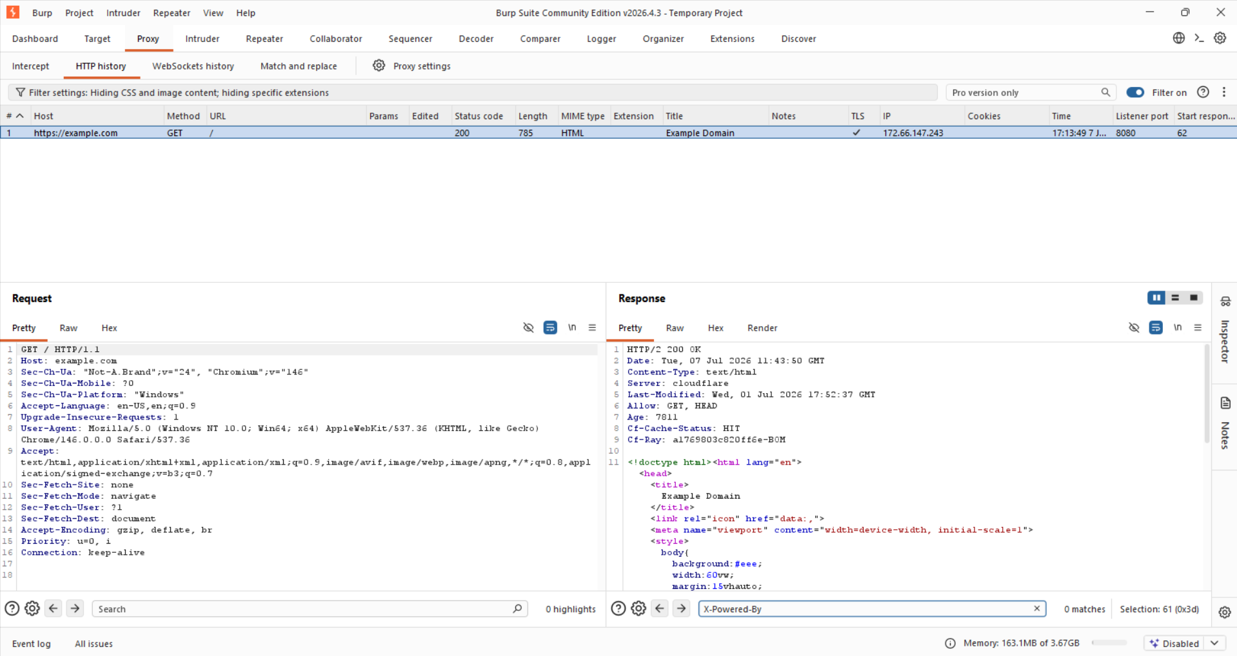
Screenshot 4 — Information Disclosure Check: response search for the X-Powered-By header returning 0 matches

10. Risk Analysis — Findings Summary
The table below consolidates all findings identified during this assessment, along with their category, observation, assigned risk level, and recommendation, for quick reference.
ID | Category | Observation | Risk Level | Recommendation
F1 | Reconnaissance | Server identified as Cloudflare; HTTP/2, status 200 OK on GET / | Informational | Baseline observation only; no action required
F2 | Security Headers | Content-Security-Policy, X-Frame-Options and Strict-Transport-Security headers not present in the response | Low – Medium | Implement CSP, X-Frame-Options/frame-ancestors and HSTS at the web server or CDN edge
F3 | Cookie Security | No Set-Cookie header issued by the application for this request | Informational | Re-test if/when session cookies are introduced; enforce Secure, HttpOnly and SameSite at that time
F4 | Information Disclosure | X-Powered-By header not present; backend technology not disclosed via this header | Low (positive finding) | Maintain current configuration; continue to suppress version-revealing headers

11. Recommendations
- Implement a restrictive Content-Security-Policy header tailored to the resources the application actually needs to load.
- Set X-Frame-Options (or CSP frame-ancestors) to prevent the site from being embedded in an unauthorized frame.
- Enable Strict-Transport-Security with an appropriate max-age and includeSubDomains to enforce HTTPS-only connections.
- If session or authentication functionality is added in future, ensure all cookies are issued with Secure, HttpOnly, and SameSite attributes, and re-test cookie handling at that time.
- Continue to avoid exposing version- or framework-identifying headers such as X-Powered-By.
- Periodically re-run this header-level review, particularly after infrastructure or CDN configuration changes, as security header configuration can silently regress.

12. Limitations
- This assessment used Burp Suite Community Edition, which does not include the automated scanner available in the Professional edition; all analysis was performed manually.
- Testing was limited to a single unauthenticated request to the root path of the target and does not reflect a full application security assessment.
- The target is a static reference domain with no authentication, forms, or dynamic functionality, which limited the range of security controls that could be meaningfully evaluated (for example, cookie and session security).
- No active exploitation, automated scanning, or intrusive testing was performed, in line with the authorized and intentionally limited scope of the exercise.

13. Learning Outcomes
This task provided practical exposure to the fundamentals of HTTP-based web application security testing using an industry-standard interception proxy. Key skills developed and reinforced through this exercise include:
- Configuring a browser to route traffic through Burp Suite and navigating the Proxy → HTTP History module.
- Reading and interpreting raw HTTP requests and responses, including status codes, headers, and metadata.
- Understanding the purpose and security function of key browser-enforced headers (CSP, X-Frame-Options, HSTS).
- Understanding cookie attributes (Secure, HttpOnly, SameSite) and their role in session security.
- Recognizing information disclosure risks associated with technology-fingerprinting headers.
- Structuring findings using a consistent, professional risk-analysis format: observation, impact, risk level, and recommendation.
- Producing a formal, client-ready security assessment report suitable for a professional cybersecurity portfolio.

14. Conclusion
This assessment applied a structured, header-focused methodology to evaluate the HTTP security configuration of an authorized reference target using Burp Suite Community Edition. Four findings were documented: a baseline reconnaissance observation, the absence of three recommended security headers, an informational note on the absence of cookie issuance, and a positive finding regarding the suppression of technology-disclosing headers.
While the target itself is a low-risk, static reference page, the methodology demonstrated here — reconnaissance, header analysis, cookie inspection, and information-disclosure checking — is directly transferable to production web applications, where these same gaps are frequently observed and carry materially higher risk. Completing this task has strengthened practical proficiency with Burp Suite and reinforced a disciplined, evidence-based approach to identifying and reporting web application security weaknesses.

15. References
- OWASP Foundation — OWASP Secure Headers Project.
- OWASP Foundation — OWASP Testing Guide, Web Application Security Testing.
- Mozilla Developer Network (MDN) — HTTP Headers Documentation.
- PortSwigger — Burp Suite Community Edition Documentation.
- Internet Assigned Numbers Authority (IANA) — Reserved Example Domains (RFC 2606).

