#### sort and uniq

1. More piping with sort and uniq (This is a repeat from a previous assignment, just a little refresher)
   1. Create the following file:

perl -e 'foreach(1..100){print $_."\n".($_ / 2)."\n"}' > uniq.txt

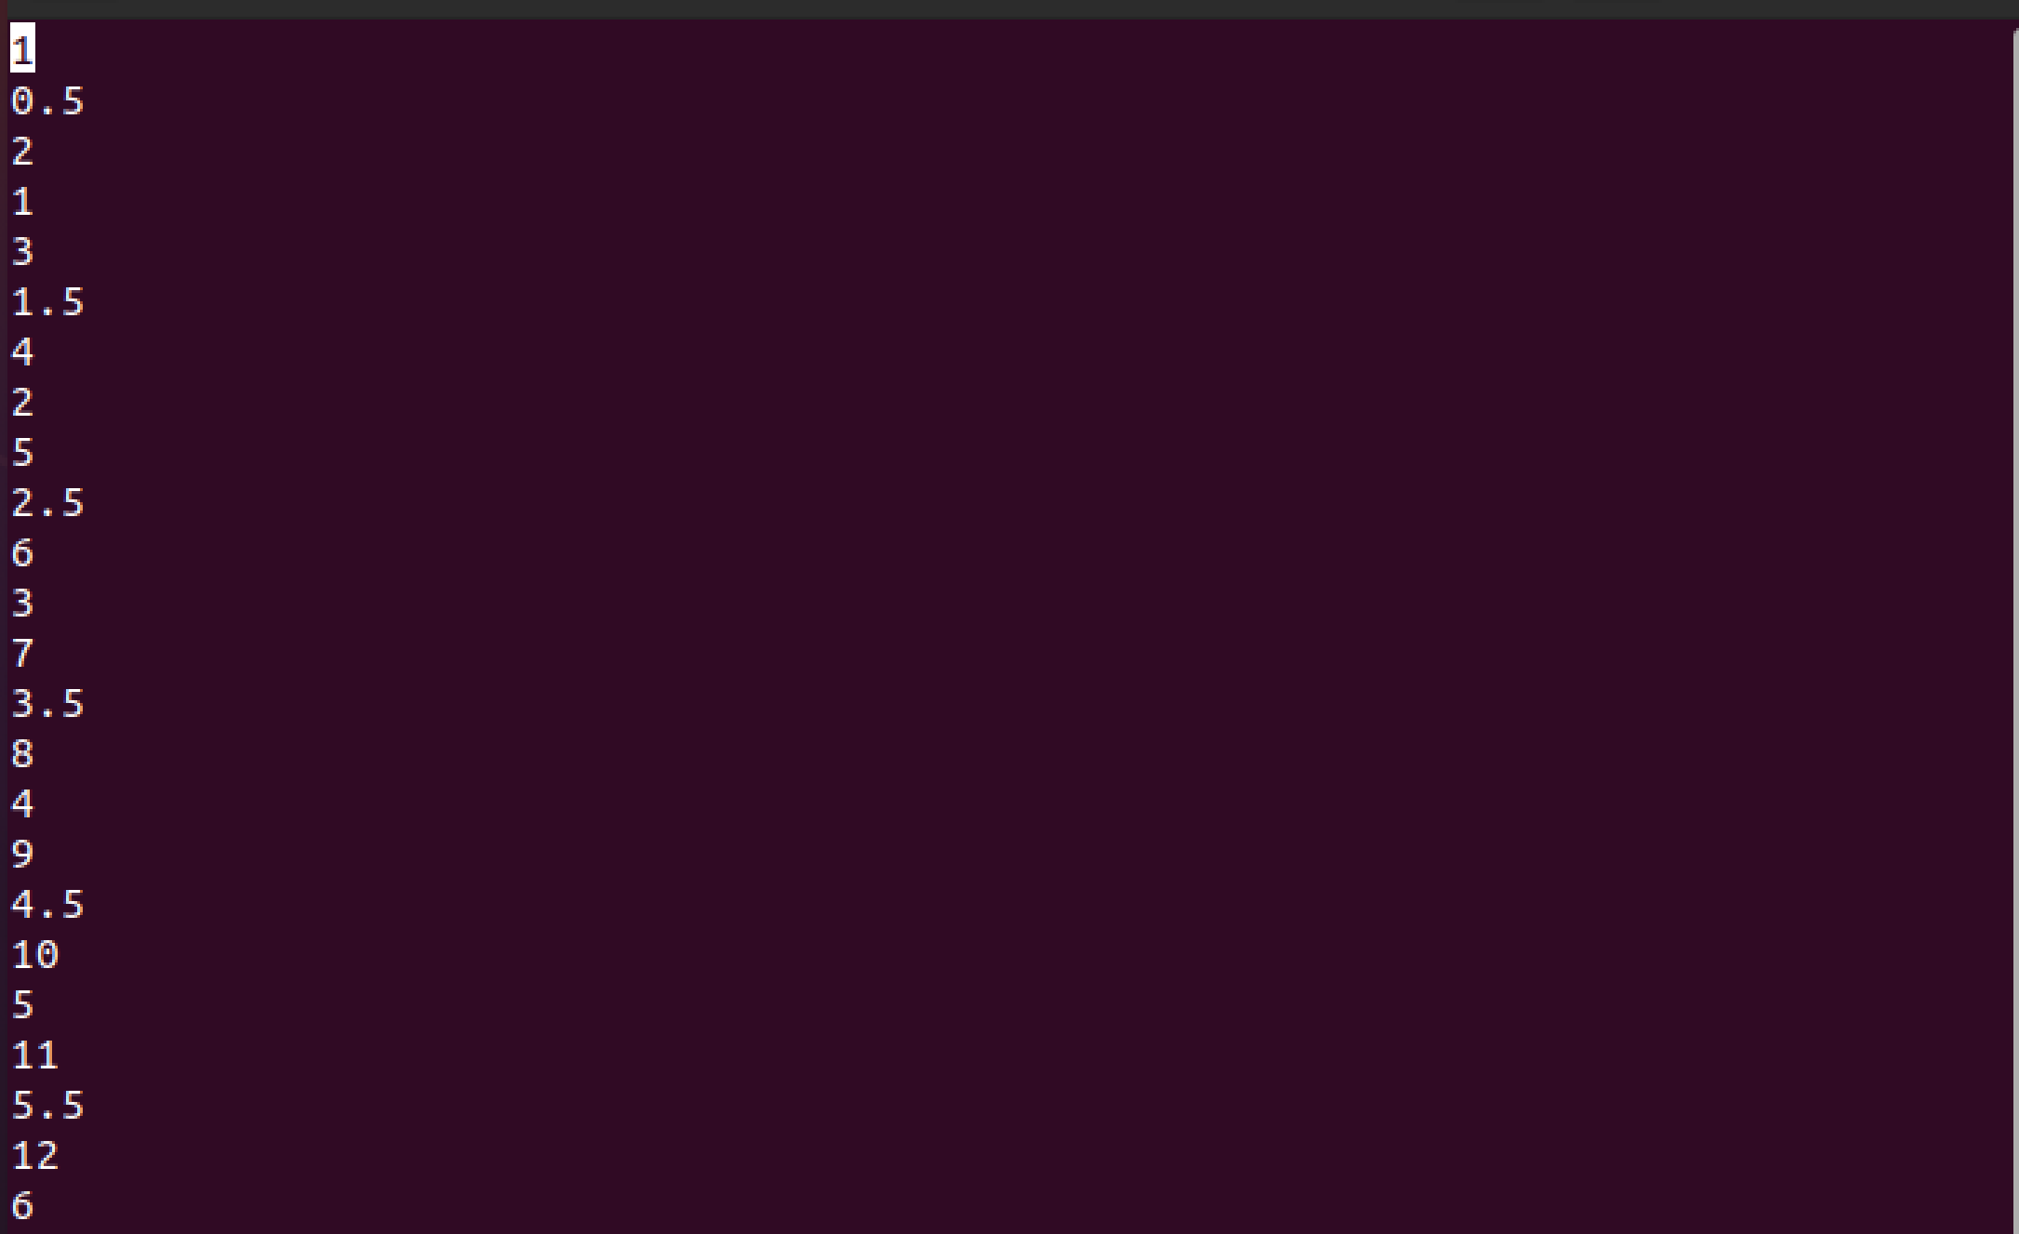

* 1. sort the file numerically and output it to another file without using > and count the number of lines



* 1. Pipe the result of the sort to uniq. What happened? How many lines are there?



* 1. Pipe the result of the sort to uniq and discard all lines that appear more than once. I.e., I don’t want the lines (e.g., 1, 2, etc.) which occur more than once.



* 1. Pipe the result of the sort to uniq and count the number of times each number appear

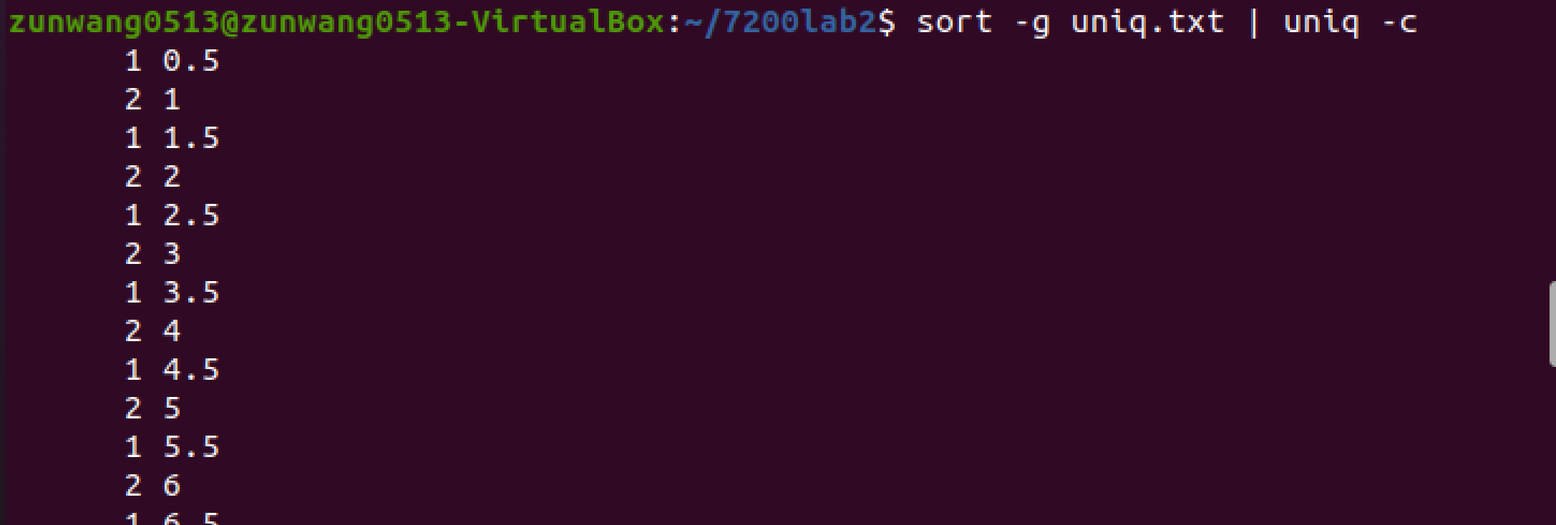

#### Basic Shell scripting

1. Write shell scripts for the following:
   1. Write a shell loop that adds up all the numbers from 1-100

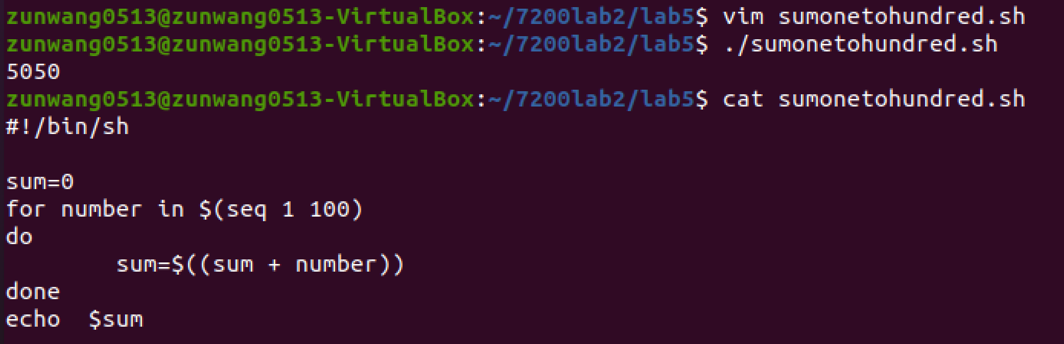

* 1. Write a shell loop that prints each letter in the word Hello separately. This can be done using a for loop iterating through the letters H e l l o. This is a 5 line script; don’t make it harder than that.

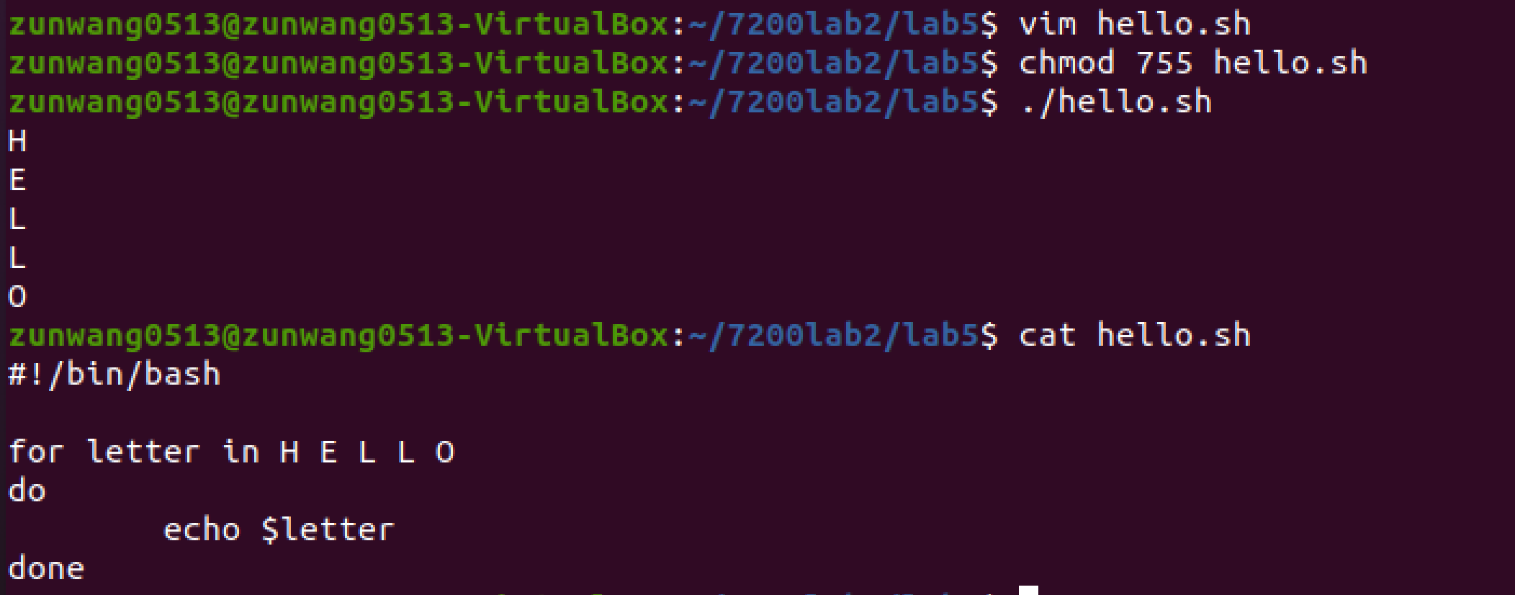

* 1. Have variable x increase from 0 to 100 and variable y decrease from 100 to 0 by 1 unit at a time and print "x and y are equal" when the variables are equal

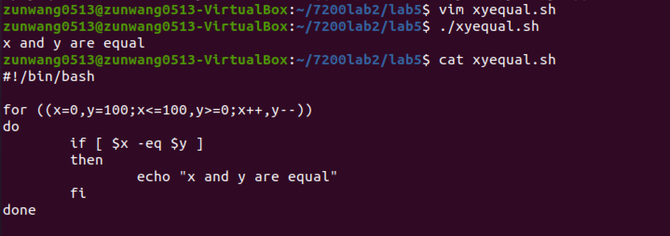

* 1. Repeat the above (c) but this time print the difference between x and y ($x-$y) when they are not equal and print "x and y are equal” when they are equal

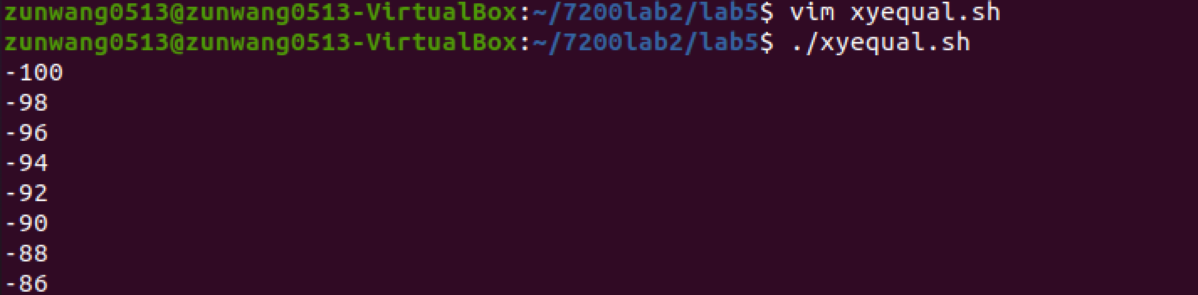

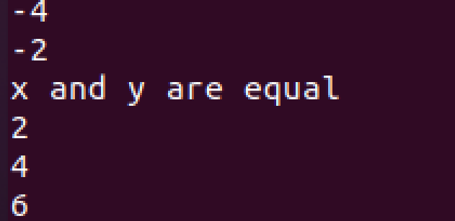

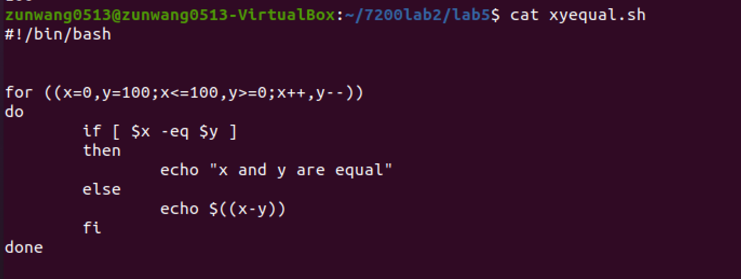

* 1. Write a getopts block with 3 options including one that requires an argument

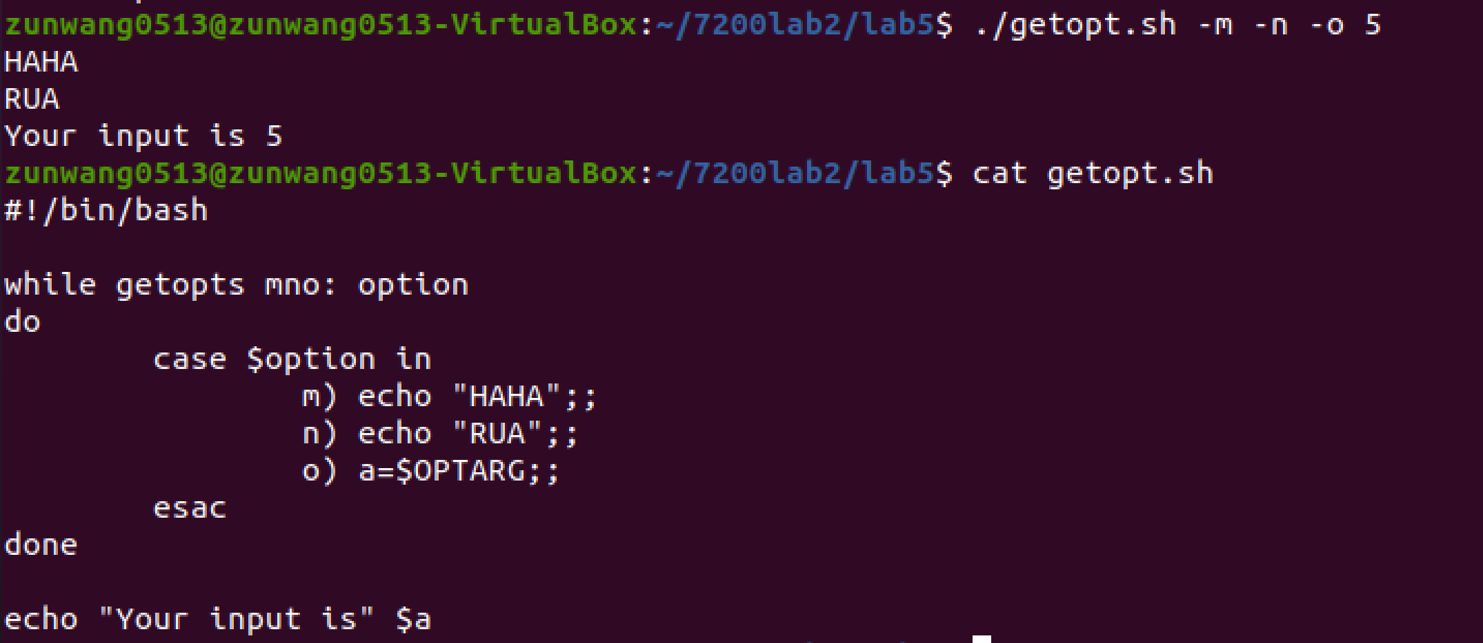

* 1. Write a script utilizing case that asks the user the day of the week and prints the day number based on user input

Monday = 1; Tuesday = 2; ...; Sunday = 7

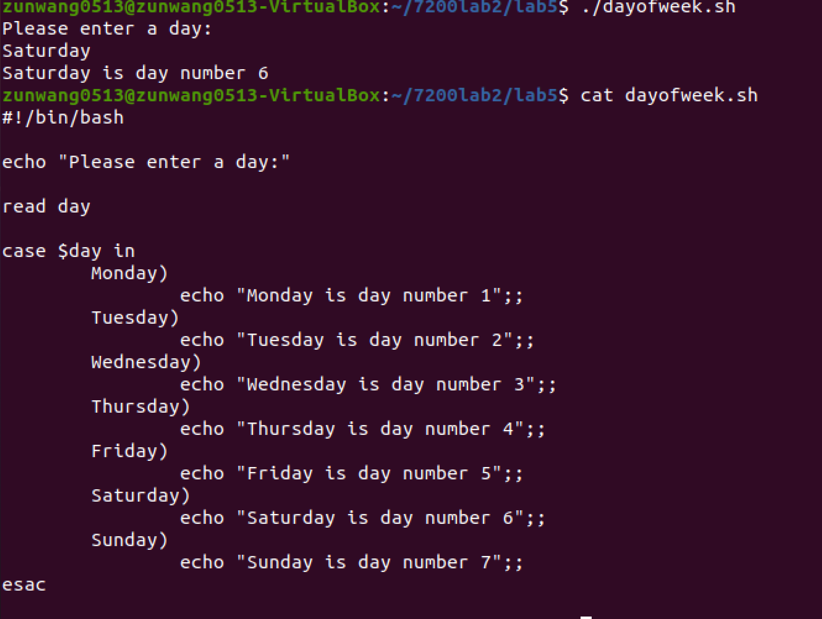

Example terminal output (lines that start with > are output from the script, lines that start with $ are user input):

./scriptName.sh

> Please enter a day:

$ Monday

> Monday is day number 1

#### Mini challenge part 1

1. We are going to do an exercise for fun, but it will enforce shell concepts and will help you prepare for this week. To make things easier for you, I have provided you with stepwise instructions on how to proceed. You will add one element each time, making the loop a little more complicated as compared with the step before.
   1. Write a for loop to create 10 files by the name seq1.fasta, seq2.fasta, seq3.fasta, and so on. You can create a file using the touch command.

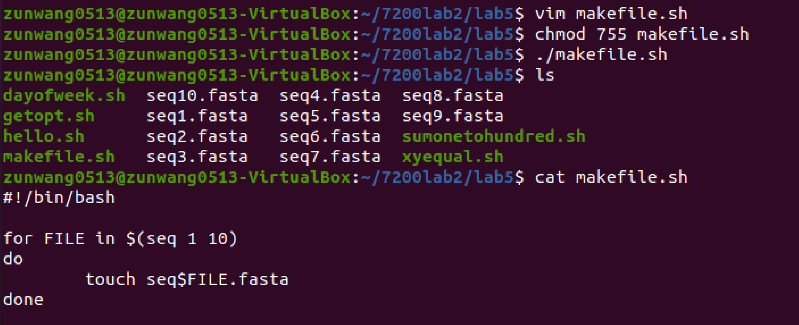

* 1. Modify this loop to now do two more things:
     1. Delete the seq1.fasta, seq2.fasta, seq3.fasta, etc. if they exist
     2. Create new seq1.fasta, seq2.fasta, seq3.fasta, etc. files with a FASTA description line in it. The FASTA description lines needs to be like this: >seq1 for seq1.fasta, >seq2 for seq2.fasta, >seq3 for seq3.fasta, etc.

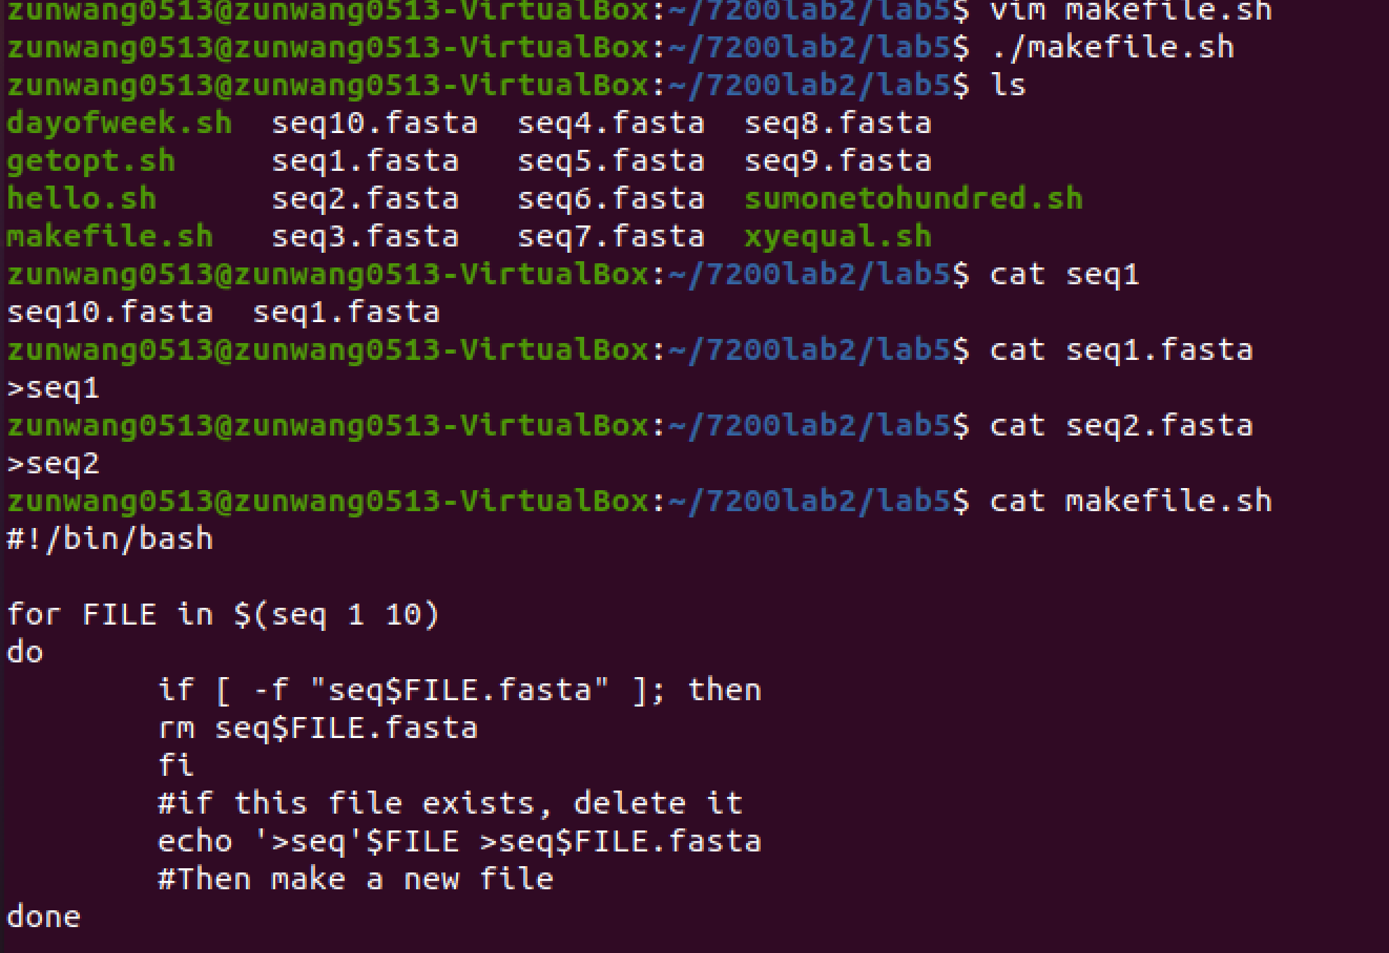

* 1. Add another element to this loop: the loop now also adds a random DNA sequence along with the FASTA description line. The following command will give you a random DNA string of 50x10 letters:

cat /dev/urandom | tr -dc 'ACGT' | fold -w 50 | head

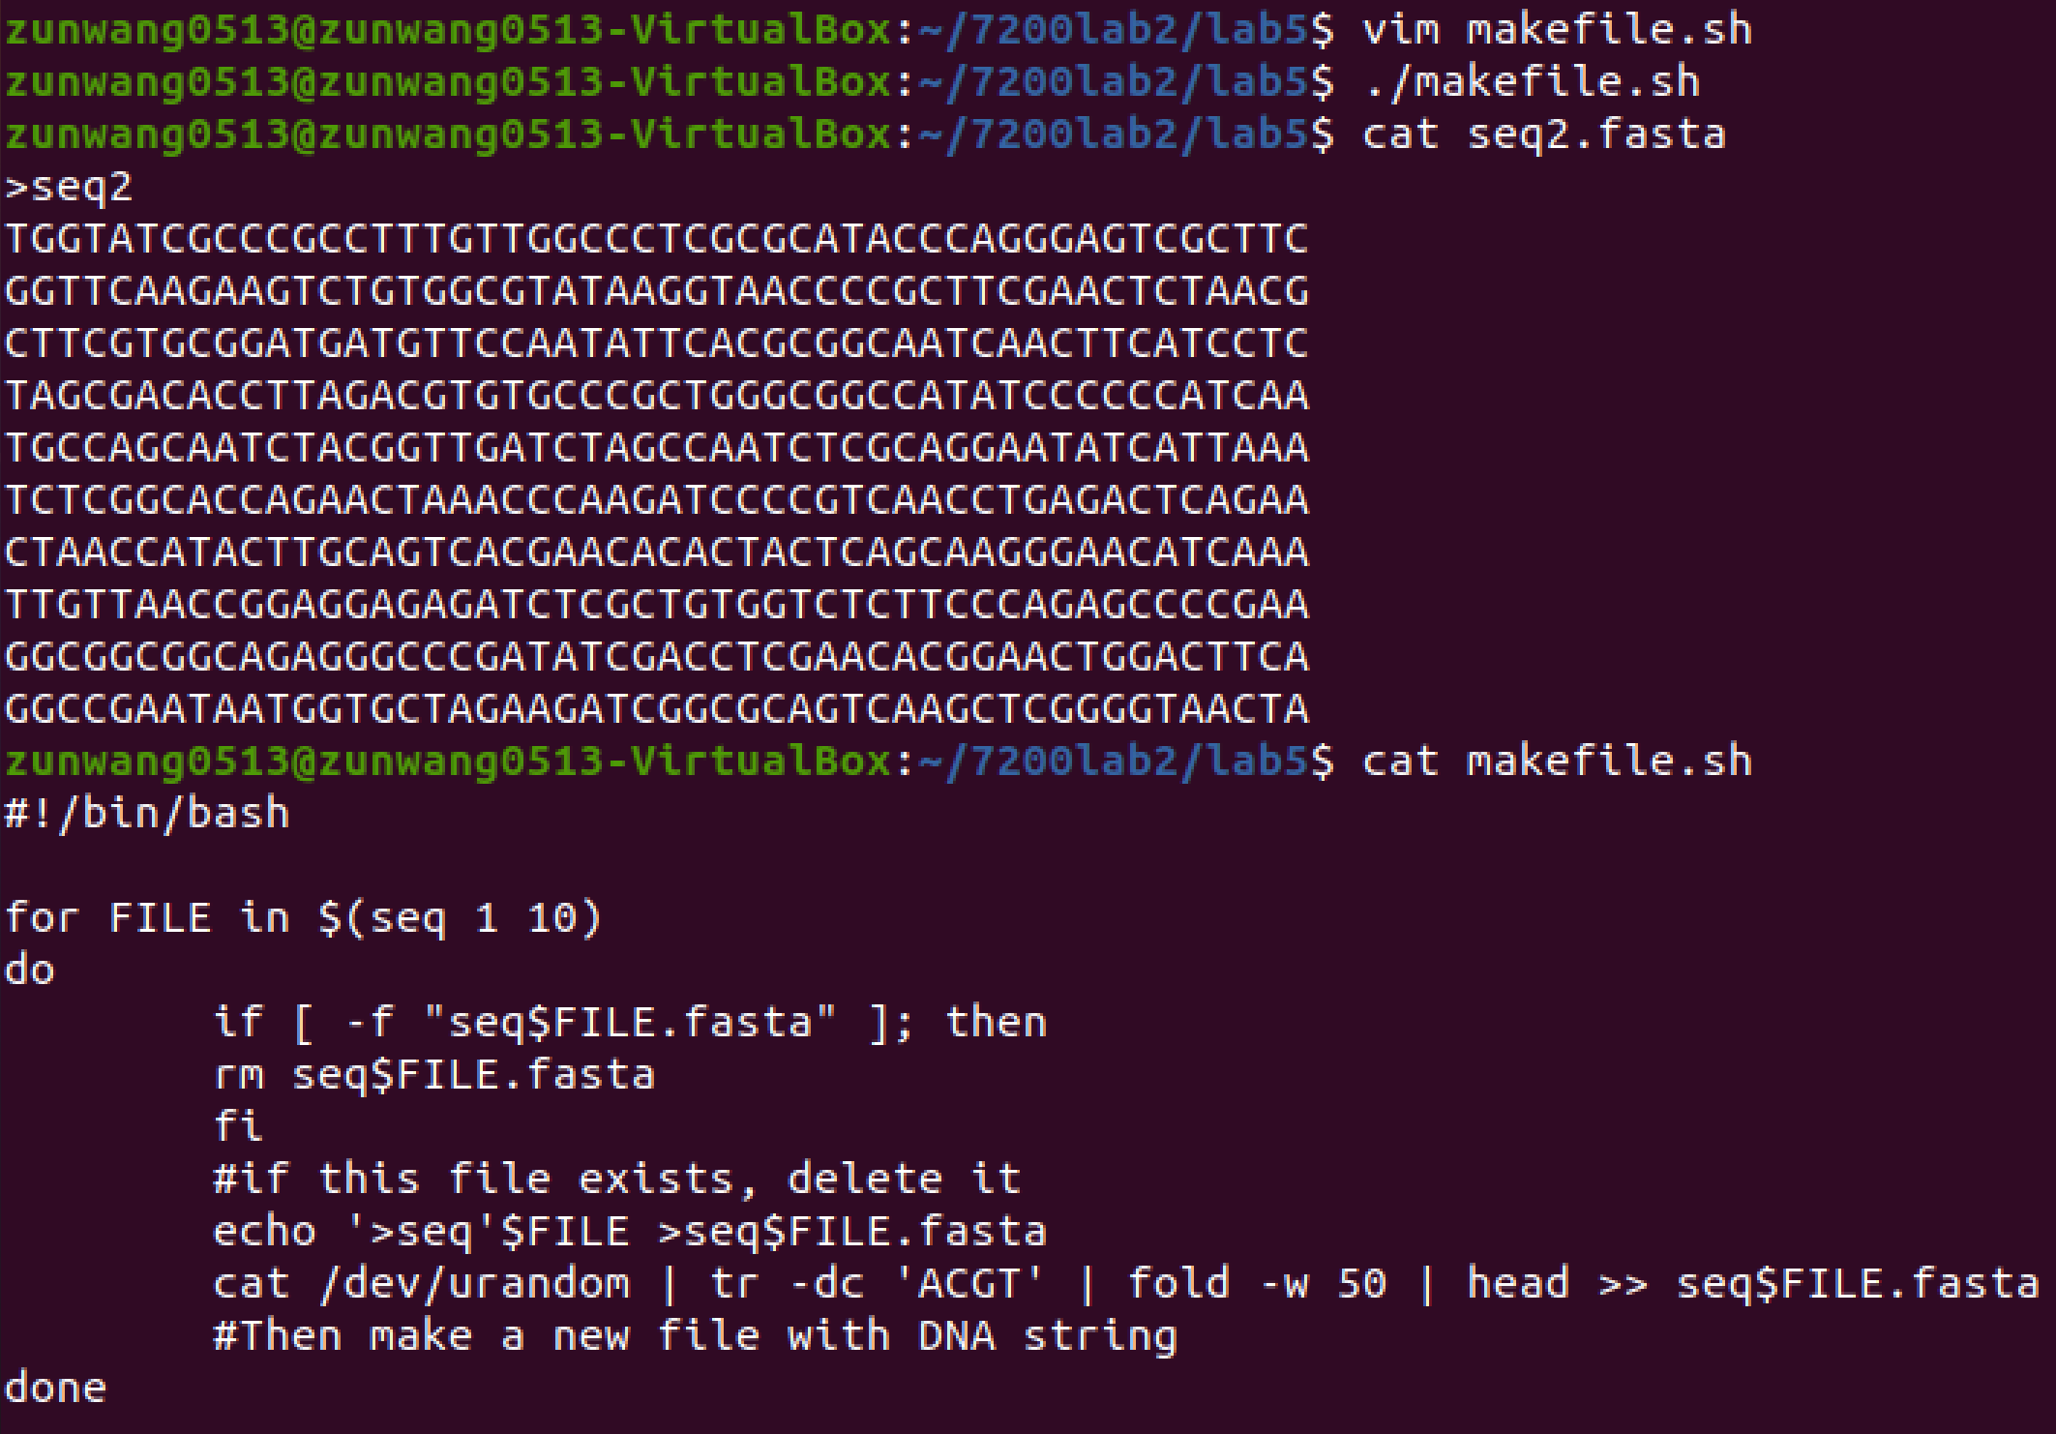

#### Mini challenge part 2: Let’s try nesting the loops

1. Nesting loops is really having a loop within a loop. Instead of creating 10 single sequence files, as in part 1, we will create 10 multiple sequence FASTA files (aka, 10 multi-FASTA files) with 8 sequences in each.

The FASTA descriptors for file 1 will go like this: >seq1_1, >seq1_2, >seq1_3, …; the FASTA descriptor for file2 will go like this: >seq2_1, >seq2_2, >seq2_3, … ; etc.

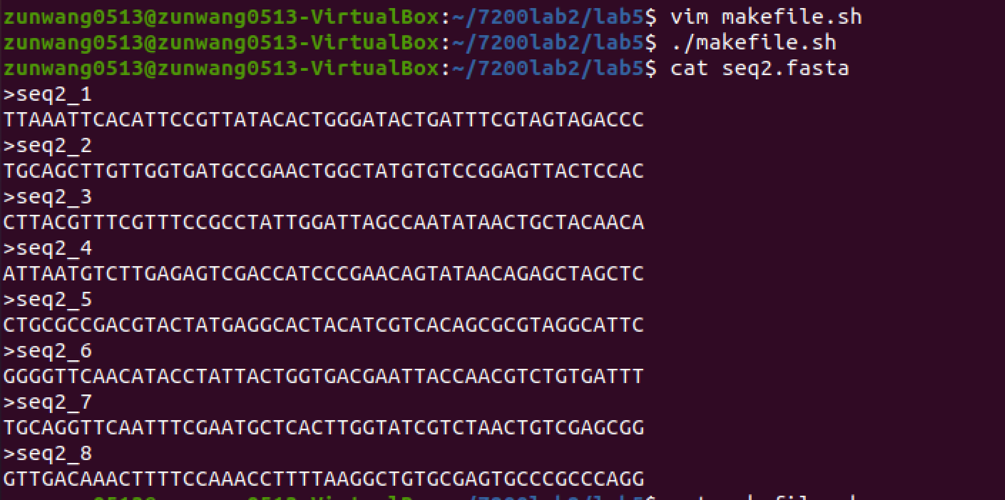

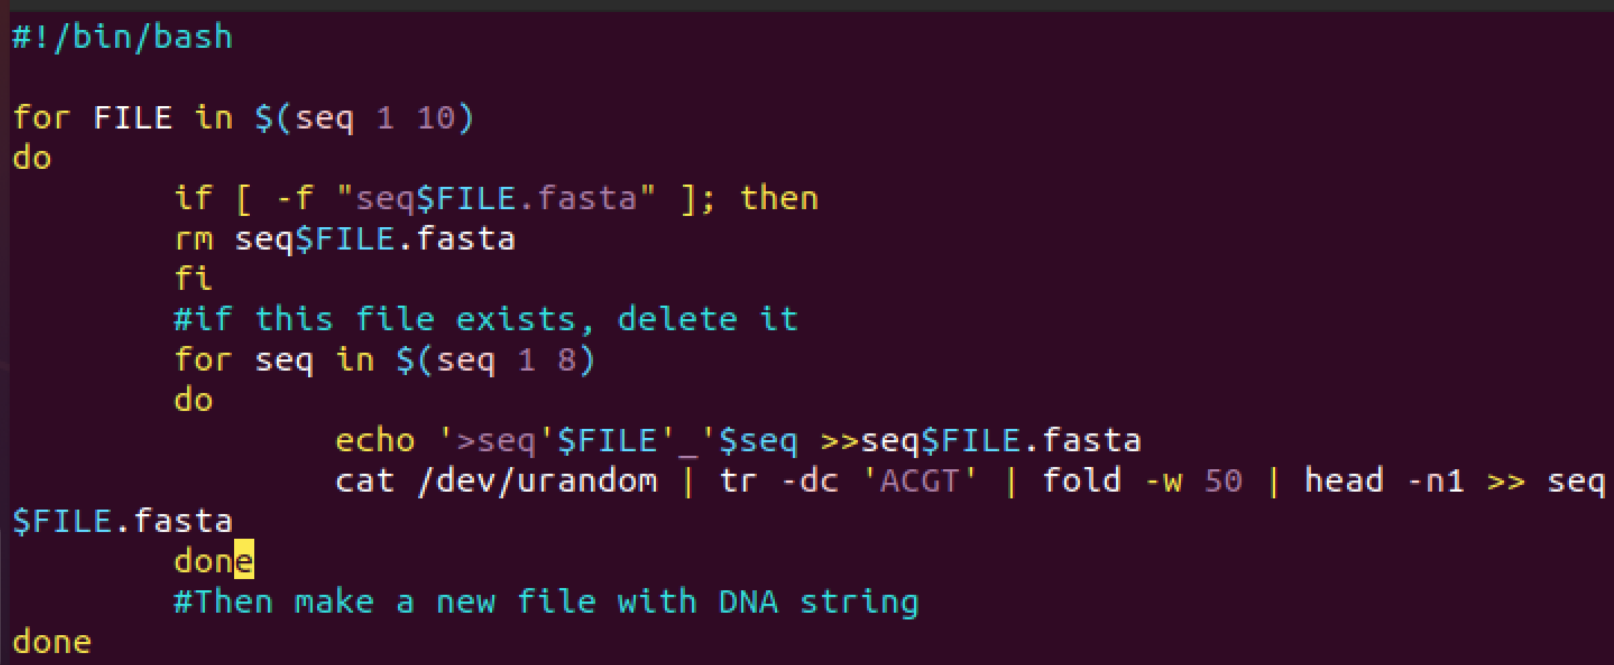

#### Mini challenge part 3: Now add getopts to the beginning of the script

1. For the final part of this series of questions, I want you to add getopts to the script so that it takes take three options:

- Option n => will take a number as an input. This argument describes the number of files to be created (which until now was 10)

- Option m => will take a number as an input. This argument describes the number of sequence to be added in each file (which until now was 8)

- Option v => verbose mode, i.e., I want the script to print out every single action it is doing (e.g., what file is the script currently working on? what sequence number?). This is a flag, so no input is expected with it.

* Again, you should submit a script for the 3rd Mini Challenge as part of your submission on Canvas.

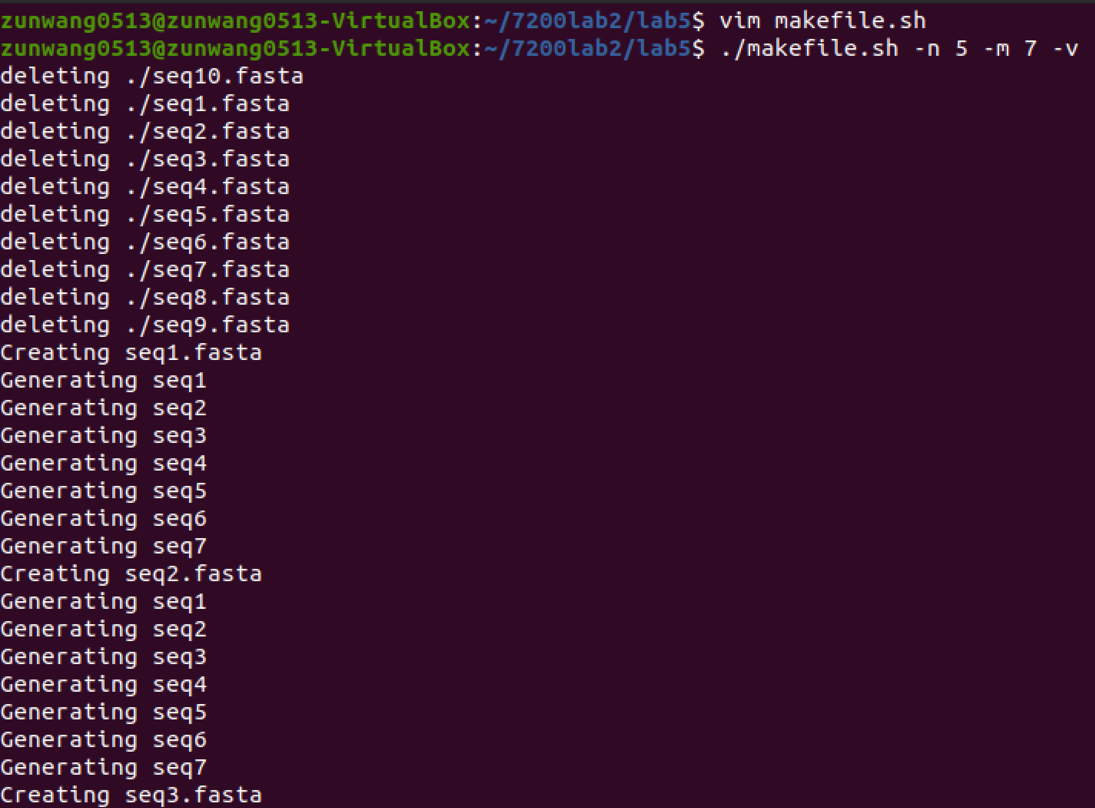

Instead of deleting the number of files in the -n flag, it is deleting all the fasta files beginning with seq. Also, the default file number created is 10 and seq created is 8 if not using m and n flags.

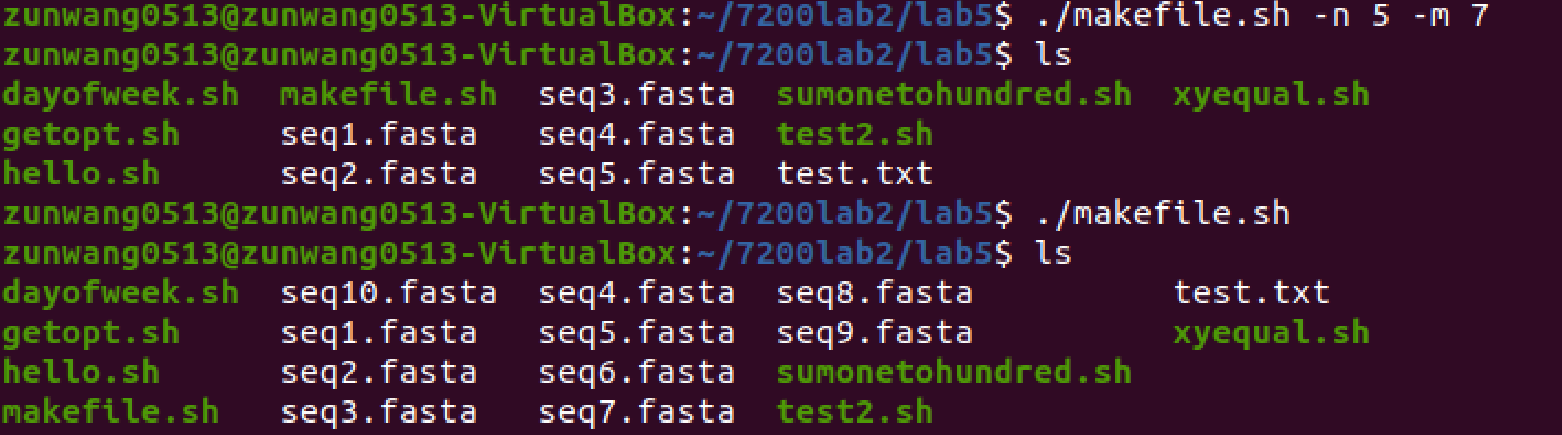

Code:

