# For the variant selected in the spreadsheet, I used VEP to annotate and filtered only variants that codon change is recorded. All variants selected also has allele frequency less than 0.01 in the sample’s population.

# The variant I chose is rs201008398, it has a DNA change from G to T and results in an amino acid change from G to V. It has an allele frequency of less than 1% in all populations. The frequency can be referred to in table 1. The frequency in her own population is 0.003602. The highest frequency is in her own population East Asian, and the frequency in all populations is 0.002414.

# 

# Table 1. Requency in different ethnics groups.

# The gene associated is *PRAMEF12*, or with GeneID: ENSG00000116726. The protein it transcribes is O95522. According to UniprotKB, the gene is involved in the genitive regulation of cell apoptosis. A paper describes that it has expression in the ovary, brain, spleen, lymph nodes, and liver,1 while another paper claimed the discovery in mice spermatogonial stem cells (SSC) and plays a key role in maintaining spermatogenic lineage.2 It maintains SSC homeostasis and keeps male fertility by aiding germ cell differentiation. In another paper sequencing humans, rats, and chimpanzees, they found that pramef12 is conservative and can be a placental hormone.3 One paper that researches a group of German families states its activity in immune sensing.4 Few papers researched the variant of this gene, Wang’s paper did experiments on pramef12 KO male mice and it results in infertility, which is consistent with their result.2 My variant is not necessarily the same as what is done in the paper, but if structural change is big, it will probably lead to a similar result in mice, because if the variant results in a malfunctioning protein, it will achieve the same condition as described in the paper. However, in humans, there may be a chance that it leads to male infertility as well, since no paper has researched the *pramef12* variant in humans. Only Wang’s paper suggests that their variant study can be translated to human male infertility treatment in the future.

# I used VEP to annotate the vcf file that contains gene variations. To determine the malignance level of the variant, I annotate the variant with SIFT score and Polyphen score. SIFTscore is 0 means it is deleterious, and the Polyphen score of 0.982 convinces the idea.

Below in figure 1 is the structural view of the wild-type protein from the alphafold database and a predicted variant protein with alphafold2 simulation. The QMEANS are very high in the center of the protein and decrease at the tip of the two ends. Around the targeted amino acid in the two models, the QMEANS are both around 70 which is acceptable. They both show interactions with the cytidine across the turn. In this way, although there is a missense mutation at the place, there is no structural difference and has low probability of leading to protein malfunctioning. In minor cases, the functional group change may result in difference in intermolecular binding.

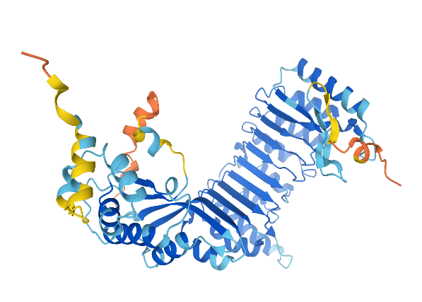

1a

1b

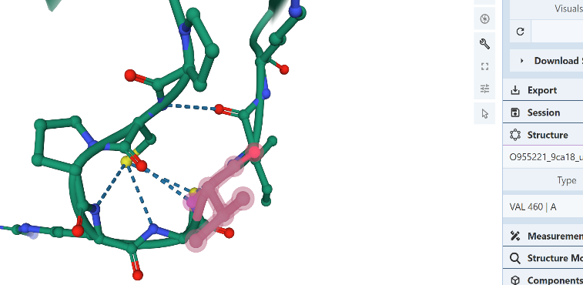

Val 460

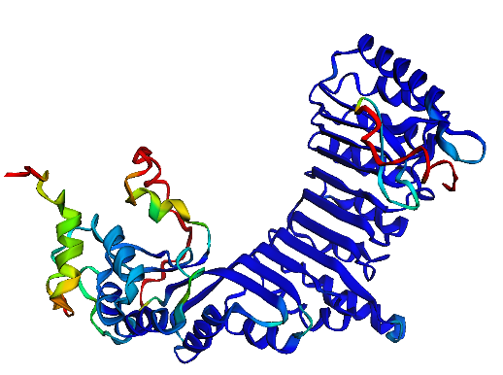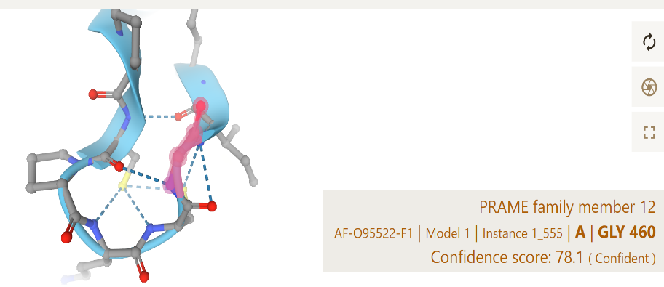

Gly 460

1c

1d

Figure 1. Structural Representation of wild-type and variant O95522. (1a) This is the wild type representation of O95522. (1b) Highlighting the structure around the variant amino acid Glycine. (1c) The variant structure of the protein. (1d) Highlighting the structure around the variant amino acid Valine.

# 

Reference:

1. Mistry, B. V., Chang, T.-C., Yasue, H., Kim, D., Oatley, J., & Liu, W.-S. (2011). Roles of prame in spermatogenesis. Biology of Reproduction, 85(Suppl_1), 574–574. https://doi.org/10.1093/biolreprod/85.s1.574
2. Wang, Z., Xu, X., Li, J.-L., Palmer, C., Maric, D., & Dean, J. (2019). Sertoli cell-only phenotype and scrna-seq define Pramef12 as a factor essential for spermatogenesis in mice. Nature Communications, 10(1). https://doi.org/10.1038/s41467-019-13193-3
3. Knox, K., Leuenberger, D., Penn, A. A., & Baker, J. C. (2011). Global hormone profiling of murine placenta reveals secretin expression. Placenta, 32(11), 811–816. https://doi.org/10.1016/j.placenta.2011.08.013
4. Kishore, A., Petersen, B.-S., Nutsua, M., Müller-Quernheim, J., Franke, A., Fischer, A., Schreiber, S., & Petrek, M. (2018). Whole-exome sequencing identifies rare genetic variations in German families with pulmonary sarcoidosis. Human Genetics, 137(9), 705–716. https://doi.org/10.1007/s00439-018-1915-y