**Report**

1. **System Spec.**

kenel version : 5.0.0-46-generic

OS : Ubuntu 18.02

CPU core : AMD Ryzen 5 2600X Six-core Processor

Memory : 16GB

1. **Show your screenshot to prove that you use Qemu**

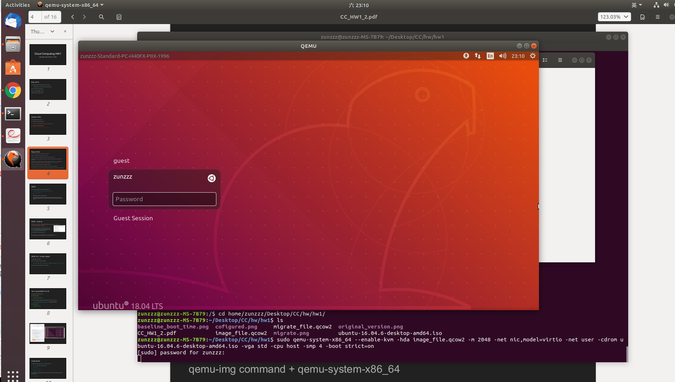

1. **Which module did you modify in kernel? What do these modules use for?**

**Power Management**

Power Management Debug Support (disable) : 用來debug

ACPI (disable) : Advanced Configuration and Power Interface

**Firmware Drivers**

Export DMI identification via sysfs to userspace (disable) : 把DMI的認證部分移到userspace

Add firmware-provided memory map to sysfs (disable)

**Bus options**

PCI Express ASPM control (disable)

PCI Express Downstream Port Containmeant support (disable)

PCI Express Prection Time Measurement support (disable)

**Wireless**

Enable powersave by default (disable) : 使用節省電力的方法

cfg80211 DebugFS entries (disable) : 能夠進入debug模式

1. **Did you find any other OS image boot faster than ubuntu and why? Show your screenshot of your experiment.**
2. **Compare the boot time between general config and modify config & Show your screenshot of your experiment.**

baseline

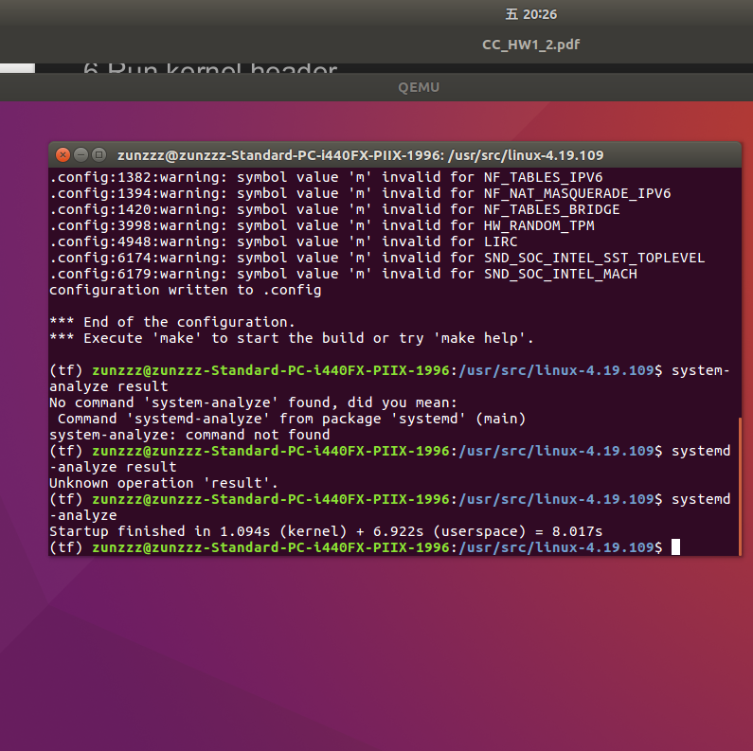

advance

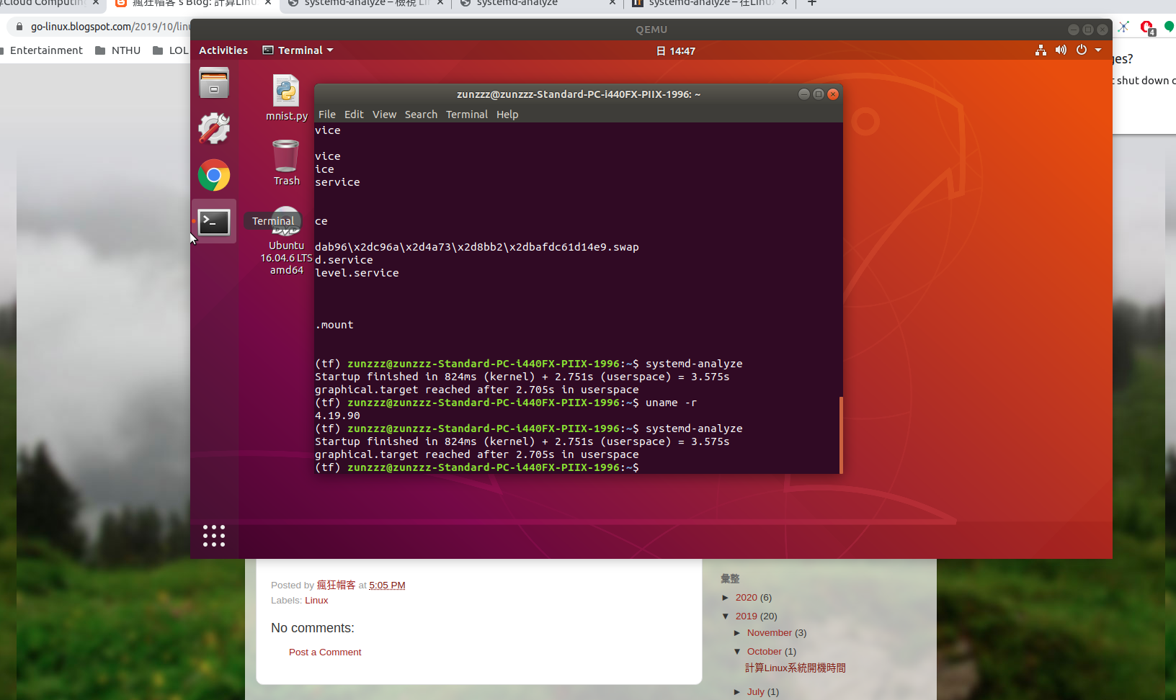

1. **Show your screenshot to prove that your migrate is success.**

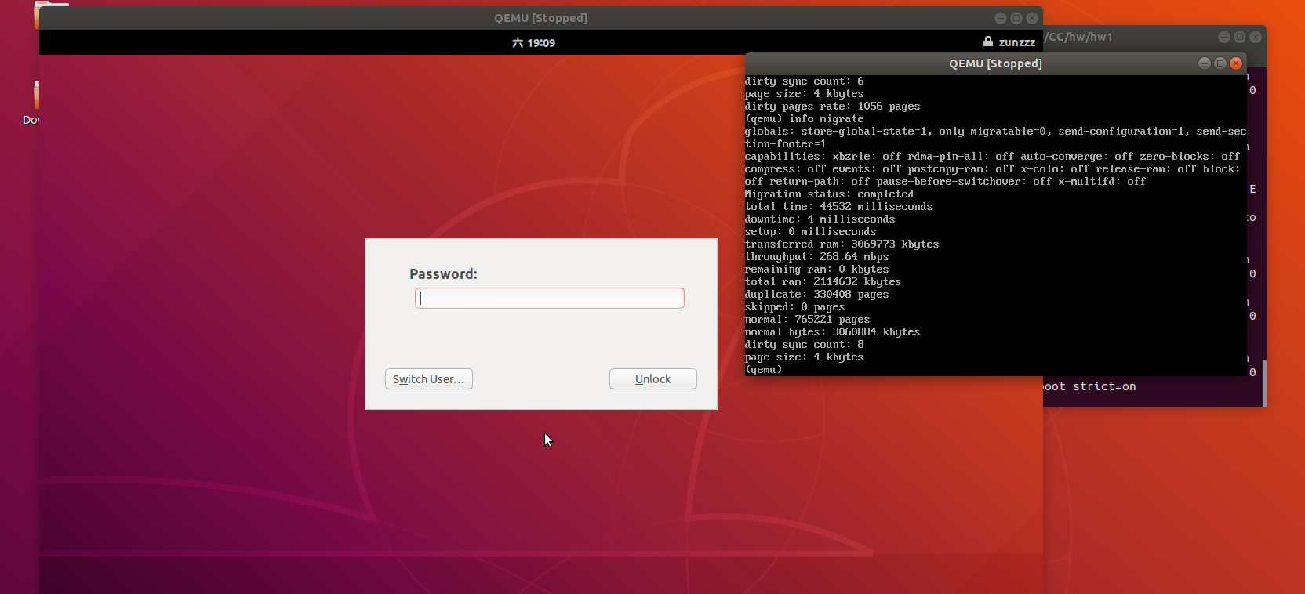

1. **Use different number of CPU core to test MNIST execution time and make a table.**
2. **Please simply explain what is the difference between cold migration, warm migration and live migration.**