**Report**

1. **System Spec.**

kernel version : 5.0.0-46-generic

OS : Ubuntu 18.02

CPU core : AMD Ryzen 5 2600X Six-core Processor

Memory : 16GB

1. **Show your screenshot to prove that you use Qemu**

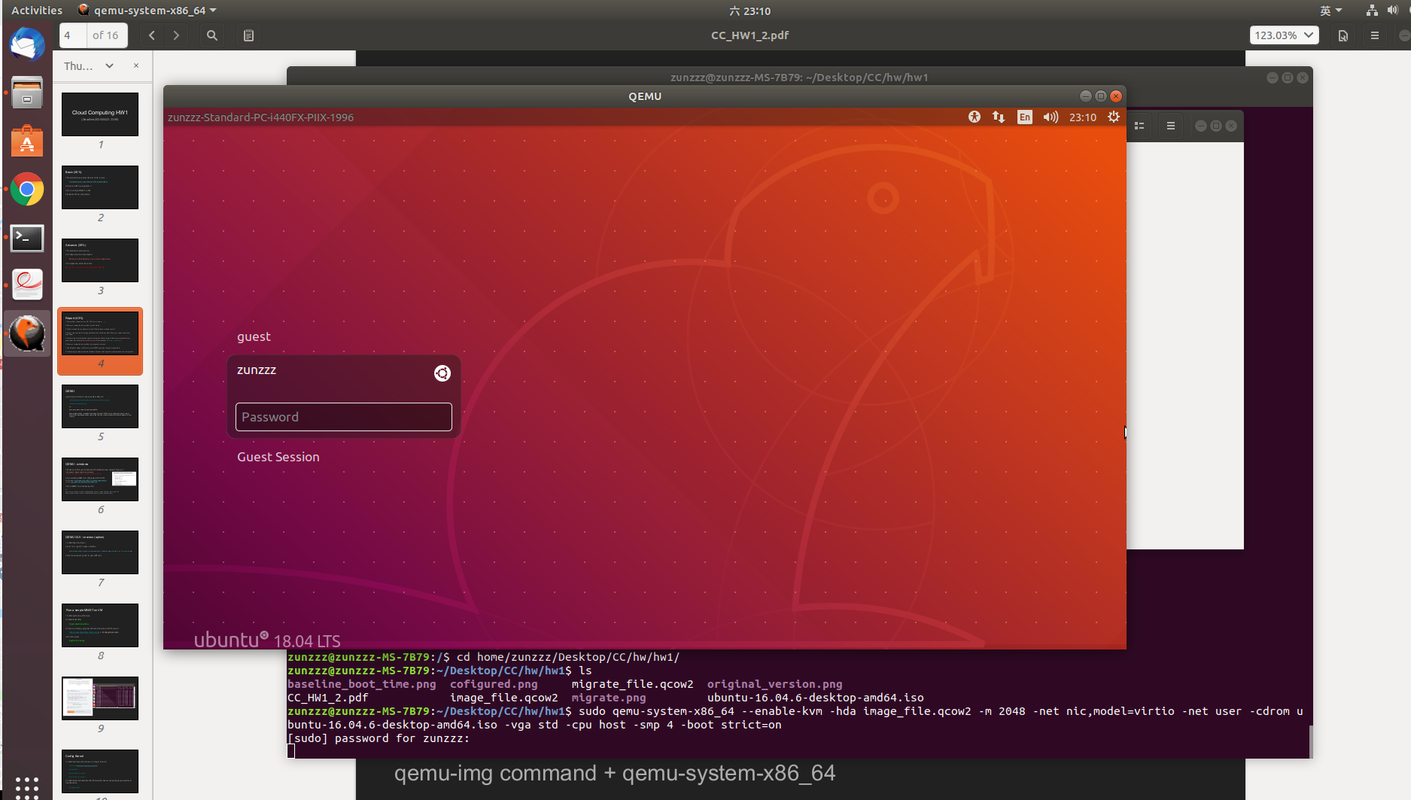

1. **Which module did you modify in kernel? What do these modules use for?**

**Power Management**

Power Management Debug Support (disable) : 用來debug

ACPI (disable) : Advanced Configuration and Power Interface

**Firmware Drivers**

Export DMI identification via sysfs to userspace (disable) : 把DMI的認證部分移到userspace

Add firmware-provided memory map to sysfs (disable)

**Bus options**

PCI Express ASPM control (disable)

PCI Express Downstream Port Containmeant support (disable)

PCI Express Precision Time Measurement support (disable)

**Wireless**

Enable powersave by default (disable) : 使用節省電力的方法

cfg80211 DebugFS entries (disable) : 能夠進入debug模式

接著我用systemd-analyze blame去看時間花在哪邊最多之後去刪除一些service

snapd (remove) : 管理軟體的系統

apparmor (remove) : MAC system

1. **Did you find any other OS image boot faster than ubuntu and why? Show your screenshot of your experiment.**

這是我找到比ubuntu開機還快的OS，雖然與ubuntu是同一個distribution但是他支援的功能比較少因此使他的開機速度比較快。

這個的開機時間為7秒與baseline的8秒比快了1秒

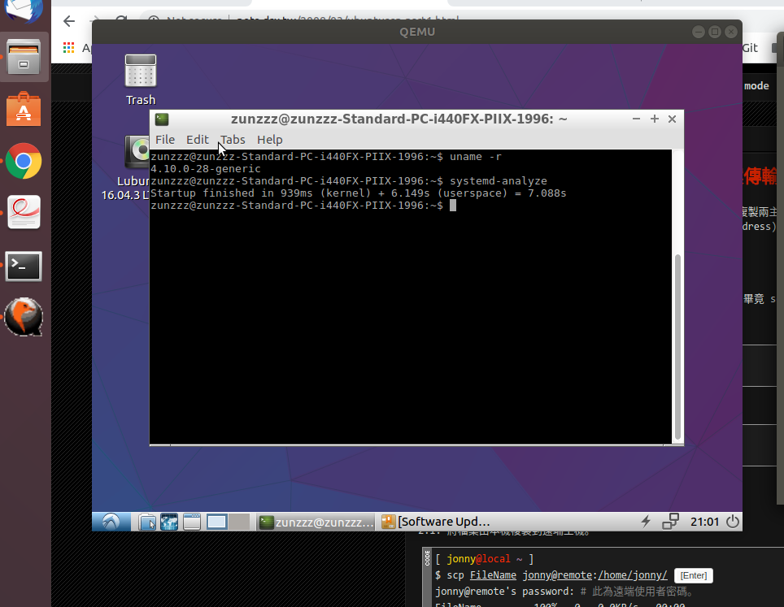

1. **Compare the boot time between general config and modify config & Show your screenshot of your experiment.**

以下都是我用-smp 4去開啟Qemu所跑出的結果

baseline

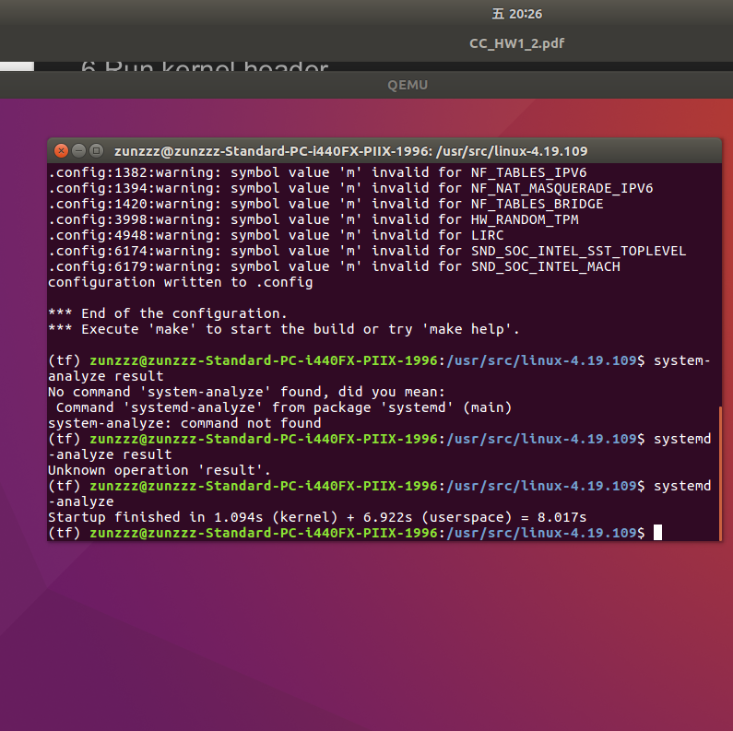

advance

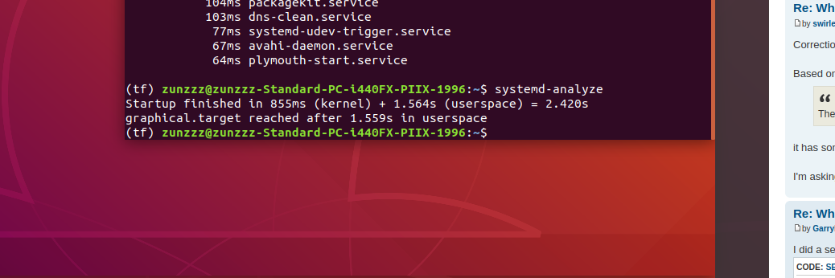

1. **Show your screenshot to prove that your migrate is success.**

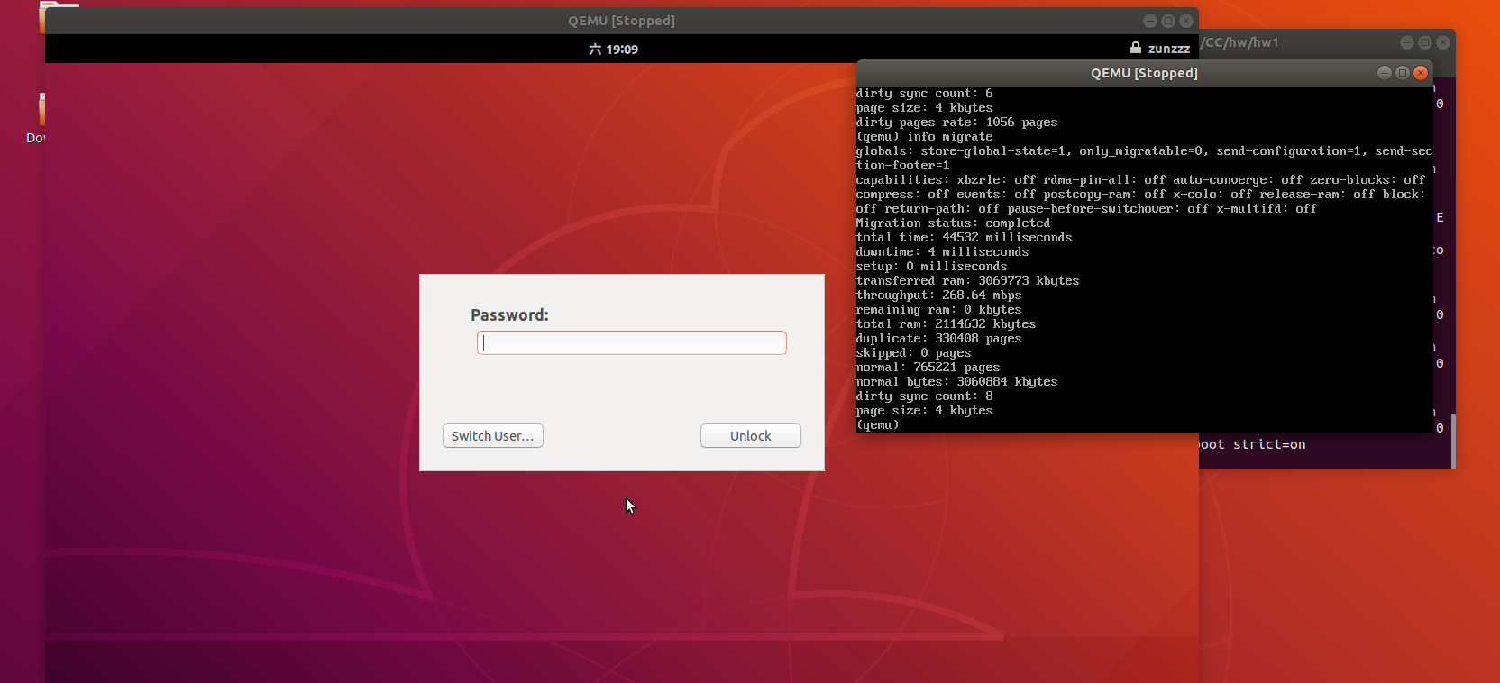

1. **Use different number of CPU core to test MNIST execution time and make a table.**

我藉由更改smp tag的參數去給VM不同數量的vCPU，以下是我CPU數量和執行時間的表格

|  |  |
| --- | --- |
| **Number of CPUs** | **Execution time** |
| 1 | 28.845s |
| 2 | 28.532s |
| 3 | 29.311s |
| 4 | 28.839s |
| 5 | 30.403s |
| 6 | 29.412s |
| 7 | 34.421s |
| 8 | 31.111s |

1. **Please simply explain what is the difference between cold migration, warm migration and live migration.**

Cold migration : 在做migration的時候，VM需要處於power off的狀態。

Live migration : 與cold migration相對應又稱hot migration，在做migration的時候，VM是處於power on的狀態。

Warm migration : 這是備用方案，target VM與source VM保持同步並且target VM保存source VM的snapshot在source VM故障時能夠藉由snapshot進行VM的migration。