- The information about the paper (published in where, when, authors…)
Title:
Federated Learning: Strategies for Improving Communication Efficiency
Authors:
Jakub Konečný, H. Brendan McMahan, Felix X. Yu, Peter Richtárik, Ananda Theertha Suresh, Dave Bacon
Publish time:
30 Oct 2017
- What problem they want to solve?
A round of Federated Learning is composed of several steps:
- A subset of existing clients is selected, each of which downloads the current model.
- Each client in the subset computes an updated model based on their local data.
- The model updates are sent from the selected clients to the sever.
- The server aggregates these models (typically by averaging) to construct an improved global model.
Original implementation of model update requires each client to send a full model back to the server, uploading models become a bottleneck of Federated Learning. Thus, authors of this paper introduce some methods to reduce the upload time of clients while keeping original model quality.
- Proposed methods
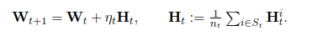
Authors use this equation to represent model update.
W is matrix of model parameters, and dimension is d1 x d2, d1 and d2 represents the output and input dimensions respectively.
H represents the difference between local model and server model of each clients, then average each client’s difference to upload to the server.

Then authors propose two kinds of method to reduce time of uploading model.
- Structured update
First type of efficient communication update restricts the updates H to have a pre-specified structure, two types of structures are introduced in this paper: low rank and random mask.

Low rank.
Authors express H as product of A and B, and dimension of A and B are constrained by k, which is a fixed number. In every round, each client will refresh matrix A by random seed independently and optimize matrix B then send matrix B to the server.
Random mask.
In this structure, authors restrict the update H to be a sparse matrix. In every round, each client will have a new mask by random seed independently and use this mask to wipe out some entries of original matrix H. Finally, each client only sends non-zero entries and random seed of mask to the server.
- Sketched update
In sketched update, each client will do their local training without any constraint then update matrix H with some lossy form.
Subsampling.
Instead of sending H, each client only communicates matrix H which is formed from a random subset of the values of H. The server then averages the subsampled updates, producing the global update H’.
Probabilistic quantization.
In Probabilistic quantization, first vectorize original matrix H into vector h, then take the maximum and minimum of vector h, then quantize each value to 1-bit with below equation. If we want to quantize value to b-bits, we should divide interval of maximum and minimum to b intervals, if value falls in one interval, then use upper value of this interval to represent h’max and use lower values of this interval to represent h’min to use equation to quantize value.
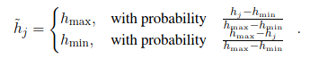
Improving the quantization by structured random rotations
When max = 1 and min = −1 and most of values are 0, the 1-bit quantization
will lead to a large error. We note that applying a random rotation on h before the quantization (multiplying h by a random orthogonal matrix) solves this issue. This claim has been theoretically supported in Suresh et al. (2017).
- Experimental results
They use their methods on two different tasks to test their performance, they first experiment with CIFAR-10 image classification task using CNN. Next, they experiment with next word prediction tasks based on Reddit post data by RNN, which is more realistic scenario.
CIFAR-10 image classification (CNN)
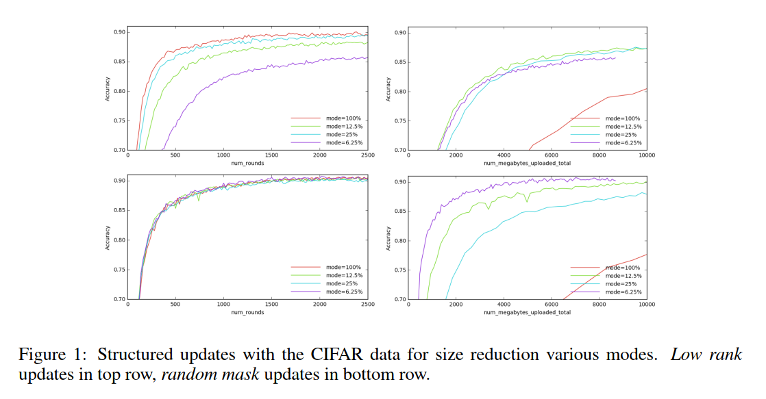
In this picture, they compare different result of structure updates, mode = 25% represents that the fixed number k is equal to 1 / 4 of original rank in low rank and represents that only 25% of data will remain in random mask.
From this result, we can see that random mask outperform low rank, random mask uses less round and less data sent to the server to train a good model than low rank.
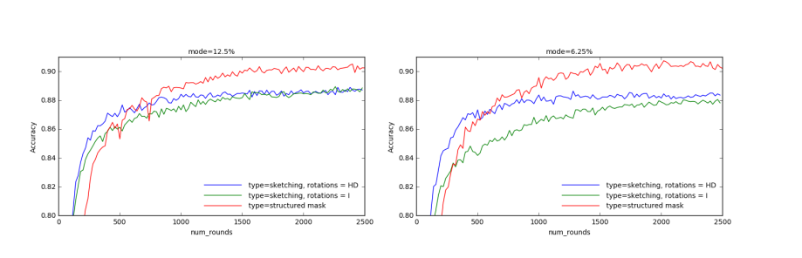
In this picture, they compare different result of structured updates and sketched updates, rotation = I means no rotation and rotation = HD means model is sketched with rotation.
In this experiment, we can see that structured updates perform better than sketched updates. This is because sketched updates will loss some information when uploading models, thus reducing the performance of model.
Next word prediction using Reddit post data (RNN)
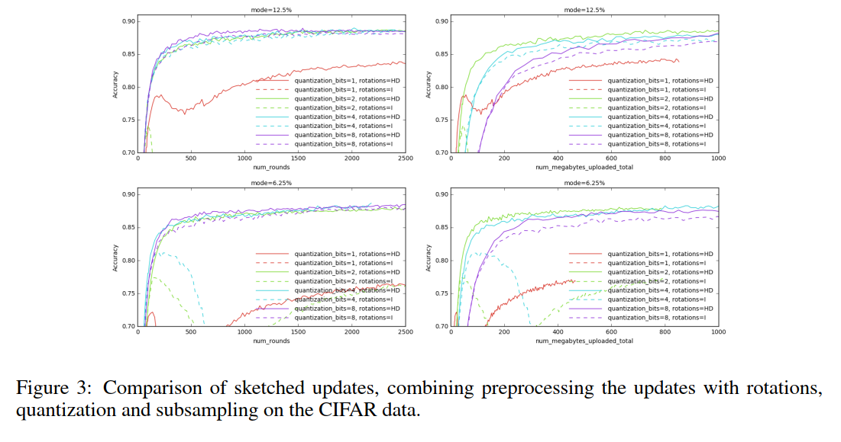
In this experiment, they compare different result of using different quantization bits and with or without rotation of sketched updates.
So, we can find that quantized sketched update with rotation will perform better than without rotation and if we use only 1-bit to quantize values, we might get terrible performance.
- Weakness and strength of this paper
Strength:
This paper is easy to understand, partitioned very clearly and use several experiment results to validate their methods.
Weakness:
They introduce 2 methods for structured updates and 2 methods for sketched updates, but experiment result doesn’t have subsampling of sketch updates, so reader can’t know performance of subsampling.
- Possible extensions
Suggestion engine:
Because search history is private data, if we don’t use Federated Learning to train this model, we will encounter shared data problem, if we use Federated Learning with this paper’ methods, we can train a good model without influencing client’s experiences.

