1、Java的8中基本类型

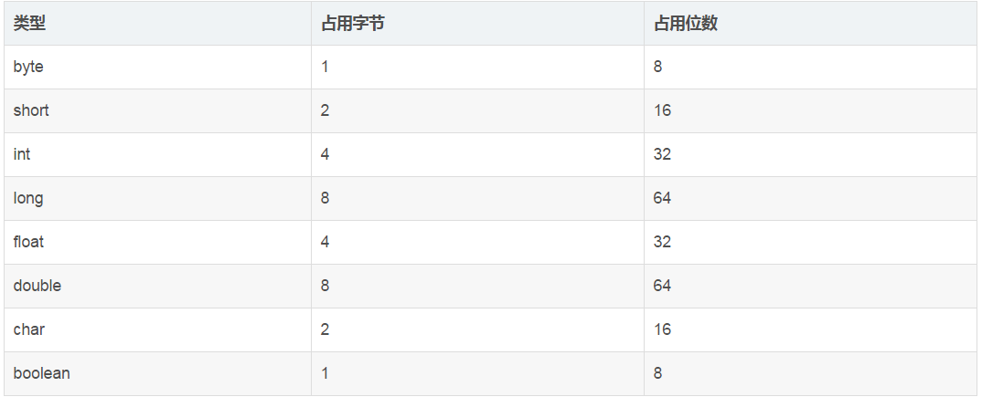

1. String Integer都是final不可以被子类继承
2. String,StringBuffder和StringBuilder的区别

<https://www.cnblogs.com/Wilange/p/7570633.html>

4、String.intern()

<https://blog.csdn.net/soonfly/article/details/70147205>

1. arrayList和linkedList的区别

https://www.cnblogs.com/huzi007/p/5550440.html

1. 类的实例执行顺序

https://blog.csdn.net/u014042066/article/details/77574956

1. Map的种类和使用场景

<https://blog.csdn.net/qq_30683329/article/details/80455779>

<http://www.cnblogs.com/xrq730/p/7048693.html>

<http://www.importnew.com/28263.html>

JVM

1. 内存溢出

<https://blog.csdn.net/cp_panda_5/article/details/79613870>

1. 新生代Eden与两个Survivor区的解释

https://blog.csdn.net/lojze_ly/article/details/49456255