Below the analysis on the cpu profile of fabric:

44.40% cpu time is spent on runtime._ExternalCode.

This part is unexpectedly high. I suppose it account for time spent in native libraries. The Callers of runtime.cgocall show the native libraries are most likely sqlite and rocksdb. I will use perf system profiler to get insights into native/kernel performance bottlenecks.

Ps:runtime._System called to runtime._ExternalCode. The program probably suffers from contention.

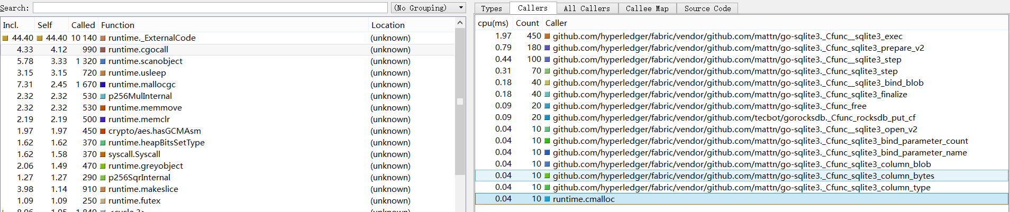

7.31% cpu time is spent on runtime.mallocgc

The program potentially makes excessive amount of small memory allocations. I will get the memory profile to see where the allocations are come from.

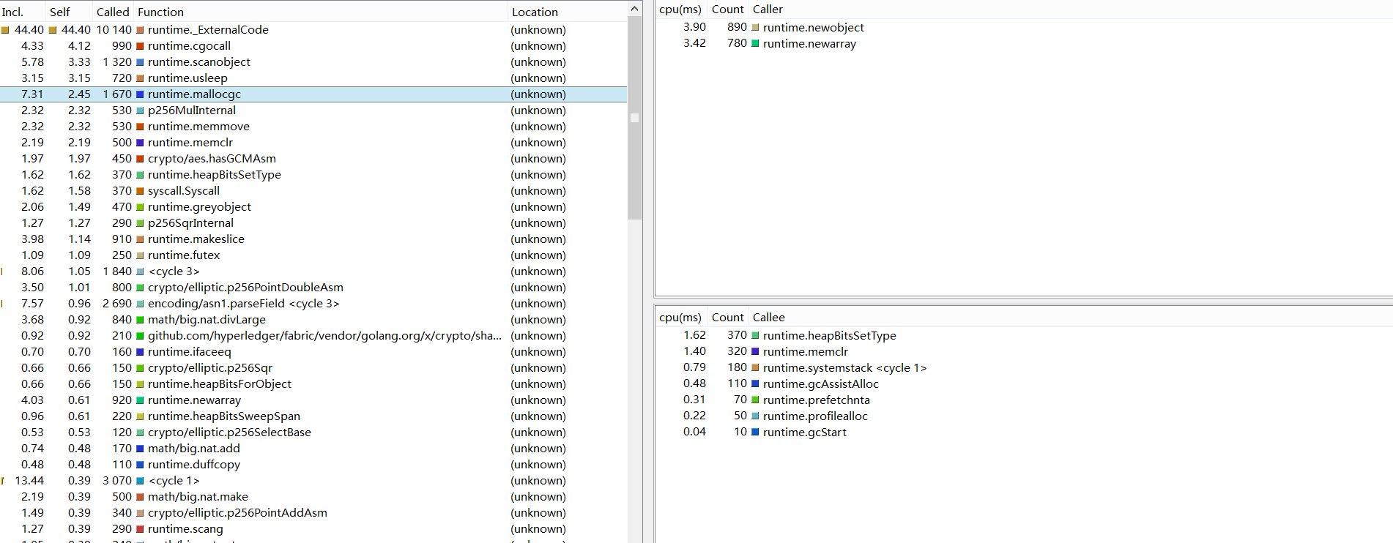

channel operations, sync.Mutex code are not the bottleneck as show in below：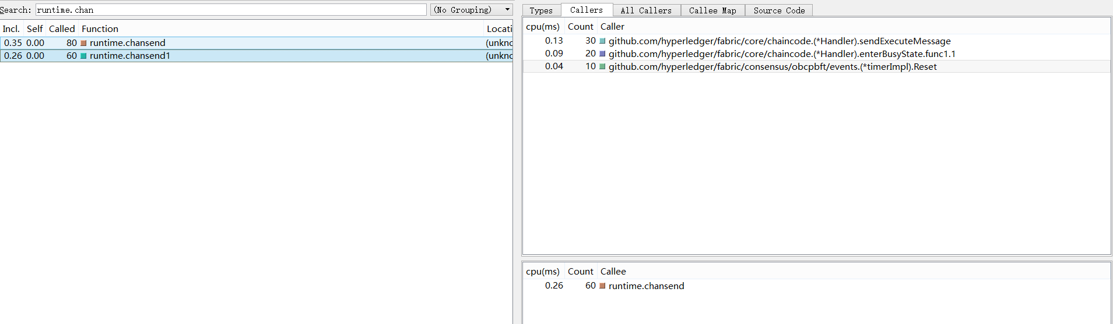

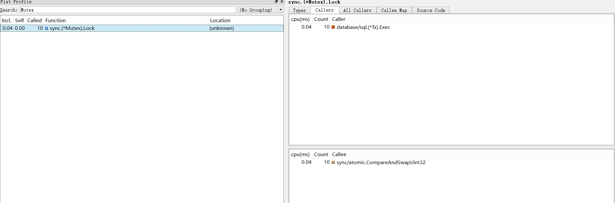

1.23% cpu time is spent in syscall.Read/Write, the program potentially makes excessive amount of small reads and writes. Bufio wrappers around os.File or net.Conn can help in this case.

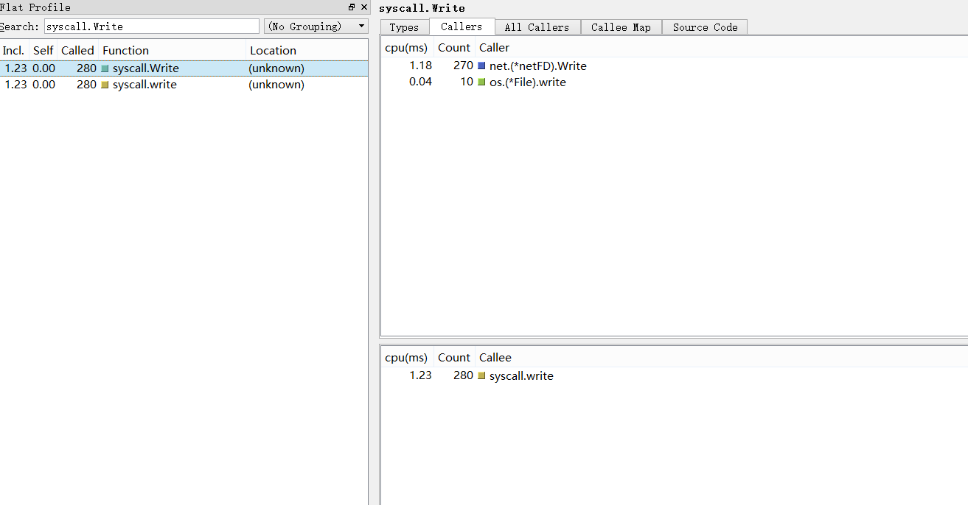

8.63% cpu time is spent in GC component, the program either allocates too many transient objects or heap size is very small so garbage collections happen too frequently. 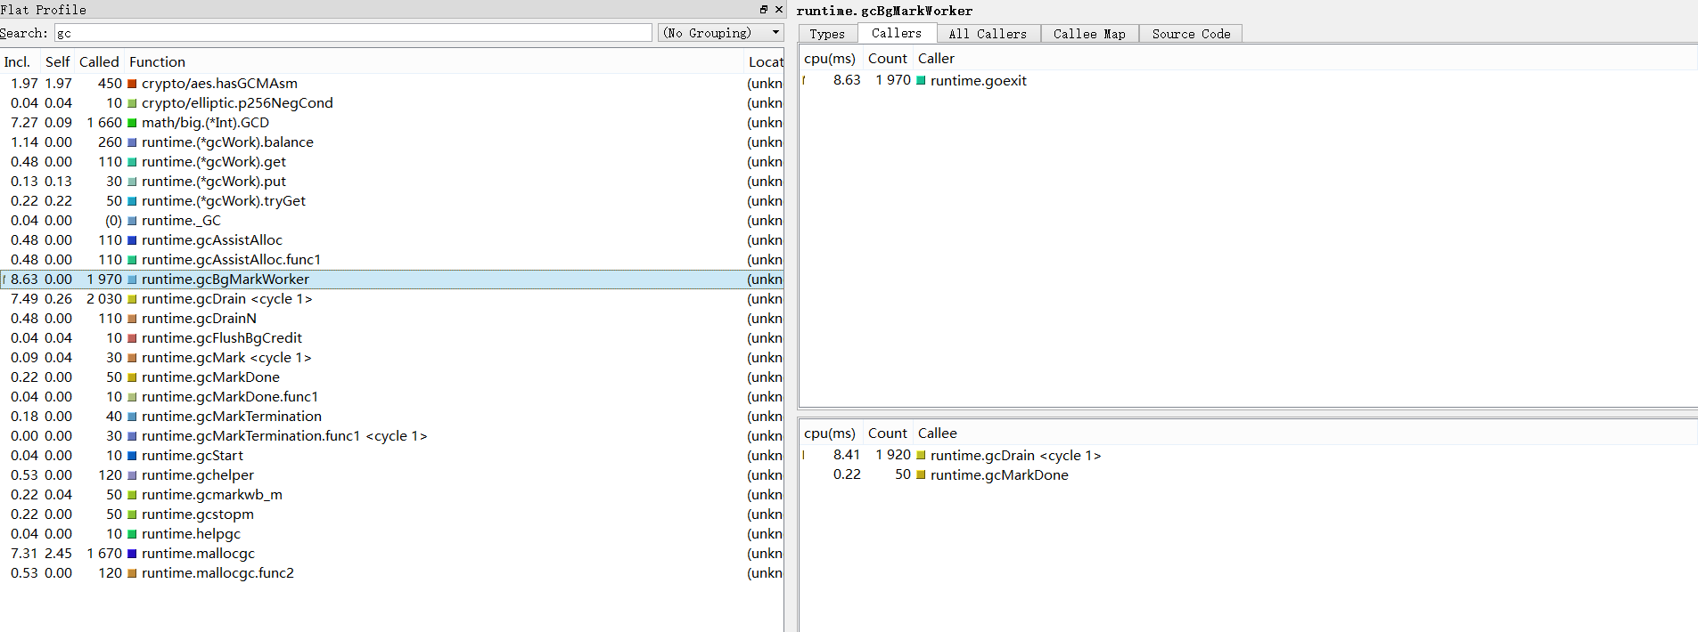

1692 of 3813 memory allocation is related to Crypto. TotalAlloc = 80,359,908,528(80GB). That’s a lot!