Auditing when evidence integration improves therapeutic target prioritization
Xianbo Zuo1,2,*, Jingtao Li2,3,†, Xuejiao Song1,2,†, Xiaoyan Qi4,5, Lili Chen6
†These authors contributed equally: Jingtao Li, Xuejiao Song. *Correspondence: Xianbo Zuo (zuoxianbo@qq.com).
1 Big Data Center, China-Japan Friendship Hospital, Beijing 100029, China.
2 NHC Key Laboratory of Clinical Big Data Standardization & Integration, Beijing 100029, China.
3 Department of Gastroenterology, China-Japan Friendship Hospital, Beijing 100029, China.
4 Chinese Academy of Medical Sciences & Peking Union Medical College, Beijing 100730, China.
5 China-Japan Friendship Hospital, Beijing 100029, China.
6 China-Japan Friendship Institute for Clinical Medicine, China-Japan Friendship Hospital, Beijing 100029, China.

Abstract
Therapeutic target prioritization often combines heterogeneous evidence, but whether integration improves ranking remains unclear. We audited this assumption in pancreatic ductal adenocarcinoma (PDAC) by comparing 13 scoring strategies across nine evidence layers and six primary endpoints, including external-label endpoints and constructed or circular controls. Fixed-form composites outperformed network centrality only on the two constructed endpoints whose labels contained druggability. Removing that layer reduced the support-term AUROC on the essential-and-druggable endpoint from 0.889 to 0.535. No fixed-form composite exceeded centrality on external-label endpoints, whereas random forest reached an AUROC of 0.750 for PDAC dependency through nonlinear reweighting. Missing-data encoding and combination rules also changed rankings; recoding missing values increased the multiplicative composite's AUROC by 0.241 on E1. Integration gains therefore depend on endpoint provenance and implementation choices and should be audited before being interpreted as improved target prioritization.
Therapeutic target prioritization seeks to identify genes whose perturbation may produce selective antitumour effects. Large-scale functional screens have made cancer dependencies measurable at genome scale, while genomic and pharmacological resources have made it possible to consider these dependencies alongside disease context and target tractability ^{1–3}.
This has made evidence integration increasingly common in cancer research. Genomic, transcriptomic, proteomic, network and pharmacological data are combined to capture complementary aspects of disease biology and therapeutic relevance ^{4–10}. Integration can improve predictive performance when different data modalities contribute non-redundant information, but benchmark studies show that its benefit depends on the data, task and evaluation setting ^{5–6,9–10}.
Evaluation becomes more difficult when the evidence used to construct a score is also present, directly or indirectly, in the endpoint used to judge it. In biological machine learning, such overlap can create information leakage or circular evaluation, leading to performance estimates that do not reflect generalization to unseen evidence ^{11–12}. This concern is particularly relevant to target prioritization, where labels such as essentiality, druggability or clinical development status may themselves be connected to the evidence used to rank targets ^{13–14}. A high score on such an endpoint may therefore reflect agreement with the way the endpoint was constructed rather than a general advantage of integrating evidence.
The key question is when evidence integration actually improves therapeutic target prioritization. We use pancreatic ductal adenocarcinoma (PDAC) as a testbed because it combines extensive functional-dependency data with genomic, network and pharmacological annotations ^{1–2,15–16}. We audit this question across nine evidence layers and six primary endpoints with different provenance, comparing fixed-form composites with single-layer and supervised baselines. We then test whether apparent gains persist after removing label-embedded evidence, recoding missing annotations, varying the aggregation rule and transferring the scoring functions across contexts ^{5–6,9–10}. This design distinguishes predictive evaluation from circular benchmark diagnostics and tests whether an integration advantage survives explicit challenges to evidence overlap and implementation choices.

Results

Six primary endpoints expose a dependence on endpoint provenance
The benchmark comprised nine evidence layers spanning network topology, somatic mutation, model-organism knockout viability, population genetic constraint, cancer-driver annotation, disease-specific germline association, chemical tractability, prognostic association and tissue specificity (Fig. 1a; Methods). We evaluated six primary endpoints with different provenance. E1 measured PDAC-wide dependency in DepMap 23Q2; E4 tested zero-shot transfer to colorectal cancer without refitting; E5 measured historical concordance with pancreatic-cancer clinical target development; and E6 defined a pharmacological-response proxy from GDSC. E3 was an essential-and-druggable construct, whereas E3-C used the tractability layer itself as the label. E2 and E3-A were retained for continuity but were not treated as independent endpoints: E2 is a stratification within E1, and E3-A reproduces the E1 positive set exactly (Fig. 1b; Supplementary Table 2). Two operational definitions of pancreatic essentiality differed by one gene; this discrepancy is documented in the audit ledger (Supplementary Table 1).

Network centrality is the strongest single-layer baseline on external-label endpoints
Across E1, E4, E5 and E6, network centrality ranked above every fixed-form composite (Fig. 2). Its AUROC was 0.695 on E1, 0.702 on E4, 0.986 on E5 and 0.910 on E6, compared with 0.575, 0.576, 0.941 and 0.846, respectively, for the harmonic composite. On E5, the paired AUROC difference between the harmonic composite and centrality was -0.045 (95% CI -0.085 to -0.013; P = 0.0167; Fig. 3a). The multiplicative composite performed below chance on E1 and E4, reaching an AUROC of 0.415 on E4. Random forest reached AUROCs of 0.750 on E1 and 0.631 on E2, showing that a supervised learner can recover signal from the same evidence layers even when fixed-form integration does not. We also corrected two reporting discrepancies from the earlier configuration: mutation frequency and genetic constraint on E1 were 0.499 and 0.524, respectively, and the cancer-driver single-layer scorer, which had been described but not computed, reached 0.507. These findings are consistent with prior benchmarking work showing that method rankings can depend on task definition and integration strategy ^{5–6,9–10}.

Integration gains disappear when label-embedded evidence is removed
Fixed-form integration exceeded network centrality only on E3 and E3-C, the two explicitly constructed endpoints in which the evaluation label contained an input layer (Fig. 2). On E3, the harmonic composite reached an AUROC of 0.893 versus 0.738 for centrality; on E3-C, it reached 0.936 versus 0.620. Decomposition of the harmonic score showed that the support term alone achieved 0.889 on E3, within 0.003 of the full composite. Removing the druggability layer reduced this value to 0.535. On E3-C, the same deletion reduced the support mean from 0.968 to 0.534. Conversely, removing druggability from the support term did not degrade performance on E5 (0.927 to 0.943) and reduced it on E6 (0.843 to 0.778). E3-C also produced AUROCs above 0.999 for four scorers, consistent with a label-as-input control rather than predictive generalization (Fig. 2). These comparisons localize the apparent integration advantage to the layer embedded in the endpoint definition.

Missing-data encoding and combination algebra can reverse the effect of integration
The nine evidence layers were min-max scaled to [0,1], with genes absent from a source assigned a sentinel value of -3.0. A mean of 57.8% of genes carried this value across layers, and in five layers the median gene was unannotated; driver annotation was missing for 98.8% of genes (Fig. 4a). Under the multiplicative rule, the signed sentinel changed the direction of the score for a substantial fraction of genes: the gain factor was negative for 84.0% of genes, the driver term was negative for 28.0%, and both were negative for 26.2%, making their product positive. Among genes with positive driver scores, the correlation between the support term and the integrated score was +0.80, but among genes with negative driver scores it was -0.37. Thus, for 28.0% of genes, additional supporting evidence could lower the integrated score (Fig. 4b). Recoding the sentinel as missing and averaging over available evidence increased the harmonic-composite AUROC by 0.052 on E1 and 0.054 on E4, while the multiplicative composite improved by 0.241 on E1. On E3, the corrected encoding reduced AUROC by 0.022, consistent with removal of annotation-pattern signal from the constructed endpoint (Fig. 5d). The sensitivity of downstream results to missingness representation is consistent with prior work on incomplete proteomic data ¹⁵.

Integration is sensitive to weighting and functional form
Across 1,000 symmetric Dirichlet draws on E3, the weighted fixed-form score had a mean AUROC of 0.333, a median of 0.288 and an interquartile range of 0.251-0.365; 91.2% of draws performed below chance and only 3.2% exceeded the centrality baseline of 0.738. The prespecified 0.8/0.1/0.1 weighting achieved 0.693, also below centrality (Fig. 5b). Holding the layers and weights fixed while changing only the aggregation rule moved E3 AUROC from 0.893 for the harmonic mean to 0.825 for the additive mean, 0.758 for the geometric mean, 0.693 for the multiplicative rule and 0.636 for rank aggregation (Fig. 5a). No aggregation rule was uniformly best across endpoints. Negative controls further localized the signal: for the multiplicative/ECS rule, replacing tissue specificity with Gaussian noise increased E3 AUROC from 0.693 to 0.780, whereas permuting druggability reduced it to 0.434; shuffling the network layer had little effect (0.688). Community-level resampling gave a mean difference of -0.066 between the multiplicative composite and centrality (95% CI -0.450 to +0.092; Fig. 3b).

Cross-context transfer and pharmacological response do not restore a fixed-form integration advantage
The ranking of methods transferred from PDAC to colorectal dependency without refitting: centrality remained ahead of the harmonic composite on E4 (0.702 versus 0.576), and method-level AUROCs were perfectly correlated between E1 and E4 (Spearman rho = 1.00). Because both contexts used DepMap 23Q2, this result represents cross-context transfer rather than fully independent external validation. We next tested whether the pattern depended on genetic dependency as the endpoint. In E6, median natural-log IC50 across 29 pancreatic cell lines was used to define 32 nominal-target positives from 125 compounds. Network centrality achieved an AUROC of 0.910, compared with 0.846 for the harmonic composite and 0.780 for tractability alone, whereas the random-forest learner reached 0.913, slightly above centrality (Fig. 6). Thus, a pharmacological-response proxy did not provide evidence for a fixed-form integration advantage. Studies of drug-response prediction likewise show that translating models from cell lines to tumours requires explicit transfer or validation rather than assuming transportability ^{16–18}.

Re-ranked genes remain prospective computational hypotheses
Nine genes previously reported as prioritized candidates were recomputed using the released pipeline and represented by genome-wide percentiles, druggability and dependency flags in PDAC and colorectal screens (Extended Data Fig. 4). Recomputing the harmonic composite changed the order of six of the nine genes. The previously reported order could not be reproduced from either the recomputed composite or network centrality and was traced to an intermediate file outside the final analysis workflow. In light of the benchmark results, these genes are retained as prospective computational hypotheses rather than a validated target ranking.

Discussion
Evidence integration is now a common strategy for computational target prioritization, reflecting the expectation that complementary molecular and pharmacological information should provide a more complete view of therapeutic relevance ^{4,7–8,13,14,19,20–21}. Our audit shows that this expectation is conditional. Across external-label endpoints, no fixed-form composite exceeded network centrality, whereas the apparent gains occurred on constructed endpoints that contained an input layer. Removing the label-embedded druggability layer largely abolished those gains. The result is not that integration is ineffective, but that an observed integration advantage cannot be interpreted without establishing how the evaluation endpoint relates to the evidence used by the scorer.
The same audit principle can be applied beyond therapeutic target prioritization. Whenever heterogeneous measurements are combined into a predictive score, the apparent benefit of integration can be affected by how the endpoint is defined and whether that endpoint reuses information from the inputs. This issue is relevant to multimodal biomarker modelling, drug-response prediction and single-cell or multi-omics integration, where differences in preprocessing, modality composition and evaluation design can change method rankings ^{4–6,9,10,17,18}. A useful benchmark should therefore report not only the model and metric, but also the provenance of the label and its overlap with the variables supplied to the model. In practice, four checks are broadly applicable: define the endpoint independently of the model inputs whenever possible; audit input–label overlap before interpreting performance; test sensitivity to missing-data representation and aggregation choices; and evaluate the resulting ranking on an independent or cross-context task. These checks do not argue against data integration. They provide a way to distinguish gains that reflect complementary information from gains that arise from benchmark construction or implementation. This standard may also make benchmark comparisons more interpretable across studies.
The same issue can arise whenever a benchmark reuses evidence that is already part of the scoring model. An endpoint such as "essential and druggable" is useful for describing actionability, but it is unsuitable for evaluating a score that already includes druggability without an explicit audit of the overlap. Similar concerns arise in biological machine learning, where dependencies between training information and evaluation data can produce optimistic estimates that fail under the intended use scenario ^{11–12}. Benchmarking studies in multimodal biology likewise show that task definition, preprocessing and modality composition can alter method rankings ^{5–6,9–10}. Endpoint provenance should therefore be reported alongside the dataset, model and metric rather than treated as an implicit detail of benchmark design.
The random-forest result points to a separate issue: combining evidence is not the same as allowing a model to learn how the evidence should be weighted. Random forest improved dependency discrimination, whereas fixed-form composites were highly sensitive to missing-data encoding, weighting and aggregation algebra. The signed sentinel encoding could invert the direction of evidence for a substantial subset of genes, and changing the representation of missing annotations altered benchmark performance without changing the underlying evidence layers. These observations argue against interpreting a single composite score as a stable measure of biological support unless its monotonicity, missingness behaviour and sensitivity to plausible aggregation choices have been demonstrated ¹⁵. Supervised integration and fixed-form evidence aggregation are better treated as distinct methodological classes rather than interchangeable examples of multi-evidence integration.
The study has several limitations. It examines one disease context and one evidence base, and the external-label endpoints are not uniformly independent of the input data. E4 is a cross-context transfer test using the same DepMap 23Q2 release rather than a fully independent external validation; E5 measures historical clinical-target concordance and contains only 35 positive targets; and E6 uses nominal compound targets and therefore does not resolve polypharmacology or causal target attribution. The benchmark also evaluates a family of fixed-form composites rather than every possible integration architecture, and network centrality itself may partly reflect annotation density. These limitations limit how broadly the negative finding can be generalized. The practical implication is narrower and more useful: claims of improved target prioritization should survive endpoint-provenance audits, leakage checks, representation sensitivity analyses and evaluation on labels that are not constructed from the model inputs ^{11–12,21}. Prospective experimental validation of the candidate genes remains necessary, moving from computational prioritization to perturbation, pharmacological testing and model-system validation ²⁰.

Methods

Ethics and study design
This study is a secondary computational analysis of publicly available aggregate or secondary resources, including DepMap, Genomics of Drug Sensitivity in Cancer (GDSC), Cancer Cell Line Encyclopedia (CCLE), STRING, COSMIC, gnomAD, the International Mouse Phenotyping Consortium (IMPC), Open Targets Genetics, Human Protein Atlas and ClinicalTrials.gov. No individual-level participant data were accessed and no new experiments were performed. Institutional review was therefore not applicable to this secondary analysis.

Evidence layers
Nine gene-level evidence layers were harmonised to HUGO Gene Nomenclature Committee (HGNC) symbols across 20,751 protein-coding genes defined by the intersection of STRING v12.0 and DepMap 23Q2: network degree centrality from STRING (confidence >0.4) ²²; somatic mutation frequency from COSMIC and The Cancer Genome Atlas pancreatic adenocarcinoma (TCGA-PAAD) ^{23,24}; knockout viability from the International Mouse Phenotyping Consortium (IMPC) ²⁵; population genetic constraint from gnomAD using loss-of-function observed/expected upper-bound fraction (LOEUF)-derived measures ²⁶; cancer-driver annotation from the COSMIC Cancer Gene Census ²⁴; pancreatic-cancer germline association from Open Targets Genetics ²⁷; chemical tractability, referred to here as the tractability/druggability layer, from the Drug–Gene Interaction Database (DGIdb) and ChEMBL tiers ^{28–29}; pancreatic-cancer prognostic association from Human Protein Atlas ³⁰; and RNA tissue specificity from Human Protein Atlas ³¹. Each layer was min-max scaled to [0,1]. Genes absent from a source were assigned a sentinel value of -3.0. This encoding was retained to reproduce the evaluated configuration and was subsequently audited against a missingness-aware representation.

Endpoints and provenance
Eight operational endpoints were evaluated, of which six were treated as primary evaluation endpoints. E1 was PDAC-wide dependency, defined from DepMap 23Q2 Chronos gene effect in pancreatic cell lines below the essentiality threshold 1–2 (4,584 positives). E2 was PDAC-enriched dependency, defined as the upper quartile of a PDAC-versus-other selectivity statistic among E1 positives (1,147 positives); because it is nested within E1, it was not counted as a primary endpoint. E3 was an essential-and-druggable construct, defined as E1 positivity plus an annotated druggability label (1,159 positives). E3-A removed the druggability conjunct from E3 and therefore reproduced the E1 positive set exactly (4,584 positives); it was retained for continuity but not counted independently. E3-C used the chemical-tractability layer directly as the label (5,188 positives) and served as a circular control. E4 was colorectal cancer zero-shot transfer: the PDAC scoring functions were applied without refitting to DepMap 23Q2 colorectal lines (4,608 positives). E5 measured historical concordance with the nominal primary targets of agents entering pancreatic-cancer clinical development (35 positives). E6 was a pharmacological-response proxy based on Genomics of Drug Sensitivity in Cancer (GDSC): among 125 compounds with annotated targets, 41 fell in the most sensitive tertile, and a gene was positive when it was the nominal target of one of those compounds across 29 pancreatic cell lines and not in the most resistant tertile, yielding 32 positives ³². E5 and E6 were defined outside the nine-layer evidence matrix but their target lists overlap the tractability layer; this overlap is documented in Supplementary Table 3.

Scoring strategies
Thirteen scorers were evaluated. Five were single-layer scorers: network centrality, chemical tractability, mutation frequency, genetic constraint and cancer-driver annotation.
Five fixed-form composites were constructed from a driver component and a support term. The driver component was defined as
$$D = 0.8 × centrality + 0.1 × mutation + 0.1 × viability$$
The support term, Φ, was defined as the unweighted mean of six layers: genetic constraint, cancer-driver annotation, germline association, tractability, prognostic association and tissue specificity.
The five fixed-form integration rules were arithmetic mean, rank aggregation, weighted rank aggregation, the multiplicative rule
$$D(1 + 0.6Φ)$$
and the harmonic mean
$$\frac{2(D + 3.0)(Φ + 3.0)}{D + Φ + 6.0}$$
A geometric mean was evaluated as an additional sensitivity analysis and was not included among the 13 benchmark scorers.
The implementation-specific weights and rank normalization for weighted rank aggregation were defined in the released analysis code; no additional weighting formula is specified here beyond the prespecified driver and support components above.
Three additional scorers were supervised learners: logistic regression, elastic net and random forest.
Supervised learners were fitted with five-fold stratified cross-validation and evaluated using out-of-fold predictions. No hyperparameter search was performed against any endpoint in the released benchmark. Because every scorer consumed the same nine evidence layers, models evaluated on E3 and E3-C were circular by construction and are reported as diagnostics rather than predictive validation. A leakage-safe nested five-fold protocol with inner-fold hyperparameter tuning, a fixed candidate grid and seed is provided in Supplementary Table 5.

Statistical analysis
Discrimination was summarized by AUROC, with AUPRC provided in Source Data. Confidence intervals were percentile intervals from 2,000 stratified bootstrap resamples. Whether a single scorer exceeded chance was assessed with the Mann-Whitney U statistic. Differences between scorers on the same endpoint used the fast DeLong method together with paired bootstrap intervals. The prespecified primary contrasts were fixed-form composite versus centrality, random forest versus centrality, and deletion of the label-embedded druggability layer from E3. All other scorer-endpoint comparisons were exploratory. Eight operational endpoints were examined, but only six were treated as primary endpoints; P values were therefore interpreted descriptively, with Holm-Bonferroni correction applied across the prespecified primary contrasts when a family-wise statement was made. Network-community resampling was performed in addition to gene-level bootstrap because network centrality induces dependence among genes.

Reproducibility
All numerical claims were recomputed from the released analysis pipeline. The audit ledger in Supplementary Table 1 records the provenance of each finding. The harmonic composite reproduced AUROCs of 0.893 on E3, 0.575 on E1 and 0.941 on historical clinical-target concordance. A clean rerun from the released inputs reproduced all 104 scorer-endpoint benchmark cells to six decimals, with a maximum absolute difference of 0.0, together with confidence intervals, negative controls, functional-form analyses and the full 1,000-draw Dirichlet weight-space analysis. The run record is identified by git commit SHA 5eb8a48cfade7def159eac0c2dd7f8010613827b and results-manifest SHA-256 1b9a1b6db0032ead15e0865a90e4b258127b7cbdb93dc4d33ce16e5614c911a8.

Data and code availability

All inputs are public. DepMap 23Q2 is available from depmap.org; GDSC IC50 and CCLE annotation from cancerrxgene.org; STRING v12.0 from string-db.org; COSMIC from cancer.sanger.ac.uk; gnomAD from gnomad.broadinstitute.org; IMPC from mousephenotype.org; Open Targets Genetics from genetics.opentargets.org; Human Protein Atlas from proteinatlas.org; and pancreatic-cancer clinical development history from ClinicalTrials.gov, with the clinical-development query frozen on 31 December 2024. The harmonised nine-layer evidence table, endpoint label vectors and complete benchmark output are released in the accompanying repository. Third-party source files are not redistributed; their identities are recorded by SHA-256 checksum and byte size. Source Data for the six main display items are supplied as a machine-readable table. Analysis code is released under the MIT licence and includes the primary benchmark, weight-space analysis, sentinel and combination-rule audits, and figure-rendering scripts, together with a pinned environment specification and input manifest. The four main scripts run in approximately 90 minutes on a single CPU without network access and regenerate the manuscript results and display items.
[Author names withheld for anonymized repository copy.]
[Author names withheld for anonymized repository copy.]
[Author names withheld for anonymized repository copy.]

[Author names withheld for anonymized repository copy.]
[Author names withheld for anonymized repository copy.]

[Author names withheld for anonymized repository copy.]
[Author names withheld for anonymized repository copy.]

[Author names withheld for anonymized repository copy.]
[Author names withheld for anonymized repository copy.]

[Author names withheld for anonymized repository copy.]
[Author names withheld for anonymized repository copy.]

Display items

Fig. 1 | Single evidence layers and endpoint dependency.
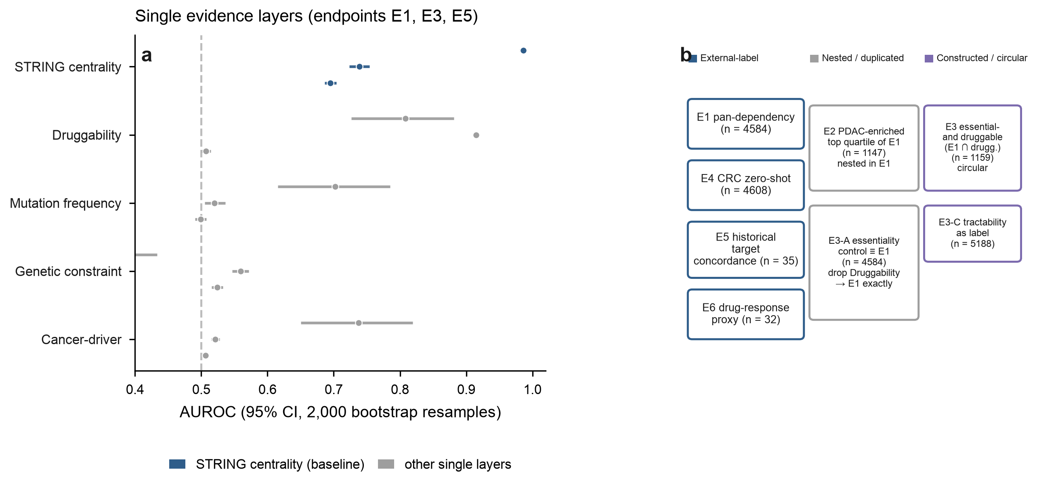

a, AUROC with 95% bootstrap confidence intervals for five single evidence layers on three endpoints. b, Relationships among evaluated endpoints: E2 is the upper quartile of an E1-derived selectivity statistic; E3 intersects E1 with tractability; E3-A reproduces the E1 positive set exactly.

Fig. 2 | Benchmark matrix.
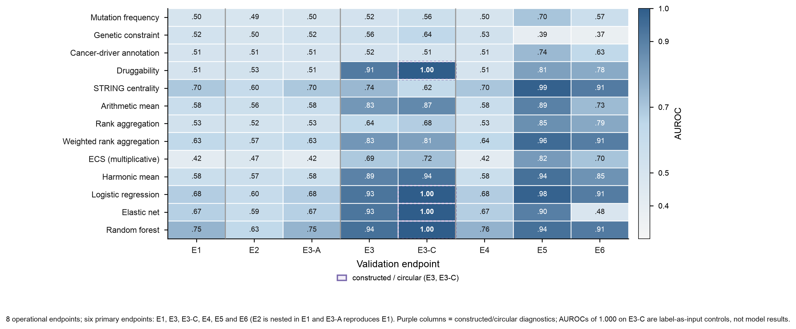

AUROC for 13 scorers across eight operational endpoints, with a sequential colour scale from light (low AUROC) to dark blue (high AUROC). Constructed and circular diagnostics E3 and E3-C are marked separately. AUROC = 1.000 on E3-C is displayed as a label-as-input control, not as predictive performance.

Fig. 3 | Integration versus network centrality.
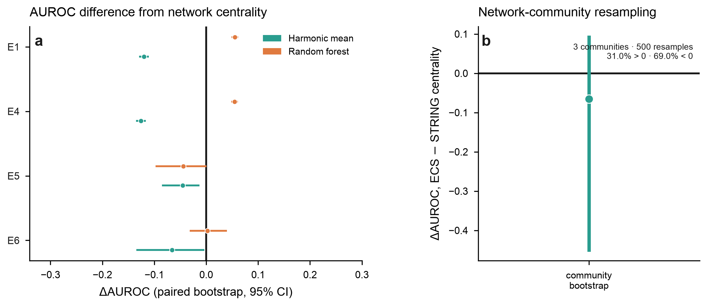

a, Paired AUROC difference relative to centrality with 95% confidence intervals across the external-label endpoints E1, E4, E5 and E6. b, Mean AUROC difference between the multiplicative composite and STRING centrality under network-community resampling (500 resamples across 3 communities).

Fig. 4 | Why integration appears to work.
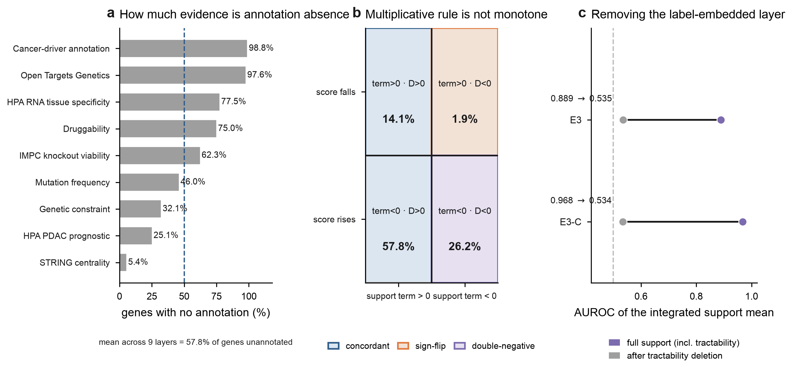

a, Percentage of genes carrying the missing-data sentinel in each evidence layer. b, Failure of order preservation under the multiplicative rule, highlighting the 26.2% double-negative region. c, Support-term AUROC on E3 and E3-C with and without the tractability layer.

Fig. 5 | Sensitivity analyses.
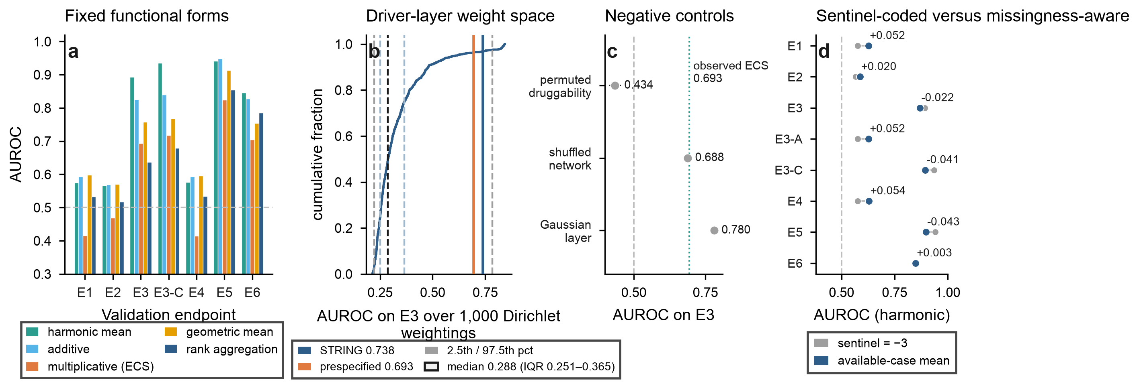

a, AUROC by aggregation rule. b, Distribution of E3 AUROC across 1,000 symmetric Dirichlet weight draws, showing the median, interquartile range, 2.5th-97.5th percentile range, the prespecified weighting and the centrality baseline. c, Negative controls on E3. d, Change in AUROC after recoding missing values as missing and averaging over available evidence.

Fig. 6 | Pharmacological stress test.
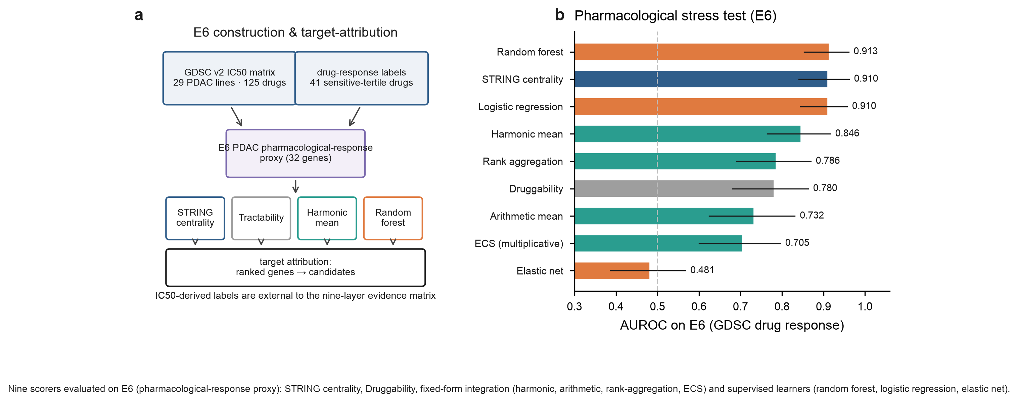
a, Construction of the E6 pharmacological-response proxy and nominal-target attribution. b, AUROC for the nine scorers shown on E6. The nine candidate genes are treated as prospective computational hypotheses and are shown in Extended Data Fig. 4.
Main figures (Figs. 1–6) are embedded above. Extended Data items and Supplementary files should be uploaded separately where requested by the submission system.

Extended Data and Supplementary Information
Extended Data Fig. 1 | Study-bias and annotation-density audit of network centrality.
Extended Data Fig. 2 | Missingness-encoding sensitivity, comparing available-case handling with missingness-aware analysis.
Extended Data Fig. 3 | Full Dirichlet weight-space distribution, including median, interquartile range, 2.5th-97.5th percentile range, maximum and proportion exceeding centrality.
Extended Data Fig. 4 | Nine candidate genes as prospective computational hypotheses, with genome-wide percentiles, druggability and dependency flags.
Supplementary Table 1 | Audit ledger documenting each P0/P1 item, severity, finding and action taken.
Supplementary Table 2 | Endpoint provenance and independence matrix.
Supplementary Table 3 | Evidence-layer overlap with E5 and E6 labels.
Supplementary Table 4 | Full scorer x endpoint AUROC, AUPRC, confidence intervals and P values.
Supplementary Table 5 | Nested cross-validation hyperparameters and outer-fold results.
Source Data | AUROC, 95% confidence interval, AUPRC, positive count and Mann–Whitney P against chance for every scorer-endpoint pair in source_data.csv.

References
1. Tsherniak, A. et al. Defining a Cancer Dependency Map. Cell 170, 564–576.e16 (2017). https://doi.org/10.1016/j.cell.2017.06.010
2. Behan, F. M. et al. Prioritization of cancer therapeutic targets using CRISPR–Cas9 screens. Nature 568, 511–516 (2019). https://doi.org/10.1038/s41586-019-1103-9
3. Iorio, F. et al. A Landscape of Pharmacogenomic Interactions in Cancer. Cell 166, 740–754 (2016). https://doi.org/10.1016/j.cell.2016.06.017
4. Lipkova, J. et al. Artificial intelligence for multimodal data integration in oncology. Cancer Cell 40, 1095–1110 (2022). https://doi.org/10.1016/j.ccell.2022.09.012
5. Cantini, L. et al. Benchmarking joint multi-omics dimensionality reduction approaches for the study of cancer. Nat. Commun. 12, 124 (2021). https://doi.org/10.1038/s41467-020-20430-7
6. Hu, Y. et al. Benchmarking algorithms for single-cell multi-omics prediction and integration. Nat. Methods 21, 2182–2194 (2024). https://doi.org/10.1038/s41592-024-02429-w
7. Liu, F. et al. Advancing AI for multi-omics and clinical data integration in basic and translational cancer research. Nat. Rev. Cancer 26, 497–512 (2026). https://doi.org/10.1038/s41568-026-00922-2
8. Baltušytė, G. et al. A network medicine framework for multi-modal data integration in therapeutic target discovery. Commun. Chem. 9, 244 (2026). https://doi.org/10.1038/s42004-026-02049-9
9. Luecken, M. D. et al. Benchmarking atlas-level data integration in single-cell genomics. Nat. Methods 19, 41–50 (2022). https://doi.org/10.1038/s41592-021-01336-8
10. Liu, C. et al. Multitask benchmarking of single-cell multimodal omics integration methods. Nat. Methods 22, 2449–2460 (2025). https://doi.org/10.1038/s41592-025-02856-3
11. Bernett, J. et al. Guiding questions to avoid data leakage in biological machine learning applications. Nat. Methods 21, 1444–1453 (2024). https://doi.org/10.1038/s41592-024-02362-y
12. Pavlović, M. et al. Improving generalization of machine learning-identified biomarkers using causal modelling with examples from immune receptor diagnostics. Nat. Mach. Intell. 6, 15–24 (2024). https://doi.org/10.1038/s42256-023-00781-8
13. Duffy, Á. et al. Development of a human genetics-guided priority score for 19,365 genes and 399 drug indications. Nat. Genet. 56, 51–59 (2024). https://doi.org/10.1038/s41588-023-01609-2
14. Pacini, C. et al. A comprehensive clinically informed map of dependencies in cancer cells and framework for target prioritization. Cancer Cell 42, 301–316.e9 (2024). https://doi.org/10.1016/j.ccell.2023.12.016
15. Voß, H. et al. HarmonizR enables data harmonization across independent proteomic datasets with appropriate handling of missing values. Nat. Commun. 13, 3523 (2022). https://doi.org/10.1038/s41467-022-31007-x
16. Carli, F. et al. Learning and actioning general principles of cancer cell drug sensitivity. Nat. Commun. 16, 1654 (2025). https://doi.org/10.1038/s41467-025-56827-5
17. Chawla, S. et al. Gene expression based inference of cancer drug sensitivity. Nat. Commun. 13, 5680 (2022). https://doi.org/10.1038/s41467-022-33291-z
18. Tang, Y.-C., Powell, R. T. & Gottlieb, A. Molecular pathways enhance drug response prediction using transfer learning from cell lines to tumors and patient-derived xenografts. Sci. Rep. 12, 16109 (2022). https://doi.org/10.1038/s41598-022-20646-1
19. Shi, X. et al. Building a translational cancer dependency map for The Cancer Genome Atlas. Nat. Cancer 5, 1176–1194 (2024). https://doi.org/10.1038/s43018-024-00789-y
20. Pun, F. W. et al. Target identification and assessment in the era of AI. Nat. Rev. Drug Discov. 25, 534–552 (2026). https://doi.org/10.1038/s41573-026-01412-8
21. Arafeh, R. et al. The present and future of the Cancer Dependency Map. Nat. Rev. Cancer 25, 59–73 (2025). https://doi.org/10.1038/s41568-024-00763-x
22. Szklarczyk, D. et al. The STRING database in 2023: protein–protein association networks and functional enrichment analyses for any sequenced genome of interest. Nucleic Acids Res. 51, D638–D646 (2023). https://doi.org/10.1093/nar/gkac1000
23. Raphael, B. J. et al. Integrated Genomic Characterization of Pancreatic Ductal Adenocarcinoma. Cancer Cell 32, 185–203 (2017). https://doi.org/10.1016/j.ccell.2017.07.007
24. Sondka, Z. et al. The COSMIC Cancer Gene Census: describing genetic dysfunction across all human cancers. Nat. Rev. Cancer 18, 696–705 (2018). https://doi.org/10.1038/s41568-018-0060-1
25. Groza, T. et al. The International Mouse Phenotyping Consortium: comprehensive knockout phenotyping underpinning the study of human disease. Nucleic Acids Res. 51, D1038–D1045 (2023). https://doi.org/10.1093/nar/gkac972
26. Karczewski, K. J. et al. The mutational constraint spectrum quantified from variation in 141,456 humans. Nature 581, 434–443 (2020). https://doi.org/10.1038/s41586-020-2308-7
27. Ghoussaini, M. et al. Open Targets Genetics: systematic identification of trait-associated genes using large-scale genetics and functional genomics. Nucleic Acids Res. 49, D1311–D1320 (2021). https://doi.org/10.1093/nar/gkaa840
28. Cotto, K. C. et al. DGIdb 3.0: a redesign and expansion of the drug–gene interaction database. Nucleic Acids Res. 46, D1068–D1073 (2018). https://doi.org/10.1093/nar/gkx1143
29. Davies, M. et al. ChEMBL web services: streamlining access to drug discovery data and utilities. Nucleic Acids Res. 43, W612–W620 (2015). https://doi.org/10.1093/nar/gkv352
30. Uhlen, M. et al. A pathology atlas of the human cancer transcriptome. Science 357, eaan2507 (2017). https://doi.org/10.1126/science.aan2507
31. Uhlén, M. et al. Tissue-based map of the human proteome. Science 347, 1260419 (2015). https://doi.org/10.1126/science.1260419
32. Yang, W. et al. Genomics of Drug Sensitivity in Cancer (GDSC): a resource for therapeutic biomarker discovery in cancer cells. Nucleic Acids Res. 41, D955–D961 (2013). https://doi.org/10.1093/nar/gks1111

