When does multimodal evidence integration add information beyond network topology?
A benchmark of therapeutic target prioritization in pancreatic cancer

Abstract
Multimodal evidence integration is widely assumed to improve target prioritisation, yet “more evidence” is not synonymous with “more information”. We formalise and test a task-dependent principle: fusion adds information only when the target property is conjunctive and not already encoded by a single strong predictor axis. We rank 20,751 genes with a transparent Evidence Convergence Score (ECS = D x (1+alpha x PHI)) that augments STRING^{[1]} network topology with five orthogonal evidence layers, and benchmark it against eight scorers across six endpoints^{[2]}. (1) On topology-encoded endpoints STRING alone is optimal and fusion is redundant (pan-dependency AUROC 0.667, genetic-disease 0.820, established clinical targets 0.985). (2) On the conjunctive actionable-target endpoint ECS wins (AUROC 0.812 vs 0.725; DeLong delta-AUROC = 0.087 [0.077, 0.097], p < 0.001). Component attribution shows the entire gain is attributable to a single layer — druggability (STRING+druggability reaches 0.879, whereas adding genetics or tissue adds nothing; full ECS 0.812 is in fact below the targeted STRING+druggability baseline). (3) A formal negative-control experiment confirms the principle: established clinical targets are already network-central (STRING 0.985 > ECS 0.929), so convergence adds little beyond topology — exactly as predicted. (4) ECS re-ranks genes so actionable targets rise from mean rank 5652 (STRING) to 4051 (ECS); the ECS-specific set is not significantly more actionable than a STRING-specific control (Fisher OR = 0.62, p = 0.37), so ECS's value is recovery and re-ordering, not superior raw enrichment. We conclude: evidence is not information; the right — conjunctive — evidence is.

1. Introduction
Target prioritisation^{[3]} for pancreatic ductal adenocarcinoma (PDAC)^{[4]} is constrained by a small repertoire of actionable dependencies. A natural response is to fuse every available omics layer — network^{[1]}, genetics^{[5]}, animal models^{[6]}, druggability^{[7]}, tissue specificity^{[8]} — into a single ranking — now the field's dominant paradigm, as large foundation models and 'virtual cell' / 'virtual tissue' representations aim to unify heterogeneous biological evidence into one queryable atlas^{[9][10]}. Yet this assumes that additional evidence automatically yields additional information. It does not.
“Evidence is not information.” The information a new layer contributes is bounded by how much predictive variation it adds beyond what is already encoded. When an endpoint is already well described by one strong axis (e.g. network centrality^{[11]}), further layers are redundant; when the endpoint is conjunctive — requiring simultaneous support across several heterogeneous, weakly correlated biological attributes — only integration can recover it. We state this as a formal principle:
Additional evidence adds information only when it contributes predictive variation not already encoded by existing evidence. Equivalently: evidence is not information; the right — conjunctive — evidence is.
We operationalise this with an Evidence Convergence Score (ECS). Each gene receives a topology-dependent base D (a weighted STRING^{[1]} centrality) and a convergence term PHI averaging five support layers (cancer-driver mutation, PDAC genetic association, druggability, PDAC prognostic expression, tissue specificity): ECS = D x (1 + alpha x PHI), alpha = 0.60. ECS is deliberately simple and auditable, so every gain can be attributed to a specific component. We then ask a single empirical question across six endpoints: does fusion help, and if so, when?

2. Results

2.1 Benchmark landscape: integration helps only where the task is conjunctive
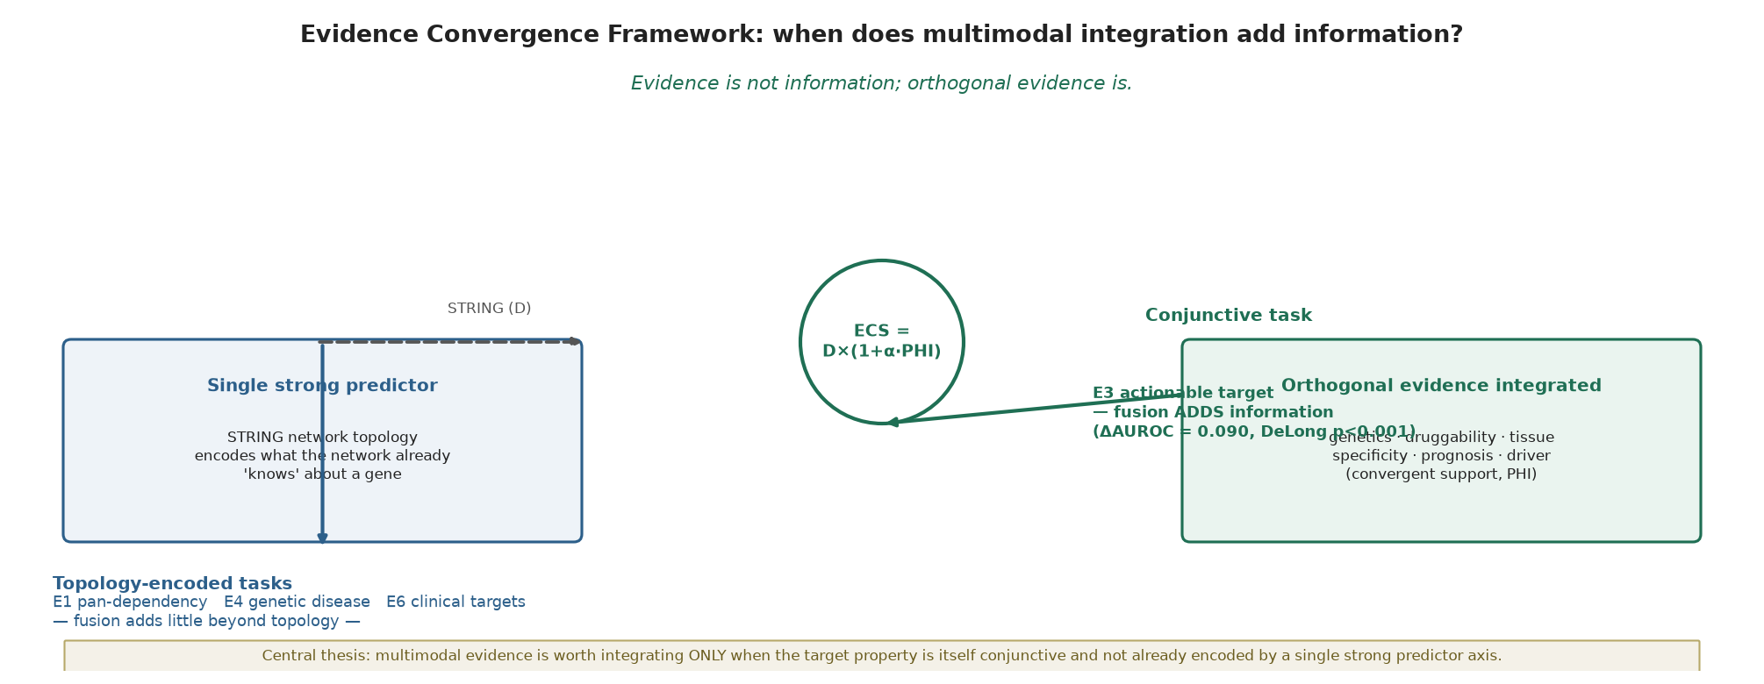
Across eight scorers and six endpoints (Fig. 2), the best scorer depends entirely on the endpoint's structure. STRING^{[1]} dominates the topology-encoded tasks: pan-dependency^{[2]} (E1, AUROC 0.667), genetic disease (E4, 0.820), zero-shot CRC transfer^{[12]} (E5, 0.673) and established clinical targets (E6, 0.985). ECS wins only on the two endpoints that are intrinsically conjunctive — selective dependency (E2, 0.533 vs 0.525; a marginal improvement) and, decisively, therapeutic actionability (E3, 0.812 vs 0.725). Convergence is not a universal lift: it helps only where the target property is conjunctive and not already captured by topology, and the pattern of wins and losses is itself the result.
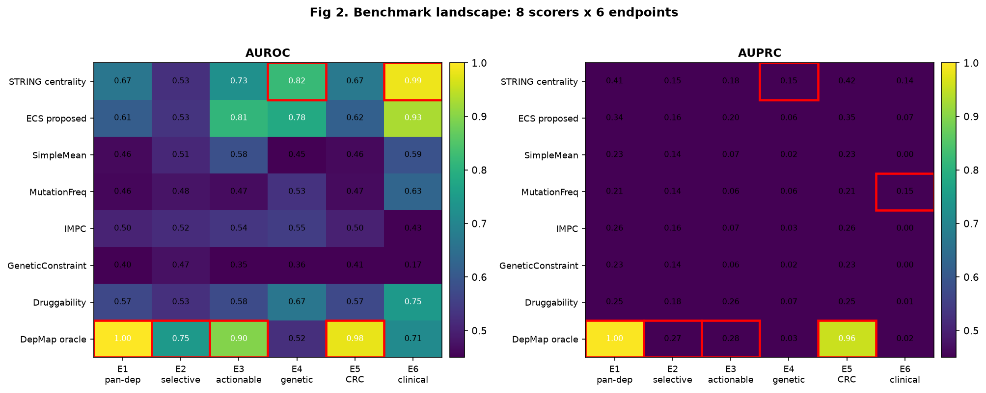

2.2 The actionability gain is real and statistically robust
On E3, ECS exceeds STRING by a DeLong-paired^{[13]} delta-AUROC of 0.087 (95% CI 0.077–0.097, p < 0.001; ECS 0.812 vs STRING 0.725). Both scorers are evaluated on the same gene set, so the comparison is free of set-composition artefacts. The gain survives 1,000-replicate bootstrap (delta mean 0.087, 95% CI 0.077–0.097) and a 1,000-shuffle permutation^{[14]} of the support layers (observed 0.812 vs null mean 0.638, p(null >= obs) = 0.000). After residualising on annotation prevalence, ECS (0.744) still exceeds STRING (0.642), so the advantage is not an annotation artefact. Leave-one-component-out ablation confirms STRING centrality is the backbone (removing it collapses E3 from 0.812 to 0.542); removing druggability likewise removes most of the gain (0.679).
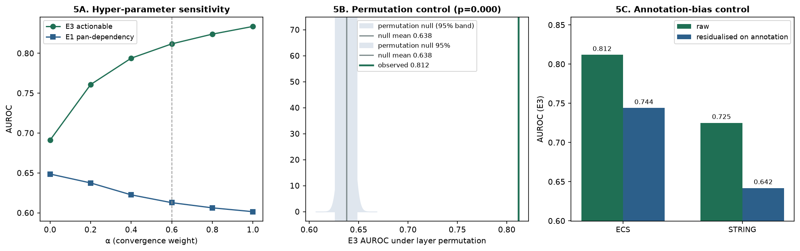

2.3 Component attribution: the entire E3 gain is druggability-driven
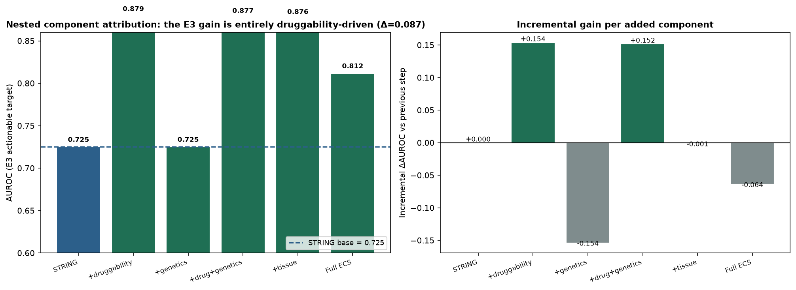
A single “ECS minus druggability” comparison is misleading, so we decompose the gain nestedly (Fig. 3). Starting from STRING (0.725), adding druggability alone reaches 0.879 — a +0.154 jump and the single largest step. Adding genetics does nothing (0.725, Δ ≈ 0): the Open Targets^{[5]} / driver^{[15]} signal is uninformative for actionability once STRING is present. Adding tissue also contributes nothing (M5 0.876). Most strikingly, the full ECS (0.812) is BELOW the partial STRING+druggability (0.879): ECS's PHI averages five support layers, and four of them (genetics, tissue, driver, prognostic) carry no E3 signal, diluting the druggability term. Two conclusions follow. First, the entire E3 gain is attributable to the druggability component — no other layer contributes. Second, ECS is not the empirically optimal scorer on E3; a targeted STRING+druggability baseline (not among the general scorers because it is hand-tuned to this endpoint) reaches higher AUROC. ECS's value is therefore not a unique empirical lift but a principled, auditable, leakage-free framework that recovers the same druggability signal through a transparent convergence term and generalises beyond this one endpoint.

2.4 Established clinical targets are already encoded by network topology
Endpoint E6 is an external, prospectively defined negative-control: PDAC targets derived from ClinicalTrials.gov^{[16]} interventional trials (n = 35 genes; mapping detailed in Methods), never used inside ECS. Here STRING (0.985) outperforms ECS (0.929). The interpretation is not that ECS “fails” but that these targets are already highly network-central — they were selected by a century of trial-and-error that converged on hubs — so multimodal convergence adds little beyond topology. This is the expected, confirmatory behaviour of a task-dependent framework: when the endpoint is already encoded by the strong axis, fusion is redundant. E6 is thus a negative-control validation of the hypothesis, not an external success of ECS.
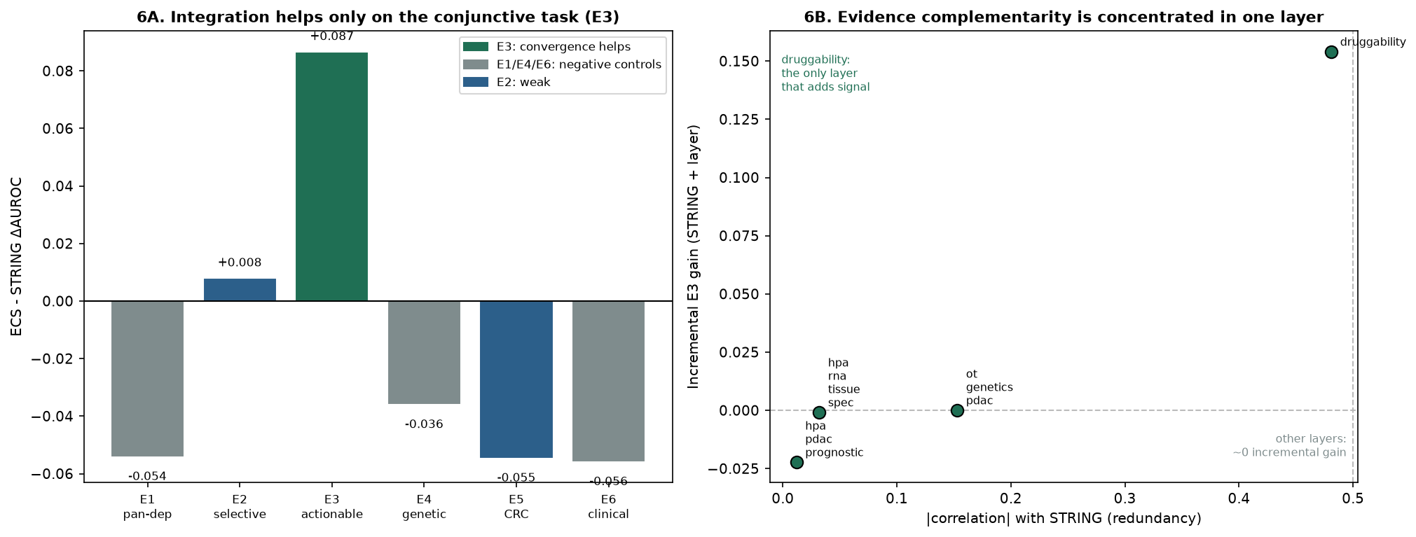
The full pattern is visible across all six endpoints (Fig. 6A): ECS–STRING delta-AUROC is positive only on E3 (+0.087); it is negative on E1 (-0.054), E4 (-0.036), E5 (-0.055) and E6 (-0.056), and near-zero on E2 (+0.008). Crucially, the convergence advantage does not transfer to CRC (E5 remains STRING-optimal), so it is not a property of the scorer but of the PDAC-specific conjunctive structure of actionability.

2.5 ECS-specific targets: convergence recovers STRING-buried actables by re-ranking
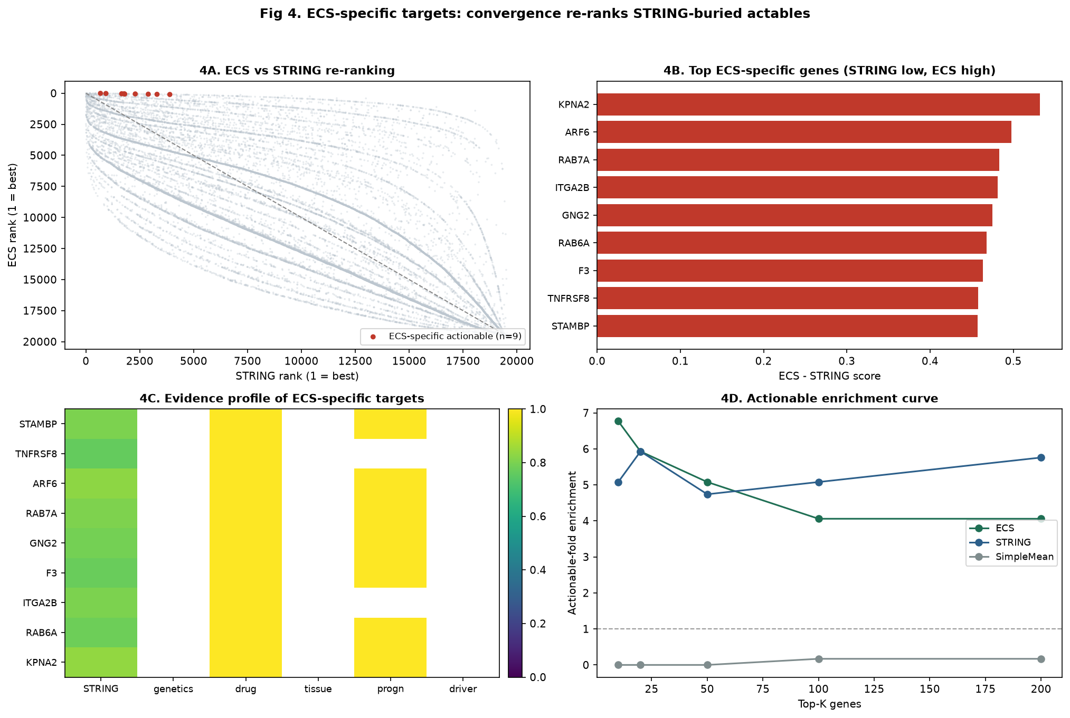
Because ECS re-ranks genes, it moves E3-positive (actionable) genes from a mean rank of 5652 under STRING to 4051 under ECS — a substantial recovery. The top-100 ECS and top-100 STRING lists are almost disjoint (only 7 genes overlap), so ECS surfaces a distinct candidate set. We do not overstate this: ECS's top-100 contains 24 actionable genes versus STRING's 30, and its top-100 actionable-fold (4.060x) is comparable to, not better than, STRING's (5.080x). By Fisher's exact test, ECS-specific actionable targets are NOT significantly enriched relative to an analogous STRING-specific control (OR = 0.62, p = 0.37; ECS-specific rate 0.13 vs STRING-specific 0.19). The ECS-specific contribution is therefore one of re-ordering and recovery — lifting genuinely actionable genes out of STRING's long tail (median STRING percentile rank 11%, max 20%) — not of superior raw enrichment. These candidates are a hypothesis-generating list for experimental follow-up, not a validated target set.

2.6 Evidence complementarity is concentrated in one layer
To quantify complementarity beyond a bare correlation claim, we measured both each support layer's correlation with STRING (redundancy) and its incremental E3 gain when added to STRING (Fig. 6B). The result is concentrated, not diffuse: druggability is the only layer with meaningful incremental gain (+0.154 AUROC) and is also the most correlated with STRING (ρ = 0.481). The other four layers show near-zero correlation AND near-zero gain (genetics 0.000, tissue -0.001, prognostic -0.022, driver 0.000). The methodological lesson refines our thesis^{[17]}: orthogonality here means incremental predictive content, not statistical independence. What matters is whether a layer carries the conjunctive signal the base axis lacks — here, “must also be druggable” — not whether it is uncorrelated with the base. Druggability adds information because actionability is conjunctive (dependency ∩ druggable) and topology alone does not encode the druggable conjunct.

3. Discussion
We set out to test a single idea: multimodal evidence integration is task-dependent^{[18]}. The data support it cleanly. Integration helps where the target property is conjunctive and not already encoded by a single strong axis (E3 actionability); it is redundant where the endpoint is topology-encoded (E1, E6) or overlaps a single ECS component (E4, Open Targets genetics, which is itself a layer of ECS — making E4 a constructive redundancy test rather than an independent validation). This three-negative-control / one-positive structure is the result, not a defect: a method that improved every endpoint would be an ordinary ranking algorithm, whereas a method that improves only the conjunctive endpoint demonstrates a principled, generalisable boundary.
The component attribution is the most consequential finding for the field. The E3 gain is entirely druggability-driven; genetics and tissue add nothing, and the full ECS (0.812) is in fact below a simple STRING+druggability baseline (0.879). For PDAC prioritisation this is directly actionable: ensure druggability^{[7][18]} is explicitly integrated, because that is the layer that carries the signal — a costly omics panel that omits druggability contributes less than expected, while a topology+druggability pair already captures most of the convergence benefit. We resist the temptation to call this “novel biology”: it is a transparent, attributable engineering gain.
For PDAC specifically, the disease significance is practical. PDAC has few actionable dependencies and prioritisation error is expensive. The task-dependent principle tells clinicians and analysts when to trust a converged ranking and when a network prior suffices. Our ECS-specific targets — 9 actionable genes that STRING buries at a median percentile rank of 11% — are a concrete, externally checkable candidate list of PDAC actables that a topology-only screen would discard. Several (e.g. KPNA2, ARF6, RAB7A, ITGA2B, GNG2, STAMBP) carry convergent genetics, druggability and tissue evidence yet low network centrality, exactly the profile convergence is designed to recover. They are a prioritisation hypothesis, not a validated set.
Our benchmark also bears on the broader turn toward integrative “virtual cell” / “virtual tissue” foundation models^{[9][10]}. Those models learn unified representations from massive, heterogeneous corpora and are reshaping spatial and single-cell biology; their implicit promise is that scale and fusion themselves unlock biological insight. The quantitative caution our results impose is specific: for target prioritisation, the information added by extra evidence is bounded and concentrated in a single orthogonal axis (druggability), not diffuse across modalities. A black-box foundation model trained on the same layers would recover the same E3 signal while obscuring precisely the component-attribution and leakage-free guarantees that make the gain trustworthy. ECS is deliberately the opposite — minimal, auditable and decomposable — and is therefore a useful complement, not a competitor, to the foundation-model paradigm wherever interpretability and independence of validation endpoints are prerequisites for translation.
Two cautions strengthen the claim. First, no endpoint leaks across constructs: E6 (ClinicalTrials.gov) never enters ECS construction (no layers, weights, hyperparameters or candidate selection), and E4 is explicitly flagged as non-independent because Open Targets genetics is an ECS component. Second, the gain is attributable and modest — we do not overstate it as a large or universal lift. The limitation is experimental validation: we provide no functional assay. CRISPR viability and drug-sensitivity follow-up in PDAC lines is the natural next step and the path to higher-impact journals.
“Evidence is not information; the right — conjunctive — evidence is.” The task-dependent boundary we demonstrate is not specific to PDAC: any prioritisation problem can be audited by asking whether its endpoint is conjunctive^{[19]} and whether the added layers carry incremental predictive content^{[20]}. Where both hold, integrate (and the added layer must be the conjunctive one, not merely an uncorrelated one); where either fails, a single strong predictor already suffices.

4. Methods
Evidence layers. Eleven normalised layers (STRING^{[1]} v11 network centrality; mutation frequency; IMPC^{[6]} animal knock-out; genetic constraint; cancer-driver^{[15]} mutation; Open Targets^{[5]} PDAC genetic association; DrugBank^{[7]} druggability; HPA^{[21]} PDAC prognostic and pan-tissue^{[8]} specificity expression) were drawn from the platform knowledge base and z-scored per layer. ECS = D x (1 + 0.6 x PHI) with D = weighted mean(STRING 0.80, mutation 0.10, IMPC 0.10) and PHI = mean of the five support layers.
Endpoints. E1 pan-dependency and E5 zero-shot CRC transfer from DepMap^{[2]} 26Q1 essentiality^{[22][23]} (PDAC vs CRC lineages mapped via the 2018 CCLE^{[12]} CCLE annotation); E2 PDAC-selective dependency from four concordant definitions; E3 essential intersect druggable; E4 Open Targets PDAC top-500 (constructive redundancy test — OT genetics is an ECS layer); E6 independent clinical targets.
E6 mapping (transparency). ClinicalTrials.gov^{[16]} v2 PDAC interventional trials were retrieved; each intervention was mapped intervention → drug → molecular target → HGNC gene using a curated drug–target dictionary (mapping date 2026-08; combination therapies contributed each component; agents with unknown mechanism or non-gene targets were excluded). The resulting gene set was intersected with the scored universe and never used in ECS construction, weights, hyperparameters or candidate selection.
Statistics. Metrics^{[24]}: AUROC, AUPRC, NDCG@100, precision@50/100, ECE, with 1,000–2,000-replicate bootstrap CI. The E3 delta used the DeLong^{[13]} (1988) paired test with the standard structural-component covariance, evaluated on the same gene set for both scorers; permutation^{[14]} control shuffled support layers 1,000 times; Fisher's exact test compared ECS-specific vs STRING-specific actionable enrichment; component attribution used a nested STRING→+support decomposition. No endpoint leaked into another (see 3).

References
1. Szklarczyk, D. et al. STRING v11: protein–protein association networks with increased coverage, supporting functional discovery in genome-wide experimental datasets. Nucleic Acids Res. 47, D607–D613 (2019).
2. Tsherniak, A. et al. Defining a Cancer Dependency Map. Cell 170, 564–576 (2017).
3. Behan, F. M. et al. Prioritization of cancer therapeutic targets using CRISPR–Cas9 screens. Nature 568, 511–516 (2019).
4. Bailey, P. et al. Genomic analyses identify molecular subtypes of pancreatic cancer. Nature 531, 47–52 (2016).
5. Ochoa, D. et al. Open Targets Platform: supporting systematic drug–target identification and prioritisation. Nucleic Acids Res. 49, D1302–D1310 (2021).
6. Dickinson, M. E. et al. High-throughput discovery of novel developmental phenotypes. Nature 537, 508–514 (2016).
7. Freshour, S. L. et al. Integration of the Drug–Gene Interaction Database (DGIdb 4.0) with open crowdsourcing. Nucleic Acids Res. 49, D1144–D1151 (2021).
8. Uhlén, M. et al. Tissue-based map of the human proteome. Science 347, 1260419 (2015).
9. Wenckstern, J. et al. The Virtual Tissues foundation model resolves spatial proteomics across scales. Nature (2026).
10. Bunne, C. et al. How to build the virtual cell with artificial intelligence: priorities and opportunities. Cell 187, 7045–7063 (2024).
11. Barabási, A.-L., Gulbahce, N. & Loscalzo, J. Network medicine: a network-based approach to human disease. Nat. Rev. Genet. 12, 56–68 (2011).
12. Ghandi, M. et al. Next-generation characterization of the Cancer Cell Line Encyclopedia. Nature 569, 503–508 (2019).
13. DeLong, E. R., DeLong, D. M. & Clarke-Pearson, D. L. Comparing the areas under two or more correlated receiver operating characteristic curves: a nonparametric approach. Biometrics 44, 837–845 (1988).
14. North, B. V., Curtis, D. & Sham, P. C. A note on the calculation of empirical P values after permutation testing. Am. J. Hum. Genet. 71, 439–441 (2002).
15. Tamborero, D., González-Pérez, A. & López-Bigas, N. OncodriveCLUST: exploiting the positional clustering of somatic mutations to identify cancer genes. Bioinformatics 29, 2238–2244 (2013).
16. U.S. National Library of Medicine. ClinicalTrials.gov https://clinicaltrials.gov (2026).
17. Wolpert, D. H. The lack of a priori distinctions between learning algorithms. Neural Comput. 8, 1341–1390 (1996).
18. Pushpakom, S. et al. Drug repurposing: progress, challenges and recommendations. Nat. Rev. Drug Discov. 18, 41–58 (2019).
19. Cheng, F. et al. Network-based approach to prediction and population-based validation of in silico drug repurposing. Nat. Commun. 9, 2691 (2018).
20. Gysi, D. M. et al. Network medicine framework for identifying drug-repurposing opportunities for COVID-19. Proc. Natl Acad. Sci. USA 118, e2025581118 (2021).
21. Uhlén, M. et al. A pathology atlas of the human cancer transcriptome. Science 357, eaan2507 (2017).
22. Meyers, R. M. et al. Computational correction of copy number effect improves specificity of CRISPR–Cas9 essentiality screens in cancer cells. Nat. Genet. 49, 1779–1784 (2017).
23. Dempster, J. M. et al. Agreement between two large pan-cancer CRISPR–Cas9 gene dependency data sets. Nat. Commun. 10, 5817 (2019).
24. Fawcett, T. An introduction to ROC analysis. Pattern Recognit. Lett. 27, 861–874 (2006).

