Small Consumer Behavior Change Leading to Market-Wide Depletion During Crisis
Connecting Empirical Evidence with Computational Model
Xucheng Zuo
2026-09-30

Abstract
To be drafted

Introduction
To be drafted

Study 1: Rice Supply News and Responses to Shortage Information
Study 1 asked whether news about the future supply of rice changes how consumers respond when they meet shortage information. Rice is a staple in Japanese households, and Japanese consumers had recently lived through a market-wide rice shortage. In August 2024, rice disappeared from supermarket shelves across the country, and retail prices stayed high through 2025, in what became known as the "Reiwa rice crisis" [CITE: Reiwa rice crisis]. We planned the study in late 2025 and ran it in January 2026, while the shortage was still recent and rice was still expensive, so a rice shortage was a credible scenario for participants.
The study tested one link in the account of panic buying proposed in this thesis (see Introduction). In this account, a sudden rise in demand does not require irrational consumers. Consumers meet a genuine signal of shortage, such as an empty shelf or a photo of one, and respond to it reasonably: if rice will be harder to get, it makes sense to buy now while it is still available, and to tell others. Whether a signal is read this way depends on the background against which it is seen. If consumers already see the supply as unstable, an empty shelf looks like evidence of a shortage in the market, worth acting on and worth passing on. If they see the supply as stable, the same shelf looks like noise: a problem of one store that will be restocked soon, not worth reacting to or sharing. We therefore manipulated the background with news articles that were either negative or positive about the future supply of rice, and then showed all participants the same shortage signals. If the account holds, the negative articles should make participants more pessimistic about supply than the positive articles, and participants in the negative condition should then be more willing to buy rice and to share the information when they see the signal. The study was exploratory and was not preregistered.

Method

Participants
Participants were Japanese adults aged 18 or older, recruited through a crowdsourcing service with age quotas for each 10-year group. They were compensated according to the service’s rules. Data were collected on January 7–8, 2026, with an online survey built in Qualtrics. We planned to collect 500 responses. The survey was closed once 500 responses were completed, but participants who had already started could finish, so the raw data contained 594 responses. We analyzed 284 participants (46.8% men; age M = 45.28, SD = 8.87, range 26–67): 165 in the negative news condition and 119 in the positive news condition. Most exclusions came from the comprehension checks on the news articles, which excluded every participant with any wrong answer. The remaining exclusions were test responses, repeated responses and responses without consent (Appendix 7.2.1). More participants failed the comprehension checks in the positive condition, which is why the conditions differ in size. The study was approved by the Ethics Committee of the Graduate School of Humanities and Sociology, The University of Tokyo (UTSP-25047).

Design and procedure
The study had one between-participants factor with two levels: negative or positive news about the future supply of rice. After giving consent, participants answered household questions, such as household size and whether they were the main food buyer. We used these as control variables (Appendix 7.2.2). They were then randomly assigned to a condition and read two newspaper articles.
The articles were shortened versions of real articles from the Nihon Keizai Shimbun and the Asahi Shimbun published in October–November 2025. The negative articles were meant to make participants expect unstable supply in the long run. They reported that repeated heat damage from climate change and the aging of rice farmers were making supply risk permanent. The positive articles were meant to make participants expect stable supply. They reported a large harvest in 2025, after the shortage of 2024, and a warmer climate that was opening new land for rice, such as in eastern Hokkaido; together they suggested that the shortage had been temporary. After each article, participants answered two two-choice comprehension questions about its content (Supplementary Materials [LINK]).
Participants then rated their expectations about the future supply of rice and responded to two shortage scenarios. Each scenario presented a shortage signal of the kind described above and asked about two responses to it: buying rice, which adds to demand, and telling others, which passes the signal on to people who have not seen it. The scenarios differed in how the signal reached the participant. In the shelf scenario, participants imagined finding the rice shelf of their usual supermarket almost empty during their weekly shopping, with only a few bags left; an AI-generated image of such a shelf was shown, and participants were told that the image was generated. In the SNS scenario, they imagined seeing a post on social media with a photo of the same shelf. The shelf scenario gives firsthand information. The SNS scenario gives secondhand information, which is how a shortage seen by one consumer reaches others. Comparing the two shows whether people respond to a shortage they only hear about as strongly as to one they see themselves, and so how far a signal can travel from where it was seen. After the scenarios, participants reported their age, gender, personal and household income and education, and were debriefed about the two versions of the articles.

Measures
Pessimism. Three items measured expectations about the future supply of rice: whether supply would become unstable or stable (1 = very unstable to 5 = very stable), how optimistic or pessimistic participants felt about the supply (1 = very pessimistic (rice will run short) to 5 = very optimistic (there will be enough rice)), and how likely it was that a rice sellout like the "Reiwa rice crisis" would happen again (1 = very low to 5 = very high). We coded all three so that higher values mean more pessimistic expectations, reversing the first two, and averaged them into a pessimism score (Cronbach’s $α$ = .82).
Responses to shortage information. Twelve items measured behavioral intentions on 5-point scales (1 = definitely not to 5 = definitely; Table 7 in the Appendix). In each scenario, three items asked about buying rice when the household had only a few days of rice left, more than a week left, or more than a month left. In the shelf scenario, participants were asked whether they would buy the remaining rice; in the SNS scenario, whether they would go to a nearby store to buy rice right away. Three items in each scenario asked whether participants would tell people they live with or close others such as best friends or partners, tell acquaintances or friends, and post to many unspecified people on SNS (in the SNS scenario: share or repost).

Analysis
We first checked the manipulation by comparing pessimism between conditions with Welch’s t-test. The behavioral items were written for this study and are not an established scale, so before comparing conditions we checked how the items grouped, to decide which behavioral variables to compare. We ran an exploratory factor analysis (EFA) on the twelve behavioral items (minimum residual extraction, varimax rotation; promax rotation as a check) and retained the factors with eigenvalues greater than 1. For each factor, we checked internal consistency with Cronbach’s $α$ and computed a scale score as the mean of the items that loaded on it. We compared conditions on each scale score with Welch’s t-tests, with a Holm correction for the three tests. As an exploratory analysis, we tested the associations between pessimism and the scale scores with Pearson correlations, across and within conditions. Finally, we compared firsthand (shelf) and secondhand (SNS post) sharing with close others with a paired t-test and tested whether this difference depended on the condition. Analyses used Python (pandas, SciPy) and R (psych). Tests were two-tailed with $α$ = .05.

Results

Manipulation check
The news articles changed expectations. Participants in the negative condition were more pessimistic about the future supply of rice (M = 4.05, SD = 0.66) than participants in the positive condition (M = 3.12, SD = 0.76), $t$(231.0) = 10.75, p < .001, d = 1.32 (Table 2). Pessimism was high overall (M = 3.66 on the 1–5 scale): even in the positive condition the mean was above the scale midpoint.

Structure of responses to shortage information
Three eigenvalues of the item correlation matrix exceeded 1 (4.96, 2.26 and 1.37; the fourth was 0.92), so we retained three factors. The varimax solution explained 62.7% of the item variance (Table 1).
We had designed the items expecting the source of the information, firsthand (shelf) or secondhand (SNS post), to form separate factors, and the sharing items to form one factor. The factors did not follow this design: the source did not separate the items, and sharing split by audience. The factors followed the target of the behavior. All six purchase items loaded on one factor, from both scenarios. The four items about telling close others, acquaintances and friends loaded on a second factor, again from both scenarios. The two items about posting to many people on SNS formed a third factor. The promax solution gave the same pattern (Appendix 7.2.3).
We call the three scores purchase, close sharing and SNS sharing. Their item means had good internal consistency ($α$ = .87, .86 and .88). Participants were more willing to buy (M = 2.77) and to tell close others (M = 2.83) than to post to many people (M = 1.71, below probably not). Purchase correlated with close sharing (r = .49, p < .001), close sharing correlated with SNS sharing (r = .30, p < .001), but purchase and SNS sharing were unrelated (r = .05, p = .430).
Table 1: Study 1: descriptive statistics and varimax-rotated loadings of the twelve behavioral items (N = 284). Loadings $≥$ .40 in bold. $h^{2}$ = communality.
Item | Scenario | M | SD | Purchase | Close | SNS | $h^{2}$​
Buy: a few days left | Shelf | 3.33 | 1.10 | .54 | .29 | –.27 | .44
Buy: a week left | Shelf | 2.97 | 1.07 | .79 | .23 | –.20 | .71
Buy: a month left | Shelf | 2.25 | 0.99 | .74 | .10 | .14 | .57
Go to buy: a few days | SNS post | 3.12 | 1.07 | .63 | .35 | –.05 | .52
Go to buy: a week | SNS post | 2.77 | 1.03 | .80 | .23 | .04 | .69
Go to buy: a month | SNS post | 2.16 | 0.93 | .72 | .10 | .28 | .61
Tell housemates/close | Shelf | 3.23 | 1.08 | .22 | .79 | –.04 | .68
Tell acquaintances | Shelf | 2.69 | 1.01 | .12 | .75 | .26 | .65
Tell housemates/close | SNS post | 2.89 | 1.08 | .35 | .68 | .12 | .60
Tell acquaintances | SNS post | 2.49 | 0.99 | .26 | .66 | .36 | .63
Post to many on SNS | Shelf | 1.68 | 0.86 | –.01 | .17 | .80 | .67
Share/repost on SNS | SNS post | 1.73 | 0.84 | .02 | .15 | .85 | .75
% variance |  |  |  | 27.1 | 20.7 | 14.9

Effect of the news condition
Although the articles changed expectations, they had little effect on behavior (Table 2). Purchase (d = 0.08, p = .521) and SNS sharing (d = 0.02, p = .853) did not differ between conditions. Close sharing was slightly higher in the negative condition (M = 2.91 vs 2.70), $t$(258.2) = 2.02, p = .044, d = 0.24, but this difference was not significant after Holm correction for the three tests (adjusted p = .133). Regression factor scores gave the same result (Appendix 7.2.3).
Table 2: Study 1: pessimism and behavioral scores by news condition, with Welch’s t-tests (negative minus positive). Values are M (SD).
Measure | Negative (n = 165) | Positive (n = 119) | t | df | p | d
Pessimism | 4.05 (0.66) | 3.12 (0.76) | 10.75 | 231.0 | < .001 | 1.32
Purchase | 2.79 (0.83) | 2.73 (0.78) | 0.64 | 262.6 | .521 | 0.08
Close sharing | 2.91 (0.88) | 2.70 (0.85) | 2.02 | 258.2 | .044 | 0.24
SNS sharing | 1.72 (0.85) | 1.70 (0.75) | 0.18 | 269.7 | .853 | 0.02

Pessimism and responses to shortage information
Pessimism also varied within each condition (SD = 0.66 and 0.76), and the positive condition was on average slightly pessimistic rather than optimistic. We therefore examined, as an exploratory analysis, how pessimism itself related to behavior. Across conditions, participants who were more pessimistic about the supply were more willing to buy, $r$(282) = .18, 95% CI [.07, .29], p = .002, and more willing to tell close others, $r$(282) = .18, 95% CI [.06, .29], p = .003. Pessimism was not related to SNS sharing, $r$(282) = .05, 95% CI [–.07, .16], p = .420. Regression factor scores gave the same pattern (Appendix 7.2.3).
The associations did not differ detectably between conditions. For purchase, r = .26 in the negative condition and .12 in the positive condition (z = 1.15, p = .249); for close sharing, .18 and .08 (z = 0.84, p = .398); for SNS sharing, .05 in both.

Firsthand and secondhand sharing
Averaging the two close-sharing items within each scenario, participants were more willing to tell close others about a shortage they had seen themselves (M = 2.96, SD = 0.95) than about one they had seen in an SNS post (M = 2.69, SD = 0.95), $t$(283) = 5.85, p < .001, $d_{z}$ = 0.35. The two composites were strongly correlated (r = .68). After rescaling both means to 0–1, secondhand sharing was 87% of firsthand sharing. The difference appeared in both conditions and did not depend on the condition: firsthand sharing exceeded secondhand sharing by 0.32 in the negative condition and by 0.19 in the positive condition, Welch’s $t$(261.7) = 1.43, p = .155, d = 0.17.

Discussion
Study 1 tested whether negative news about the supply of rice makes consumers respond more strongly to shortage information. The news changed expectations: the negative articles made participants more pessimistic by more than one standard deviation. It did not change behavior. Purchase and SNS sharing did not differ between conditions, and the small difference in close sharing was not significant after correction for multiple tests. The prediction that behavior would follow the change in expectations was not supported.
Our interpretation is that the positive articles did not remove the crisis background. Pessimism was high in the whole sample (M = 3.66 on the 1–5 scale), and even in the positive condition it was slightly above the scale midpoint. The study ran in January 2026, when the 2024 shortage was recent and rice was still expensive, so participants in both conditions probably still saw the supply as uncertain. The manipulation therefore compared very pessimistic participants with slightly pessimistic ones, not participants who perceived a crisis with participants who did not. For both groups, an empty rice shelf may have looked like a signal worth responding to. Two other features of the study weaken the comparison. The comprehension checks removed more participants in the positive condition than in the negative condition, so the groups may differ in attention or reading effort. And the change in pessimism may partly reflect the content of the articles, which participants had just read closely for the checks, rather than a lasting change in how they saw the supply.
Because the conditions did not create a clear contrast in the background, the variation in pessimism within the sample is more informative. More pessimistic participants were more willing to buy and to tell close others, although the associations were weak (r of about .18), and they did not differ detectably between conditions.
The factor structure was the clearest result, and it was not the structure the items were designed for. Responses separated by the target of the behavior: buying, telling close others, and posting to many people. They did not separate by whether the shortage was seen firsthand or on SNS. Posting to many people was rare, unrelated to purchase and unrelated to pessimism. Telling close others went together with purchase and with pessimism. Close sharing was higher for firsthand than for secondhand information in both conditions, but the two were strongly correlated, which suggests one sharing propensity applied with less strength to secondhand information.
These results shaped Study 2 in two ways. First, the three-factor structure was found after the fact, so Study 2 tested it as a preregistered hypothesis with other commodities, together with the associations between pessimism and behavior. Second, Study 1 suggests that news articles cannot easily create or remove a crisis background while a real shortage is recent. Study 2 did not manipulate expectations; it was run during a real supply crisis and measured concern about that crisis directly. For the simulation, the results suggest that shortage information travels mainly through close relationships rather than public broadcasts.

Study 2: A Preregistered Replication with Toilet Paper and Laundry Detergent
Study 1 suggested that responses to shortage information separate by who receives the information rather than by how it was obtained, and that pessimism about supply goes with purchase intention and sharing with close others but not with public posting. Study 2 tested whether these findings hold for other commodities and in a real crisis context. It was conducted in June 2026, when the 2026 Strait of Hormuz crisis had raised public concern about the supply of oil and of daily goods made from petrochemicals. The hypotheses, design and analysis plan were preregistered on OSF [OSF LINK] before data collection.
The target commodities were toilet paper and laundry detergent. In May 2026, newspaper reports named both among the daily goods likely to be affected by the oil shock through petrochemical raw materials and packaging [CITE: news reports, May 2026], but neither had yet run short because of panic buying. We avoided commodities that were already short, so that participants would respond to a possible shortage rather than to one they were already experiencing. Designated garbage bags, for example, had already run short in several municipalities, which news reports attributed mainly to stockpiling, and reports of this shortage were circulating while the study was planned [CITE: news reports on garbage bags, May 2026].
The preregistered hypotheses were:
- H1. The twelve behavioral items reproduce the three-factor structure of Study 1: purchase intention, sharing with close others, and sharing with many people through SNS.
- H2a. Pessimism about the supply of the target commodity is positively associated with purchase intention.
- H2b. Pessimism is positively associated with sharing with close others.
- H3. Pessimism is not associated with sharing through SNS.
The preregistration states H2a, H2b and H3 in terms of perceived stability, with negative associations; we report the same tests with the predictor reversed, so that it has the same direction as in Study 1. The commodity was a between-participants factor included to check generalizability; no difference between commodities was hypothesized.

Method

Participants
Participants were Japanese adults recruited through an online survey company and compensated according to the company’s rules. As preregistered, only participants aged 30 to 60 were eligible. Data were collected on June 10–11, 2026, with Qualtrics. The planned sample was 500 valid responses: a two-sided test of a correlation of r = .13, slightly smaller than the smallest relevant correlation in Study 1, with $α$ = .05 and power = .80 requires about 461 participants. The study was approved by the Ethics Committee of the Graduate School of Humanities and Sociology, The University of Tokyo [APPROVAL NO.].
The raw data contained 1,028 responses. We applied the preregistered exclusion rules: no consent, age outside 30–60, completion time under 60 seconds, any failed attention check, and missing values on the variables needed for the planned analyses. Most exclusions came from the attention checks (Appendix 7.3.1). The final sample was 536 participants (53.7% men; age M = 44.66, SD = 8.71, range 30–60): 257 in the toilet paper condition and 279 in the laundry detergent condition.

Design and procedure
Participants were randomly assigned to toilet paper or laundry detergent. After giving consent, they read a short description of the crisis: the attack on Iran on February 28, 2026, the blockade of the Strait of Hormuz, and the resulting fall in Japan’s crude oil imports from the Middle East (Supplementary Materials [LINK]). They then answered the crisis-context and pessimism items and completed three blocks of behavioral items in random order: shelf purchase, shelf sharing and SNS. The shelf and SNS scenarios were the same as in Study 1, with AI-generated images of the assigned commodity; participants were told that the images were generated. Demographic questions came last. Six attention checks were embedded in the blocks and at the end: three asked whether the participant had looked at the image, two asked for a specified answer, and one asked whether the participant had read the questions carefully.

Measures
Crisis context. Three exploratory items asked how concerned participants were about the oil-supply situation, how much it would affect their daily shopping, and how long it would last (5-point scales). They were averaged into a crisis-context score ($α$ = .67).
Pessimism. As in Study 1, three items asked about the future supply of the commodity: whether it would become unstable, whether the participant could get it as usual, and whether it would sell out in stores (5-point scales). We coded them so that higher values mean more pessimistic expectations and averaged them into a pessimism score ($α$ = .72). The preregistered perceived-stability index is the same score with the opposite sign.
Responses to shortage information. The twelve behavioral items had the same structure as in Study 1 (Table 7 in the Appendix). The only change was in the purchase items, which described household stock relative to the amount usually bought at once (the usual amount, about half of it, or only a few days’ worth) instead of days of rice left.

Analysis
The analysis followed the preregistration. To test H1, we fitted a confirmatory factor analysis (CFA) to the twelve behavioral items with three mutually independent factors: purchase intention (six items), close sharing (four items) and SNS sharing (two items). The model was estimated with robust maximum likelihood (MLR) in lavaan. The preregistered criteria for support were CFI $≥$ .90, TLI $≥$ .90, RMSEA $≤$ .08 and SRMR $≤$ .08; the $χ^{2}$ test is reported but was not used alone. If the model was not supported, the preregistered fallback was to allow the factors to correlate, and if that model was not supported either, to check the internal consistency of the three item groups with Cronbach’s $α$ and to use their mean scores. H2a, H2b and H3 were tested with two-tailed Pearson correlations between pessimism and the three behavioral scores in the pooled sample ($α$ = .05).
As preregistered exploratory analyses, we ran an EFA on the twelve items (minimum residual extraction, varimax and promax rotations), compared pessimism between the two commodities with Welch’s t-test and, because it differed (see Results), computed the correlations within each commodity, and related the crisis-context score to pessimism and behavior. As in Study 1, we also compared firsthand and secondhand sharing with close others. This comparison was not preregistered.

Results

Descriptive statistics
Participants expected the supply of their commodity to be moderately uncertain (pessimism M = 2.96, SD = 0.66) and were concerned about the crisis (M = 3.91, SD = 0.84). As in Study 1, participants were more willing to buy (M = 3.44, SD = 0.84) and to tell close others (M = 2.94, SD = 0.94) than to post to many people on SNS (M = 1.67, SD = 0.83). Purchase intention was highest when the household had only a few days’ worth left (shelf M = 4.12, SNS M = 3.78).

H1: factor structure
The preregistered model with three independent factors did not fit the data, $χ^{2}$(54) = 1103.70, p < .001, CFI = .715, TLI = .652, RMSEA = .202, SRMR = .214 (Table 3). Following the preregistered fallback, we allowed the factors to correlate. Fit improved but still failed all criteria except SRMR, $χ^{2}$(51) = 884.59, p < .001, CFI = .768, TLI = .699, RMSEA = .188, SRMR = .089. H1 was therefore not supported as specified. In the correlated model all standardized loadings were substantial (.55–.88), and the factors correlated .53 (purchase and close sharing), .45 (close sharing and SNS sharing) and .15 (purchase and SNS sharing).
Table 3: Study 2: fit of the preregistered CFA models (MLR, N = 536). $χ^{2}$ is the scaled statistic; CFI, TLI and RMSEA are robust versions. Preregistered criteria: CFI and TLI $≥$ .90, RMSEA and SRMR $≤$ .08.
Model | $χ^{2}$​ | df | CFI | TLI | RMSEA | SRMR
Independent factors | 1103.70 | 54 | .715 | .652 | .202 | .214
Correlated factors | 884.59 | 51 | .768 | .699 | .188 | .089
The next preregistered step was to check the internal consistency of the three item groups. All three were acceptable: $α$ = .88 for purchase, .87 for close sharing and .86 for SNS sharing. As preregistered, the tests of H2a, H2b and H3 therefore used the item means of the three groups.
The exploratory factor analysis recovered the structure of Study 1 (Table 4). Three eigenvalues exceeded 1 (5.03, 2.40 and 1.21; the fourth was 0.83), and the three varimax factors explained 63.4% of the variance. Every item loaded highest on its preregistered factor, and the promax solution gave the same pattern (Appendix 7.3.2). The poor CFA fit therefore does not come from items belonging to the wrong factor. Two features of the preregistered models may explain the poor fit: the factors are not independent, and items within each factor share more than the factor, since the same questions were asked in the shelf and SNS scenarios and at three stock levels. The preregistered models did not include these residual correlations.
Table 4: Study 2: descriptive statistics and varimax-rotated loadings of the twelve behavioral items (N = 536). Loadings $≥$ .40 in bold.
Item | Scenario | M | SD | Purchase | Close | SNS
Buy: usual amount left | Shelf | 3.22 | 1.09 | .76 | .16 | .08
Buy: half left | Shelf | 3.51 | 1.05 | .81 | .13 | –.02
Buy: a few days left | Shelf | 4.12 | 1.02 | .67 | .05 | –.21
Go to buy: usual amount | SNS post | 2.88 | 1.03 | .68 | .31 | .21
Go to buy: half | SNS post | 3.13 | 1.06 | .75 | .28 | .15
Go to buy: a few days | SNS post | 3.78 | 1.13 | .67 | .23 | –.06
Tell housemates/close | Shelf | 3.26 | 1.15 | .25 | .72 | .02
Tell acquaintances | Shelf | 2.75 | 1.07 | .13 | .76 | .28
Tell housemates/close | SNS post | 3.09 | 1.15 | .27 | .78 | .08
Tell acquaintances | SNS post | 2.65 | 1.06 | .18 | .73 | .32
Post to many on SNS | Shelf | 1.63 | 0.87 | –.02 | .21 | .76
Repost/share on SNS | SNS post | 1.71 | 0.90 | .01 | .18 | .90
% variance |  |  |  | 27.7 | 21.6 | 14.2

H2a, H2b and H3: pessimism and responses to shortage information
Pessimism was positively correlated with all three behavioral scores (Figure 1; Table 11 in the Appendix). More pessimistic participants were more willing to buy, $r$(534) = .18, 95% CI [.10, .26], p < .001, supporting H2a, and more willing to tell close others, $r$(534) = .20, 95% CI [.11, .28], p < .001, supporting H2b. Contrary to H3, they were also more willing to post to many people on SNS, $r$(534) = .19, 95% CI [.10, .27], p < .001. H3 was not supported. The correlations with purchase and close sharing were close to those in Study 1 (both .18); the correlation with SNS sharing was larger than in Study 1 (.05). As in Study 1, purchase correlated with close sharing (r = .45) and close sharing with SNS sharing (r = .36), while purchase and SNS sharing were almost unrelated (r = .07, p = .098).
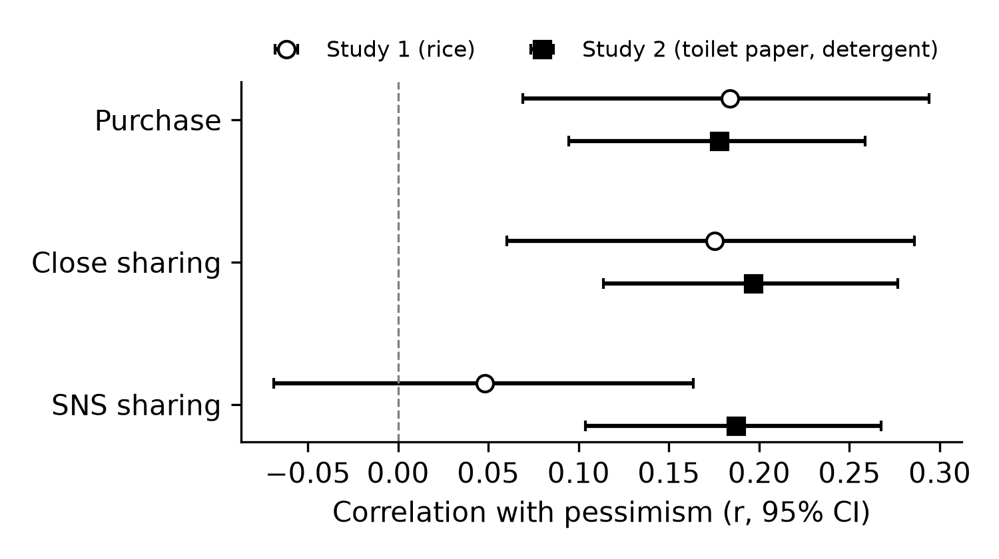
Figure 1: Correlations between pessimism and the three behavioral scores in Study 1 (N = 284) and Study 2 (N = 536), with 95% confidence intervals. The Study 2 correlations test H2a, H2b and H3.

Exploratory analyses
Commodity. Pessimism was higher for laundry detergent (M = 3.06, SD = 0.60) than for toilet paper (M = 2.85, SD = 0.70), $t$(504.4) = 3.71, p < .001, d = 0.32. Purchase intention was higher for toilet paper (M = 3.56 vs 3.33, $t$(534.0) = 3.23, p = .001, d = 0.28), while close sharing, SNS sharing and crisis concern did not differ (p $≥$ .114). Because pessimism differed, the preregistered rule called for commodity-specific correlations. They were similar for both commodities: for toilet paper, r = .21 (purchase), .20 (close sharing) and .16 (SNS sharing); for laundry detergent, r = .20, .21 and .24 (all p $≤$ .009).
Crisis context. Concern about the oil-supply crisis was related to pessimism about the commodity (r = .17, p < .001), to purchase (r = .26, p < .001) and to close sharing (r = .18, p < .001), but not to SNS sharing (r = –.05, p = .255). In regressions with commodity, pessimism, crisis context and their interaction (predictors mean-centered), both pessimism and crisis context predicted purchase (b = 0.21 and 0.24, both p < .001) and close sharing (b = 0.25 and 0.18, both p < .001). For SNS sharing, only pessimism did (b = 0.27, p < .001; crisis b = –0.08, p = .061). The interaction was not significant for any outcome (all p $≥$ .222).

Firsthand and secondhand sharing
As in Study 1, participants were more willing to tell close others about a shortage they had seen themselves (M = 3.01, SD = 1.00) than about one seen in an SNS post (M = 2.87, SD = 1.01), $t$(535) = 4.47, p < .001, $d_{z}$ = 0.19. The two composites were strongly correlated (r = .75). On a 0–1 scale, secondhand sharing was 93% of firsthand sharing.

Discussion
Study 2 replicated the main pattern of Study 1 in a different setting. The commodities were different, the sample was about twice as large, the study was preregistered, and it took place during a real supply crisis. Responses to shortage information again separated into purchase, sharing with close others and posting to many people, and not by the source of the information. Pessimism again went with purchase and close sharing, with correlations of about .2, close to those of Study 1. These associations held for both commodities and remained when concern about the broader crisis was controlled.
Two results differ from the preregistered predictions. First, the three-factor structure was not confirmed by the CFA. The EFA placed every item on its expected factor, so the problem is not which items belong together. The preregistered model was too strict: it assumed independent factors, although purchase and close sharing were clearly correlated in both studies, and it ignored the shared wording of items asked in both scenarios. The structure is better described as three correlated types of responses, with close sharing linked to both purchase and posting, than as three independent ones.
Second, pessimism was correlated with SNS sharing, contrary to H3. In Study 1 this correlation was close to zero. The difference may come from the crisis context. In June 2026 the possible shortage was tied to a widely reported international event, which may have made a shortage post seem more worth passing on to a wide audience. The difference may also come from the commodities: during the 2020 toilet paper shortage in Japan, posts showing empty shelves spread widely on SNS [CITE: Iizuka et al., 2022], which may make posting about such shortages more familiar. Even so, SNS sharing stayed rare (M = 1.67), so a correlation of .19 changes the behavior of few people. Crisis concern, unlike pessimism about the specific commodity, was not related to SNS sharing at all.
The exploratory analyses add two points. Concern about the crisis and pessimism about the specific commodity were only weakly correlated (r = .17), and both predicted purchase and close sharing independently, without an interaction. General worry and commodity-specific expectations therefore seem to add up rather than amplify each other. And close sharing was again lower for secondhand than for firsthand information but strongly correlated with it, which supports modeling one sharing propensity with a weaker secondhand channel.

Simulation: Shortage Information on a Network of Close Relationships
Studies 1 and 2 describe individual intentions. They cannot show what happens when many consumers act on the same shortage at once. The simulation asks whether the small individual differences found in the surveys can add up to a large, fast depletion of stock in a whole market. The model is the network version of our earlier agent-based model [CITE: Zuo & Ohtsubo, 2025]. The earlier version let a consumer see every active sharer within a spatial radius. The surveys suggest a different channel: people mostly tell family, partners and friends, and these close others do not have to live nearby. The network version therefore replaces the spatial radius with a small number of close relationships on a small-world network [CITE: Watts & Strogatz, 1998].

Model

Overview
The model contains consumers, retailers and one commodity. Consumers shop when they are exposed to shortage information, retailers run out, and consumers who fail to buy may tell their close contacts. Figure 2 shows this loop. The loop stays quiet if too few consumers hear the information, if those who hear do not react, or if those who witness a shortage do not tell anyone. The experiments below therefore change these links one at a time and then together.
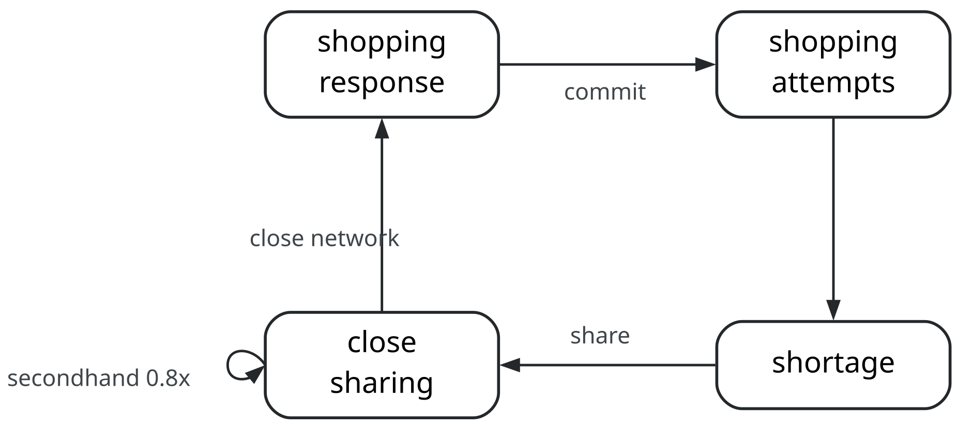
Figure 2: The feedback loop in the model. The shopping response turns received information into shopping attempts, attempts empty districts, failed attempts produce shortage information, and close sharing passes it through the close network. Heard information can be forwarded once at 80% of the close-sharing probability.

World and consumers
The market contains 2,500 consumers and 25 districts. Districts sit on a ring, and consumer identifiers run around the same ring, so consumer $c$ lives in district $⌊cD/N⌋$, where $D$ is the number of districts and $N$ the number of consumers. Each district has 100 residents and one retailer. Stock is set by an abundance of .5: each retailer holds 50 units, and the whole market holds 1,250 units for 2,500 consumers. Stock is not replenished, so the model covers a short period in which the only question is how fast the fixed stock runs out. District 0 starts with no stock. This seeded shortage is the only source of shortage information at the start of every run (Figure 3).
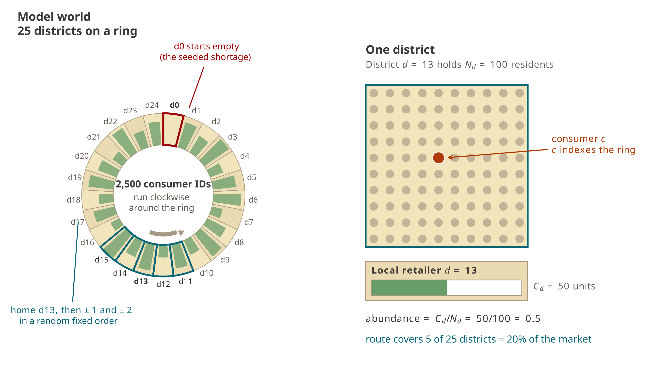
Figure 3: The 25 districts on a ring. District 0 starts empty. A consumer’s shopping route is fixed at setup: the home district first, then the two districts on each side in random order.
A consumer makes one shopping commitment and buys at most one unit. Once committed, the consumer goes to the home district first. If the district has run out, the consumer tries the next district on a fixed route of five districts (home, then two on each side, in an order drawn at setup). A consumer who fails at all five gives up. When a district has fewer units than shoppers in a step, the remaining units are allocated at random among that step’s shoppers.

Close relationships and rewiring
Information moves only through close relationships. The network is a Watts–Strogatz graph built on the consumer ring. Each consumer starts with 10 close relationships, the five consumers on each side. Because a 10-person neighborhood sits well inside a 100-resident district, 97% of these links connect consumers of the same district, and information on the unrewired ring stays almost entirely local. Each link is then rewired with the rewiring probability: one endpoint is replaced by a randomly chosen consumer (Figure 4). Rewiring keeps the total of 12,500 links fixed while individual degrees change. The rewiring probability replaces the information radius of the earlier model as the parameter for how far information can reach. The network is generated once per run from its own random stream and is then fixed.
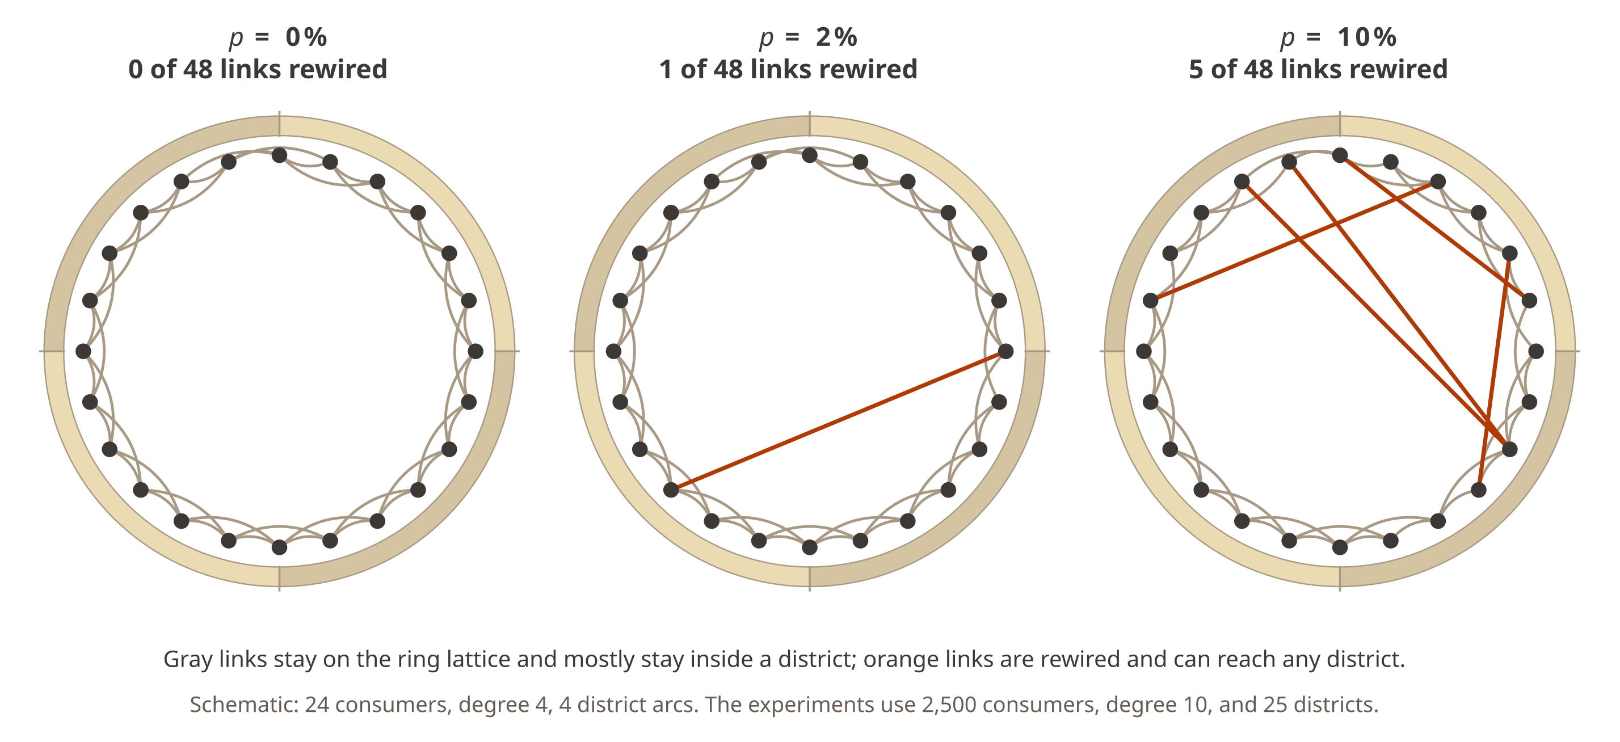
Figure 4: Watts–Strogatz rewiring on the consumer ring. Gray links belong to the original lattice and mostly stay inside a district. Orange links have been rewired and can land anywhere on the ring.

Sharing
A consumer who fails to buy in an empty district holds firsthand shortage information. With the close-sharing probability $p_{close}$, this consumer tells all current contacts at once. Sharing is undirected, so either end of a link can hear the other, and a sharer stays visible to all contacts for 10 steps. A consumer who hears about the shortage for the first time gets one chance to forward it as secondhand information, with probability $0.8×p_{close}$. There is no separate secondhand trait. This follows the survey results: in both studies, firsthand close sharing was higher than secondhand close sharing, but the two were strongly correlated (see Firsthand and secondhand sharing in the Results of both studies). The ratio of .8 sets the shape of the assumption, not a calibrated value, because intentions on a 1–5 scale are not probabilities. Public SNS posting is not modeled.

Shopping response
The number of contacts currently sharing, $I_{i,t}$, sets the shopping probability through a sigmoid response:
$$P_{i,t}(\text{shop})=P_{0}+\frac{L−P_{0}}{1+e^{−G(I_{i,t}−M)}} \text{if }I_{i,t}>0,$$
and $P_{i,t}(\text{shop})=P_{0}$ if no contact is sharing. Here $P_{0}=.01$ is the baseline shopping probability per step, $L=.10$ is the maximum, $G=20$ is the steepness and $M$ is the reaction midpoint. With this steepness the response is close to a step, so the midpoint works almost as a threshold count of contacts sharing at the same time. Against a mean degree of 10, a midpoint of 10 means a consumer needs the whole neighborhood to share at once, while a midpoint below 1 means one sharing contact is enough (Figure 5).
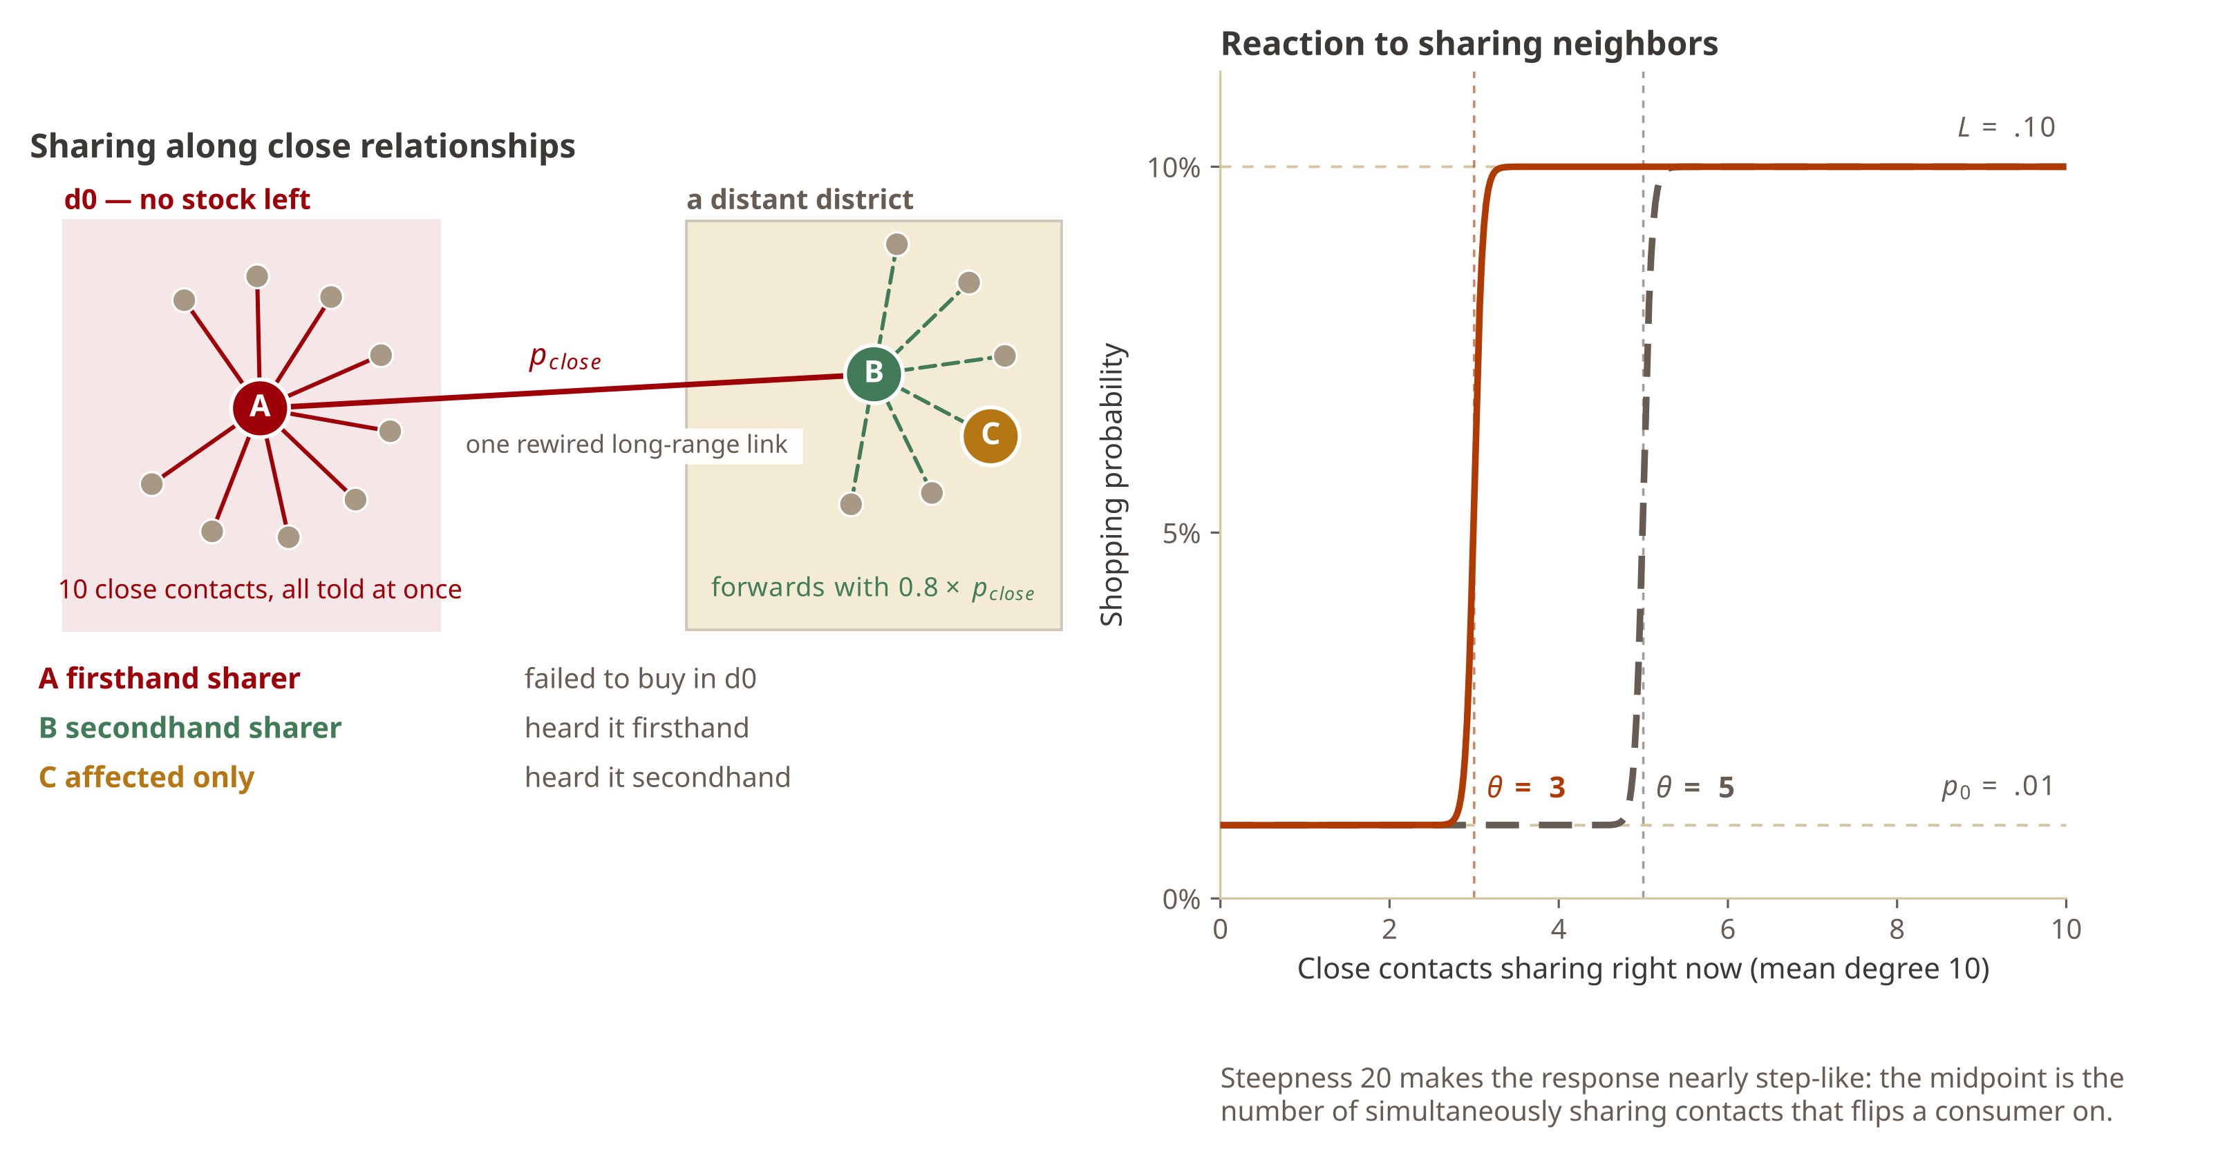
Figure 5: Left: a consumer who fails to buy in the empty district tells all 10 close contacts at once with probability $p_{close}$, and anyone who hears it can forward it once with probability $0.8×p_{close}$. Right: the shopping response at the two reaction midpoints used in the four-treatment summary.

Shortage feedback
Shortage feedback is a switch. When it is on, a failed purchase in any empty district creates new firsthand information. When it is off, only failures in the seeded district 0 do, so all information traces back to the seeded shortage. Comparing the two shows how much the loop in Figure 2 adds beyond the spread of the initial signal.

One simulation step
- Sharing scheduled in the previous step becomes active. Every consumer counts the contacts who are currently sharing.
- A consumer who hears the information for the first time may schedule a secondhand share for the next step.
- The count sets the shopping probability. Consumers who decide to shop are committed and go to their home district first.
- Each district allocates its remaining stock at random among that step’s shoppers. A buyer leaves the market. A consumer who fails witnesses the shortage, may schedule a firsthand share for the next step, and moves to the next district on the route.
- Sharing that has lasted 10 steps expires.
Each consumer decides at most once whether to share firsthand information and at most once whether to forward secondhand information. The outcome is the depletion time: the first step at which 97% of the districts have run out of stock. With 25 districts this means all districts. Runs stop at 150 steps. Lower depletion times mean faster depletion.

Simulation experiments
All experiments use the settings in Table 5 and change only the parameters listed for each experiment. Consumers are homogeneous: every consumer has the same close-sharing probability and reaction midpoint. Each condition was run with 15 matched seeds (42–56), and every reported value is the mean of these 15 runs. Each experiment was run twice with the same seeds and the same realized networks, once with shortage feedback off and once with it on. The paired difference (on minus off) is negative when feedback makes depletion faster. Initialization, shopping decisions, sharing decisions, stock allocation and network generation each use a separate random stream, so a different number of sharing draws cannot shift the shopping or allocation draws.
Table 5: Settings shared by all network experiments.
Setting | Value
Consumers | 2,500
Districts | 25 (100 residents each)
Stock per district | 50 (abundance .5)
Shopping route | home + 2 districts each side
Initial degree | 10
Secondhand sharing | $0.8×p_{close}$​
Sharing duration | 10 steps
Baseline / maximum shop prob. | .01 / .10
Sigmoid steepness $G$ | 20
Seeded shortage | district 0
Depletion criterion | 97% of districts empty
Maximum steps | 150
Seeds | 42–56 (15 per condition)
The experiments were:
- Sharing only. $p_{close}$ from 0 to 1 in steps of .1, with a sensitive shopping response ($M=.5$), so that one sharing contact raises the shopping probability from .01 to about .10. Rewiring from 0% to 10% in steps of .5%.
- Reaction midpoint only. $M$ from .5 to 10 in steps of .5, with certain sharing ($p_{close}=1$). Same rewiring levels.
- Midpoint $×$ sharing. $M∈\{.5,1,2,…,10\}$ crossed with $p_{close}$ from 0 to 1 in steps of .1, at rewiring 0, .5, 1, 2, 3, 4, 6, 8 and 10%.
- Four-treatment summary. A conservative setting ($M=5$, $p_{close}=.4$), one change in sharing ($p_{close}=.6$), one change in the midpoint ($M=3$), and both changes together, across rewiring from 0% to 10%.
- District granularity. The four treatments at 25 districts and at 125 districts of 20 residents and 10 units each. Total stock stays at 1,250 units.
Experiments 1–3 contain 52,200 run records. Overlapping conditions were reused, so they required 47,340 unique simulations. All runs reached the depletion criterion within 150 steps (range 12–86 steps). The simulation code is src/network_rewiring_experiment.py.

Results

Baseline without information
With sharing switched off, mean depletion time was 73.5 steps at every rewiring level. Rewiring cannot matter when nothing is transmitted. This value is the reference for all other conditions.

Sharing alone
With a sensitive shopping response, the effect of sharing depended on rewiring (Figure 6). Weak sharing changed little: at $p_{close}=.2$, depletion time went from 72.9 steps on the unrewired ring to 69.3 steps at 10% rewiring. Stronger sharing produced a clear small-world transition. At $p_{close}=.4$, depletion time fell from 72.2 to 28.1 steps across the rewiring range, and at $p_{close}=.6$ from 70.7 to 16.7 steps. At 10% rewiring the means were 14.6 steps for $p_{close}=.8$ and 13.7 steps for $p_{close}=1$. Most of the acceleration happened within the first few percentage points of rewiring.
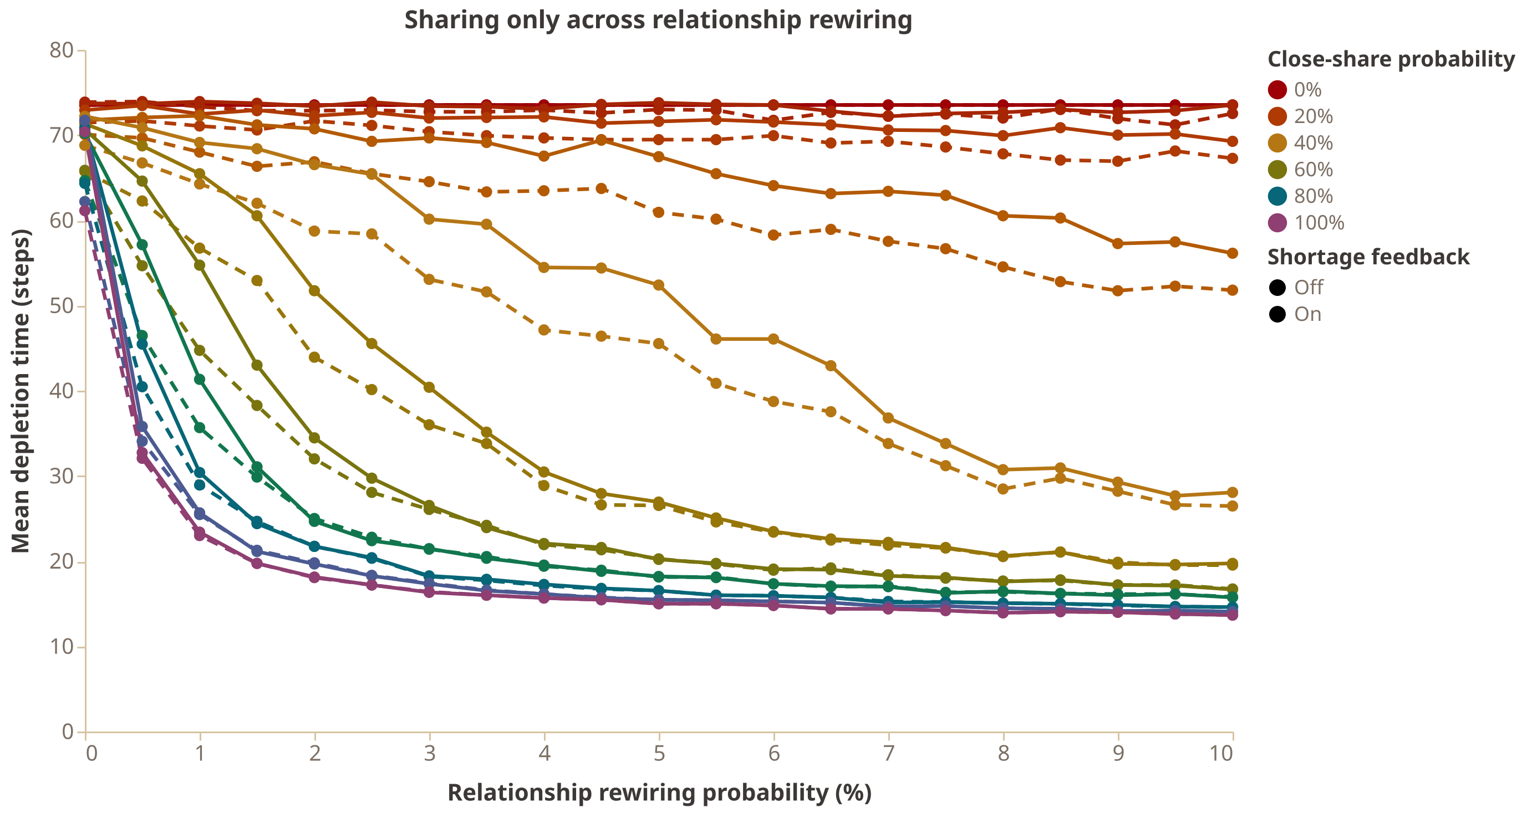
Figure 6: Sharing-only sweep across rewiring ($M=.5$). Solid lines: shortage feedback off; dashed lines: feedback on. Each point is the mean of 15 matched runs.

Reaction midpoint alone
With certain sharing, the midpoint mattered only after rewiring (Figure 7). On the unrewired ring every midpoint stayed near the baseline (70.3–73.5 steps), because information moved slowly along the local ring. For midpoints from .5 to 6, rewiring strongly accelerated depletion: at 1% rewiring the means ranged from 23.0 to 27.9 steps, and at 10% from 13.7 to 17.1 steps. In this region a few long-range relationships mattered much more than extra sensitivity. Midpoints of 7 and above moved back toward the baseline. At 10% rewiring, the mean was 28.3 steps at $M=7$, 47.4 at $M=8$, 61.6 at $M=9$ and 70.1 at $M=10$. A threshold close to the number of contacts shielded consumers from the seeded signal even when every witness shared.
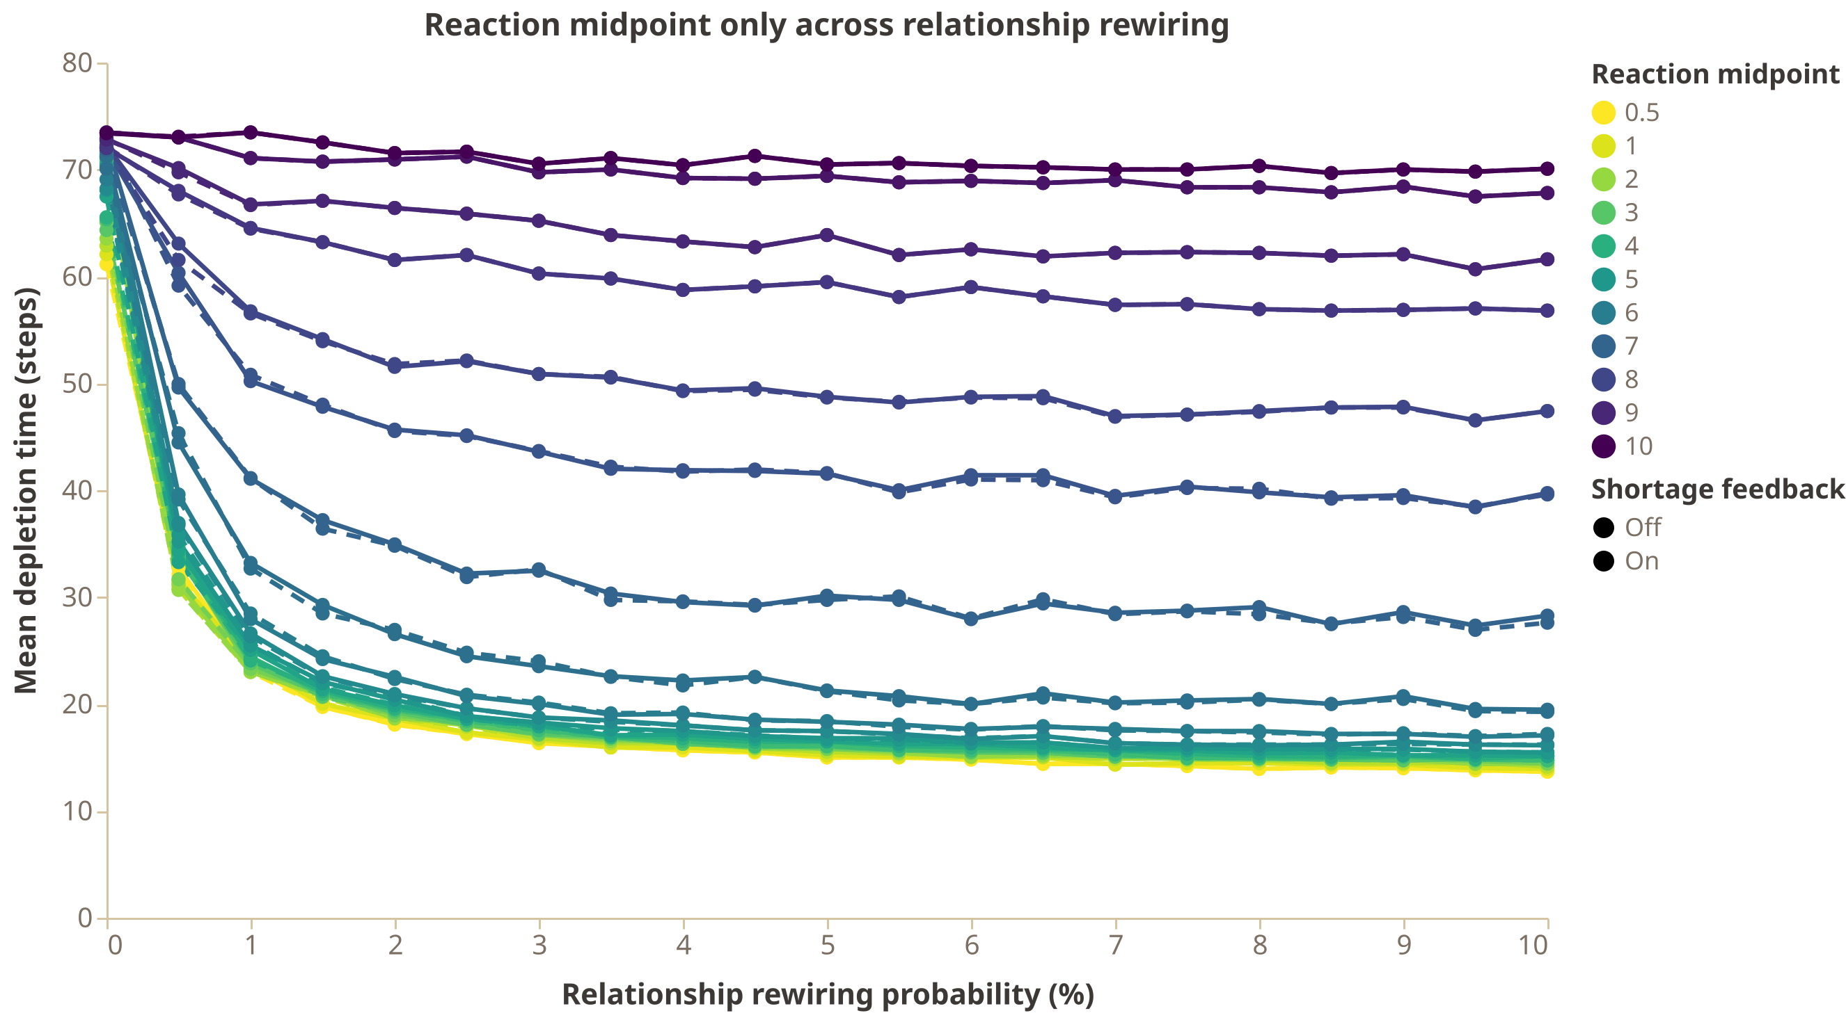
Figure 7: Reaction-midpoint sweep across rewiring ($p_{close}=1$). Solid lines: shortage feedback off; dashed lines: feedback on.

Sharing and midpoint together
Figure 8 crosses the two parameters. On the unrewired ring the surface was flat: all 121 cell means lay between 70.2 and 74.2 steps, so neither high sharing nor a low midpoint was enough while information stayed local. Rewiring opened a curved boundary between baseline-like and fast depletion. The boundary moved toward lower sharing as rewiring increased, and toward higher sharing as the midpoint increased: less sensitive consumers needed more reliable transmission. At 10% rewiring and $M=.5$, mean depletion time was 69.3 steps at $p_{close}=.2$, 28.1 at .4 and 16.7 at .6. At $M=5$ the transition came later: 69.9 steps at $p_{close}=.4$, 49.7 at .6, 22.5 at .8 and 15.5 at 1.
The largest structural change happened at very low rewiring. The fastest cell fell from 70.2 steps on the unrewired ring to 31.2 steps at .5% rewiring, 23.0 at 1% and 18.1 at 2%. No cell reached 30 steps or less at .5% rewiring, 13 cells did at 1%, 22 at 2% and 34 at 10%, while the fastest cell improved more slowly, to 13.7 steps at 10%.
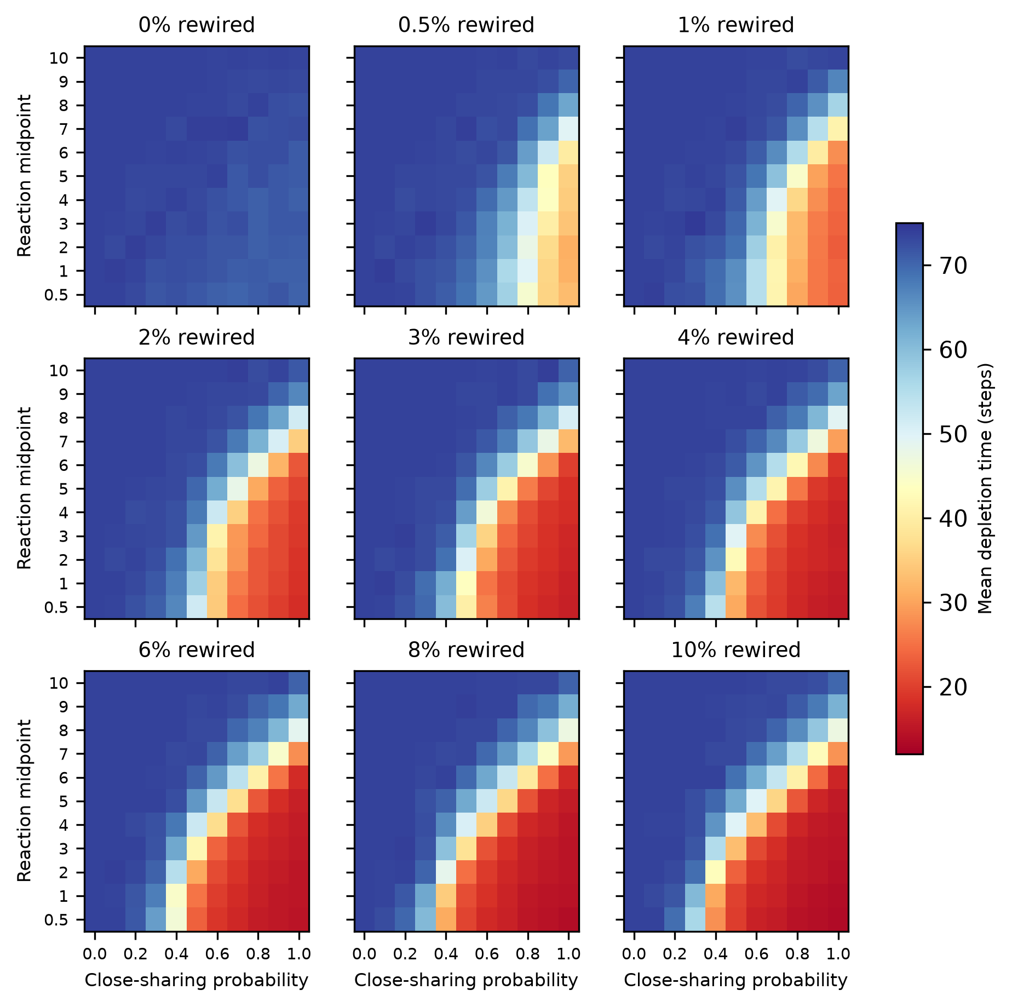
Figure 8: Mean depletion time (steps) across reaction midpoint and close-sharing probability at nine rewiring levels, shortage feedback off. Each cell is the mean of 15 runs. Blue: slow, baseline-like depletion; red: fast depletion.

Four-treatment summary
Figure 9 shows the joint threshold with four treatments. The conservative setting ($M=5$, $p_{close}=.4$) was nearly inert: its mean fell only from 73.2 to 69.9 steps across the rewiring range, within one seed-level standard deviation of the 73.5-step baseline. Each single change had a partial effect. At 10% rewiring with feedback off, raising sharing to .6 gave 49.7 steps and lowering the midpoint to 3 gave 55.3 steps, reductions of 20.2 and 14.6 steps. Both changes together gave 20.9 steps, a reduction of 49.0 steps, or 70% faster depletion.
The combination beat the sum of its parts, and the excess was largest where the small-world transition happened. At 2% rewiring, the sharing change and the midpoint change reduced depletion time by 10.7 and 0.9 steps, but both together reduced it by 31.8 steps, an interaction of $−20.1$ steps. The interaction was $−24.0$ steps at 4% rewiring and $−14.2$ steps at 10%, where the single changes had themselves grown. All four treatments stayed near the baseline on the unrewired ring.
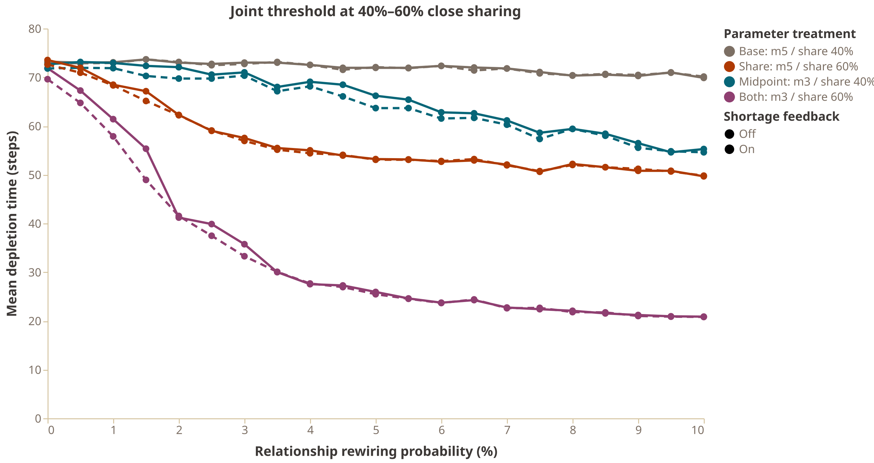
Figure 9: Joint threshold around $M=5$ and $p_{close}=.4$. Colors: the conservative setting, each single change, and both changes. Solid lines: shortage feedback off; dashed lines: feedback on. Each point is the mean of 15 matched runs.

Shortage feedback
Shortage feedback had little effect at this district size. Across all 16,335 matched pairs of the midpoint $×$ sharing experiment, feedback shortened depletion by 0.64 steps on average (mean absolute difference 0.96 steps). Its effect was largest near the transmission boundary. In the sharing-only experiment, the mean paired difference was 0 at $p_{close}=0$, $−1.99$ steps at .2, $−4.96$ at .3, $−4.83$ at .4, $−1.62$ at .6 and $−0.49$ at 1. Where information is absent, feedback has nothing to amplify; where information already spreads reliably, it adds little. In the four-treatment summary, the feedback-on means at 10% rewiring were 70.1, 49.8, 54.6 and 20.8 steps, almost the same as with feedback off.
Feedback became more important with smaller districts. Feedback can only matter if districts other than the seeded one run out while the process can still react to the information they create, and a 50-unit district runs out late. With 125 districts of 10 units, a second district ran out earlier in the run: in the conservative treatment, at step 23.6 of a 79.3-step run (30% of the way through) instead of step 39.4 of a 73.2-step run (54%). Pooled across treatments and rewiring levels, the mean paired difference grew from $−0.44$ steps at 25 districts to $−1.79$ steps at 125 districts. The change was concentrated in the combined treatment (from $−0.28$ to $−3.97$ steps) and at low rewiring, where the seeded signal alone spreads slowly: $−7.0$ steps on the unrewired ring and $−8.4$ steps at 2% rewiring, compared with $−2.3$ and $+0.8$ steps at 25 districts (Table 6). From 4% rewiring on, the two resolutions converged, because long-range relationships already spread the seeded signal.
Table 6: Mean depletion time (steps) of the combined treatment ($M=3$, $p_{close}=.6$) with shortage feedback off and on, at two district resolutions. Diff = on minus off.
Rewiring (%) | 25 off | 25 on | Diff | 125 off | 125 on | Diff
0 | 71.5 | 69.2 | -2.3 | 80.3 | 73.3 | -7.0
2 | 40.0 | 40.8 | +0.8 | 66.1 | 57.7 | -8.4
4 | 26.4 | 26.6 | +0.2 | 50.0 | 46.4 | -3.6
6 | 22.8 | 22.7 | -0.1 | 36.7 | 35.7 | -1.0
8 | 20.9 | 20.7 | -0.2 | 36.3 | 33.3 | -3.0
10 | 20.2 | 20.1 | -0.1 | 30.8 | 30.0 | -0.8
Changing the number of districts also changes other properties that cannot be held constant: route coverage falls from 20% to 4% of the market, the seeded district shrinks from 100 to 20 residents, fewer lattice links stay inside a district (85% instead of 97%), and the 97% criterion requires 122 of 125 districts rather than all 25. The first two work against faster depletion and the last two work for it, so this comparison shows the direction of the feedback effect, not its size.

Discussion
The simulation shows that a large aggregate response does not require a large change in any single behavior. Neither more sharing nor more sensitive shopping was enough on its own at the conservative setting. Together they made depletion about 70% faster, far more than the sum of their separate effects. This joint threshold is the main result. A market can sit close to a boundary where two modest changes, each hard to detect at the individual level, turn a slow, local event into a fast, market-wide one.
The network structure decides whether this boundary can be crossed. With close relationships only between neighbors, every combination of sharing and sensitivity stayed near the baseline, because information stayed near the seeded district. A small share of long-range relationships was enough to change this: the first 1–2% of rewired links produced most of the acceleration. Close relationships that reach other districts, such as family members or friends who shop elsewhere, can therefore carry a local shortage to the whole market without any public broadcast. This matters for the survey results, where sharing with close others, not public posting, was the sharing behavior most consistently tied to pessimism.
The shortage-feedback loop, in which new shortages create new information, added little at the default district size and more with small districts. Its role therefore depends on how quickly local shortages appear relative to the spread of the first signal. With large stores, the seeded signal decides the outcome before other stores run out. With small stores, secondary shortages appear early enough to feed the process.
The model has several limitations. The parameters are not estimated from data. The surveys measured intentions on a 1–5 scale, not probabilities, so they constrain the structure of the model (one sharing propensity, a weaker secondhand channel, sharing with a few close others) rather than its values. Consumers are homogeneous, the network is fixed, stock is not replenished and public SNS posting is not modeled. The shopping response is close to a step function, which makes the midpoint act like a threshold. The granularity comparison changes several properties at once. Finally, depletion time measures how fast the market runs out, not whether a real panic-buying episode is recognized as one.

General Discussion
This thesis asked how panic buying can empty a whole market in a few days when the behavior of each consumer changes only a little. Two surveys measured how consumers respond to shortage information, and an agent-based model asked what these responses imply for a market.

Small individual differences
At the individual level, the effects were consistently small. In Study 1, news about the future supply of rice changed expectations by more than one standard deviation but changed purchase and sharing intentions little or not at all. In both studies, more pessimistic participants were more willing to buy and to tell close others, with correlations of about .18–.20 (Figure 1). These correlations were similar across rice, toilet paper and laundry detergent, across the positive and negative news conditions, and with and without the crisis context. In Study 1, the correlations did not differ detectably between the news conditions, even though the conditions differed strongly in pessimism. The link between expectations and behavior was therefore stable, and it was weak: pessimism accounted for about 3–4% of the variance in purchase and close sharing.
The structure of the responses was the most stable result. In both studies, responses separated into purchase, sharing with close others, and posting to many people, and not by whether the shortage was seen on a shelf or in an SNS post. Posting to many people was rare in both studies. Purchase and posting were unrelated, and close sharing was related to both. The preregistered CFA with independent factors failed, but the EFA recovered the same three groups of items in both studies, so the three types of response are better seen as distinct but correlated.
The role of SNS posting was the main inconsistency. Pessimism was unrelated to posting for rice (r = .05) but related to it for toilet paper and detergent during the oil-supply crisis (r = .19); the difference between the two correlations was only marginal (z = 1.91, p = .056). Whatever its size, the association concerns a behavior that few participants said they would perform. The evidence therefore does not support the idea that pessimistic consumers drive panic buying mainly by broadcasting shortages to strangers. It is more consistent with shortage information spreading through close relationships.

From individuals to the market
The simulation shows why small individual differences do not imply small aggregate effects. When close sharing and sensitivity to shared information were both set to modest values, the market behaved as if there were no information at all. Raising either one alone had a partial effect. Raising both made depletion about 70% faster, far more than the sum of the separate effects. Most of this acceleration required only a small share of close relationships that reach other districts. In such a market, small shifts in two behaviors, each hard to detect in a survey, can together turn a local shortage into a market-wide one.
This suggests a view of what changes in an emergency. Study 1 found no sign that negative news changes how strongly expectations are linked to behavior. Study 2 found that concern about the crisis added to purchase and close sharing without amplifying the effect of pessimism. An emergency may therefore work less by changing how each person responds and more by shifting many people slightly in the same direction at the same time: a little more pessimistic, a little more willing to tell family and friends, a little quicker to shop when they hear about a shortage. Common sources such as mass media reports could produce such simultaneous shifts [CITE]. Because the market can sit close to a joint threshold, these shifts do not need to be large.
This view also explains why panic buying is rare despite the constant availability of information channels. In the model, the conservative setting stayed near the baseline across the whole range of network structures. The same networks that carry a panic in an emergency carry little in normal times, because too few people share and too few react.

Limitations
The surveys measured intentions in hypothetical scenarios, not actual purchases or messages, and both used online panels. Many responses were excluded for failed comprehension or attention checks (46% of consenting responses in Study 1 and 40% of eligible responses in Study 2), so the samples are selected toward attentive participants. In Study 1 the comprehension checks excluded more participants in the positive condition, which weakens the comparison between conditions. The correlations are cross-sectional and do not show that pessimism causes purchase or sharing. The simulation is not calibrated: its parameters are chosen to explore the model, and the surveys constrain only its structure. The model assumes homogeneous consumers, a fixed network, no restocking, and no public posting.

Future directions
Three steps would connect the parts of this thesis more closely. First, the distributions of sharing and purchase intentions in the surveys could inform heterogeneous consumers in the model, instead of one value for everyone. Second, the number of close contacts who live and shop in other areas could be measured directly, since the simulation shows that this share decides whether a local shortage can spread. Third, observed purchase data or messaging data from a real shortage would show whether the small differences in intentions found here appear in behavior.

Conclusion
Individual consumers respond to shortage information in modest and stable ways. They buy and tell the people close to them somewhat more when they expect supply to be unstable, and they rarely broadcast shortages to the public. The simulation shows that such modest responses are enough for a market-wide shortage when several of them shift together and when close relationships reach beyond the local neighborhood. Large-scale panic buying does not require panicking consumers; it can emerge from small, simultaneous changes in ordinary behavior.

References
Bentall, R. P., Lloyd, A., Bennett, K., McKay, R., Mason, L., Murphy, J., McBride, O., Hartman, T. K., Gibson-Miller, J., Levita, L., Martinez, A. P., Stocks, T. V. A., Butter, S., Vallières, F., Hyland, P., Karatzias, T., & Shevlin, M. (2021). Pandemic buying: Testing a psychological model of over-purchasing and panic buying using data from the United Kingdom and the Republic of Ireland during the early phase of the COVID-19 pandemic. PLOS ONE, 16(1), e0246339. https://doi.org/10.1371/journal.pone.0246339
Iizuka, R., Toriumi, F., Nishiguchi, M., Takano, M., & Yoshida, M. (2022). Impact of correcting misinformation on social disruption. PLOS ONE, 17(4), e0265734. https://doi.org/10.1371/journal.pone.0265734
Keane, M., & Neal, T. (2021). Consumer panic in the COVID-19 pandemic. Journal of Econometrics, 220(1), 86–105. https://doi.org/10.1016/j.jeconom.2020.07.045
Watts, D. J., & Strogatz, S. H. (1998). Collective dynamics of "small-world" networks. Nature, 393(6684), 440–442. https://doi.org/10.1038/30918
Zuo, X., & Ohtsubo, Y. (2025). Kaishime sawagi ni okeru jōhō kyōyū keikō to jōhō hannō ikichi no eikyō [Effects of information-sharing tendency and information-reaction threshold in panic buying]. Proceedings of the 71st Annual Meeting of the Japanese Group Dynamics Association. https://doi.org/10.2130/jjesp.65-S1 [CHECK]

Appendix
Placeholder, to be completed. Details moved out of the main text are collected here.

Behavioral items
Table 7: Behavioral items in Studies 1 and 2 (translated from Japanese). Each item was answered on a 5-point scale from definitely not to definitely. Target is the factor found in the Study 1 EFA and preregistered for Study 2.
Scenario | Target | Study 1 (rice) | Study 2 (toilet paper, laundry detergent)
Shelf | Purchase | Buy the remaining rice; a few days of rice left at home | Buy the remaining stock; only a few days’ worth at home
Shelf | Purchase | Same; more than a week of rice left | Same; about half the usual amount at home
Shelf | Purchase | Same; more than a month of rice left | Same; the usual amount at home
Shelf | Close sharing | Tell housemates (family), best friends or partner | Tell housemates (family), best friends or partner
Shelf | Close sharing | Tell acquaintances or friends | Tell acquaintances or friends
Shelf | SNS sharing | Post to many unspecified people on SNS | Post to many people on SNS
SNS post | Purchase | Go to buy rice right away; a few days of rice left | Go to buy right away; only a few days’ worth
SNS post | Purchase | Same; more than a week of rice left | Same; about half the usual amount
SNS post | Purchase | Same; more than a month of rice left | Same; the usual amount
SNS post | Close sharing | Tell housemates (family), best friends or partner | Tell housemates (family), best friends or partner
SNS post | Close sharing | Tell acquaintances or friends | Tell acquaintances or friends
SNS post | SNS sharing | Share or post to many unspecified people | Repost or share to many people

Study 1

Exclusions
Responses were excluded in the order shown in Table 8. Test responses were recorded before the survey was launched on January 7, 2026. We dropped every response whose participant ID or IP address appeared more than once, because we could not tell which copy was valid. The comprehension checks excluded every participant with a wrong answer to any of the four questions of the assigned condition. Among consenting responses, they excluded 100 of 265 in the negative condition and 146 of 265 in the positive condition. We also inspected response duration. The shortest response took 70 seconds; because the survey was short and these participants passed all comprehension checks, no response was excluded for duration.
Table 8: Study 1: responses excluded at each step.
Step | Excluded | Remaining
Raw responses |  | 594
Unfinished | 0 | 594
Test responses before launch | 19 | 575
Participant ID or IP address repeated | 6 | 569
No consent | 39 | 530
Any wrong comprehension answer | 246 | 284

Household questions
Before reading the articles, participants reported their household size, whether they were the main buyer of food in the household, how often per week they cooked rice and ate rice, and how much rice they cooked at a time. [PLACEHOLDER: descriptive statistics, and the condition comparisons and correlations repeated with these variables as controls.]

Robustness checks
Number of factors. We kept the three factors with eigenvalues greater than 1. Parallel analysis (minimum residual extraction, 100 simulated data sets) suggested five factors; the fourth and fifth eigenvalues of the item correlation matrix were 0.92 and 0.73.
Promax rotation. The promax solution gave the same three factors as the varimax solution. The factor correlations were .56 between purchase and close sharing, .18 between close sharing and SNS sharing, and –.01 between purchase and SNS sharing. [PLACEHOLDER: promax loading table.]
Regression factor scores. We repeated the condition comparisons and the correlations with regression factor scores from the varimax solution instead of item means. Close sharing was again slightly higher in the negative condition, $t$(257.1) = 2.15, p = .032, d = 0.26, but not after Holm correction (adjusted p = .096); purchase (p = .760) and SNS sharing (p = .977) did not differ. Pessimism correlated with purchase (r = .16, p = .006) and close sharing (r = .15, p = .014) but not with SNS sharing (r = .03, p = .589).
Correction for multiple tests. Table 9 shows the p-values of the three condition comparisons before and after Holm correction, separately for item means and factor scores.
Table 9: Study 1: condition comparisons of the behavioral scores, with Holm-corrected p-values (three tests per score type).
Score | Type | p | Holm p
Purchase | Item mean | .521 | 1.000
Close sharing | Item mean | .044 | .133
SNS sharing | Item mean | .853 | 1.000
Purchase | Factor score | .760 | 1.000
Close sharing | Factor score | .032 | .096
SNS sharing | Factor score | .977 | 1.000

Study 2

Exclusions
Responses were excluded by the preregistered rules, in the order shown in Table 10. The preregistration had no rule for repeated participant IDs or IP addresses, so, unlike in Study 1, none was applied. Eight raw responses shared a participant ID or an IP address with another response. Two of them remained in the final sample; in both cases the other response had been excluded by the preregistered rules, so no participant appears twice in the final sample.
Table 10: Study 2: responses excluded at each step.
Step | Excluded | Remaining
Raw responses |  | 1028
Unfinished | 0 | 1028
No consent | 80 | 948
Age outside 30–60 | 44 | 904
Duration under 60 s | 3 | 901
Any failed attention check | 365 | 536
Missing analysis variables | 0 | 536

Robustness checks
Number of factors. As in Study 1, we kept the three factors with eigenvalues greater than 1. Parallel analysis (minimum residual extraction, 100 simulated data sets) suggested four factors; the fourth and fifth eigenvalues of the item correlation matrix were 0.83 and 0.69.
Promax rotation. Every item loaded highest on its preregistered factor in both the varimax solution (purchase .67–.81, close sharing .72–.78, SNS sharing .76 and .90) and the promax solution. The promax factor correlations were .48 between purchase and close sharing, .44 between close sharing and SNS sharing, and .07 between purchase and SNS sharing. [PLACEHOLDER: promax loading table.]

Correlations with pessimism
Table 11: Pearson correlations between pessimism and the behavioral scores in both studies. Study 2 tests are the preregistered hypotheses (pooled over commodities).
Outcome | Study (hypothesis) | n | r | 95% CI | p
Purchase | Study 1 | 284 | .184 | [.069, .294] | .002
 | Study 2 (H2a) | 536 | .178 | [.095, .259] | < .001
Close sharing | Study 1 | 284 | .175 | [.060, .286] | .003
 | Study 2 (H2b) | 536 | .197 | [.114, .277] | < .001
SNS sharing | Study 1 | 284 | .048 | [–.069, .164] | .420
 | Study 2 (H3) | 536 | .187 | [.104, .267] | < .001

