**PS5**

**12132243 左小幸**

**1. More Linux Commands**

In this exercise, we will learn a few more Linux commands. For each command, please use man to learn what it does and how to use it correctly. First, change your directory to ~.

**1.1 [2 points]** Make a link called data_demo_link to data_demo folder using ln.



**1.2 [2 points]** Print your home directory using echo.



**1.3 [2 points]** Go to data_demo/molecules/, make an empty file test.pdb with touch.

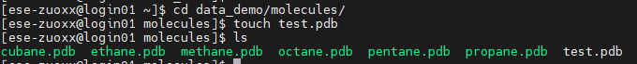

**1.4 [3 points]** Find how many files in data_demo/data/elements/ using find.



**1.5[2points]** Compare data_demo/data/pdb/ethane.pdb and data_demo/data/pdb/ethanol.pdb with diff.

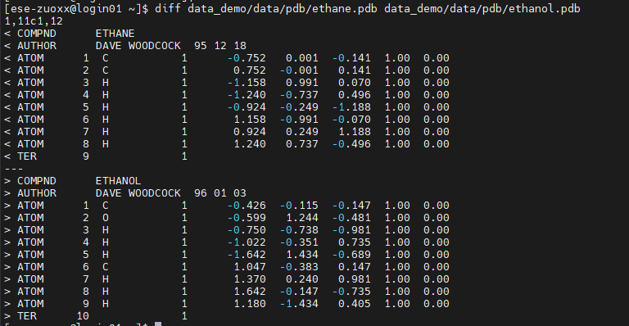

**1.6 [3 points]** Count how many But she string appears in data_demo/writing/data/LittleWomen.txt with grep.



**1.7 [2 points]** Check the total file size of the data_demo/data/ folder using du.



**1.8 [3 points]** Copy the data_demo/writing/ folder to data_demo/writing_new/,compress data_demo/writing_new/ using zip, and decompress the .zip file with unzip.







**1.9 [3 points]** Change the file permissions flags on writing_new to drwxr-x---using chmod.

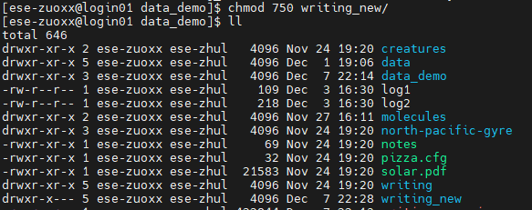

**1.10 [3 points]** Print the last 10 commands you made using history.

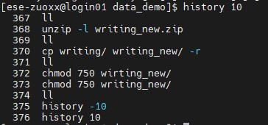

**2. BASH for Loop**

**[5 points]** Write a shell script to print file size (in bytes) of each *.pdb file in data_demo/data/pdb/, line by line.



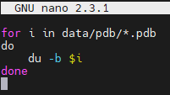



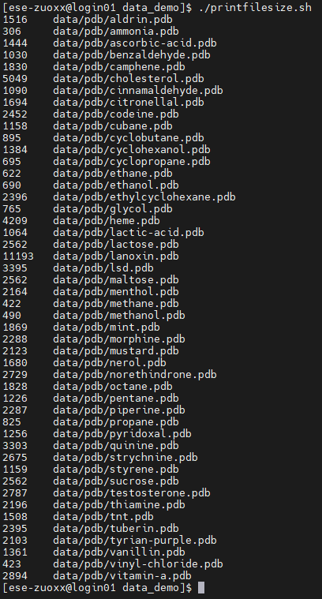

**Collaboration:**

<https://www.runoob.com/linux/linux-tutorial.html>

https://zhu-group.github.io/ese5023/Section_12.html