**PS6**

**12132243左小幸**

**1. Matrix multiplication**

**1.1 [5 points]** Write a program Main.f90 to read fortran_demo1/M.dat as the matrix M, and fortran_demo1/N.datas the matrix N.

**1.2 [5 points]** Write a subroutine Matrix_multip.f90 to do matrix multiplication.

**1.3 [5 points]** Call the subroutine Matrix_multip() from Main.f90 to compute M*N; write the output to a new file MN.dat, values are in formats of f9.2.

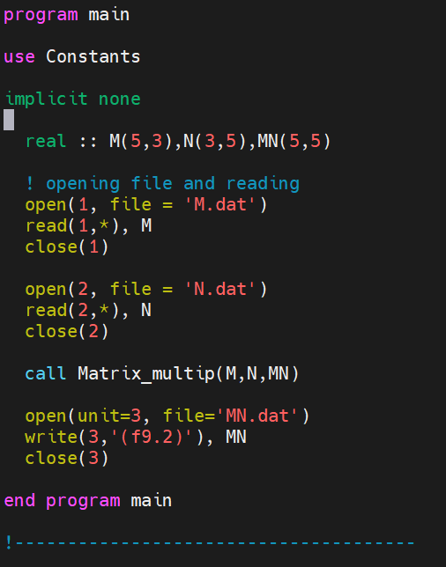

This is the **main.f90** file

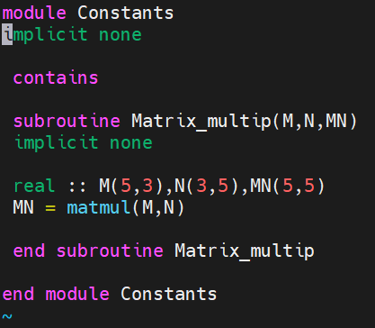

This is the **Matrix_multip.f90** file contains the subroutine.

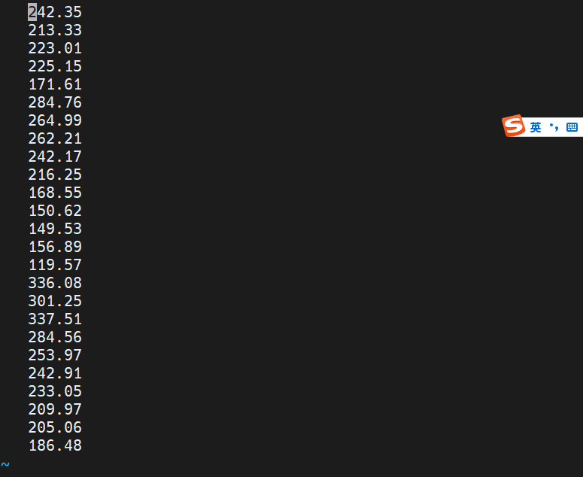

This is the result MN.dat

**2. Calculate the Solar Elevation Angle**

**2.1 [5 points]** Write a module Declination_angle that calculates the declination angle on a given date.

[**Hint:** using the “Better formula” from [Solar Declination Angle & How to Calculate it](https://solarsena.com/solar-declination-angle-calculator/)]

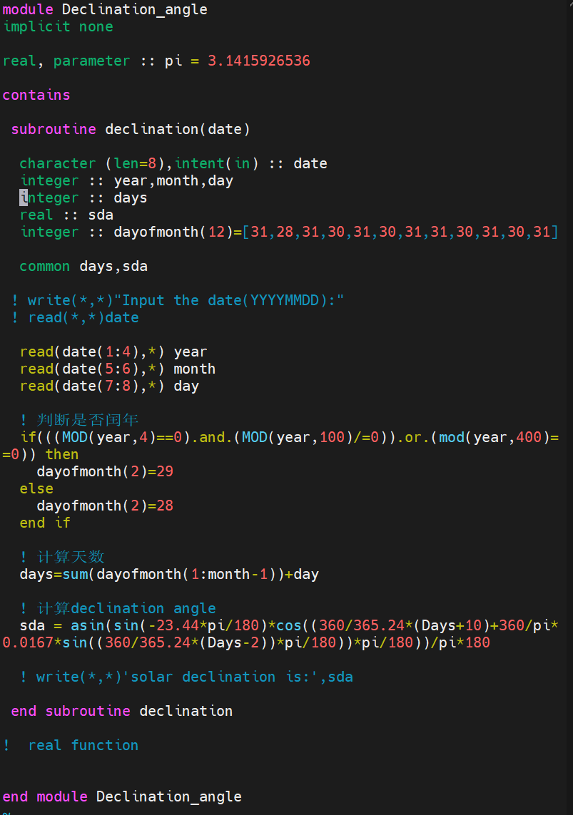

**This is module Declination_angle**

**2.2 [10 points]** Write a module Solar_hour_angle that calculates the solar hour angle in a given location for a given date and time.

[**Hint:** using the formulas from [Solar Hour Angle & How to Calculate it](https://solarsena.com/solar-hour-angle-calculator-formula/)]

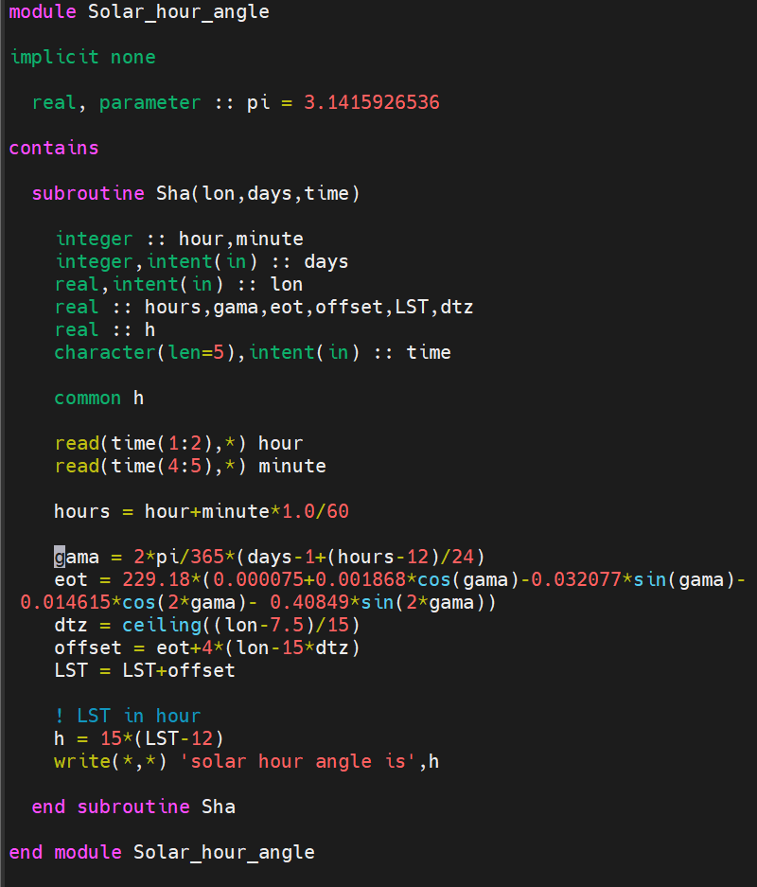

This is solar hour angle module

**2.3 [5 points]** Write a main program (Solar_elevation_angle.f90) that uses module Declination_angle and Solar_hour_angle to calculate and print the SEA in a given location for a given date and time.:

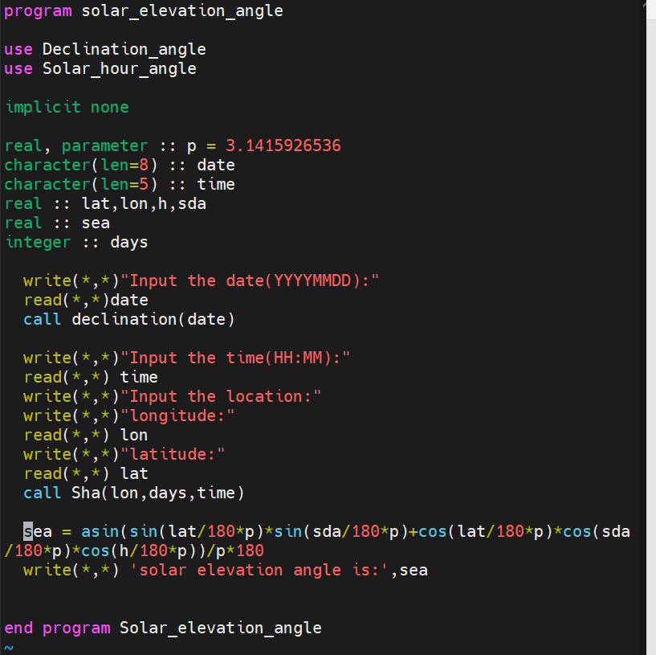

This is the main programe.

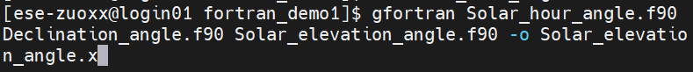

Compile the programe file with two modules.

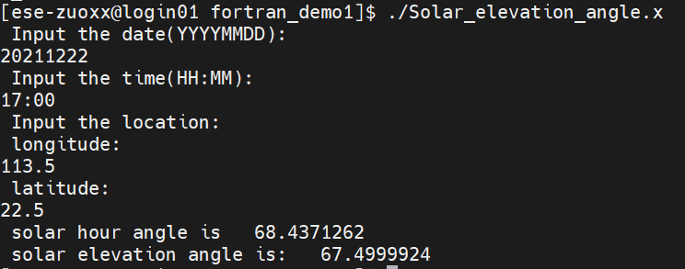

result

**2.4 [5 points]** Create a library (libsea.a) that contains Declination_angle.o and Solar_hour_angle.o. Compile Solar_elevation_angle.f90 using libsea.a. Print the SEA for Shenzhen (22.542883N, 114.062996E) at 10:32(Beijing time; UTC+8) on 2021-12-31.

