Background:

* Anthropometric measurements evaluate the size, shape, and composition of the human body
  + Constant measures: skeletal measurements and three “bony” girths
  + Changeable girths: shoulder, chest, waist, navel, hip, thigh, bicep, forearm, calf

Objective:

* Our objective was to evaluate the relationships between body measurements and to develop and evaluate prediction models for body build weight and gender.

Methods (description of dataset):

* 247 males and 260 females
* Twenties to early thirties
* Physically active
* Nine skeletal and twelve girth measurements
* Additional variables: height, weight, age, gender

Methods (Aim 2):

* Logistic regression using forward and backward stepwise selection methods
  + P-value for addition: 0.1
  + P-value for removal: 0.25
* Model selection completed with and without height
* Akaike information criterion
* Sensitivity and specificity
* Internal validation: ten-fold cross validation

Results (Aim 2):

* Log(y)= chest depth + bitrochanteric + biacromial + wrist + knee + elbow + height
* Forward stepwise regression
* AIC: 127.0
* Sensitivity: 96.5%
* Specificity: 95%
* Internal validation R2: 0.8420

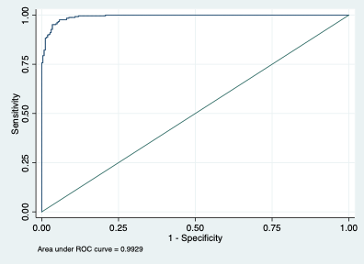

Discussion:

* Height, chest depth, bitrochanteric, biacromial, wrist, knee, and elbow skeletal measurements best predicted gender
* Addition of height adds predictive ability