Summary

AES is an aggregator that we leverage to provide tracking updates that come directly from the Steam Ship Lines (SSLs).
We enable these updates on a customer-by-customer basis (see instructions on how to enable AES tracking updates).
In order for the tracking to start there is a list of prerequisite items. More details can be found in the “Customer requirements” section.
All AES tracking updates are transposed to an Inbound 315 message (Internally – 515) and these updates will be seen in the tracking log within Navisphere (in the Container Details and in the Driver Log). Additionally, the updates will be visible to customers through Navisphere.com.

How will I be able to see the AES updates?
In Order Load edit, go to Load – Container Details – Container Tracking
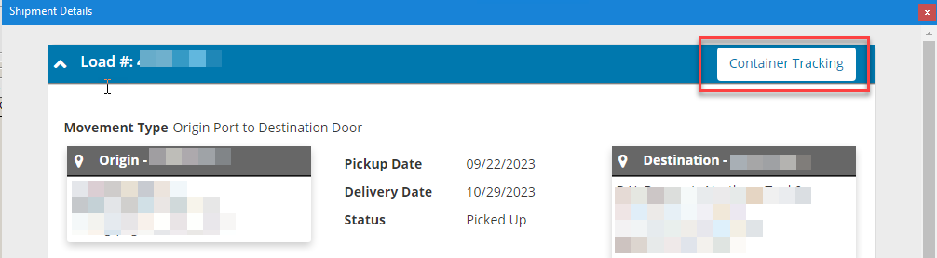

How to enable AES tracking updates
- If your customer would like AES to be enabled for their shipments, please post to the Market Solutions Collaboration General Channel to request set-up.
- Market Solutions will confirm once your customer has been enabled.
  - A tenant must be created in Advanced Visibility if it does not exist today in either Legacy Vision or Online.
  - Tech must then enable that tenant in the backend to receive the tracking updates.

Customer requirements needed to start tracking
- Tenant id - this is done in the first step of How to enable AES tracking updates by the Market Solutions team.
- Service Offering of Ocean is present for the customer.
- Customer is enabled to receive the updates - step 2b from the How to enable AES tracking updates.
- Load level MBOL reference is filled in (or Load level BN Reference). If you pass this in as an Order Level Reference, this should flow to the Load. See below example. If the forwarder provides a 301 with the MBOL, this will also update the load level reference for MBOL.
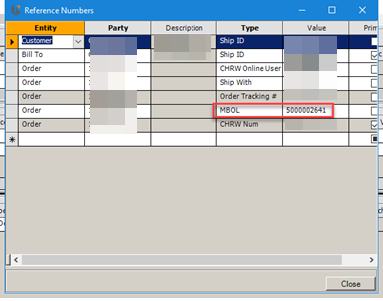
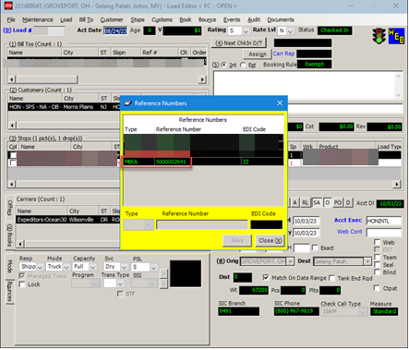
- Container is added and container number is filled in. See below example.
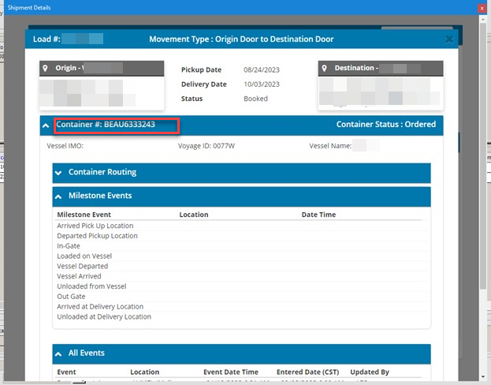
- SCAC needs to be from the list below. AES will only return updates for the SSLs that they are connected with.

CODE | SCAC | Name
ACL | ACLU | ACL
ALIANCA | ANRM | ALIANCA
ANTILLEAN | AMLU | ANTILLEAN
APL | APLU | APL
ARKAS | ARKU | ARKAS
AUSTRALIA-NAT | ANNU | AUSTRALIA NATIONAL
BAHRI | NSAU | BAHRI
CAPITAL | CSMC | CAPITAL
CHINA-SHIPPING | CHNJ | CHINA SHIPPING
CK LINE | CKCO | CK LINE
CMA-CGM | CMDU | CMA-CGM
CNC | CHNL | CNC
COSCO | COSU | COSCO
CROWLEY | CLAM | CROWLEY
CSAV | CHIW | CSAV
CULINES | CULV | CULINES
DOLE | DOLQ | DOLE
DONG-YOUNG | PCSL | DONG YOUNG
ECU | ECUI | ECU
EIMSKIP | EIMU | EIMSKIP
EMIRATES | ESPU | EMIRATES
ENTERPRISES | ESHT | ENTERPRISES
EVERGREEN | EGLV | EVERGREEN
FESCO | FESO | FESCO
G2 OCEAN | GSSW | G2 OCEAN
GOLD-STAR | GOSU | GOLD STAR LINE
GREAT-WHITE | GWFT | GREAT WHITE FLEET
GRIMALDI | GDSL | GRIMALDI
HANJIN | HJSC | HANJIN
HAPAG | HLCU | HAPAG
HASCO | HHOS | HASCO
HEUNG-A | HASL | HEUNG-A
HMM | HDMU | HMM
ICL | IILU | ICL
INTERASIA | IAAU | INTERASIA
IRISL | IRSU | IRISL
JIN JIANG | JJCN | JIN JIANG | JJ SHIPPING
KAMBARA | KKCL | KAMBARA
KING | KOSL | KING OCEAN
KLINE | KKLU | K LINE
KMTC | KMTC | KOREA MARINE
MAERSK | MAEU | MAERSK
MARFRET | MFUS | MARFRET
MARIANA | MELL | MARIANA EXPRESS
MATSON | MATS | MATSON
MCC | MCPU | MCC
MESSINA | LMCU | MESSINA
MOL | MOLU | MOL
MSC | MSCU | MSC
NAMSUNG | NSSL | NAMSUNG
NDS | NIDU | NILE DUTCH
NYK | NYKS | NYK LINE
ONE | ONEY | ONE
OOCL | OOLU | OOCL
PANCON | PLCU | PANCON
PANOCEAN | POBU | PANOCEAN
PASHA | PSHI | PASHA HAWAII
PIL | PABV | PIL
POLYNESIA | PLLU | POLYNESIA LINE
RAMIREZ | TNRA | RAMIREZ
RCL | REGU | RCL
SAFMARINE | SAFM | SAFMARINE
SAMSKIP | SKII | SAMSKIP
SCF | SCVB | SCF MGMT
SEABOARD | SMLU | SEABOARD
SEAFREIGHT | SEFN | SEAFREIGHT
SEAGO | SEJJ | SEAGO
SEALAND | SEAU | SEALAND
SEALEAD | SJHH | SEALEAD
SEATRADE | SGNV | SEATRADE
SETH | SSPH | SETH SHIPPING
SHIP-CO | SHPT | SHIP-CO
SINOKOR | SKLU | SINOKOR
SINOTRANS | SNBU | SINOTRANS
SITC | SITG | SITC
SM LINE | SMLM | SM LINE
SUD | SUDU | SUD
SWIRE | CHVW | SWIRE
THENAMARIS | TNAR | THENAMARIS
THORCO | THZS | THORCO PROJECTS
TKB | TKBH | TKB
TROPICAL | TSCW | TROPICAL SHIPPING
TSL | TLWN | TS LINES
TURKON | TRKU | TURKON
UAS | UASU | UAS
ULTRABULK | NULG | ULTRABULK
VANGUARD | NAQA | VANGUARD
WALLENIUS | WLWH | WALLENIUS
WEC | WECU | WEC
WESTWOOD | WWSU | WESTWOOD
WHL | WHLC | WHL
YANG MING | YMLU | YANG MING
ZIM | ZIMU | ZIM

Milestones logic
These are the AES milestone list which we currently use.
Event Description | Event Description | Event Description
Arrival at Port of Discharge | Dispatched By Barge | Rail Gate-In to Outbound
Arrival Notice Issued | Empty At Consignee | Rail Gate-Out From Inbound
Arrived at Hub | Empty Container Delivered to Shipper | Rail In-Transit Update
Arrived at Port | Feeder Vessel Arrived | Rail Last Free Day
Arrived on Road | Feeder Vessel Departed | Rail Loaded At Origin Ramp
Arrived-Waterway | Feeder Vessel Loaded | Rail Loaded at Outbound Origin
Avaialbe for Pickup | Feeder Vessel Unloaded | Rail Location Updates
Berthing at Transhipment Port | Freight On Hold | Rail Outbound Departed
Berthing at Port of Discharge | Gate-In to Inbound | Rail Outbound Unloaded at POL
Booked | Gate-In to Inbound CFS | Rail Unloaded at Destination Ramp
Carrier Released | Gate-In to Outbound | Ready to be Loaded
Conatiner Positioned in | Gate-In to Outbound | Returned Empty
Confirmed On Board | Gate-Out | Returned Empty
Container Boooking Cancelled | Gate-Out Delivery Full | Transhipment Arrived
Container Positioned out | Gate-Out From Inbound | Transhipment Loaded
Container Ramped | Gate-Out From Outbound | Unloaded at Transhipment Port
Container Stuffed | Highway Departure | Unloaded From Barge
Container Transfer | In Transit Scan | Verified Gross Mass
Container Unstuffed | In Transit Update | Vessel Departed
Customs Hold | In-Bond Authorized | Vessel Departed Port of Loading
Customs Released | Loaded on Waterway Origin
Delay At Port | Off Hire Empty
Delayed | On Hired Empty
Delivered to Door | Picked up for Delivery at POD
Departed From Shipper | Prior BOL Returned Empty
Departed From Transhipment Port | Rail Arrival Ingate
Departed Intermodal Hub | Rail Arrived at Destination Ramp
Departed Shipper | Rail Container Deramped
Departed-Waterway | Rail Departed At Origin Ramp
Discharged | Rail Gate-In to Inbound

Please keep in mind that:
- We may not receive all these updates for each shipment. Updates may vary based on a number of factors, such as:
    - Timing of when we received shipment;
    - Movement type;
    - SSL.
- These milestones are mapped to our 315/515 Inbound. Details on which milestones will update stop locations and status are listed below.
Milestone Status Mapping
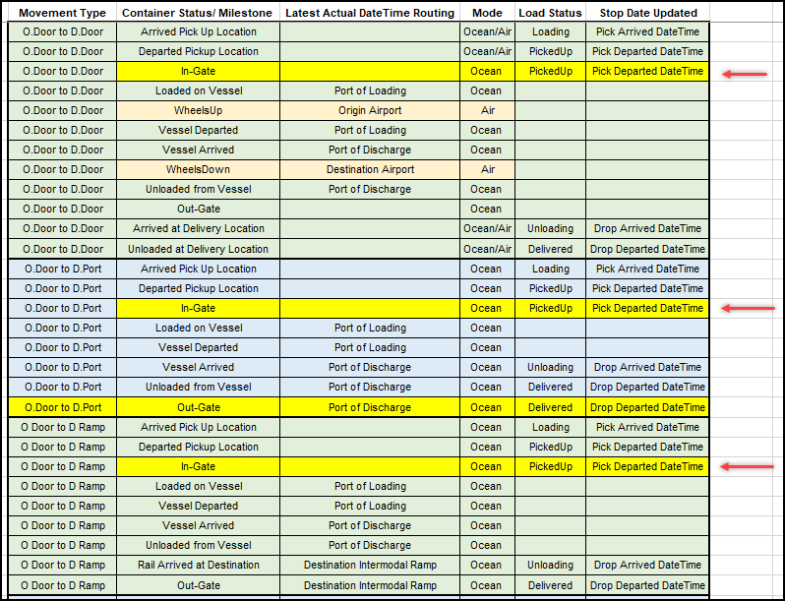

Kibana search
Similarly to DocTracker, you can leverage Kibana to look up the data we receive from AES, when we started tracking, and any (error) messages.
Steps
- Use the following Link to Kibana
  - Username:
  - Password:
- Ensure you are on the Discover Tab
- From the dropdown on the left-hand side, ensure you have “enterpriseapi-application-filebeat-k8s*” selected
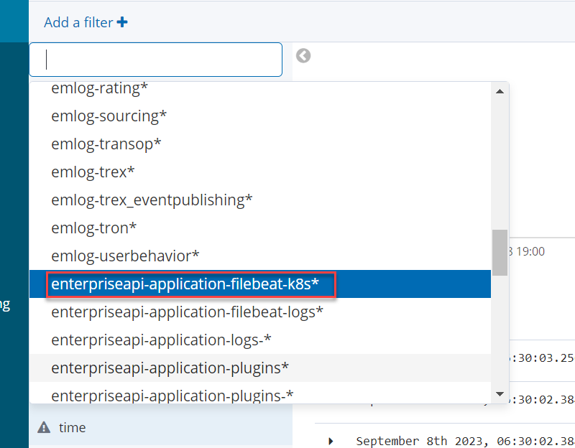
- Adjust your date range in the right-hand corner.
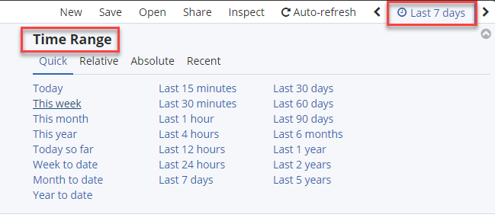
- Search at the top of the screen – use quotation marks around the reference you are searching for. For AES, you should be able to find the messages using the MBOL, Load # or Container #
- To make it easier to select the messages that you want to see, hover over the Available Field titled “label” and select “add”
  - This will summarize your view so you can only see the message type;
  - When searching for AES messages, the label you will want to look for is “tracking.external.gateway.api”;
  - Click the arrow to expand the message and see the data exchanged with AES.
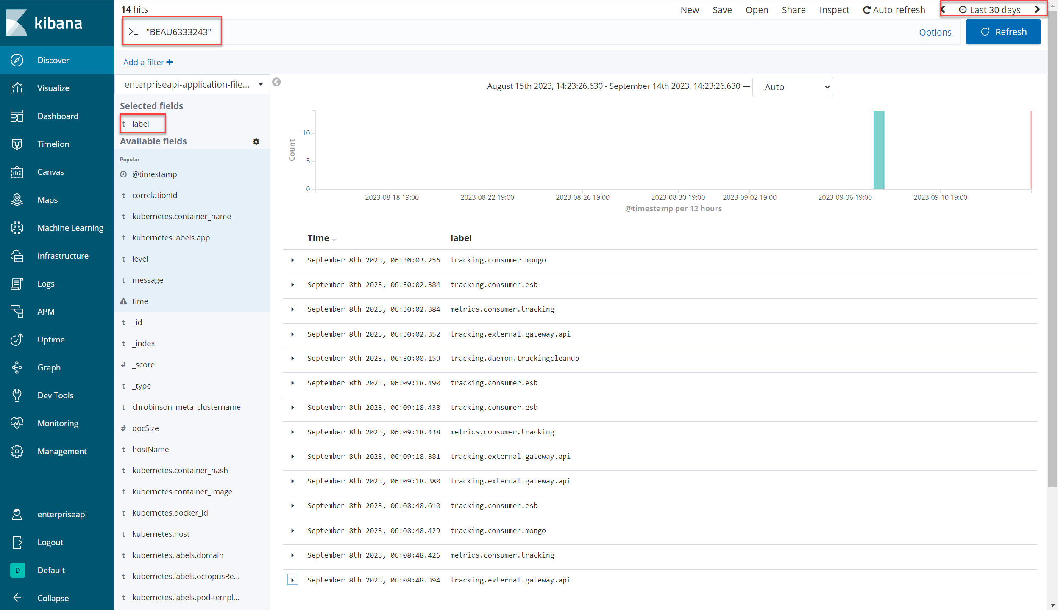

Start Tracking Message Example success.
Incoming success update:
{
"provider": "aes",
"correlationId": "cb6a4008-0ba8-48db-a528-b96add42f72d",
"shipmentKey": "340|TREX|201488045|41996996217",
"eventType": "start",
"carrierCode": null,
"customerCode": null,
"trackingStartDateUtc": "2023-07-01T08:00:00.000Z",
"trackingEndDateUtc": "2023-07-25T12:00:00.000Z",
"stops": null,
"options": [
{
"key": "ContainerNumber",
"value": "BEAU6333243"
},
{
"key": "_id",
"value": "cb6a4008-0ba8-48db-a528-b96add42f72d"
},
{
"key": "eventSystem",
"value": "maven"
},
{
"key": "maven.trackingNumber",
"value": "HNXGHLFB4X7ZY7NGV5RWX4H8B2"
}
],
"dataSource": null
}

Response from AES
Successful Events Update. This message has many events as this is for the Return Container event, which is one of the last events we would receive. You can see all event codes received, along with date/time stamps and event descriptions.
Incoming gps update:
{
"provider": "aes",
"shipmentKey": "340|TREX|201488045|41996996217",
"correlationId": "cb6a4008-0ba8-48db-a528-b96add42f72d",
"latitude": null,
"longitude": null,
"updatedDateUtc": "2023-09-08T11:09:16.716Z",
"originalUpdate": "{\r\n \"msgkey\": \"api/pushtracking\",\r\n \"msgid\": \"643f8eff7d53a4609133742a\",\r\n \"cbl\": \"ONEYRICD39826900\",\r\n \"cnt\": null,\r\n \"result\": {\r\n \"UNIQUEID\": \"7A2DCB48-09F2-4F43-ACC7-1B069E840D4C\",\r\n \"CBL\": \"ONEYRICD39826900\",\r\n \"BKG\": null,\r\n \"BILLTYPE\": 0,\r\n \"REFERENCES\": null,\r\n \"CARRIER\": {\r\n \"SCAC\": \"ONEY\",\r\n \"Name\": \"One Ocean Network Express\",\r\n \"CommonName\": \"ONE\",\r\n \"Type\": 1\r\n },\r\n \"CONTAINERS\": [\r\n {\r\n \"CNT\": \"BEAU6333243\",\r\n \"CNTTYPE\": {\r\n \"Tag\": \"40HC\",\r\n \"ShortName\": \"40' HC DRY\",\r\n \"LongName\": \"40 FT HIGH CUBE DRY\",\r\n \"AlternativeNamesText\": null,\r\n \"LengthInFeet\": 40.0,\r\n \"WidthInFeet\": 8.0,\r\n \"HeightInFeet\": 9.5,\r\n \"CapacityInCubicFeet\": 2715.0,\r\n \"Description\": \"40' x 9'6 Dry High Cube\"\r\n },\r\n \"POR\": {\r\n \"LocationText\": \"Louisville\",\r\n \"UnLocode\": \"USLUI\",\r\n \"City\": \"Louisville\",\r\n \"Province\": \"KY\",\r\n \"CountryCode\": \"US\",\r\n \"GeoWayPoints\": \"3814N 08546W\",\r\n \"OLSENTZ\": \"America/New_York\",\r\n \"MSTZ\": \"Eastern Standard Time\"\r\n },\r\n \"POL\": {\r\n \"LocationText\": \"Los Angeles\",\r\n \"UnLocode\": \"USLAX\",\r\n \"City\": \"Los Angeles\",\r\n \"Province\": \"CA\",\r\n \"CountryCode\": \"US\",\r\n \"GeoWayPoints\": \"3403N 11814W\",\r\n \"OLSENTZ\": \"America/Los_Angeles\",\r\n \"MSTZ\": \"Pacific Standard Time\"\r\n },\r\n \"POD\": {\r\n \"LocationText\": \"Melbourne\",\r\n \"UnLocode\": \"AUMEL\",\r\n \"City\": \"Melbourne\",\r\n \"Province\": \"28\",\r\n \"CountryCode\": \"AU\",\r\n \"GeoWayPoints\": \"3441N 13510E\",\r\n \"OLSENTZ\": \"Asia/Tokyo\",\r\n \"MSTZ\": \"Tokyo Standard Time\"\r\n },\r\n \"DEL\": {\r\n \"LocationText\": \"Melbourne\",\r\n \"UnLocode\": \"AUMEL\",\r\n \"City\": \"Melbourne\",\r\n \"Province\": \"28\",\r\n \"CountryCode\": \"AU\",\r\n \"GeoWayPoints\": \"3441N 13510E\",\r\n \"OLSENTZ\": \"Asia/Tokyo\",\r\n \"MSTZ\": \"Tokyo Standard Time\"\r\n },\r\n \"MILESTONES\": {\r\n \"POR\": \"USLUI\",\r\n \"POL\": \"USLAX\",\r\n \"POD\": \"AUMEL\",\r\n \"DEL\": \"AUMEL\",\r\n \"SHIPMENTTERMS\": \"PORT\",\r\n \"VESSEL\": \"NYK VEGA\",\r\n \"VOYAGE\": \"0077W\",\r\n \"IMO\": \"9312781\",\r\n \"MMSI\": \"372218000\",\r\n \"ATA\": \"2023-04-08T10:28:00Z\",\r\n \"ATD\": \"2023-03-20T18:15:00Z\",\r\n \"ETD\": \"2023-03-20T18:15:00Z\",\r\n \"ETA\": \"2023-04-08T10:28:00Z\",\r\n \"ETAFINAL\": null,\r\n \"UpdatedETD\": \"2023-03-20T18:15:00Z\",\r\n \"UpdatedETA\": \"2023-04-08T10:28:00Z\",\r\n \"UpdatedETAFINAL\": null,\r\n \"TERMINAL\": null,\r\n \"FIRMS\": null,\r\n \"TERMINALCODE\": null,\r\n \"PODDISCHARGE\": \"2023-04-08T19:24:00Z\",\r\n \"EMPTYRETURNFACILITY\": null,\r\n \"EMPTYRETURNFACILITYCODE\": null,\r\n \"LFD\": \"2023-04-17T00:00:00Z\",\r\n \"LFDDETENTION\": \"2023-04-21T00:00:00Z\",\r\n \"DISCHARGE\": \"2023-04-08T19:24:00Z\",\r\n \"DERAMPED\": null,\r\n \"AVAILABLE\": \"2023-04-09T19:24:00Z\",\r\n \"PICKEDUP\": \"2023-04-17T10:02:00Z\",\r\n \"DELIVERED\": \"2023-04-17T10:02:00Z\",\r\n \"EMPTYRETURN\": \"2023-04-18T11:31:00Z\",\r\n \"OBL\": \"NOT APPLICABLE\",\r\n \"CUSTOMS\": \"RELEASED\",\r\n \"FREIGHT\": \"RELEASED\",\r\n \"NOTES\": \"\",\r\n \"MILESTONEINDICATOR\": \"EMPTY-RETURNED\"\r\n },\r\n \"EVENTS\": [\r\n {\r\n \"Sequence\": 1,\r\n \"EventCode\": \"E1\",\r\n \"Description\": \"EMPTY TO SHIPPER\",\r\n \"VesselName\": null,\r\n \"VoyageNumber\": \"\",\r\n \"IMO\": null,\r\n \"MMSI\": null,\r\n \"RailCar\": null,\r\n \"Mode\": null,\r\n \"IsEstimate\": false,\r\n \"EventDate\": \"2023-02-16T10:04:00Z\",\r\n \"TimeZone\": \"Eastern Standard Time\",\r\n \"IANATZ\": \"America/New_York\",\r\n \"EventLocation\": {\r\n \"LocationText\": \"Louisville\",\r\n \"UnLocode\": \"USLUI\",\r\n \"City\": \"Louisville\",\r\n \"Province\": \"KY\",\r\n \"CountryCode\": \"US\",\r\n \"GeoWayPoints\": \"3814N 08546W\",\r\n \"OLSENTZ\": \"America/New_York\",\r\n \"MSTZ\": \"Eastern Standard Time\"\r\n },\r\n \"Facility\": null,\r\n \"FacilityCode\": null,\r\n \"Reference\": \"17190193\",\r\n \"Hash\": \"17190193\",\r\n \"Leg\": null\r\n },\r\n {\r\n \"Sequence\": 2,\r\n \"EventCode\": \"K2\",\r\n \"Description\": \"RAIL GATE IN TO OUTBOUND\",\r\n \"VesselName\": null,\r\n \"VoyageNumber\": \"\",\r\n \"IMO\": null,\r\n \"MMSI\": null,\r\n \"RailCar\": null,\r\n \"Mode\": null,\r\n \"IsEstimate\": false,\r\n \"EventDate\": \"2023-02-16T14:48:00Z\",\r\n \"TimeZone\": \"Eastern Standard Time\",\r\n \"IANATZ\": \"America/New_York\",\r\n \"EventLocation\": {\r\n \"LocationText\": \"Louisville\",\r\n \"UnLocode\": \"USLUI\",\r\n \"City\": \"Louisville\",\r\n \"Province\": \"KY\",\r\n \"CountryCode\": \"US\",\r\n \"GeoWayPoints\": \"3814N 08546W\",\r\n \"OLSENTZ\": \"America/New_York\",\r\n \"MSTZ\": \"Eastern Standard Time\"\r\n },\r\n \"Facility\": \"NS APPLIANCE PK\",\r\n \"FacilityCode\": \"NSAPPLIANCEPK\",\r\n \"Reference\": \"17198492\",\r\n \"Hash\": \"17198492\",\r\n \"Leg\": null\r\n },\r\n {\r\n \"Sequence\": 3,\r\n \"EventCode\": \"R5\",\r\n \"Description\": \"RAIL LOADED AT OUTBOUND ORIGIN\",\r\n \"VesselName\": null,\r\n \"VoyageNumber\": \"\",\r\n \"IMO\": null,\r\n \"MMSI\": null,\r\n \"RailCar\": null,\r\n \"Mode\": \"Rail\",\r\n \"IsEstimate\": false,\r\n \"EventDate\": \"2023-02-17T18:47:00Z\",\r\n \"TimeZone\": \"Eastern Standard Time\",\r\n \"IANATZ\": \"America/New_York\",\r\n \"EventLocation\": {\r\n \"LocationText\": \"Louisville\",\r\n \"UnLocode\": \"USLUI\",\r\n \"City\": \"Louisville\",\r\n \"Province\": \"KY\",\r\n \"CountryCode\": \"US\",\r\n \"GeoWayPoints\": \"3814N 08546W\",\r\n \"OLSENTZ\": \"America/New_York\",\r\n \"MSTZ\": \"Eastern Standard Time\"\r\n },\r\n \"Facility\": \"NS APPLIANCE PK\",\r\n \"FacilityCode\": \"NSAPPLIANCEPK\",\r\n \"Reference\": \"17206824\",\r\n \"Hash\": \"17206824\",\r\n \"Leg\": null\r\n },\r\n \t\t\t\t\t{\r\n\t\t\t\t\t\t\"Sequence\": 4,\r\n\t\t\t\t\t\t\"EventCode\": \"R6\",\r\n\t\t\t\t\t\t\"Description\": \"RAIL OUTBOUND DEPARTED\",\r\n\t\t\t\t\t\t\"VesselName\": null,\r\n\t\t\t\t\t\t\"VoyageNumber\": \"\",\r\n\t\t\t\t\t\t\"IMO\": null,\r\n\t\t\t\t\t\t\"MMSI\": null,\r\n\t\t\t\t\t\t\"RailCar\": null,\r\n\t\t\t\t\t\t\"Mode\": \"Rail\",\r\n\t\t\t\t\t\t\"IsEstimate\": false,\r\n\t\t\t\t\t\t\"EventDate\": \"2023-02-17T20:51:00Z\",\r\n\t\t\t\t\t\t\"TimeZone\": \"Eastern Standard Time\",\r\n\t\t\t\t\t\t\"IANATZ\": \"America/New_York\",\r\n\t\t\t\t\t\t\"EventLocation\": {\r\n\t\t\t\t\t\t\t\"LocationText\": \"Louisville\",\r\n\t\t\t\t\t\t\t\"UnLocode\": \"USLUI\",\r\n\t\t\t\t\t\t\t\"City\": \"Louisville\",\r\n\t\t\t\t\t\t\t\"Province\": \"KY\",\r\n\t\t\t\t\t\t\t\"CountryCode\": \"US\",\r\n\t\t\t\t\t\t\t\"GeoWayPoints\": \"3814N 08546W\",\r\n\t\t\t\t\t\t\t\"OLSENTZ\": \"America/New_York\",\r\n\t\t\t\t\t\t\t\"MSTZ\": \"Eastern Standard Time\"\r\n\t\t\t\t\t\t},\r\n\t\t\t\t\t\t\"Facility\": \"NS APPLIANCE PK\",\r\n\t\t\t\t\t\t\"FacilityCode\": \"NSAPPLIANCEPK\",\r\n\t\t\t\t\t\t\"Reference\": \"17206825\",\r\n\t\t\t\t\t\t\"Hash\": \"17206825\",\r\n\t\t\t\t\t\t\"Leg\": null\r\n\t\t\t\t\t},\r\n \r\n\t\t\t\t\t{\r\n\t\t\t\t\t\t\"Sequence\": 5,\r\n\t\t\t\t\t\t\"EventCode\": \"R6\",\r\n\t\t\t\t\t\t\"Description\": \"RAIL OUTBOUND DEPARTED\",\r\n\t\t\t\t\t\t\"VesselName\": null,\r\n\t\t\t\t\t\t\"VoyageNumber\": \"\",\r\n\t\t\t\t\t\t\"IMO\": null,\r\n\t\t\t\t\t\t\"MMSI\": null,\r\n\t\t\t\t\t\t\"RailCar\": null,\r\n\t\t\t\t\t\t\"Mode\": \"Rail\",\r\n\t\t\t\t\t\t\"IsEstimate\": false,\r\n\t\t\t\t\t\t\"EventDate\": \"2023-02-21T07:15:00Z\",\r\n\t\t\t\t\t\t\"TimeZone\": \"Central Standard Time\",\r\n\t\t\t\t\t\t\"IANATZ\": \"America/Chicago\",\r\n\t\t\t\t\t\t\"EventLocation\": {\r\n\t\t\t\t\t\t\t\"LocationText\": \"Northlake\",\r\n\t\t\t\t\t\t\t\"UnLocode\": \"USNTI\",\r\n\t\t\t\t\t\t\t\"City\": \"Northlake\",\r\n\t\t\t\t\t\t\t\"Province\": \"IL\",\r\n\t\t\t\t\t\t\t\"CountryCode\": \"US\",\r\n\t\t\t\t\t\t\t\"GeoWayPoints\": \"4154N 08754W\",\r\n\t\t\t\t\t\t\t\"OLSENTZ\": \"America/Chicago\",\r\n\t\t\t\t\t\t\t\"MSTZ\": \"Central Standard Time\"\r\n\t\t\t\t\t\t},\r\n\t\t\t\t\t\t\"Facility\": \"UP GLOBAL II\",\r\n\t\t\t\t\t\t\"FacilityCode\": \"UPGLOBALII\",\r\n\t\t\t\t\t\t\"Reference\": \"17250611\",\r\n\t\t\t\t\t\t\"Hash\": \"17250611\",\r\n\t\t\t\t\t\t\"Leg\": null\r\n\t\t\t\t\t},\r\n \r\n\t\t\t\t\t{\r\n\t\t\t\t\t\t\"Sequence\": 5,\r\n\t\t\t\t\t\t\"EventCode\": \"R6\",\r\n\t\t\t\t\t\t\"Description\": \"RAIL OUTBOUND DEPARTED\",\r\n\t\t\t\t\t\t\"VesselName\": null,\r\n\t\t\t\t\t\t\"VoyageNumber\": \"\",\r\n\t\t\t\t\t\t\"IMO\": null,\r\n\t\t\t\t\t\t\"MMSI\": null,\r\n\t\t\t\t\t\t\"RailCar\": null,\r\n\t\t\t\t\t\t\"Mode\": \"Rail\",\r\n\t\t\t\t\t\t\"IsEstimate\": false,\r\n\t\t\t\t\t\t\"EventDate\": \"2023-02-25T17:12:00Z\",\r\n\t\t\t\t\t\t\"TimeZone\": \"Central Standard Time\",\r\n\t\t\t\t\t\t\"IANATZ\": \"America/Chicago\",\r\n\t\t\t\t\t\t\"EventLocation\": {\r\n\t\t\t\t\t\t\t\"LocationText\": \"Northlake\",\r\n\t\t\t\t\t\t\t\"UnLocode\": \"USNTI\",\r\n\t\t\t\t\t\t\t\"City\": \"Northlake\",\r\n\t\t\t\t\t\t\t\"Province\": \"IL\",\r\n\t\t\t\t\t\t\t\"CountryCode\": \"US\",\r\n\t\t\t\t\t\t\t\"GeoWayPoints\": \"4154N 08754W\",\r\n\t\t\t\t\t\t\t\"OLSENTZ\": \"America/Chicago\",\r\n\t\t\t\t\t\t\t\"MSTZ\": \"Central Standard Time\"\r\n\t\t\t\t\t\t},\r\n\t\t\t\t\t\t\"Facility\": \"UP GLOBAL II\",\r\n\t\t\t\t\t\t\"FacilityCode\": \"UPGLOBALII\",\r\n\t\t\t\t\t\t\"Reference\": \"17323321\",\r\n\t\t\t\t\t\t\"Hash\": \"17323321\",\r\n\t\t\t\t\t\t\"Leg\": null\r\n\t\t\t\t\t},\r\n \t\t\t{\r\n\t\t\t\t\t\t\"Sequence\": 6,\r\n\t\t\t\t\t\t\"EventCode\": \"R8\",\r\n\t\t\t\t\t\t\"Description\": \"RAIL OUTBOUND UNLOADED AT POL\",\r\n\t\t\t\t\t\t\"VesselName\": null,\r\n\t\t\t\t\t\t\"VoyageNumber\": \"\",\r\n\t\t\t\t\t\t\"IMO\": null,\r\n\t\t\t\t\t\t\"MMSI\": null,\r\n\t\t\t\t\t\t\"RailCar\": null,\r\n\t\t\t\t\t\t\"Mode\": \"Rail\",\r\n\t\t\t\t\t\t\"IsEstimate\": false,\r\n\t\t\t\t\t\t\"EventDate\": \"2023-03-14T03:40:00Z\",\r\n\t\t\t\t\t\t\"TimeZone\": \"Pacific Standard Time\",\r\n\t\t\t\t\t\t\"IANATZ\": \"America/Los_Angeles\",\r\n\t\t\t\t\t\t\"EventLocation\": {\r\n\t\t\t\t\t\t\t\"LocationText\": \"Long Beach\",\r\n\t\t\t\t\t\t\t\"UnLocode\": \"USLGB\",\r\n\t\t\t\t\t\t\t\"City\": \"Long Beach\",\r\n\t\t\t\t\t\t\t\"Province\": \"CA\",\r\n\t\t\t\t\t\t\t\"CountryCode\": \"US\",\r\n\t\t\t\t\t\t\t\"GeoWayPoints\": \"3346N 11811W\",\r\n\t\t\t\t\t\t\t\"OLSENTZ\": \"America/Los_Angeles\",\r\n\t\t\t\t\t\t\t\"MSTZ\": \"Pacific Standard Time\"\r\n\t\t\t\t\t\t},\r\n\t\t\t\t\t\t\"Facility\": \"UP ICTF\",\r\n\t\t\t\t\t\t\"FacilityCode\": \"UPICTF\",\r\n\t\t\t\t\t\t\"Reference\": \"17461066\",\r\n\t\t\t\t\t\t\"Hash\": \"17461066\",\r\n\t\t\t\t\t\t\"Leg\": null\r\n\t\t\t\t\t},\r\n \t\t{\r\n\t\t\t\t\t\t\"Sequence\": 7,\r\n\t\t\t\t\t\t\"EventCode\": \"R7\",\r\n\t\t\t\t\t\t\"Description\": \"RAIL OUTBOUND ARRIVED\",\r\n\t\t\t\t\t\t\"VesselName\": null,\r\n\t\t\t\t\t\t\"VoyageNumber\": \"\",\r\n\t\t\t\t\t\t\"IMO\": null,\r\n\t\t\t\t\t\t\"MMSI\": null,\r\n\t\t\t\t\t\t\"RailCar\": null,\r\n\t\t\t\t\t\t\"Mode\": \"Rail\",\r\n\t\t\t\t\t\t\"IsEstimate\": false,\r\n\t\t\t\t\t\t\"EventDate\": \"2023-03-16T12:29:00Z\",\r\n\t\t\t\t\t\t\"TimeZone\": \"Pacific Standard Time\",\r\n\t\t\t\t\t\t\"IANATZ\": \"America/Los_Angeles\",\r\n\t\t\t\t\t\t\"EventLocation\": {\r\n\t\t\t\t\t\t\t\"LocationText\": \"Long Beach\",\r\n\t\t\t\t\t\t\t\"UnLocode\": \"USLGB\",\r\n\t\t\t\t\t\t\t\"City\": \"Long Beach\",\r\n\t\t\t\t\t\t\t\"Province\": \"CA\",\r\n\t\t\t\t\t\t\t\"CountryCode\": \"US\",\r\n\t\t\t\t\t\t\t\"GeoWayPoints\": \"3346N 11811W\",\r\n\t\t\t\t\t\t\t\"OLSENTZ\": \"America/Los_Angeles\",\r\n\t\t\t\t\t\t\t\"MSTZ\": \"Pacific Standard Time\"\r\n\t\t\t\t\t\t},\r\n\t\t\t\t\t\t\"Facility\": \"UP ICTF\",\r\n\t\t\t\t\t\t\"FacilityCode\": \"UPICTF\",\r\n\t\t\t\t\t\t\"Reference\": \"17505086\",\r\n\t\t\t\t\t\t\"Hash\": \"17505086\",\r\n\t\t\t\t\t\t\"Leg\": null\r\n\t\t\t\t\t},\r\n \t\r\n\t\t\t\t\t{\r\n\t\t\t\t\t\t\"Sequence\": 8,\r\n\t\t\t\t\t\t\"EventCode\": \"Q5\",\r\n\t\t\t\t\t\t\"Description\": \"GATE OUT FROM OUTBOUND\",\r\n\t\t\t\t\t\t\"VesselName\": null,\r\n\t\t\t\t\t\t\"VoyageNumber\": \"\",\r\n\t\t\t\t\t\t\"IMO\": null,\r\n\t\t\t\t\t\t\"MMSI\": null,\r\n\t\t\t\t\t\t\"RailCar\": null,\r\n\t\t\t\t\t\t\"Mode\": null,\r\n\t\t\t\t\t\t\"IsEstimate\": false,\r\n\t\t\t\t\t\t\"EventDate\": \"2023-03-16T12:30:00Z\",\r\n\t\t\t\t\t\t\"TimeZone\": \"Pacific Standard Time\",\r\n\t\t\t\t\t\t\"IANATZ\": \"America/Los_Angeles\",\r\n\t\t\t\t\t\t\"EventLocation\": {\r\n\t\t\t\t\t\t\t\"LocationText\": \"Long Beach\",\r\n\t\t\t\t\t\t\t\"UnLocode\": \"USLGB\",\r\n\t\t\t\t\t\t\t\"City\": \"Long Beach\",\r\n\t\t\t\t\t\t\t\"Province\": \"CA\",\r\n\t\t\t\t\t\t\t\"CountryCode\": \"US\",\r\n\t\t\t\t\t\t\t\"GeoWayPoints\": \"3346N 11811W\",\r\n\t\t\t\t\t\t\t\"OLSENTZ\": \"America/Los_Angeles\",\r\n\t\t\t\t\t\t\t\"MSTZ\": \"Pacific Standard Time\"\r\n\t\t\t\t\t\t},\r\n\t\t\t\t\t\t\"Facility\": \"UP ICTF\",\r\n\t\t\t\t\t\t\"FacilityCode\": \"UPICTF\",\r\n\t\t\t\t\t\t\"Reference\": \"17473038\",\r\n\t\t\t\t\t\t\"Hash\": \"17473038\",\r\n\t\t\t\t\t\t\"Leg\": null\r\n\t\t\t\t\t},\r\n \t\t{\r\n\t\t\t\t\t\t\"Sequence\": 9,\r\n\t\t\t\t\t\t\"EventCode\": \"G1\",\r\n\t\t\t\t\t\t\"Description\": \"GATE IN TO OUTBOUND\",\r\n\t\t\t\t\t\t\"VesselName\": null,\r\n\t\t\t\t\t\t\"VoyageNumber\": \"\",\r\n\t\t\t\t\t\t\"IMO\": null,\r\n\t\t\t\t\t\t\"MMSI\": null,\r\n\t\t\t\t\t\t\"RailCar\": null,\r\n\t\t\t\t\t\t\"Mode\": null,\r\n\t\t\t\t\t\t\"IsEstimate\": false,\r\n\t\t\t\t\t\t\"EventDate\": \"2023-03-16T14:19:00Z\",\r\n\t\t\t\t\t\t\"TimeZone\": \"Pacific Standard Time\",\r\n\t\t\t\t\t\t\"IANATZ\": \"America/Los_Angeles\",\r\n\t\t\t\t\t\t\"EventLocation\": {\r\n\t\t\t\t\t\t\t\"LocationText\": \"Los Angeles\",\r\n\t\t\t\t\t\t\t\"UnLocode\": \"USLAX\",\r\n\t\t\t\t\t\t\t\"City\": \"Los Angeles\",\r\n\t\t\t\t\t\t\t\"Province\": \"CA\",\r\n\t\t\t\t\t\t\t\"CountryCode\": \"US\",\r\n\t\t\t\t\t\t\t\"GeoWayPoints\": \"3403N 11814W\",\r\n\t\t\t\t\t\t\t\"OLSENTZ\": \"America/Los_Angeles\",\r\n\t\t\t\t\t\t\t\"MSTZ\": \"Pacific Standard Time\"\r\n\t\t\t\t\t\t},\r\n\t\t\t\t\t\t\"Facility\": \"YUSEN LOS ANGELES\",\r\n\t\t\t\t\t\t\"FacilityCode\": \"YT\",\r\n\t\t\t\t\t\t\"Reference\": \"17473039\",\r\n\t\t\t\t\t\t\"Hash\": \"17473039\",\r\n\t\t\t\t\t\t\"Leg\": null\r\n\t\t\t\t\t},\r\n \t\t\t\t\t{\r\n\t\t\t\t\t\t\"Sequence\": 10,\r\n\t\t\t\t\t\t\"EventCode\": \"LB\",\r\n\t\t\t\t\t\t\"Description\": \"LOADED ON BOARD\",\r\n\t\t\t\t\t\t\"VesselName\": \"NYK VEGA\",\r\n\t\t\t\t\t\t\"VoyageNumber\": \"0077W\",\r\n\t\t\t\t\t\t\"IMO\": \"9312781\",\r\n\t\t\t\t\t\t\"MMSI\": \"372218000\",\r\n\t\t\t\t\t\t\"RailCar\": null,\r\n\t\t\t\t\t\t\"Mode\": \"Vessel\",\r\n\t\t\t\t\t\t\"IsEstimate\": false,\r\n\t\t\t\t\t\t\"EventDate\": \"2023-03-20T02:25:00Z\",\r\n\t\t\t\t\t\t\"TimeZone\": \"Pacific Standard Time\",\r\n\t\t\t\t\t\t\"IANATZ\": \"America/Los_Angeles\",\r\n\t\t\t\t\t\t\"EventLocation\": {\r\n\t\t\t\t\t\t\t\"LocationText\": \"Los Angeles\",\r\n\t\t\t\t\t\t\t\"UnLocode\": \"USLAX\",\r\n\t\t\t\t\t\t\t\"City\": \"Los Angeles\",\r\n\t\t\t\t\t\t\t\"Province\": \"CA\",\r\n\t\t\t\t\t\t\t\"CountryCode\": \"US\",\r\n\t\t\t\t\t\t\t\"GeoWayPoints\": \"3403N 11814W\",\r\n\t\t\t\t\t\t\t\"OLSENTZ\": \"America/Los_Angeles\",\r\n\t\t\t\t\t\t\t\"MSTZ\": \"Pacific Standard Time\"\r\n\t\t\t\t\t\t},\r\n\t\t\t\t\t\t\"Facility\": \"YUSEN LOS ANGELES\",\r\n\t\t\t\t\t\t\"FacilityCode\": \"YT\",\r\n\t\t\t\t\t\t\"Reference\": \"17505087\",\r\n\t\t\t\t\t\t\"Hash\": \"17505087\",\r\n\t\t\t\t\t\t\"Leg\": null\r\n\t\t\t\t\t},\r\n \t\t\t\t\t{\r\n\t\t\t\t\t\t\"Sequence\": 11,\r\n\t\t\t\t\t\t\"EventCode\": \"DP\",\r\n\t\t\t\t\t\t\"Description\": \"DEPARTED POL\",\r\n\t\t\t\t\t\t\"VesselName\": \"NYK VEGA\",\r\n\t\t\t\t\t\t\"VoyageNumber\": \"0077W\",\r\n\t\t\t\t\t\t\"IMO\": \"9312781\",\r\n\t\t\t\t\t\t\"MMSI\": \"372218000\",\r\n\t\t\t\t\t\t\"RailCar\": null,\r\n\t\t\t\t\t\t\"Mode\": \"Vessel\",\r\n\t\t\t\t\t\t\"IsEstimate\": false,\r\n\t\t\t\t\t\t\"EventDate\": \"2023-03-20T18:15:00Z\",\r\n\t\t\t\t\t\t\"TimeZone\": \"Pacific Standard Time\",\r\n\t\t\t\t\t\t\"IANATZ\": \"America/Los_Angeles\",\r\n\t\t\t\t\t\t\"EventLocation\": {\r\n\t\t\t\t\t\t\t\"LocationText\": \"Los Angeles\",\r\n\t\t\t\t\t\t\t\"UnLocode\": \"USLAX\",\r\n\t\t\t\t\t\t\t\"City\": \"Los Angeles\",\r\n\t\t\t\t\t\t\t\"Province\": \"CA\",\r\n\t\t\t\t\t\t\t\"CountryCode\": \"US\",\r\n\t\t\t\t\t\t\t\"GeoWayPoints\": \"3403N 11814W\",\r\n\t\t\t\t\t\t\t\"OLSENTZ\": \"America/Los_Angeles\",\r\n\t\t\t\t\t\t\t\"MSTZ\": \"Pacific Standard Time\"\r\n\t\t\t\t\t\t},\r\n\t\t\t\t\t\t\"Facility\": \"YUSEN LOS ANGELES\",\r\n\t\t\t\t\t\t\"FacilityCode\": \"YT\",\r\n\t\t\t\t\t\t\"Reference\": \"17514789\",\r\n\t\t\t\t\t\t\"Hash\": \"17514789\",\r\n\t\t\t\t\t\t\"Leg\": null\r\n\t\t\t\t\t},\r\n \t{\r\n\t\t\t\t\t\t\"Sequence\": 12,\r\n\t\t\t\t\t\t\"EventCode\": \"AD\",\r\n\t\t\t\t\t\t\"Description\": \"ARRIVAL AT PORT OF DISCHARGE\",\r\n\t\t\t\t\t\t\"VesselName\": \"NYK VEGA\",\r\n\t\t\t\t\t\t\"VoyageNumber\": \"0077W\",\r\n\t\t\t\t\t\t\"IMO\": \"9312781\",\r\n\t\t\t\t\t\t\"MMSI\": \"372218000\",\r\n\t\t\t\t\t\t\"RailCar\": null,\r\n\t\t\t\t\t\t\"Mode\": \"Vessel\",\r\n\t\t\t\t\t\t\"IsEstimate\": false,\r\n\t\t\t\t\t\t\"EventDate\": \"2023-04-08T10:28:00Z\",\r\n\t\t\t\t\t\t\"TimeZone\": \"Tokyo Standard Time\",\r\n\t\t\t\t\t\t\"IANATZ\": \"Asia/Tokyo\",\r\n\t\t\t\t\t\t\"EventLocation\": {\r\n\t\t\t\t\t\t\t\"LocationText\": \"Melbourne\",\r\n\t\t\t\t\t\t\t\"UnLocode\": \"AUMEL\",\r\n\t\t\t\t\t\t\t\"City\": \"Melbourne\",\r\n\t\t\t\t\t\t\t\"Province\": \"28\",\r\n\t\t\t\t\t\t\t\"CountryCode\": \"AU\",\r\n\t\t\t\t\t\t\t\"GeoWayPoints\": \"3441N 13510E\",\r\n\t\t\t\t\t\t\t\"OLSENTZ\": \"Asia/Tokyo\",\r\n\t\t\t\t\t\t\t\"MSTZ\": \"Tokyo Standard Time\"\r\n\t\t\t\t\t\t},\r\n\t\t\t\t\t\t\"Facility\": null,\r\n\t\t\t\t\t\t\"FacilityCode\": null,\r\n\t\t\t\t\t\t\"Reference\": \"17698336\",\r\n\t\t\t\t\t\t\"Hash\": \"17698336\",\r\n\t\t\t\t\t\t\"Leg\": null\r\n\t\t\t\t\t},\r\n \t\t{\r\n\t\t\t\t\t\t\"Sequence\": 13,\r\n\t\t\t\t\t\t\"EventCode\": \"PB\",\r\n\t\t\t\t\t\t\"Description\": \"BERTHING AT POD\",\r\n\t\t\t\t\t\t\"VesselName\": \"NYK VEGA\",\r\n\t\t\t\t\t\t\"VoyageNumber\": \"0077W\",\r\n\t\t\t\t\t\t\"IMO\": \"9312781\",\r\n\t\t\t\t\t\t\"MMSI\": \"372218000\",\r\n\t\t\t\t\t\t\"RailCar\": null,\r\n\t\t\t\t\t\t\"Mode\": \"Vessel\",\r\n\t\t\t\t\t\t\"IsEstimate\": false,\r\n\t\t\t\t\t\t\"EventDate\": \"2023-04-08T12:28:00Z\",\r\n\t\t\t\t\t\t\"TimeZone\": \"Tokyo Standard Time\",\r\n\t\t\t\t\t\t\"IANATZ\": \"Asia/Tokyo\",\r\n\t\t\t\t\t\t\"EventLocation\": {\r\n\t\t\t\t\t\t\t\"LocationText\": \"Melbourne\",\r\n\t\t\t\t\t\t\t\"UnLocode\": \"AUMEL\",\r\n\t\t\t\t\t\t\t\"City\": \"Melbourne\",\r\n\t\t\t\t\t\t\t\"Province\": \"28\",\r\n\t\t\t\t\t\t\t\"CountryCode\": \"AU\",\r\n\t\t\t\t\t\t\t\"GeoWayPoints\": \"3441N 13510E\",\r\n\t\t\t\t\t\t\t\"OLSENTZ\": \"Asia/Tokyo\",\r\n\t\t\t\t\t\t\t\"MSTZ\": \"Tokyo Standard Time\"\r\n\t\t\t\t\t\t},\r\n\t\t\t\t\t\t\"Facility\": null,\r\n\t\t\t\t\t\t\"FacilityCode\": null,\r\n\t\t\t\t\t\t\"Reference\": \"17698337\",\r\n\t\t\t\t\t\t\"Hash\": \"17698337\",\r\n\t\t\t\t\t\t\"Leg\": null\r\n\t\t\t\t\t},\r\n \t\t\t\t\t{\r\n\t\t\t\t\t\t\"Sequence\": 14,\r\n\t\t\t\t\t\t\"EventCode\": \"D1\",\r\n\t\t\t\t\t\t\"Description\": \"DISCHARGED\",\r\n\t\t\t\t\t\t\"VesselName\": \"NYK VEGA\",\r\n\t\t\t\t\t\t\"VoyageNumber\": \"0077W\",\r\n\t\t\t\t\t\t\"IMO\": \"9312781\",\r\n\t\t\t\t\t\t\"MMSI\": \"372218000\",\r\n\t\t\t\t\t\t\"RailCar\": null,\r\n\t\t\t\t\t\t\"Mode\": \"Vessel\",\r\n\t\t\t\t\t\t\"IsEstimate\": false,\r\n\t\t\t\t\t\t\"EventDate\": \"2023-04-08T19:24:00Z\",\r\n\t\t\t\t\t\t\"TimeZone\": \"Tokyo Standard Time\",\r\n\t\t\t\t\t\t\"IANATZ\": \"Asia/Tokyo\",\r\n\t\t\t\t\t\t\"EventLocation\": {\r\n\t\t\t\t\t\t\t\"LocationText\": \"Melbourne\",\r\n\t\t\t\t\t\t\t\"UnLocode\": \"AUMEL\",\r\n\t\t\t\t\t\t\t\"City\": \"Melbourne\",\r\n\t\t\t\t\t\t\t\"Province\": \"28\",\r\n\t\t\t\t\t\t\t\"CountryCode\": \"AU\",\r\n\t\t\t\t\t\t\t\"GeoWayPoints\": \"3441N 13510E\",\r\n\t\t\t\t\t\t\t\"OLSENTZ\": \"Asia/Tokyo\",\r\n\t\t\t\t\t\t\t\"MSTZ\": \"Tokyo Standard Time\"\r\n\t\t\t\t\t\t},\r\n\t\t\t\t\t\t\"Facility\": null,\r\n\t\t\t\t\t\t\"FacilityCode\": null,\r\n\t\t\t\t\t\t\"Reference\": \"17698338\",\r\n\t\t\t\t\t\t\"Hash\": \"17698338\",\r\n\t\t\t\t\t\t\"Leg\": null\r\n\t\t\t\t\t},\r\n {\r\n\t\t\t\t\t\t\"Sequence\": 15,\r\n\t\t\t\t\t\t\"EventCode\": \"G2\",\r\n\t\t\t\t\t\t\"Description\": \"GATE OUT DELIVERY FULL\",\r\n\t\t\t\t\t\t\"VesselName\": null,\r\n\t\t\t\t\t\t\"VoyageNumber\": \"\",\r\n\t\t\t\t\t\t\"IMO\": null,\r\n\t\t\t\t\t\t\"MMSI\": null,\r\n\t\t\t\t\t\t\"RailCar\": null,\r\n\t\t\t\t\t\t\"Mode\": null,\r\n\t\t\t\t\t\t\"IsEstimate\": false,\r\n\t\t\t\t\t\t\"EventDate\": \"2023-04-17T10:02:00Z\",\r\n\t\t\t\t\t\t\"TimeZone\": \"Tokyo Standard Time\",\r\n\t\t\t\t\t\t\"IANATZ\": \"Asia/Tokyo\",\r\n\t\t\t\t\t\t\"EventLocation\": {\r\n\t\t\t\t\t\t\t\"LocationText\": \"Melbourne\",\r\n\t\t\t\t\t\t\t\"UnLocode\": \"AUMEL\",\r\n\t\t\t\t\t\t\t\"City\": \"Melbourne\",\r\n\t\t\t\t\t\t\t\"Province\": \"28\",\r\n\t\t\t\t\t\t\t\"CountryCode\": \"AU\",\r\n\t\t\t\t\t\t\t\"GeoWayPoints\": \"3441N 13510E\",\r\n\t\t\t\t\t\t\t\"OLSENTZ\": \"Asia/Tokyo\",\r\n\t\t\t\t\t\t\t\"MSTZ\": \"Tokyo Standard Time\"\r\n\t\t\t\t\t\t},\r\n\t\t\t\t\t\t\"Facility\": null,\r\n\t\t\t\t\t\t\"FacilityCode\": null,\r\n\t\t\t\t\t\t\"Reference\": \"17725216\",\r\n\t\t\t\t\t\t\"Hash\": \"17725216\",\r\n\t\t\t\t\t\t\"Leg\": null\r\n\t\t\t\t\t},\r\n \t\r\n\t\t\t\t\r\n\t\t\t\r\n\r\n\t\t\t\t\t{\r\n\t\t\t\t\t\t\"Sequence\": 16,\r\n\t\t\t\t\t\t\"EventCode\": \"E2\",\r\n\t\t\t\t\t\t\"Description\": \"RETURNED EMPTY\",\r\n\t\t\t\t\t\t\"VesselName\": null,\r\n\t\t\t\t\t\t\"VoyageNumber\": \"\",\r\n\t\t\t\t\t\t\"IMO\": null,\r\n\t\t\t\t\t\t\"MMSI\": null,\r\n\t\t\t\t\t\t\"RailCar\": null,\r\n\t\t\t\t\t\t\"Mode\": null,\r\n\t\t\t\t\t\t\"IsEstimate\": false,\r\n\t\t\t\t\t\t\"EventDate\": \"2023-04-18T11:31:00Z\",\r\n\t\t\t\t\t\t\"TimeZone\": \"Tokyo Standard Time\",\r\n\t\t\t\t\t\t\"IANATZ\": \"Asia/Tokyo\",\r\n\t\t\t\t\t\t\"EventLocation\": {\r\n\t\t\t\t\t\t\t\"LocationText\": \"Melbourne\",\r\n\t\t\t\t\t\t\t\"UnLocode\": \"AUMEL\",\r\n\t\t\t\t\t\t\t\"City\": \"Melbourne\",\r\n\t\t\t\t\t\t\t\"Province\": \"28\",\r\n\t\t\t\t\t\t\t\"CountryCode\": \"AU\",\r\n\t\t\t\t\t\t\t\"GeoWayPoints\": \"3441N 13510E\",\r\n\t\t\t\t\t\t\t\"OLSENTZ\": \"Asia/Tokyo\",\r\n\t\t\t\t\t\t\t\"MSTZ\": \"Tokyo Standard Time\"\r\n\t\t\t\t\t\t},\r\n\t\t\t\t\t\t\"Facility\": null,\r\n\t\t\t\t\t\t\"FacilityCode\": null,\r\n\t\t\t\t\t\t\"Reference\": \"17733603\",\r\n\t\t\t\t\t\t\"Hash\": \"17733603\",\r\n\t\t\t\t\t\t\"Leg\": null\r\n\t\t\t\t\t}\r\n ],\r\n \"ROUTING\": null\r\n }\r\n ]\r\n },\r\n \"cref\": [\r\n \"HNXGHLFB4X7ZY7NGV5RWX4H8B2\"\r\n ],\r\n \"ack\": 1,\r\n \"exceptions\": null,\r\n \"ctoken\": null\r\n}",
"dataSource": "Aes",
"options": null
}

Questions and answers
- Both Forwarder and AES send updates. What will I see?
We apply updates based on what was received first.
Example:
    - AES milestone received for Vessel Departure, then Forwarder sends milestone after for Vessel Departure.
    - AES milestone will apply to the stop.
    - You will see both AES and forwarder milestone in the Tracking Log.
If both send the same milestone, it will be seen twice, like in the below example.
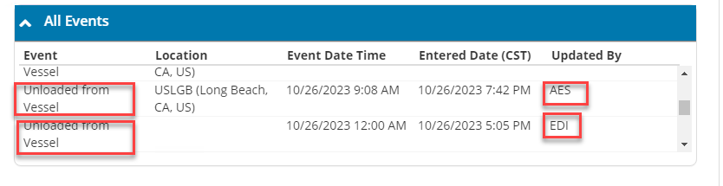
- Is there a way to differentiate between forwarder updates and AES ones?
Yes. At the Order Load edit, go to Load – Container Details – Container Tracking – Expand All Events. The Updated By column will show data based on the source: Forwarder data will have the Updated By column filled in with EDI. AES data will have the Updated By column filled in with AES.
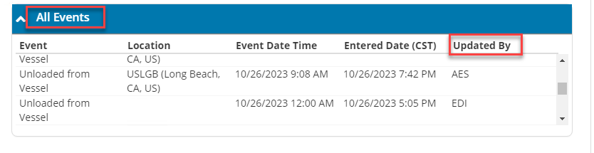
- The MBOL (BN) which we initially had at the load level is incorrect. Will we receive updates AFTER we correct them?
Yes, updates will be received after MBOL or BN is corrected.
- Are past updates still applied?
An example would be if the shipment wasn’t received until it was In Transit. Based on our current logic, we would only apply the latest AES update. We are currently looking at ways to potentially pull in the updates we had received prior.
- How can I submit a new tactical request?
If any additional enhancement requests come up for the AES tracking process, please submit a Tactical Request through the standard Market Solutions process. This form is available within the Market Solutions Collaboration Team under the “Tactical Prioritization” channel.

