**CHAPTER II - THE COMPANY**

## *a. Company Profile*

INNOVENTURE is a multifaceted company aimed at fostering technological advancement and web development established by four Information Technology students on January of 2024 from the College of Computing Studies, Western Mindanao State University.

The name "INNOVENTURE" has been carefully selected to reflect the harmonious blend of ‘innovation’ which refers to introduction of new ideas, methods, or technologies and ‘venture’ which indicates the boldness and power to take risk that defines our company's identity.

The field of our work covers Web Development and Design, Managed IT Services, and Software Development. INNOVENTURE will do its best to provide better and innovative society for our future generation.

## *2. b. Company Logo*

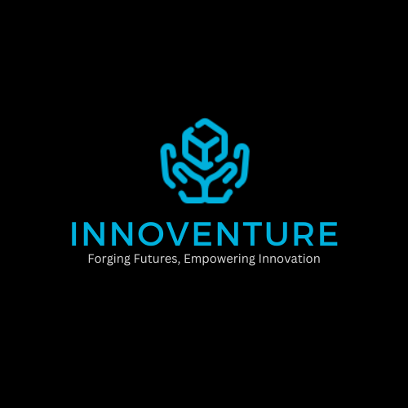

Figure II: The INNOVENTURE Logo

The company's commitment to embracing innovation and taking risks. The hands represent support and nurturing of ideas, while the box signifies the potential for future advancement in technology. Together, they reflect our dedication to pushing boundaries and driving positive change.

***2. c. Company Vision***

Our vision at INNOVENTURE is to catalyze transformative innovation and empower visionary entrepreneurs to create a brighter future.

***2. d.* *Company Mission***

To encourage and facilitate novel ideas, technologies, and solutions that have the potential to disrupt markets, solve pressing challenges, and create value for society

***2. e. Company Goals***

* Cultivate innovation both internally and externally.
* To foster a development for future purposes.
* Make an impact on the society and economy by producing valuable system.

## *2. f. Company Policies*

### *2. f. 1. Meetings*

* INNOVENTURE company’s meeting will be held at the agreed time and place.
* The company’s team shall work its assigned tasks and finish on time.
* Irrelevant topics and matters shall not be discussed during work hours.
* Any extra activities during work hours is strictly prohibited.
* 5 hours work per day will strictly followed.
* The company provides due date on each tasks and shall strictly followed.
* Drinking alcoholic beverages will not allowed during work hours.
* The company shall agree that the **Project Manager** shall act as a treasurer.
* The **System Analyst** shall be one in charge if **Project Manager** is not present.
* The money that the company will collect will not be refundable.

## *2. f. 2. Funding*

* The amount of PHP 20.00 will be collected every weekend.
* The funding must only be utilized for INNOVENTURE purposes and be fully documented for transparency's sake.
* Each member will get a single payment of PHP 500.00 as emergency funding.

### ***2. f. 3. Penalties***

* The member will be fined PHP 10.00 and an extra PHP 10.00 in the following hours if they are late for any official corporate activities.
* 3 instances of missing any formal company activities will result in disciplinary action.
* If a worker neglects 3 tasks, they will be immediately fired from the company without warning.
* If the task is not submitted on time, there will be a fee of PHP 30.00 and an extra PPHP 10.00 for each day that goes by.
* Any member who violates a rule will be penalized PHP 10,00 for each infraction.
* The Company's money will be applied to all funds obtained from the penalty.

## ***2. g. Contract of Agreement***

*Refer to next page.*

**CONTRACT OF AGREEMENT**

We, the undersigned, hereby abide the INNOVENTURE rules and regulations, policies, and penalties set by the INNOVENTURE Company.

Signed this February 4, 2024 at the College of Computing Studies, Western Mindanao State University, Normal Road, Baliwasan, Zamboanga City, Philippines, 7000

Zeinab P. Halipa

System Analyst

Kimhar A. Lim

Tester

Crisha Campomayor

Project Manager

Ahmidserhan A. Halon

Lead Programmer

Ms. Justine Ann Albay-Arip

Instructor

## ***2. h. Organizational Structure***

## ***2. h. 1. Overall Structure***

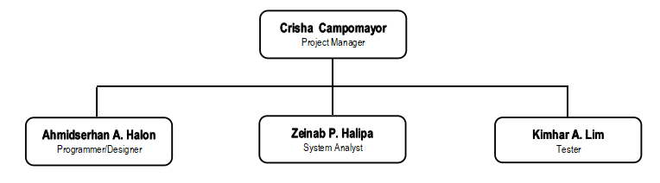

Figure III: The INNOVENTURE Overall Structure

***2. h. 2. Management Team***

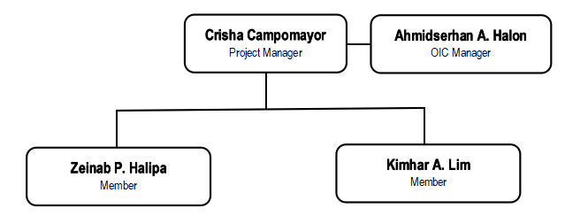

Figure IV: The INNOVENTURE Management Team

### ***2. h. 3. System Design Team***

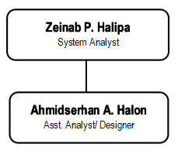

Figure V: The INNOVENTURE System Design Team

***2. h. 4. Programming Team***

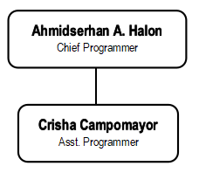

Figure VI: The INNOVENTURE Programming Team

### ***2. h. 5. Testing Team***

### Screenshot 2024-01-30 093159

Figure VII: The INNOVENTURE Testing Team

### ***2. h. 6. Training Team***

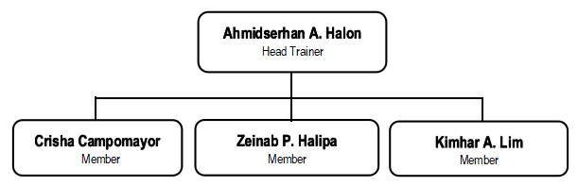

Figure VIII: The INNOVENTURE Training Team

### ***2. h. 7. Documentation Team***

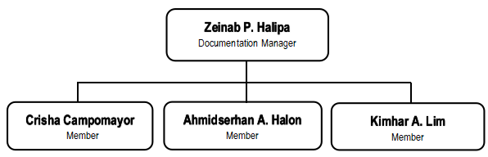

Figure IX: The INNOVENTURE Documentation Team

***2. i. Company Roles and Responsibilities***

### ***2. i. 1. Project Manager***

**Crisha Campomayor**

The project manager bears primary accountability for the project's effective start, planning, design, execution, monitoring, control, and close. In order to satisfy the needs of the client, the project manager also analyzes, designs, determines, adjusts, and improves the solution. To effectively manage and oversee the job, the project manager needs to possess strong leadership abilities, including:

* Organizing and planning project tasks, such as establishing goals, deadlines, budgets, and scope.
* Directing project teams, delegating responsibilities, and encouraging cooperation.
* Overseeing project execution, keeping an eye on developments, and resolving problems when they appear
* Keeping stakeholders informed, managing expectations, and communicating.
* Project risk identification and mitigation using proactive risk management techniques.
* Ensuring that project deliverable adhere to quality guidelines and requirements.
* Effectively managing project finances and resources to reduce expenses and maximize utilization
* Managing the project's closing procedures and carrying out reviews after the project to promote ongoing development.

### ***2. i. 2. System Analyst***

**Zeinab P. Halipa**

Prior to developing and executing a solution, the system analyst makes sure that the requirements specified by the company are accurately recorded and captured. They are also in charge of designing, evaluating, and implementing systems. The functions and responsibilities of a System Analyst are outlined below. The System Analyst enters the picture during the Analysis Phase of the system's development.

* Update the system regularly to add new features or fix issues.
* Fix any problems that come up during integration.
* Identify potential problems that could happen.
* Explain technical things in simple terms.
* Update the system regularly to add new features or fix issues.
* Use techniques such as use case analysis, user stories, and requirement prioritization to refine requirements.
* Collaborate with stakeholders from various departments to elicit, document, and analyze system requirements.
* Create detailed specifications for system components, interfaces, and interactions.

### ***2. i. 3. Chief Programmer/Designer/Trainer***

**Ahmidserhan A. Halon**

Programmers are essential to the development process because they bring

their technical know-how, creative problem-solving abilities, and problem-solving skills to the table to produce high-caliber software solutions that satisfy users' and clients' expectations.

* Develop high-quality, clean, and efficient code according to project requirements and coding standards.
* Analyze software requirements and translate them into technical solutions. Troubleshoot and debug code to identify and resolve issues.
* Work closely with other team members, such as project managers, designers, and quality assurance testers, to ensure smooth development and delivery of software products.
* Apply expertise in programming languages, frameworks, and tools to implement software solutions effectively.
* Stay updated on emerging technologies, programming languages, and development methodologies to improve skills and stay competitive in the field.
* Identifying and fixing defects or bugs in software code through debugging and troubleshooting techniques.

### **2. i. 4. Test Engineer**

**Kimhar A. Lim**

In order to validate software quality, find flaws, and make sure that products live up to consumer expectations, test engineers are essential. Their work helps to provide dependable, superior software products that increase customer happiness and boost company profitability.

* Responsible in creating test cases according to the specs, user stories, and requirements.
* Find chances for complex or repeated test cases to be automated.
* Report defects discovered during testing, including detailed descriptions, steps to reproduce, and severity assessments.
* Develop and maintain automated test scripts using testing frameworks and tools.
* Document test plans, test cases, and test results in a clear and organized manner.
* Provide feedback on user experience and suggest improvements to enhance user satisfaction and product quality.
* Maintain test documentation up-to-date to reflect changes in requirements or system behavior.

## ***2. j. Evaluation of Work Styles***

|  |  |  |  |  |
| --- | --- | --- | --- | --- |
| **NAMES** | **ROLES** | **WORK STYLE** | | **RESPONSIBILITIES** |
| **Individual Assessment** | **Group Assessment** |
| Crisha Campomayor | Project Manager | Rational Introvert | Rational Extrovert | Having a growth mindset and being open to learning new skills, willing to adapt in any working environment and have a strong leadership skills that can handle people. |
| Zeinab P. Halipa | System Analyst | Intuitive Intovert | Rational Extrovert | She is curious and inquisitive about how things work, and have a wide imagination and full of wisdom and patience to control things that under pressure. |
| Ahmidserhan A. Halon | Programmer | Rational Extrovert | Rational Extrovert | A person who is supreme and dominant due to his excellent logical and leading abilities. makes decisions that are best for the team as a whole as well as for himself. We do the assignment on time because he effectively handles our time. Sufficiently accountable to verify if the assignment is current. |
| Kimhar A. Lim | Test Engineer | Intuitive Extrovert | Intuitive Introvert | a reserved individual who is passionate about his work and shares his views with the team. opens doors and attempts to visualize the project on a much larger scale. |

Table I: Evaluation of Work Styles