**BIC 305**

**COMPOSITION AND STRUCTURE OF BIOLOGICAL MEMBRANE**

**Definition**

A biological membrane or cell membrane is a **selectively permeable membrane** that separates and protects the interior of all cells from the outside environment (the extracellular space). Membranes define the external boundaries of cells and control the molecular traffic across that boundary; In eukaryotic cells, they also divide the internal space into discrete compartments to segregate processes and components.

Membranes are flexible, self-repairing, and selectively permeable to polar solutes (ions and organic molecules). Their flexibility permits the shape changes that accompany cell growth and movement (such as amoeboid movement). With their ability to break and reseal, two membranes can fuse, as in exocytosis, or a single membrane-enclosed compartment can undergo fission to yield two sealed compartments, as in endocytosis or cell division. Because membranes are selectively permeable, they retain certain compounds and ions within cells and within specific cellular compartments while excluding others.

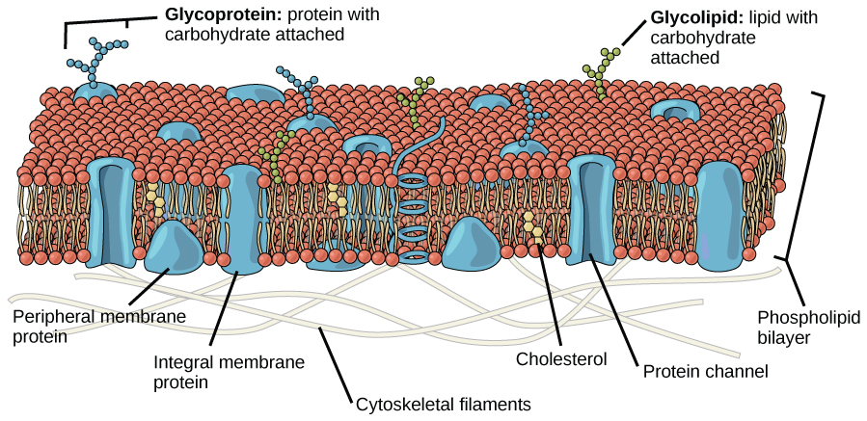

BIOLOGICAL STRUCTURE OF THE CELL MEMBRANE

FUNCTIONS:

1. Protects the integrity of the interior of the cell by allowing certain substances into the cell while keeping others out.
2. It serves as a physical barrier, protecting all the components of the cell from the outside environment and allows separate activities to occur inside and outside the cell.
3. Serves to support the cell and help maintain the shape
4. Regulate cell growth through balance of endocytosis and exocytosis.
5. It also serves as an attachment surface for several extracellular structure including cell wall, glycocalyx.

**CELLULAR PROCESSES**

They are involved in variety of cellular processes such as;

**Cell adhesion**: a process by which cells interact and attach to neighboring cells through specialized molecules of the cell surface. Adhesion is required for cell communication and regulation and tissue formation.

**Cell signaling**- Proteins called surface protein markers embedded in the cell membrane identify the cell, enabling nearby cells to communicate with each other. Cell membranes often include reporter sites for interactions with specific biochemical such as hormones. In this way, the cell can recognize and process some signals received from the extracellular environment.

**Transport**- Plasma membranes can allow transport of molecules across the cell membrane in or out of the cell with or without the use of energy. In passive transport, energy is not needed for the transport of materials. Examples include diffusion, osmosis while active transport require the use of energy to transport materials against their concentration gradient. Membranes also transport materials by the formation of vesicles as in endocytosis and exocytosis.

**COMPOSITION**

One approach to understanding membrane function is to study membrane composition. So, before describing membrane structure and function, we consider the molecular components of membranes.

The principal components of a biological membrane are Lipids (Phospholipids and Sterols), Proteins and Carbohydrates (attached to some of the lipids and some of the proteins which is present as part of glycoproteins and glycolipids). Lipids and proteins account for almost all the mass of biological membrane.

**LIPIDS**

The biological membrane is made up of lipids which are amphipathic, which means they have a polar hydrophilic heads and a non-polar hydrophobic tail. The cell membrane consists of three classes of amphipathic lipids; Phospholipids, Glycolipids and Sterols. The amount of each depends on the type of cell but in most cases phospholipids are most abundant (contributing for over 50% of all lipids in plasma membranes), glycolipids account for about 2% and sterols make up the rest.

PHOSPHOLIPIDS

Phospholipid is the main component of the cell membrane. It is made up of two fatty acid tails, a phosphate group head and a glycerol molecule. The fatty acid in phospholipids may be saturated or unsaturated. The length and degree of unsaturation of the fatty acid chains have been found to have profound effect on membrane fluidity as unsaturated lipids create a kink, preventing the fatty acids from packing closely together, thus increasing the fluidity of the membrane.

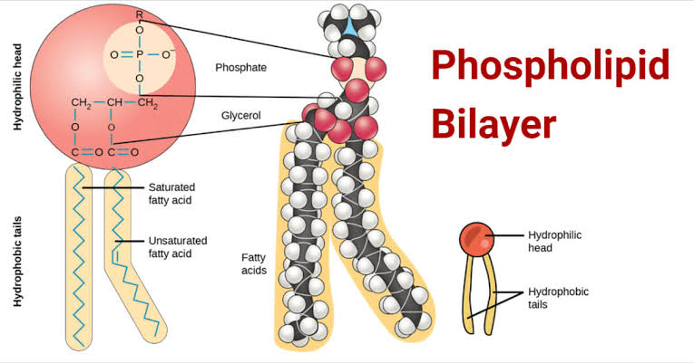

STEROLS

This is present in membranes as Cholesterol. It is normally found in varying degrees throughout cell membranes, in between the hydrophobic tails of the membrane lipids where it confers a stiffening and strengthening effect on the membrane. It is a major component of animal cell membrane. In high temperature, it inhibits the movement of the fatty acid chains causing a reduced permeability to small molecules and reduced membrane fluidity but in cooler temperature cholesterol’s production is increased as it acts as an antifreeze by interfering with fatty acid chain interactions thereby maintaining the fluidity of the membrane.

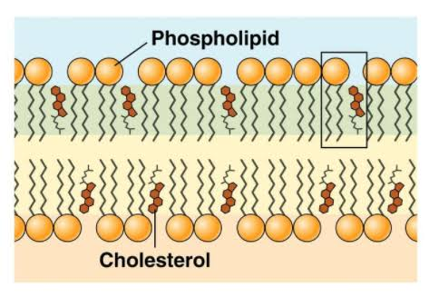

PROTEINS

The cell membrane has a large content of proteins, typically about 50% of membrane volume and are responsible for various biological activities such as transportations (channel proteins), cell adhesion, enzymatic reactions etc.

Membrane proteins consists of two main types; Integral proteins and Peripheral proteins.

**Integral proteins:** these span the membrane and have 3 domains. A hydrophilic cytosolic domain, which interacts with internal molecules, a hydrophobic membrane-spanning domain that anchors it within the cell membrane and a hydrophilic extracellular domain that interacts with external molecules. E.g. ion channels, proton pumps.

**Peripheral proteins:** these are attached to integral membrane proteins or associated with the peripheral regions of the bilayer. These proteins tend to have only temporary interactions with biological membranes and once reacted, the molecule dissociates. e.g. some enzymes and hormones.

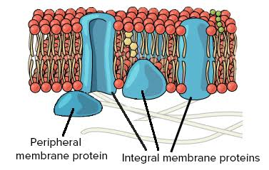

STRUCTURE OF THE MEMBRANE SHOWING THE PERIPHERAL AND INTEGRAL PROTEINS

CARBOHYDRATES

Glycoproteins: These are membrane protein with a carbohydrate(oligosaccharide) covalently bonded to it.

Glycolipids: These are lipids with a carbohydrate attached by a glycosidic (covalent) bond, some glycolipids are present (cerebrosides and gangliosides).

They can be seen as bead like strands on the surface of the cell where they recognize hosts cells and share information.

Glycoproteins and Glycolipids acts as ID tags for cell recognition and specificity in binding.

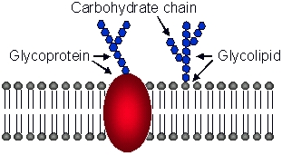

STRUCTURAL REPRESENTATION OF CARBOHYDRATES IN BIOLOGICAL MEMBRANE

Composition is not set but constantly changing for fluidity and changes in environment. Each type of membrane has characteristic lipids and proteins, this results in diversity of biological roles. For example, the myelin sheath - present in certain neurons - consists primarily of lipids (good insulators), whereas the plasma membranes of bacteria and the membranes of mitochondria and chloroplasts, the sites of many enzyme-catalyzed processes, contain more protein than lipid.

STRUCTURE

Biological membranes consist of a double sheet of lipid molecules; because of the amphipathic nature of phospholipids -having one end soluble in water (polar) and the other soluble in fat (nonpolar) – they are able to form double layer with the polar ends pointing outwards and the nonpolar ends pointing inwards. These structure is called a ‘lipid bilayer’. In addition to the various types of lipids that occur in biological membranes, membrane proteins are also key components of the structure.

Phospholipids consists of two fatty acid chain linked to glycerol and a phosphate group (which has a negative charge and allows the phospholipid to be hydrophilic). The phosphate group carries a choline group (a nitrogen containing compound). Membrane lipids naturally form a bilayer because of their amphipathic nature. When placed in water, membrane lipids will spontaneously form liposomes, which are formed of a bilayer with water inside and outside, resembling a tiny cell. The aggregation of membrane lipids (phospholipid) to form a bilayer is caused by ‘the hydrophobic effect’. This is the most favorable configuration for these lipids as it means that all the hydrophilic heads are in contact with water and all the hydrophobic tail are in a lipid environment.

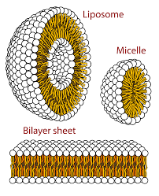

UNIT MEMBRANE HYPOTHESIS

Due to the inability of Gorter and Grendel’s model of the structure of the plasma membrane to answer certain questions (such as permeability, surface tension etc.). In 1935, two scientist Hugh Davson and James Danielli, suggested that membranes really do have proteins. They proposed that the cell membrane is composed of a lipid bilayer with a thin layer of protein coating on both sides of the membrane. They explained that the cell membrane contains a lipoid center covered by protein monolayers and simplified their model into the “pauci-molecular” theory (it is also known as the ‘sandwich’ model).

In 1950, J. David Robertson, through the use of electron microscopy proposed the **UNIT MEMBRANE MODEL**.

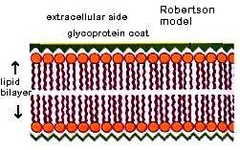

Basically, he suggested that all cellular membranes share a similar underlying structure, the unit membrane. According to the trilaminar pattern of the cellular membrane viewed by Robertson, he proposed that the membrane consists of a lipid bi-layer covered on both surfaces with thin sheets of proteins (mucoproteins). His proposal agreed with the sandwich model proposed by Davson and Danielle.

However, this model still had some serious complications, a major one being that the proteins studied then where mainly globular and could therefore not fit into the model’s claim of thin protein sheet. These difficulties with the model stimulated new research in membrane organization and paved the way for the fluid mosaic model, which was proposed in 1972.