CU1 — Social Media Marketing:
Optimisation Report
Ref: TVETLIPIS-CU1-SMM-006
Organisation: Kolej Islam Antarabangsa Kuala Lipis (KIAK) / TVET Lipis
Prepared by: Zuriel Seong Ming Ee
Report Period: Q2 2025 (April – June 2025)
Work Activities Covered: WA5 (Monitor & Evaluate), WA6 (Optimise)

1. Strategic Purpose
This optimisation report evaluates the performance of TVET Lipis's social media marketing campaigns on Meta Ads (Facebook + Instagram) for Q2 2025, documents the optimisation decisions made by management, and presents a forward-looking action plan for H2 2025. The report demonstrates a data-driven management approach: diagnose → decide → act → measure.

2. Creative Performance Analysis
The following chart compares Click-Through Rate (CTR) across all ad creatives run in Q2 2025. The benchmark CTR for Malaysian education ads is 1.50%. Creatives below benchmark were paused or refreshed; creatives above benchmark received increased budget allocation.
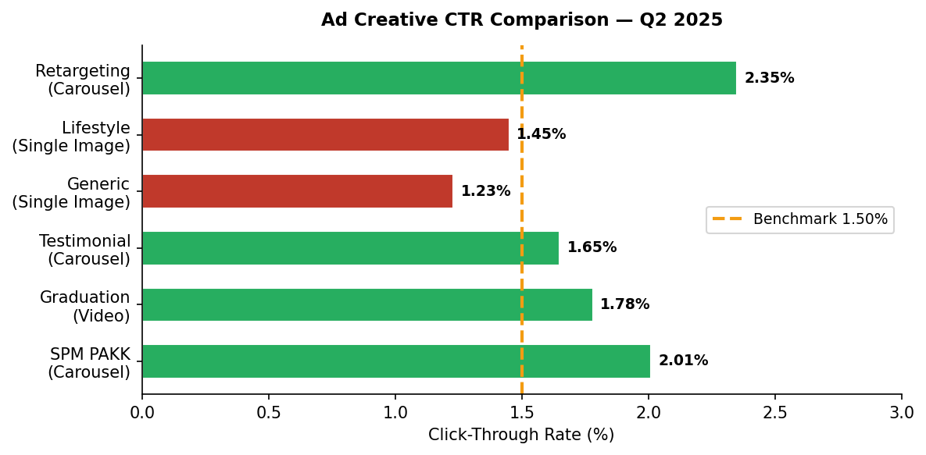
Figure 1: CTR by Ad Creative (Green = above benchmark, Red = below benchmark)

Creative | Format | CTR | vs Benchmark | Decision
SPM PAKK | Carousel | 2.01% | +0.51pp ✅ | Scale up — increase budget 30%
Graduation | Video | 1.78% | +0.28pp ✅ | Maintain — produce new variant
Testimonial | Carousel | 1.65% | +0.15pp ✅ | Maintain
Generic | Single Image | 1.23% | -0.27pp ❌ | Pause — refresh creative
Lifestyle | Single Image | 1.45% | -0.05pp ⚠️ | A/B test with new copy
Retargeting | Carousel | 2.35% | +0.85pp ✅ | Best performer — max budget

3. Placement Efficiency Analysis
Cost Per Lead (CPL) varies significantly across placements. Management decision: pause all placements with CPL > RM 15.00 and reallocate budget to proven placements.
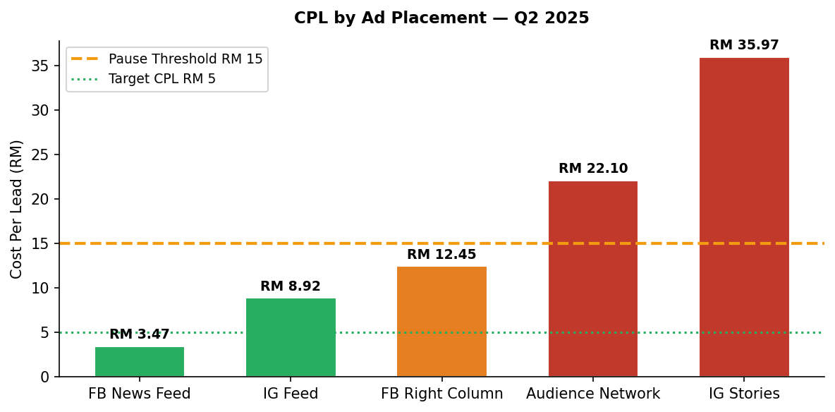
Figure 2: CPL by Placement (Green ≤ RM10, Orange RM10–20, Red > RM20)

Placement | Spend | Leads | CPL | Decision
FB News Feed | RM 1,850 | 533 | RM 3.47 | ✅ Scale — increase to RM 2,400/month
IG Feed | RM 712 | 80 | RM 8.92 | ✅ Maintain — better content needed
FB Right Column | RM 498 | 40 | RM 12.45 | ⚠️ Monitor — reduce by 30%
Audience Network | RM 441 | 20 | RM 22.10 | ❌ Pause — budget reallocated
IG Stories | RM 898 | 25 | RM 35.97 | ❌ Pause — budget reallocated

4. Budget Reallocation Decision
Based on placement efficiency data, management approved the following budget reallocation for Q3 2025. Total monthly budget maintained at RM 4,000. Savings from paused placements redirected to FB News Feed and Retargeting.
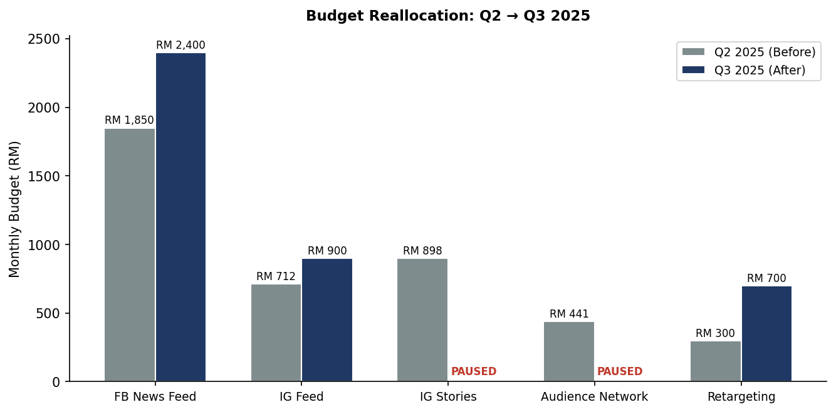
Figure 3: Monthly Budget Allocation Before vs After Optimisation

5. Performance Trend (Weekly CTR)
The following chart shows the weekly CTR improvement trajectory from the start of Q2 2025 following each optimisation action. Key interventions are annotated on the chart.
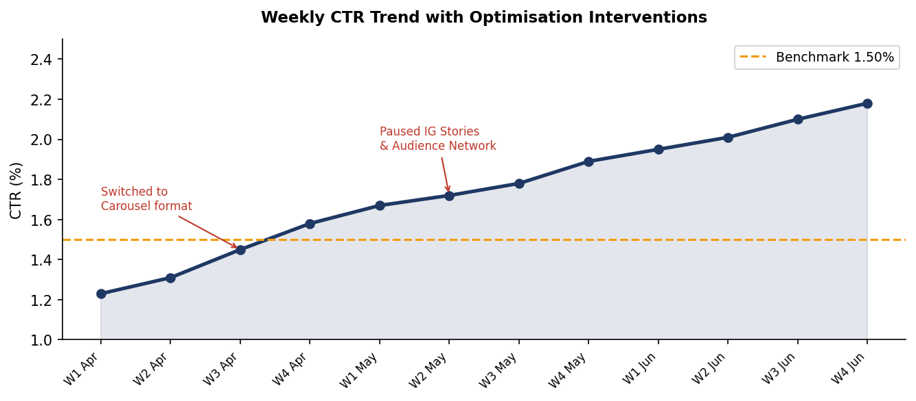
Figure 4: Weekly CTR Trend — Q2 2025 (Benchmark = 1.50%)

6. Q3 2025 Projected Outcomes
KPI | Q2 2025 Actual | Q3 2025 Target | Basis
Avg CTR | 1.89% | 2.20% | Creative refresh + Carousel-first approach
CPL | RM 4.61 | RM 3.80–4.00 | Pause high-CPL placements; scale FB News Feed
Monthly leads | ~450 | 550–600 | Budget reallocation to proven placements
Cost per conversion | RM 4.61 | RM 3.90 | LAL audience expansion + retargeting scale
Monthly ad spend | RM 3,599 | RM 4,000 | Management-approved budget increase

Approval Section
Role | Name | Signature | Date
Prepared by | Zuriel Seong Ming Ee | ___________________ | ___________
Reviewed by | [PPT Supervisor / Assessor — Pending] | ___________________ | ___________
Approved by | Puan Wan Norizan Binti Wan Badaruzaman  Koperasi WI | ___________________ | ___________

