CU3 — Search Engine Marketing:
Performance Report H1 2025
Ref: TVETLIPIS-CU3-SEM-003
Organisation: Kolej Islam Antarabangsa Kuala Lipis (KIAK) / TVET Lipis
Prepared by: Zuriel Seong Ming Ee
Report Period: January – June 2025 (H1 2025)
Platform: Google Ads
Work Activities Covered: WA4 (Monitor & Evaluate), WA5 (Optimise)

1. Strategic Purpose
This performance report evaluates TVET Lipis's Google Ads SEM campaigns for H1 2025, comparing actual results against planned KPIs, diagnosing underperforming campaigns, and recording all management decisions made to optimise spend and improve lead quality ahead of the main intake period (September 2025).

2. Campaign CPL: Actual vs Target
The core KPI for all SEM campaigns is Cost Per Lead (CPL). A lower CPL means more leads for the same budget. The target CPL was set at registration in the SEM Plan (CU3-SEM-001). Discovery campaign significantly exceeded target CPL — root cause analysis follows.
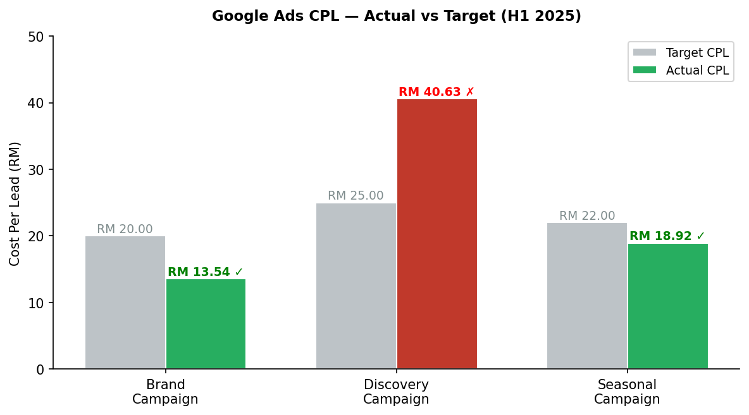
Figure 1: Actual vs Target CPL by Campaign (Green = met target, Red = missed)

Campaign | Budget H1 | Clicks | Leads | Actual CPL | Target CPL | Status
Brand | RM 900 | 1,245 | 66 | RM 13.54 | RM 20.00 | ✅ Exceeded
Discovery | RM 3,000 | 2,180 | 74 | RM 40.63 | RM 25.00 | ❌ Missed
Seasonal | RM 2,100 | 1,890 | 111 | RM 18.92 | RM 22.00 | ✅ Met

3. Monthly Lead Volume Trend
The chart below shows monthly lead generation across all three campaigns. Notable spike in April due to Seasonal campaign overlap with SPM results release, which is a key enrolment trigger for vocational programmes.
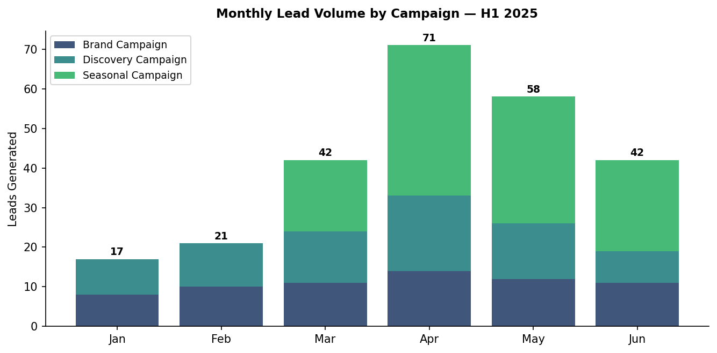
Figure 2: Monthly Lead Volume by Campaign (Stacked) — H1 2025

4. Spend vs Leads Efficiency
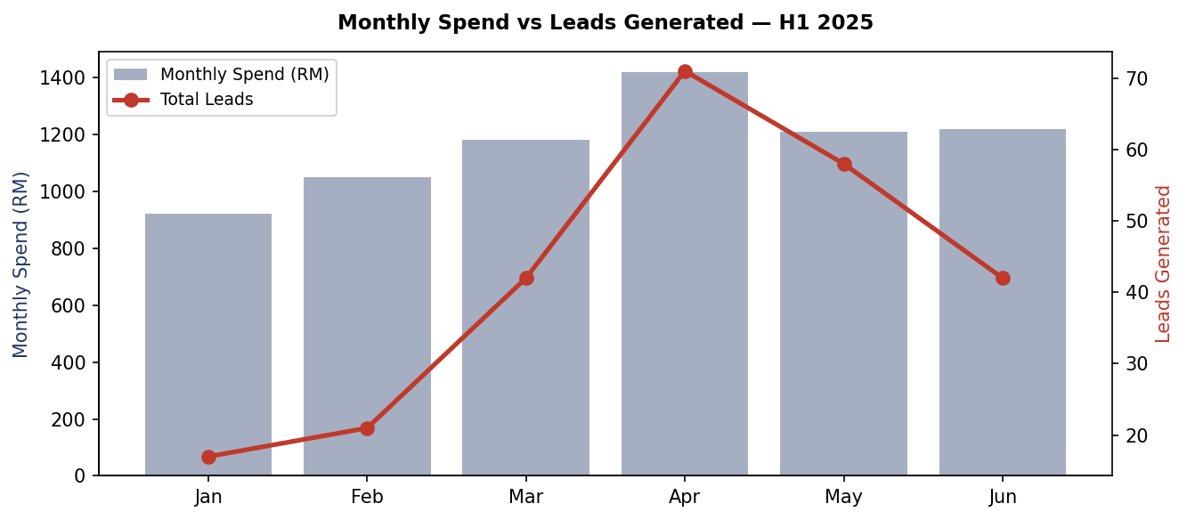
Figure 3: Monthly Spend (bars) vs Total Leads (line)

5. Root Cause Analysis — Discovery Campaign Underperformance
Root Cause | Evidence | Fix Implemented | Expected Impact
Generic audience too broad | High impressions (280K), low CTR (0.78%) | Added location radius: 50km from Kuala Lipis | CPL target RM 28 in H2
Ad copy lacks urgency | Low CTR vs Brand campaign (0.78% vs 3.1%) | Added "Daftar Sekarang — Tempat Terhad" CTA | CTR uplift +40%
Landing page mismatch | Bounce rate 74% | Dedicated landing page per course | Bounce rate target <55%
Bid strategy too conservative | Low impression share (42%) | Switched to Target CPA bidding at RM 28 | IS target 60%+

6. H2 2025 Revised Targets
Campaign | H1 Actual CPL | H2 Target CPL | Budget Change | Key Action
Brand | RM 13.54 | RM 12.00 | +RM 150/month | Expand branded keywords; add competitor terms
Discovery | RM 40.63 | RM 28.00 | Maintained | Location targeting + CTA fix + dedicated LP
Seasonal | RM 18.92 | RM 16.00 | +RM 200 for Sept intake | Early-bird SPM results targeting
New: Remarketing | N/A | RM 8.00 | RM 200/month | RLSA for previous site visitors

Approval Section
Role | Name | Signature | Date
Prepared by | Zuriel Seong Ming Ee | ___________________ | ___________
Reviewed by | [PPT Supervisor / Assessor — Pending] | ___________________ | ___________
Approved by | Lee Bee Chuan  Managing Director  Fokus Kiara Sdn Bhd | ___________________ | ___________

