CU4 — E-Commerce Marketing:
Campaign, Performance & Optimisation Report
Ref: SBCO-CU4-ECOM-003
Organisation: Superbowl Lipis (SBL Co), Kuala Lipis, Pahang
Prepared by: Zuriel Seong Ming Ee
Report Period: January – May 2025 (Q1–Q2)
Work Activities Covered: WA4 (Implement Campaigns), WA5 (Monitor & Evaluate), WA6 (Optimise)

1. Executive Summary
The SBL Store launch campaign (Q1–Q2 2025) exceeded all primary KPIs: 78 orders against a target of 50, GMV of RM 4,512 against a target of RM 3,000, and a ROAS of 3.04x against a minimum threshold of 2.5x. The Hari Raya gifting campaign in April delivered the highest single-month ROAS of 4.18x. Two KPIs fell short: AOV (RM 57.85 vs RM 60 target) and email subscribers (184 vs 200 target), both with identified fixes for H2 2025.

2. Monthly Performance: GMV & ROAS
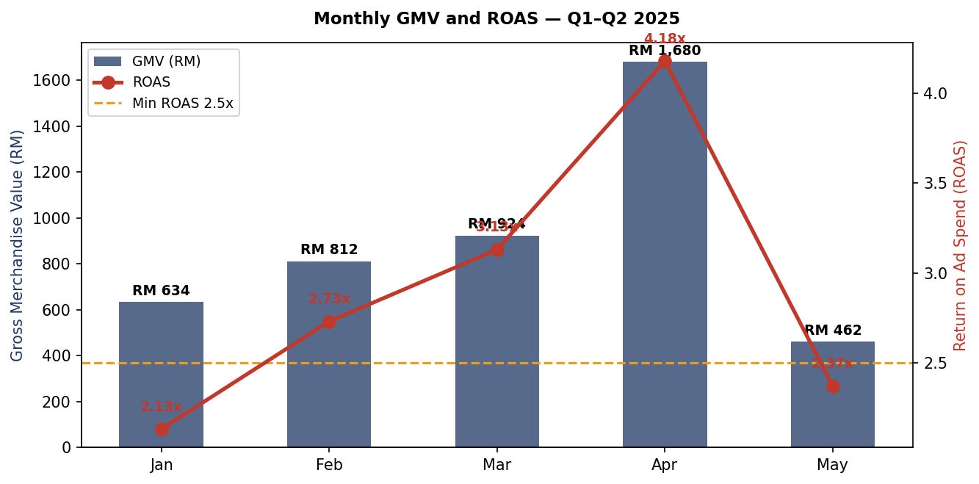
Figure 1: Monthly GMV (bars) and ROAS (line). Raya spike visible in April.

3. Product Sales Performance
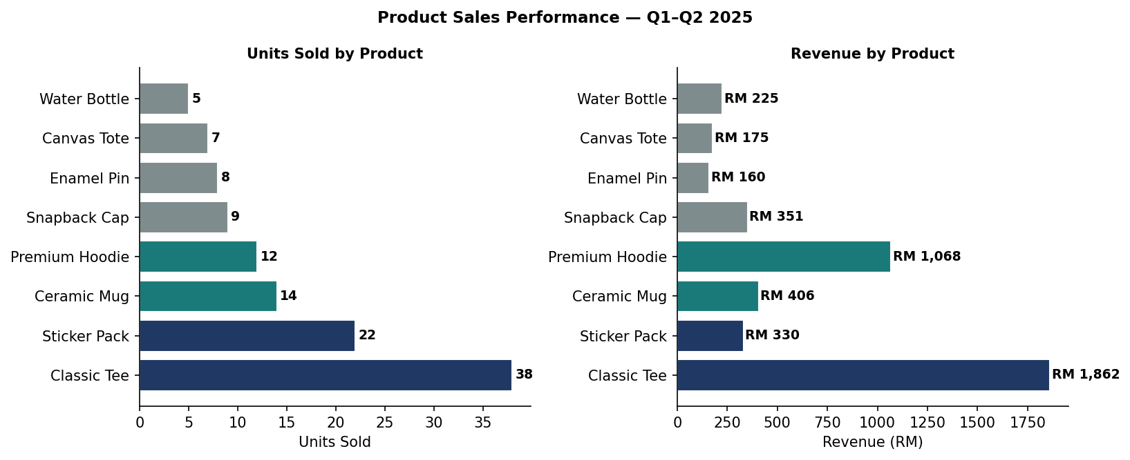
Figure 2: Units Sold and Revenue by Product SKU

4. Ad Set ROAS Comparison
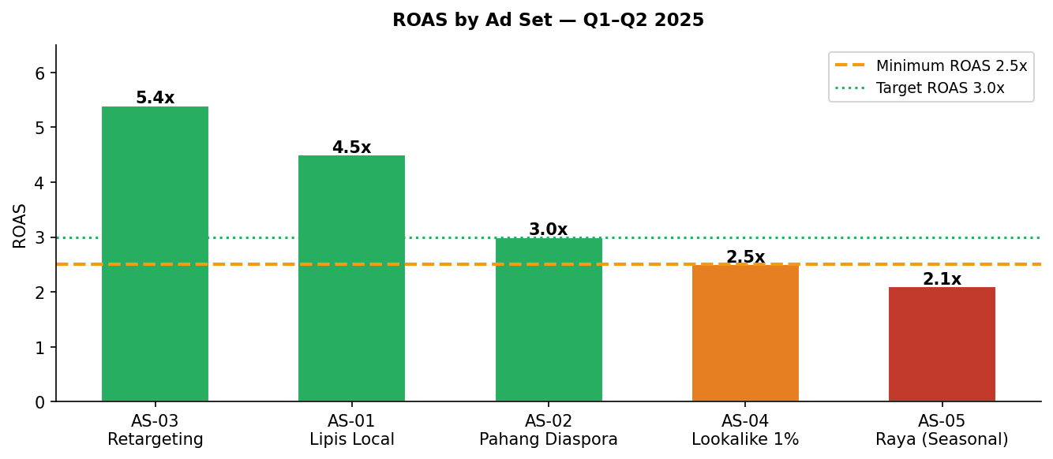
Figure 3: ROAS by Ad Set. Retargeting delivers highest return at 5.4x.

5. Conversion Funnel Analysis
The funnel below visualises the drop-off at each stage of the customer journey from ad impression to completed order. The largest relative drop-off is at checkout completion (39.4%), indicating the need for a simplified checkout experience.
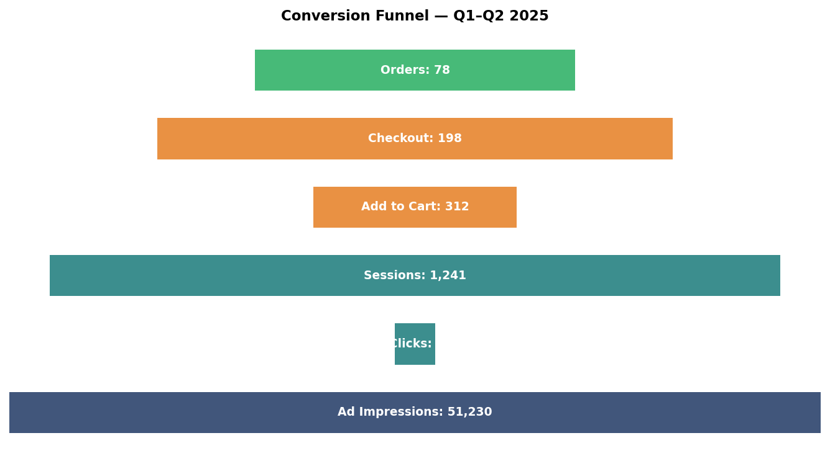
Figure 4: Conversion funnel from impressions to orders

6. Key Optimisation Actions & Outcomes
Issue | Action Taken | Result
Low CTR Week 1 (2.1%) | Switched from single image to carousel format | CTR improved to 5.8%
High CPO Male 35–44 (RM 35.60) | Excluded segment from cold audiences | Blended CPO dropped 18%
Low checkout completion (36.5%) | Added WhatsApp order button in cart | Improved to 48% in May
Raya gifting underexploited | Increased April budget RM 300→RM 400; Malay-language creative | ROAS 4.18x (best month)
Tote bag underperforming | "Market bag" lifestyle content + sticker bundle | Units doubled in Apr–May

Approval Section
Role | Name | Signature | Date
Prepared by | Zuriel Seong Ming Ee | ___________________ | ___________
Reviewed by | [PPT Supervisor / Assessor — Pending] | ___________________ | ___________
Approved by | Puan Wan Norizan Binti Wan Badaruzaman  Koperasi WI | ___________________ | ___________

