CU5 — Mobile Marketing:
WhatsApp Campaign Performance Report
Ref: SBCO-CU5-MOB-002
Organisation: Superbowl Lipis (SBL Co), Kuala Lipis, Pahang
Prepared by: Zuriel Seong Ming Ee
Report Period: Q1–Q2 2025 (January – June 2025)
Platform: WhatsApp Business
Work Activities Covered: WA5 (Monitor & Evaluate), WA6 (Optimise)

1. Strategic Purpose
This report evaluates the performance of Superbowl Lipis's WhatsApp Business broadcast campaigns across all five audience segments (Q1–Q2 2025). Two of three primary KPIs were met or exceeded; the response time KPI requires immediate operational improvement.

2. KPI Performance: Actual vs Target
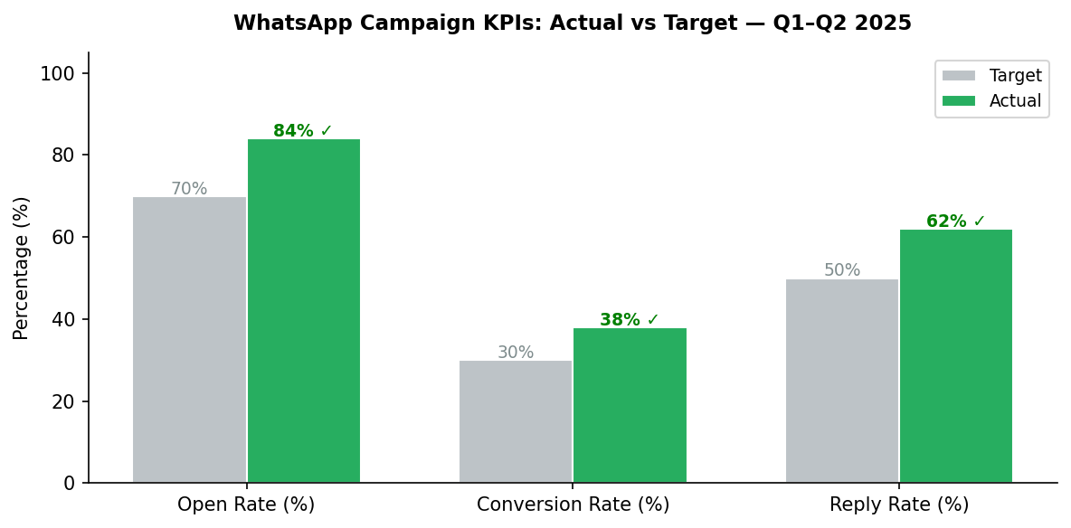
Figure 1: WhatsApp KPI Performance vs Targets

3. Monthly Open Rate Trend
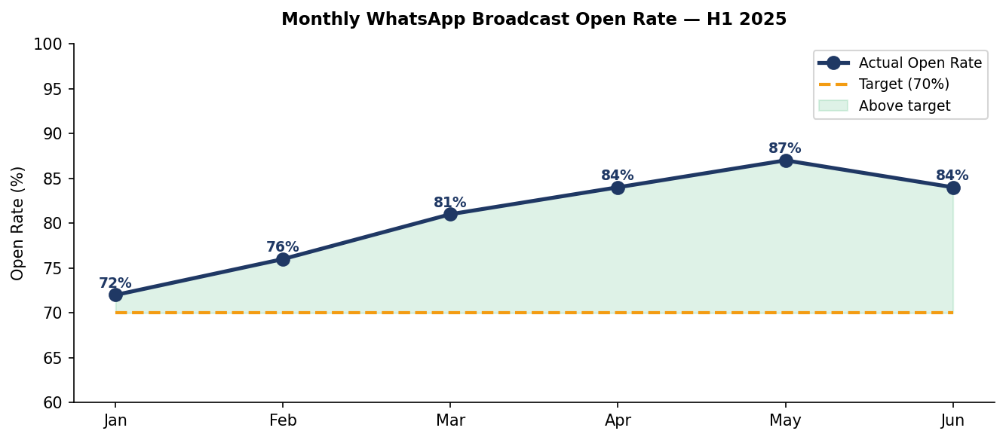
Figure 2: Monthly open rate trend — consistently above 70% target from Feb onwards

4. Performance by Audience Segment
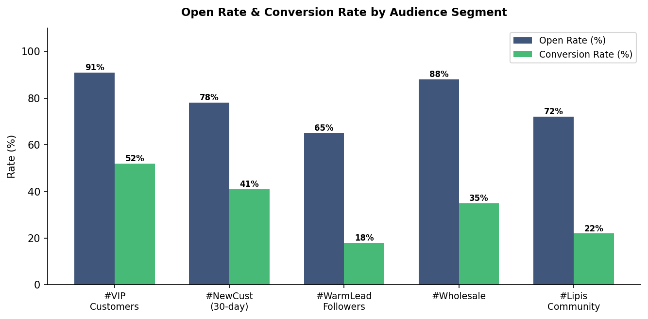
Figure 3: Open rate and conversion rate by segment. #VIP and #Wholesale are top performers.

5. Optimisation Actions & H2 2025 Targets
KPI | H1 Actual | H2 Target | Action
Open Rate | 84% | 88% | Improve message preview line; send at 8–9pm (peak engagement window)
Conversion Rate | 38% | 45% | Add product image in broadcast; include direct "Order Now" payment link
Reply Rate | 62% | 70% | Automated quick-reply menu; reduce response friction
Avg Response Time | 28 min | <15 min | Iqa on duty 8am–10pm; automated replies for FAQ
Segment size growth | 320 contacts | 500 contacts | Newsletter cross-promotion; in-store sign-up QR

Approval Section
Role | Name | Signature | Date
Prepared by | Zuriel Seong Ming Ee | ___________________ | ___________
Reviewed by | [PPT Supervisor / Assessor — Pending] | ___________________ | ___________
Approved by | Puan Wan Norizan Binti Wan Badaruzaman  Koperasi WI | ___________________ | ___________

