CU6 — Email Marketing:
Mailchimp Campaign Performance Report
Ref: TVETLIPIS-CU6-EMAIL-002
Organisation: Kolej Islam Antarabangsa Kuala Lipis (KIAK) / TVET Lipis
Prepared by: Zuriel Seong Ming Ee
Report Period: Q1 2025 (January – March 2025)
Platform: Mailchimp
Work Activities Covered: WA5 (Monitor & Evaluate), WA6 (Optimise)

1. Strategic Purpose
This report evaluates the performance of TVET Lipis's Mailchimp email marketing programme for Q1 2025. Results are benchmarked against Malaysian education-sector industry averages and global Mailchimp benchmarks. All primary KPIs exceeded targets in Q1 2025.

2. Performance vs Industry Benchmark
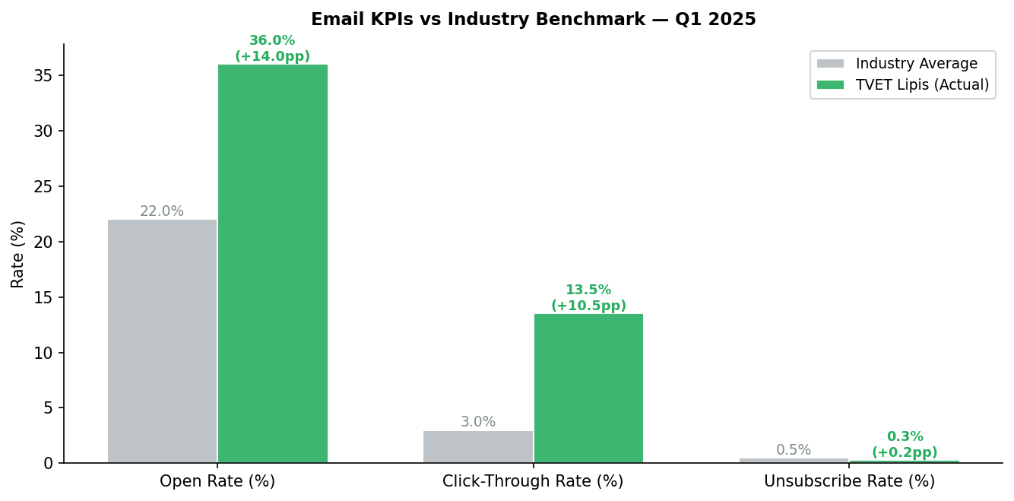
Figure 1: TVET Lipis email performance vs Malaysian education industry averages

3. Subscriber List Growth
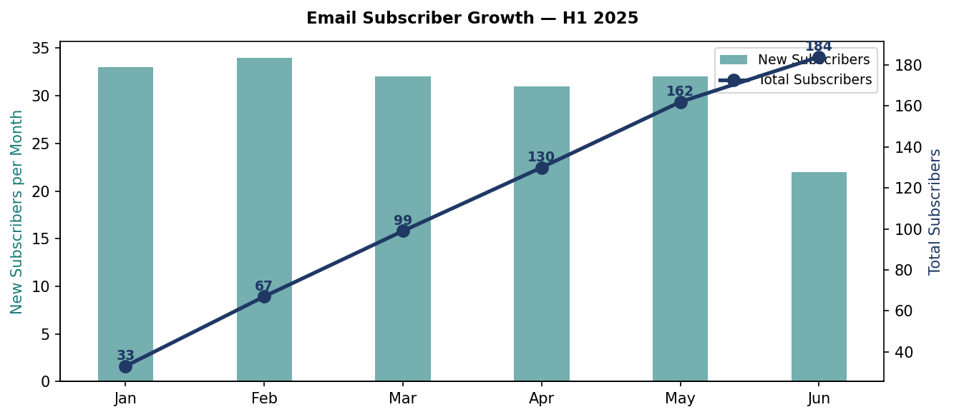
Figure 2: Monthly new subscribers (bars) and cumulative total (line) — H1 2025

4. Campaign Open Rate by Sequence
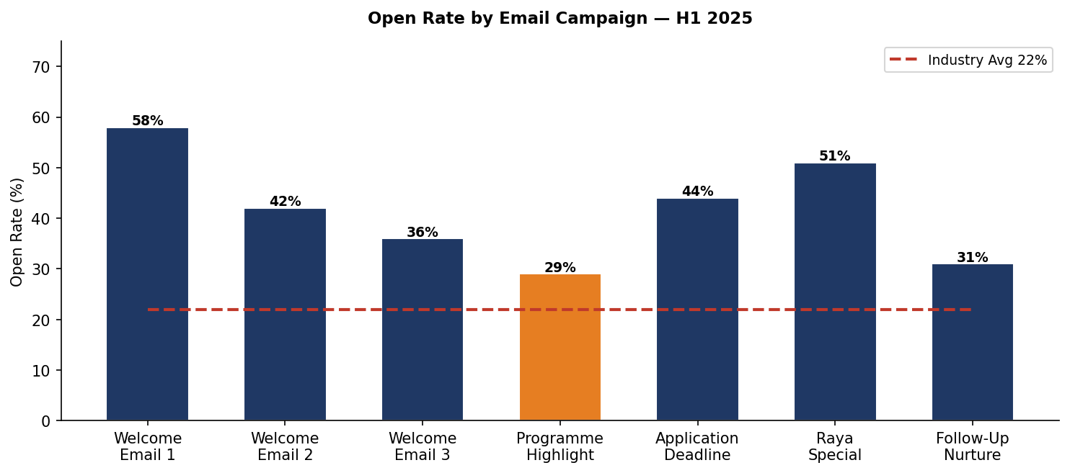
Figure 3: Open rate by email campaign vs industry average (22%). Welcome sequence drives highest engagement.

5. Key Findings & Optimisation Actions
Finding | Insight | Action | Impact
Welcome sequence open rate 58% | Highest engagement at start of relationship | Add product/service showcase in Email 1 | Increase enquiry rate at welcome stage
Application deadline email 44% OR | Urgency messaging works well | Create scarcity-based subject lines for all deadline campaigns | Target 50%+ OR for deadline emails
Follow-up nurture only 31% OR | Audience fatigue after week 4 | Reduce nurture frequency to bi-weekly; improve relevance | Target 38%+ OR
Subscriber growth slowed in Jun (22 new) | Initial campaign audience exhausted | Launch lead magnet: free programme guide PDF | Target 40+ new subscribers/month
Unsubscribe rate 0.3% (below industry) | Good content relevance | Maintain current content quality and frequency | Maintain <0.5%

Approval Section
Role | Name | Signature | Date
Prepared by | Zuriel Seong Ming Ee | ___________________ | ___________
Reviewed by | [PPT Supervisor / Assessor — Pending] | ___________________ | ___________
Approved by | Lee Bee Chuan  Managing Director  Fokus Kiara Sdn Bhd | ___________________ | ___________

