CU7 — Online Reputation Management:
Reputation Assessment Report
Ref: COMBINED-CU7-REP-001
Organisations: TVET Lipis (tvetlipis.my) + Superbowl Lipis (SBL Co)
Prepared by: Zuriel Seong Ming Ee
Assessment Date: January 2025
Work Activities Covered: WA1 (Assess Online Reputation), WA2 (Plan Reputation Strategy)

1. Strategic Purpose
This assessment establishes the baseline online reputation status of both managed organisations as of January 2025. It identifies reputation gaps, scores sentiment across platforms, and provides the foundation for the Reputation Management Plan (COMBINED-CU7-REP-002). Reputation is treated as a managed business asset, not a passive outcome.

2. Google Business Profile — Rating Comparison
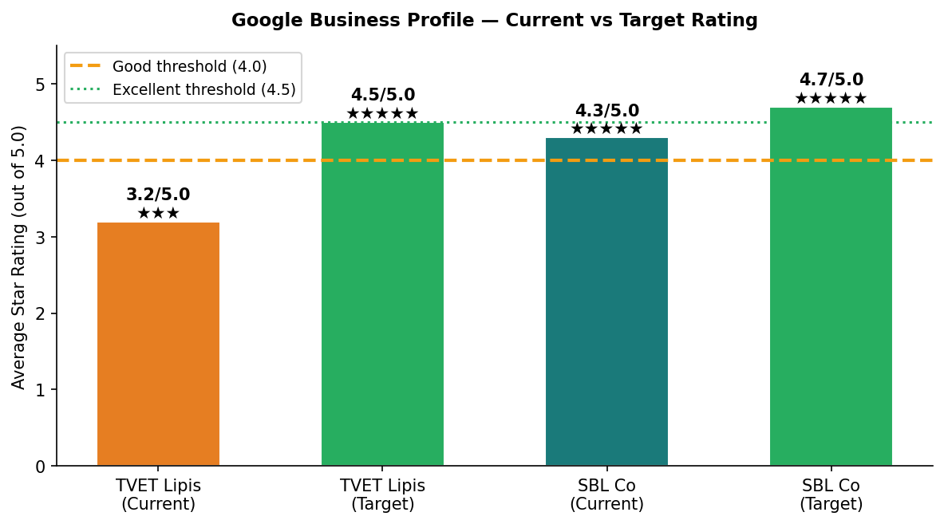
Figure 1: Current vs target ratings on Google Business Profile. TVET Lipis at 3.2 requires urgent improvement.

3. Review Volume & Sentiment
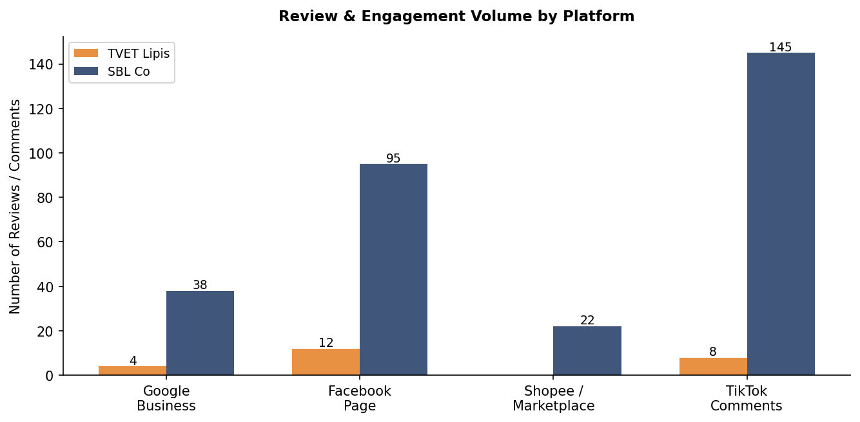
Figure 2: Review volume comparison. SBL Co has significantly more reviews across all platforms.

4. Sentiment Analysis — SBL Co (Sample 38 Google Reviews)
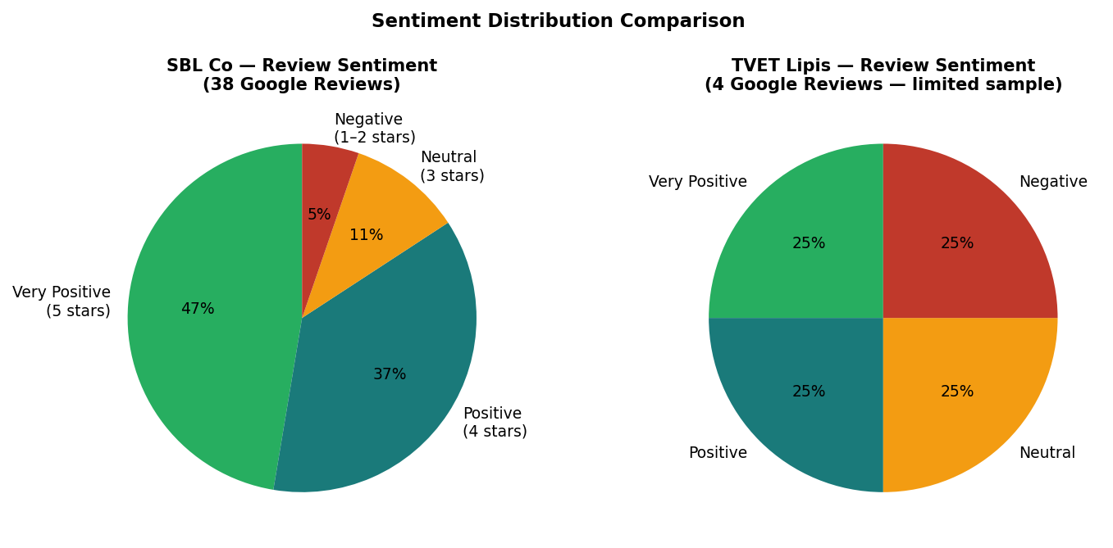
Figure 3: Sentiment distribution. TVET Lipis sample too small for reliable analysis — review generation is priority.

5. Risk Matrix
Risk | Organisation | Likelihood | Impact | Risk Score | Priority
Negative review without response | TVET Lipis | High | High | 🔴 Critical | Immediate
Low review volume (4 reviews) | TVET Lipis | Current state | High | 🔴 Critical | Immediate
Unanswered negative comment on FB | TVET Lipis | Current state | Medium | 🟠 High | This week
Rating drop from disgruntled enquiry | Both orgs | Medium | High | 🟠 High | Proactive
Competitor negative campaign | SBL Co | Low | Medium | 🟡 Medium | Monitor
Fake/malicious reviews | Both orgs | Low | High | 🟡 Medium | Protocol ready

6. Key Reputation Gaps & Action Summary
Gap | Organisation | Target | Action in Rep Management Plan
Rating 3.2/5 — below "Good" threshold | TVET Lipis | 4.5/5 within 6 months | Active review solicitation from satisfied students
Only 4 Google reviews | TVET Lipis | 40+ reviews by Jun 2025 | Post-enrolment review request sequence (WhatsApp + email)
No unanswered reviews currently responded | TVET Lipis | 100% response rate | Response templates + weekly monitoring by Zuriel
SBL Co 4.3/5 — room to improve | SBL Co | 4.7/5 by Dec 2025 | Respond to all reviews; address 2 negative reviews
No active reputation monitoring system | Both | Weekly monitoring dashboard | Google Alerts + monthly reputation report template

Approval Section
Role | Name | Signature | Date
Prepared by | Zuriel Seong Ming Ee | ___________________ | ___________
Reviewed by | [PPT Supervisor / Assessor — Pending] | ___________________ | ___________
Approved by | Lee Bee Chuan  Managing Director  Fokus Kiara Sdn Bhd | ___________________ | ___________

