 | 

ONLINE REPUTATION MANAGEMENT PLAN
Complaint handling, compliment handling and community management — Superbowl Lipis
Reference | REP/CU7/2025 | Prepared by | Zuriel Seong Ming Ee
Date | [ TARIKH ] | Position | Marketing Manager
Submitted to | [ NAMA PENGURUSAN ] | Status | For approval
PART 1 · PURPOSE AND SCOPE
Customer feedback about Superbowl Lipis is published in places the business does not own — Google reviews, TikTok and Instagram comments, Facebook posts. It is read by people deciding whether to visit or buy, and it stays visible indefinitely.
Feedback has so far been answered case by case, by whoever saw it first. There is no severity standard, no record of what was said or how quickly, and no route from a good review to published content. This plan establishes all three, covering complaints (Part 3), compliments (Part 4) and the wider community (Part 5).
Approval is sought for the response standards in Part 3, the task assignments in Parts 4 and 5, and the reporting cycle in Part 6.
PART 2 · CHANNELS MONITORED
Four channels carry public feedback. Each has a named owner and a checking frequency, so that nothing depends on someone happening to notice it.
Channel | What appears there | Checked | Owner
Google Business Profile | Star reviews and written reviews | Daily | Marketing Manager
TikTok | Video comments, direct messages | Daily | Marketing team
Instagram | Post comments, story replies, DMs | Daily | Marketing team
Facebook Page | Post comments, page messages | Daily | Marketing team
Google is treated as the priority channel. A review there is permanent, is shown next to the business name in search results, and cannot be removed by the business.
[ BUKTI DIPERLUKAN — Google Business Profile — paparan pengurusan menunjukkan profil dituntut dan diurus (nama perniagaan, kategori, waktu operasi, gambar) ]
PART 3 · HANDLING CUSTOMER COMPLAINTS (W01)
3.1 Types and sources
Complaints are classified on arrival so that the register can later show where problems cluster rather than only that they occurred.
Type | Typical source
Product or food quality | Google review, Facebook comment
Service or staff conduct | Google review, direct message
Facility condition or cleanliness | Google review, Instagram comment
Pricing or billing dispute | Direct message, in-person escalated online
Delivery or order fulfilment | TikTok Shop, direct message
3.2 Severity and response standard
Severity is graded on public exposure and on how much harm the complaint alleges — not on how strongly it is worded. The grade sets the response deadline.
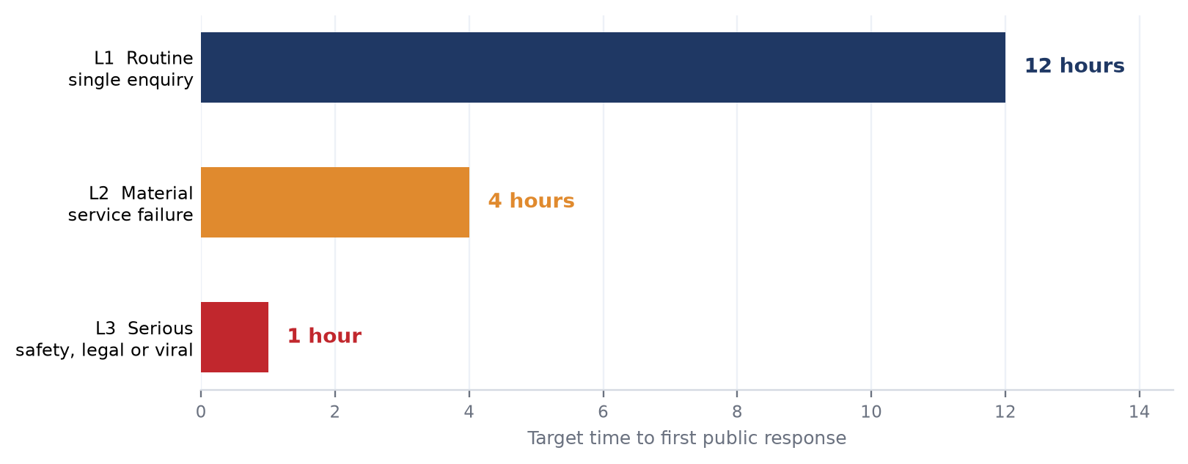
Figure 1 — Target time to first public response, by severity level
Level | Definition | Escalation
L1 Routine | One customer, one ordinary dissatisfaction, no wider claim | Handled by the team member on duty
L2 Material | Service failure affecting the visit or order; or a repeat of an L1 already seen | Marketing Manager informed same day
L3 Serious | Safety, hygiene, legal or discrimination allegation; or content gaining traction publicly | Management notified before any public reply
An L3 complaint is never answered by the person who received it. The reply is agreed with management first, because an early wrong answer to a serious allegation is harder to undo than a slow one.
3.3 Handling procedure
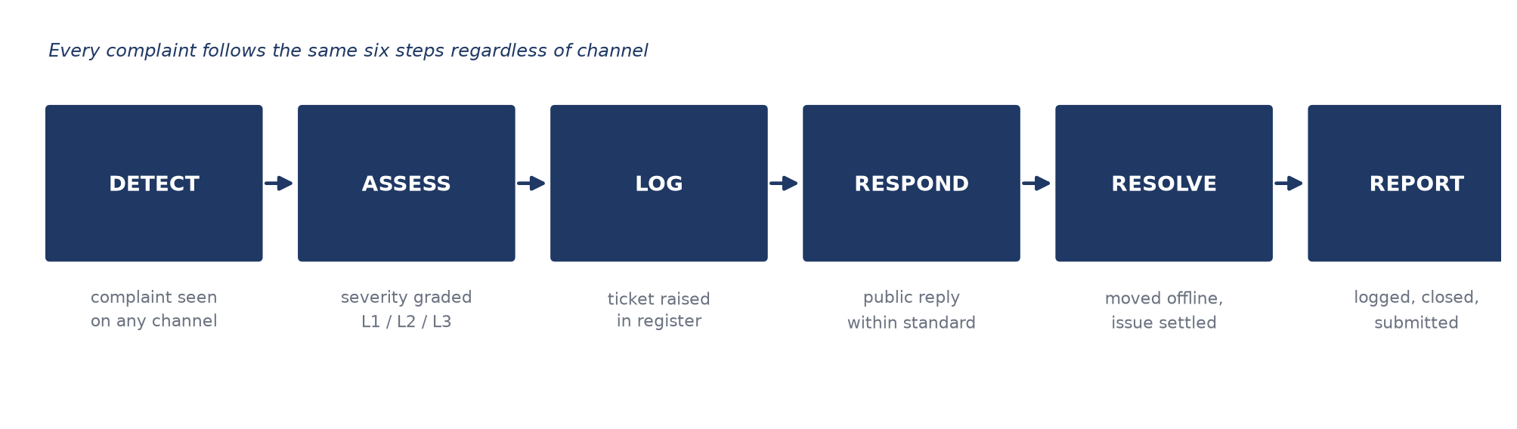
Figure 2 — Complaint handling procedure, applied to every channel
The public reply acknowledges the complaint and offers a route to resolve it; the resolution itself moves to a private channel. This keeps the customer's details out of public view while leaving visible evidence that the business responded.
3.4 Response record
Every complaint is entered in a register with a ticket reference, so that response time is measurable rather than remembered. The register carries: ticket ID, date received, channel, type, severity, action taken, owner, date closed, and elapsed response time.
[ BUKTI DIPERLUKAN — ulasan negatif di Google Business Profile berserta balasan pemilik — kedua-duanya dalam satu imej supaya jurang masa balasan kelihatan ]
[ BUKTI DIPERLUKAN — aduan di saluran kedua (komen TikTok / Instagram / Facebook) berserta balasan anda ]
[ BUKTI DIPERLUKAN — rangkaian penyelesaian secara peribadi (WhatsApp / DM) — tutup nama, nombor telefon dan alamat pelanggan ]
[ BUKTI DIPERLUKAN — daftar aduan / tiket — ID tiket, tarikh terima, saluran, jenis, tahap, tindakan, pemilik, tarikh tutup, masa balasan ]
3.5 Complaint report
A complaint report is submitted to management monthly, and immediately for any L3. It states what was received, what was done, how long it took, and whether the customer's position changed after the response.
[ BUKTI DIPERLUKAN — laporan aduan seperti yang dihantar kepada penyelia, berserta bukti penghantaran bertarikh ]
PART 4 · HANDLING CUSTOMER COMPLIMENTS (W02)
4.1 Why compliments are handled at all
A compliment answered and then left in place is worth only the goodwill of the reply. The same compliment republished as content reaches people who were never going to read the review. Compliments are therefore treated as a content source, not only as correspondence.
4.2 Compilation and repurposing
Compliments are collected weekly from all four channels into a single file, then routed to the placements below.
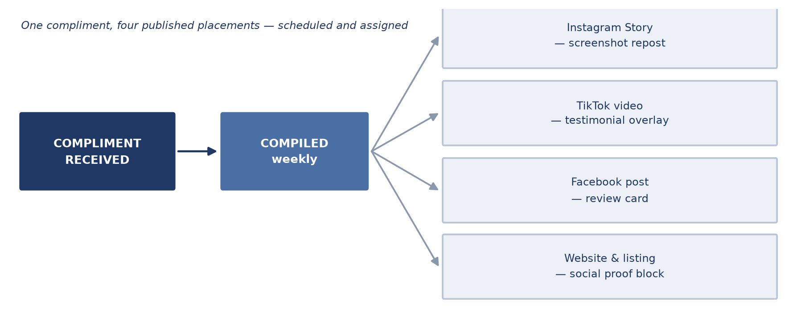
Figure 3 — Routing a compliment from receipt to published content
Placement | Form | Owner
Instagram Story | Screenshot of the review, brand frame, thanks caption | Marketing team
TikTok video | Review text overlaid on relevant footage | Marketing team
Facebook post | Review card graphic | Marketing team
Website and Google listing | Social proof block; reply visible under the review | Marketing Manager
4.3 Schedule and assignment
Step | Timing | Owner
Reply to the compliment publicly | Within 24 hours of receipt | Team member on duty
Add to the compilation file | Same week | Marketing team
Ask permission where a name or face is shown | Before publishing | Marketing Manager
Produce and schedule the content | Following week | Marketing team
Publish | Per content calendar | Marketing team
Permission is asked before a reviewer's name, photograph or handle is reused. A public review can be quoted, but republishing it as promotional content is a different act and is treated as one.
4.4 Assessing effectiveness
Republished testimonials are measured against ordinary posts on the same channel over the same period. If testimonial content does not perform at least as well, the format is changed rather than the practice abandoned.
[ BUKTI DIPERLUKAN — ulasan positif (bintang penuh) di Google Business Profile berserta balasan pemilik ]
[ BUKTI DIPERLUKAN — komen pujian di TikTok dan Instagram berserta balasan anda — sekurang-kurangnya dua rangkaian ]
[ BUKTI DIPERLUKAN — fail kompilasi pujian daripada pelbagai saluran ]
[ BUKTI DIPERLUKAN — kandungan pujian yang telah diterbitkan semula (Story / video / siaran) — versi tersiar, bukan draf ]
[ BUKTI DIPERLUKAN — baris kalendar kandungan bagi kandungan testimoni — tarikh, saluran dan orang yang ditugaskan ]
[ BUKTI DIPERLUKAN — analitik siaran testimoni tersebut — tontonan, jangkauan atau penglibatan ]
[ BUKTI DIPERLUKAN — laporan pujian seperti yang dihantar kepada penyelia, berserta bukti penghantaran bertarikh ]
PART 5 · HANDLING THE ONLINE COMMUNITY (W03)
5.1 Community categories and marketing direction
The audience is not one group, and the reason for engaging differs by group. Response priority follows commercial value, not comment volume.
Category | Who they are | Direction
Customers | Have visited or bought | Retain — answer first, invite back
Local followers | Kuala Lipis and Pahang, not yet customers | Convert — answer questions about price, hours, location
Wider followers | Follow the content, unlikely to visit | Reach — engage to sustain distribution
Detractors | Persistently negative or off-topic | Contain — reply once, then moderate
5.2 Communication channels
Comment threads and direct messages on TikTok, Instagram and Facebook carry the day-to-day community. TikTok LIVE is used where live interaction is appropriate. Podcast and streaming formats are not in use and are not claimed.
5.3 Strategies plan
Strategy | Action
Reply to every question | Any comment containing a question is answered — price, hours, availability, location
Pin the best comment | A pinned comment steers the thread and answers the question most people ask
Turn recurring questions into content | A question asked three times becomes a post, not a fourth reply
Moderate rather than argue | Hide abusive or unrelated comments; reply once to criticism, then leave it
Reply from the brand account only | Personal accounts are not used to respond on the brand's behalf
5.4 Cycle, monitoring and assessment
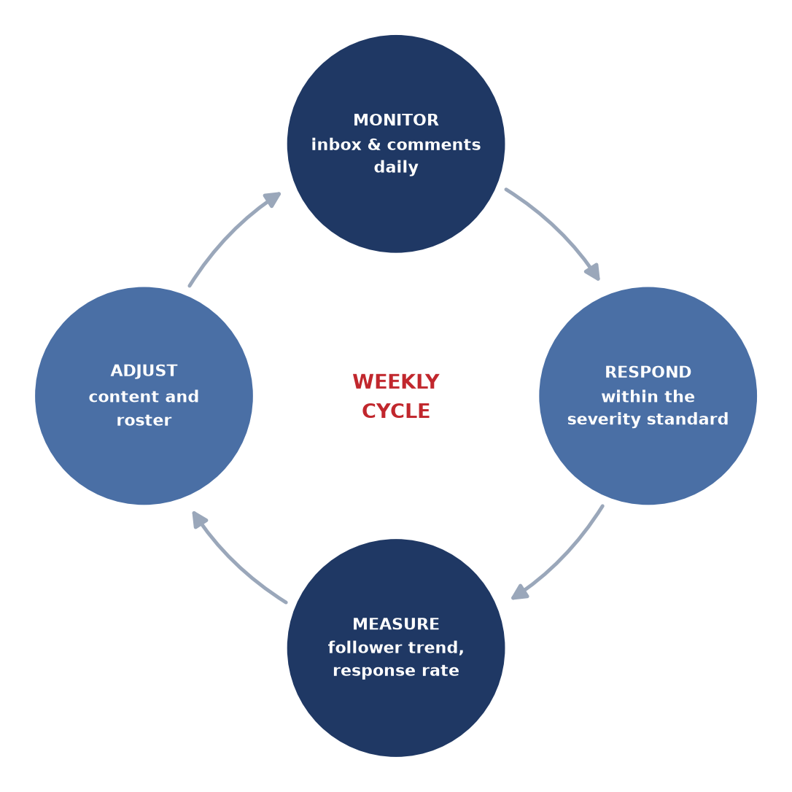
Figure 4 — Weekly community management cycle
Measure | Source | Frequency
Comments and messages received | Platform inbox | Weekly
Proportion answered | Inbox against replies sent | Weekly
Time to first reply | Complaint and comment register | Weekly
Follower trend | TikTok Analytics, Instagram Insights | Monthly
Review count and rating | Google Business Profile | Monthly
[ BUKTI DIPERLUKAN — bilangan pengikut bagi setiap saluran — TikTok, Instagram, Facebook (satu imej setiap platform, tunjukkan nama pengguna) ]
[ BUKTI DIPERLUKAN — jumlah mesej dan komen masuk di peti masuk — beban kerja pengurusan komuniti sebenar ]
[ BUKTI DIPERLUKAN — bukti moderasi — komen yang disemat, komen yang dibalas, dan komen yang disembunyikan jika ada ]
[ BUKTI DIPERLUKAN — saluran siaran langsung atau kumpulan komuniti (TikTok LIVE / WhatsApp / Telegram) — tutup nombor ahli ]
[ BUKTI DIPERLUKAN — jadual tugasan pemantauan komuniti — siapa memantau saluran mana, pada hari dan waktu apa ]
[ BUKTI DIPERLUKAN — analitik komuniti — trend pengikut dan waktu aktif sepanjang tempoh ]
[ BUKTI DIPERLUKAN — laporan strategi komuniti seperti yang dihantar kepada penyelia, berserta bukti penghantaran bertarikh ]
PART 6 · REPORTING
Three reports are produced. Each is submitted to management within the time frame stated, and each is filed so that the following month's report can be compared against it.
Report | Contents | Submitted
Complaint report | Complaints by type and severity, actions taken, response times, outcomes | Monthly; immediately for any L3
Compliment report | Compliments received, content republished, placements and performance | Monthly
Community report | Volume, proportion answered, follower trend, moderation actions, plan effectiveness | Monthly
PART 7 · RESOURCES AND RISKS
Item | Requirement | Responsibility
Channel access | Admin access to Google, TikTok, Instagram, Facebook | Marketing Manager
Register and reports | Shared file with fixed columns and report format | Marketing Manager
Staff time | Daily monitoring and response across four channels | Marketing team
Escalation contact | Named person reachable for L3 within the hour | Management

[ ISI: anggaran masa staf mingguan dan sebarang kos alat pemantauan ]
Risk | Mitigation
A serious complaint answered badly under time pressure | L3 replies are agreed with management before posting
Response depends on one person | Named owner per channel with a stated backup
Reviews cannot be removed once published | Speed and visible resolution, not deletion requests
Republishing a review without consent | Permission requested before a name or face is reused
Complaint volume outgrows manual monitoring | Review the register monthly; add saved replies or alerts if volume rises
PART 8 · APPROVAL
Approval authorises the response standards in Part 3, the assignments in Parts 4 and 5, and the reporting cycle in Part 6.
 | Prepared By | Reviewed By | Approved By
Name | Zuriel Seong Ming Ee
Position | Marketing Manager
Signature
Date

Decision: ☐ Approved ☐ Approved with amendment ☐ Not approved
Comments:
______________________________________________________________________________
______________________________________________________________________________

