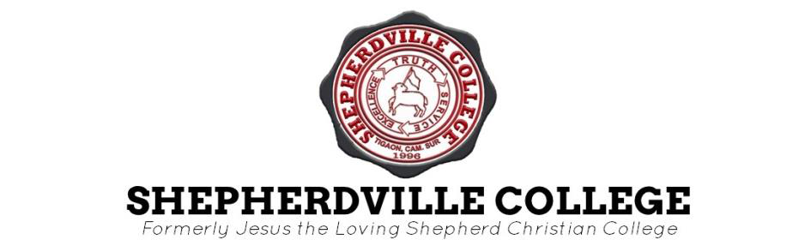

Talojongon, Tigaon, Camarines Sur

**COLLEGE OF EDUCATION**

First Semester, AY 2020-2021

|  |
| --- |
| **TECHNOLOGY IN TEACHING AND LEARNING 2 ANSWER SHEETS (SAQs)**  **MODULE 4** |

**Name: CASILI, ABEGAIL L. Course/Year: BSED ENGLISH 3K Subject: TTL2 Teacher: JOSE VALENCIA OBIAS**

**SAQ #1**(5 points): Why there is a need to prepare instructional materials (IMs)?

**ASAQ #1**  **There is a need to prepare instructional materials (IMs) because it enhances the learning experience of the students. It also promotes clarity and consistency in the learning methods of educators. These instructional materials engaged the students to participate actively in class. These can also cater the diverse needs and learning styles of the students. Instructional materials play a crucial role in making learning enjoyable, accessible and effective for all students.**

**SAQ #2**(5 points): Nowadays, what do you think are the things that need to be considered in the preparation of IMs?

**ASAQ #2**  **Nowadays, the things that need to be considered in the preparation of instructional materials is to use technology like videos and online tools to make learning more fun and engaging. Instructional materials should be easy for everyone to use, including students with special needs, and should include things that represent different cultures. Instructional materials should be interactive and motivating to keep students interested and involved in their learning. It should also match what the students are supposed to learn in class and it needs to be able to change and adapt to fit different situations and student needs. By considering these things, educators can be able to create instructional materials that are interesting, inclusive and helpful for students.**

**SAQ #3**(5 points): As a future teacher, what type of instructional materials do you prefer?

|  |
| --- |
| **ASAQ #3**  **As a future teacher, choosing the suitable instructional materials is crucial for effective teaching. I have in mind some instructional materials which I preferably use. Visual aids like charts and video clips can help simplify the information for easy understanding of the students. Manipulatives, such as physical objects, can help to better understand abstract concepts, especially in subjects like math and science. Peer instruction and collaborative activities can promote active learning on the students and peer to peer knowledge sharing. Multimedia presentations and printed materials can personalize the learning experience of the students and are a great help to cater to diverse learning styles of the students. By incorporating such**  **instructional materials, I can be able to create a personalized, effective and engaging learning environment for my students.** |

1



Talojongon, Tigaon, Camarines Sur

**COLLEGE OF EDUCATION**   
First Semester, AY 2020-2021

|  |
| --- |
| **TECHNOLOGY IN TEACHING AND LEARNING 2 ANSWER SHEETS (EVALUATION)**  **MODULE 4** |

**Name: CASILI, ABEGAIL L. Course/Year: BSED ENGLISH 3K Subject: TTL2 Teacher: JOSE VALENCIA OBIAS**

**General Instruction:** Read thoroughly the questions and follow what is being asked in every task.

1.Create a material/ instructional material using one application from the mentioned applications. Upload it in our FB group.

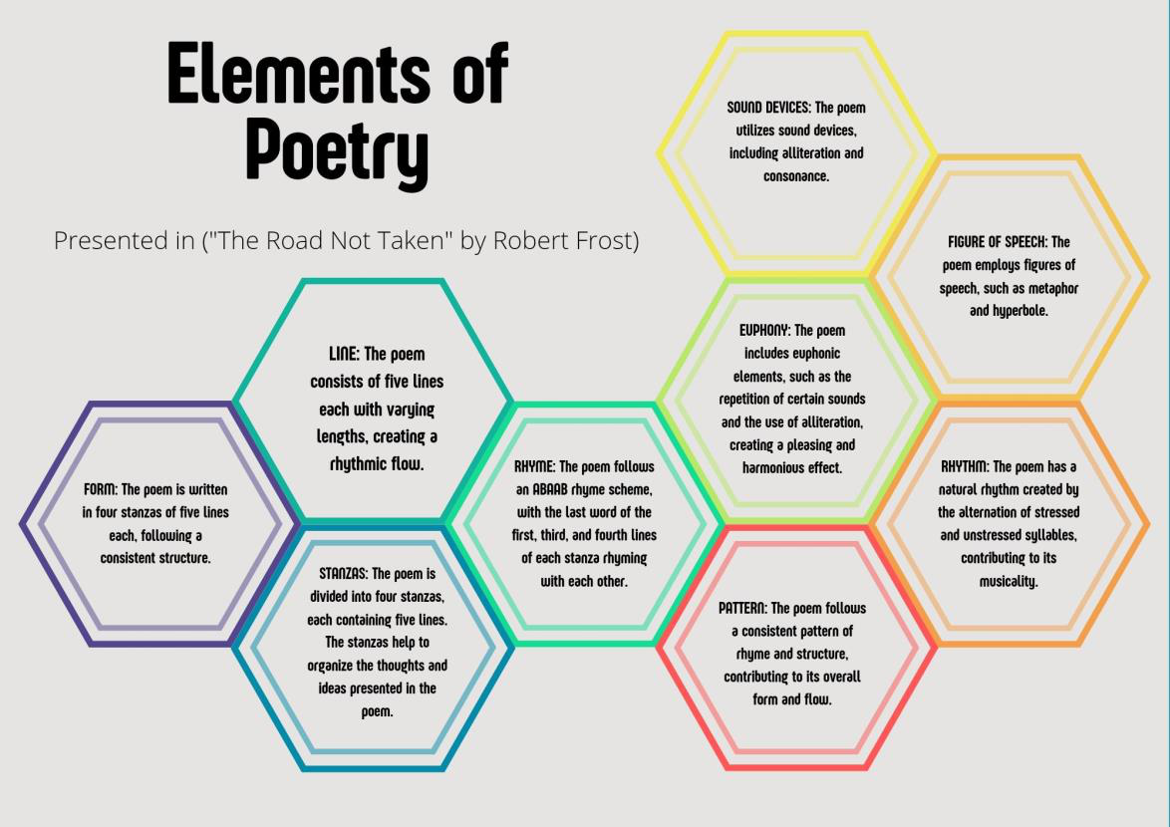

2