**THE STATE UNIVERSITY OF ZANZIBAR**



**SCHOOL OF SOCIAL AND NATURAL SCIENCE**

**DEPARTMENT OF SOCIAL SCIENCE**

**TUNGUU CAMPUS**



**LECTURE: Mr MASSOUD HAMAD**

**NATURE OF WORK: INDIVIDUAL ASSIGNMENT**

**SUBJECT NAME:** **WEBSITE DEVELOPMENT**

**COURSE CODE: INF 2205**

**SUBMISSION DATE: 22/5/2023**

**STUDENTS NAME ABDI, ZAFARAN ABDALLA**

**REG No. SIGNATURE: BITAM/9/21/035/TZ**

**GIT ACCOUNT: https://github.com/zuu12345/midTerm.git**

Question two

<!DOCTYPE html>

<html>

<head>

  <title>Mid Term Test</title>

  <style>

    table {

      border-collapse: collapse;

      width: 20%;

    }

    td {

      border: 1px solid #ccc;

      padding: 8px;

      text-align: left;

    }

  </style>

</head>

<body onload="displayValidRangeMessage()">

  <h1>Link Generator</h1>

  <form>

    <label for="startRange">Start Range:</label>

    <input type="text" id="startRange" name="startRange" value="1">

    <label for="endRange">End Range:</label>

    <input type="text" id="endRange" name="endRange" value="1"><br><br>

    <button type="button" onclick="displayTable()">display Table</button>

  </form>

  <p id="validRange"></p>

  <div id="message"></div>

  <table id="tableContainer"></table>

</body>

<script>

    // Global data array

    let data = ["syllabus.html", "p1.html", "p2.html", "style.html", "email.html", "system.html", "process.html"];

    // Function to display the table

    function displayTable() {

      var startRange = parseInt(document.getElementById("startRange").value);

      var endRange = parseInt(document.getElementById("endRange").value);

      var message = document.getElementById("message");

      if (isNaN(startRange) || isNaN(endRange) || startRange > endRange || startRange < 1 || endRange > data.length) {

        var validRange = "Valid Range: 1-" + data.length;

        message.textContent = "Invalid range, " + validRange;

        document.getElementById("tableContainer").innerHTML = "";

        return;

      }

      var table = "<table>";

      for (var i = startRange - 1; i <= endRange - 1; i++) {

        table += "<tr><td><a href='" + data[i] + "'>" + data[i] + "</a></td></tr>";

      }

      table += "</table>";

      document.getElementById("tableContainer").innerHTML = table;

      message.textContent = "";

    }

    // Function to display the initial valid range message

    function displayValidRangeMessage() {

      var validRangeMessage = "Valid Range: 1-" + data.length;

      document.getElementById("validRange").textContent = validRangeMessage;

    }

  </script>

</html>

Output

During loading file

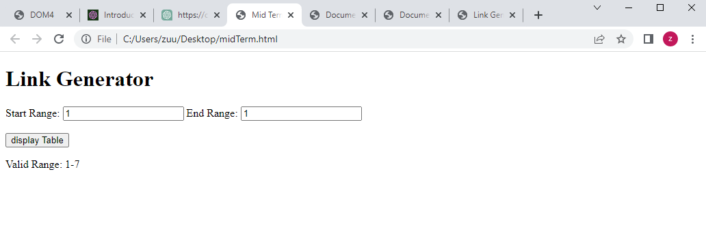

On provide invalid range

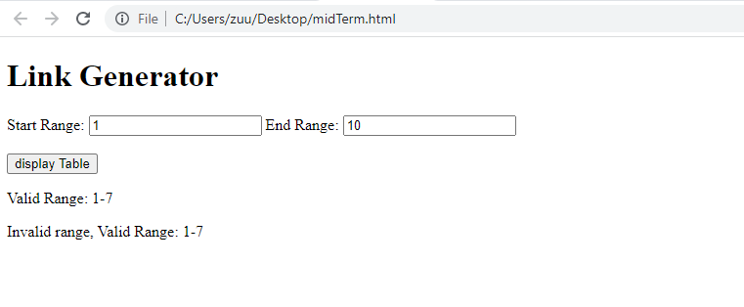

After provide valid range

