Framework:

The basic framework is a chain of User Input, Grid Generator and Playback Control. The 1st patch below is in presentation mode. On the left-hand side, user can choose either enter 12 notes as text, using the predetermined P0 or enter keys on the keyboard. Once the P0 is determined, the whole grid will be generated automatically and instantaneously. On the right-hand side is the playback section. User can choose to play one or two row and/or columns and every time the play/stop button is clicked another random row will be played. Inside the voice sub-patch there are sound presets that user can choose to use it by click the “;” message tabs.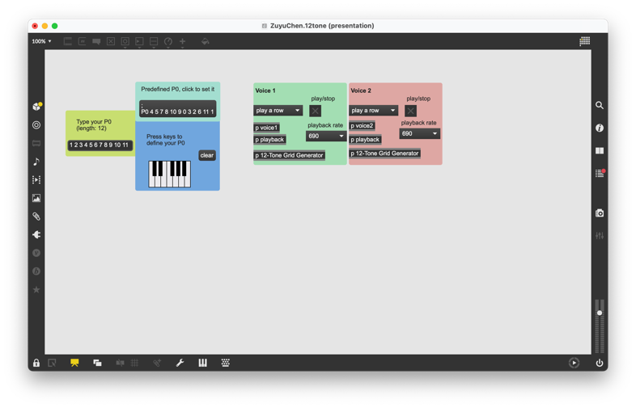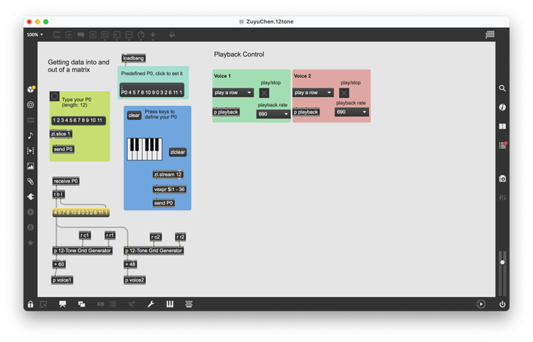
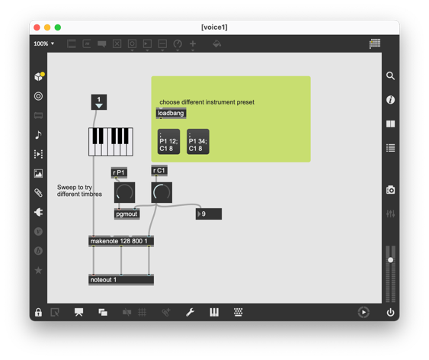

Challenges:

The most musical challenge would be having the patch be able to play across octaves. Because we’re using jit.fill which essentially deals with numbers only as far as my experience with it. The attached patch is 12-Tone-Grid-Generator sub-patch, which takes P0 input from user and automatically generate 12-Tone row matrix. Because of 0 – 11 pitch class numbers used here to denote the notes of composition. The patch can only output 12 numbers as well which is just one octave range through playback. Well, we can certainly change the user input of P0 to allow the distinction of octaves if that’s what we want.
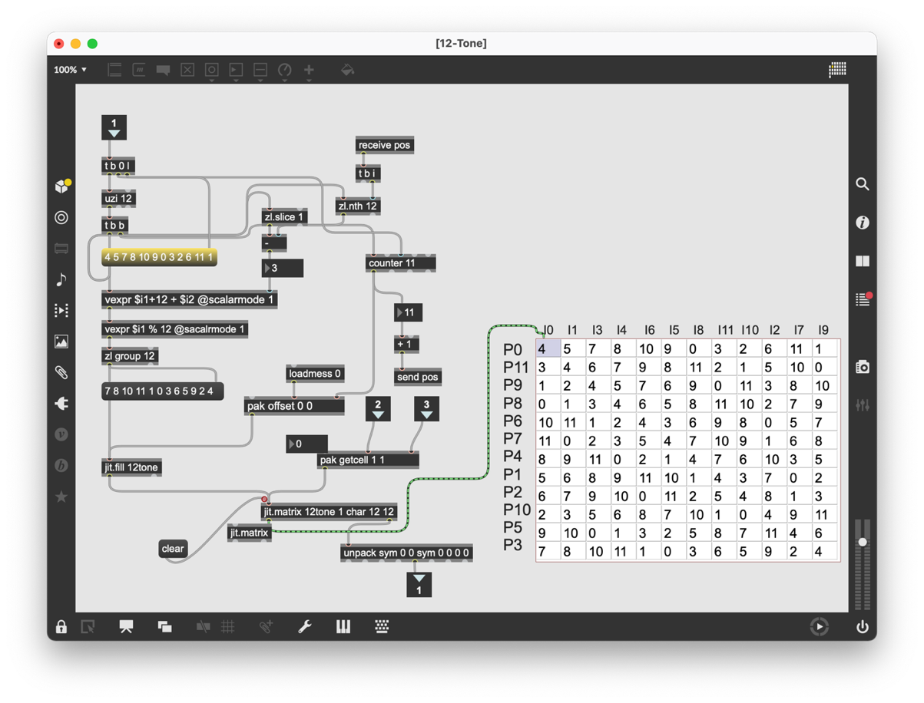
The other big challenge is also from this patch. It took me quite long to figure out the most elegant way that I could thought of that prompts it to fill out the remaining rows of the matrix once P0 has been entered. It turns out trigger, vexpr, zl.slice, zl.nth and counter objects are very useful in this problem.

