**Task assignment**

**I. Introduction**

Do you ever wonder how your favorite photo filters work, or how facial recognition technology can identify people in a crowd?

Image processing is a fascinating field that combines computer science and mathematics to analyze and manipulate digital images.

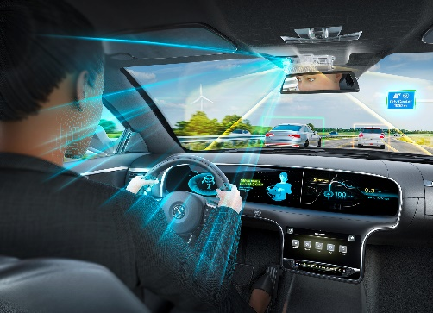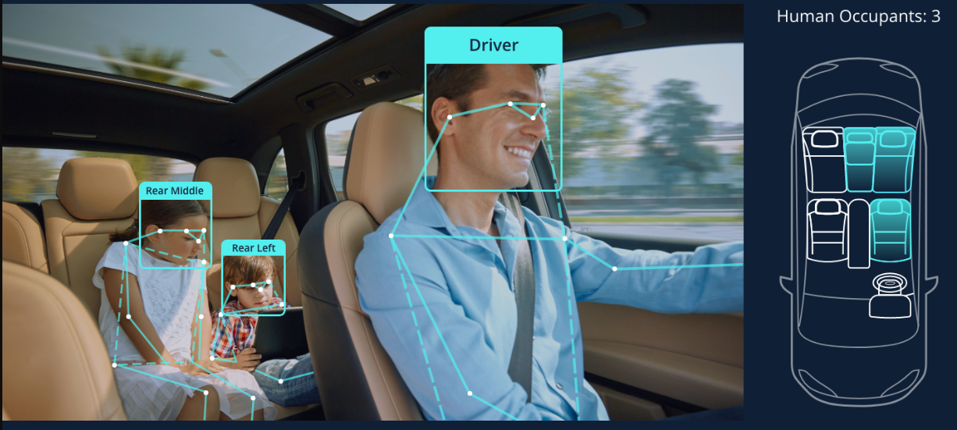

In the automotive context, image processing is used in a variety of applications, from monitoring driver behavior to detecting and alerting drivers to potential hazards on the road. By learning image processing, you can gain the skills necessary to develop and improve these technologies, and to contribute to the development of safer and more reliable driver monitoring systems.

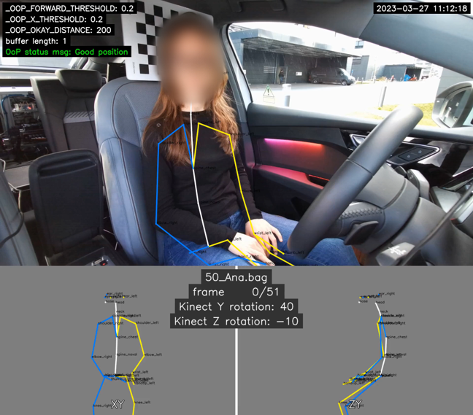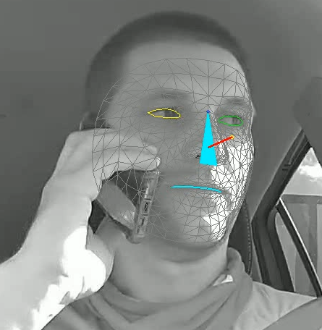

In this assignment, you will get a taste of image processing by implementing a program to search for a hidden emoji in an image. The size and resolution of both the image and emoji are known, but the coordinates of the emoji are what we're looking for.

This is just the tip of the iceberg, but with more knowledge and practice, you can unlock a whole world of possibilities. So, let's get started!

**II. Common Instructions**

* The program should be implemented in either C or Python
* The code should be well-documented with comments
* The program should be tested on different images from provided dataset

**III. Mandatory part**

Your program must include the following:

* Read in the image and emoji parameters
* Create a sliding window of the same size as the emoji
* Use a for loop to scan the image by sliding the window across it
* Compare the pixel values in the window with the pixel values of the emoji
* If the pixel values match, the program should output the coordinates of the emoji (relative to the top-left corner of the original image)

For example, consider the following image:



The image is 800x600 pixels in size, and the hidden emoji is a smiley face, which is 50x50 pixels in size. Your program should be able to output the coordinates of the smiley face in the image.

**IV. Bonus part**

For a bonus, you can implement a visualization where the program displays the image in a window and highlights the area being scanned with a red rectangle. When the emoji is found, the program should highlight the area with a green rectangle.

For example, the program could display the image as follows:

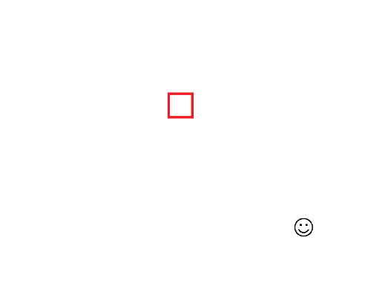

The red rectangle shows the area being scanned, and the green rectangle shows the location of the found emoji.