**Title:** Stealth Soldier

**Creator:** Evan Sullivan (zvan92)

**Libraries:** SDL 2.0, SDL_mixer 2.0 , SDL_image 2.0

**Overview:**

The player is a soldier tasked with crossing through a mine-laden supply route and into enemy territory. Using the arrow keys, the player must reach to the green zone without running into mines or being struck by vehicles.

**Concept Art:**

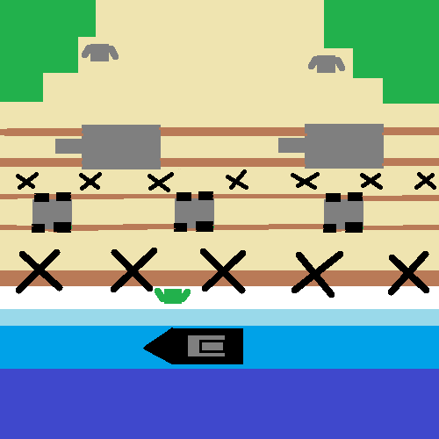

**Challenges:**

The player will encounter the following obstacles:

* Limited number of lives (5)
* Hidden mines in random spots around the map
* A convoy of enemy transports
* A convoy of tanks

**Controls:**

Player movement:

* Forward: up arrow
* Backward: down arrow
* Left: left arrow
* Right: right arrow

Pre/post game context:

* Quit: escape
* Enter: start game / play again

**Objects:**

The game’s objects will consist of:

* Scrolling vehicles (tank, transport)
* Background image
* Player
* Mine
* UI text objects (lives left, instructions)
* Splash screen images (game start, win/lose results)
* Audio objects (music, collision/game start/win/lose sounds)

**Classes:**

The game’s objects will be created from these classes:

* “App”
* “Object” and its child classes:
  + “Vehicle”
  + “Screen”
  + “Player”

Inheritance is used to discern game world objects from each other and from UI / app objects.

**Events:**

* If vehicle strikes player:
  + Player is sent back to spawn location
  + 1 life is lost
  + Collision sound is played
* If player runs over a mine:
  + Player is sent back to spawn location
  + 1 life is lost
  + Collision sound is played
* If player reaches the end successfully:
  + A “win” message is displayed
  + Player is prompted to quit or play again
  + Win result sound is played
* If player loses all lives:
  + A “lose” message is displayed
  + Player is prompted to play again
  + Lose result sound is played