# Made by: SuperClubC:\Users\Max\Downloads\ДЗ\Харли\QDE1XTvWkLU.jpg

# Калантаев Максим Пятаков Роман Звягинцев Денис

# Concept:

**Platforms:** Windows

**Technologies:** Unreal Engine 4

**Languages:**   English

**Audience:**  Targeted audience

**Genre**: Puzzle, platformer

**Mood:** cheerful, challenging

**Emotions:** joyful, happiness, rage

**Rating:**   
6+

**User Number:**    
singleplayer

**Gameplay time:**  30 second on level

**Main mechanic:** run & jump

**Setting:** fantasy

**Goal:**reach rainbow bridge at the end of level

# Targeted audience

 Any ages computer gamers which love challenge

# Game Character

## Game mechanics and operating

*Example: Actor moving: WASD*

Actor moving: WASD  
Actor rotating: mouse moving  
Throw the hammer: LMB  
Lighting bolt: RMB

Restart level: R

Return to the main menu: esc

# Interface

# Game menu

1. Play (choose game level)
2. Setting (configure game)
3. About (info about game)
4. Exit (exit from game)

# Game interface

* Timer (top of screen)
* Ability icons
* Health indicator

# Gameplay map

*Note: that you can use Miro or Microsoft Whiteboard to easy sharing your activities*

[*https://miro.com/app/board/o9J_kkLshsI=/*](https://miro.com/app/board/o9J_kkLshsI=/)

# Visual

 A 3D world consisting entirely of simple geometric shapes (cubes, platforms ..). Colors are soft and pleasant.

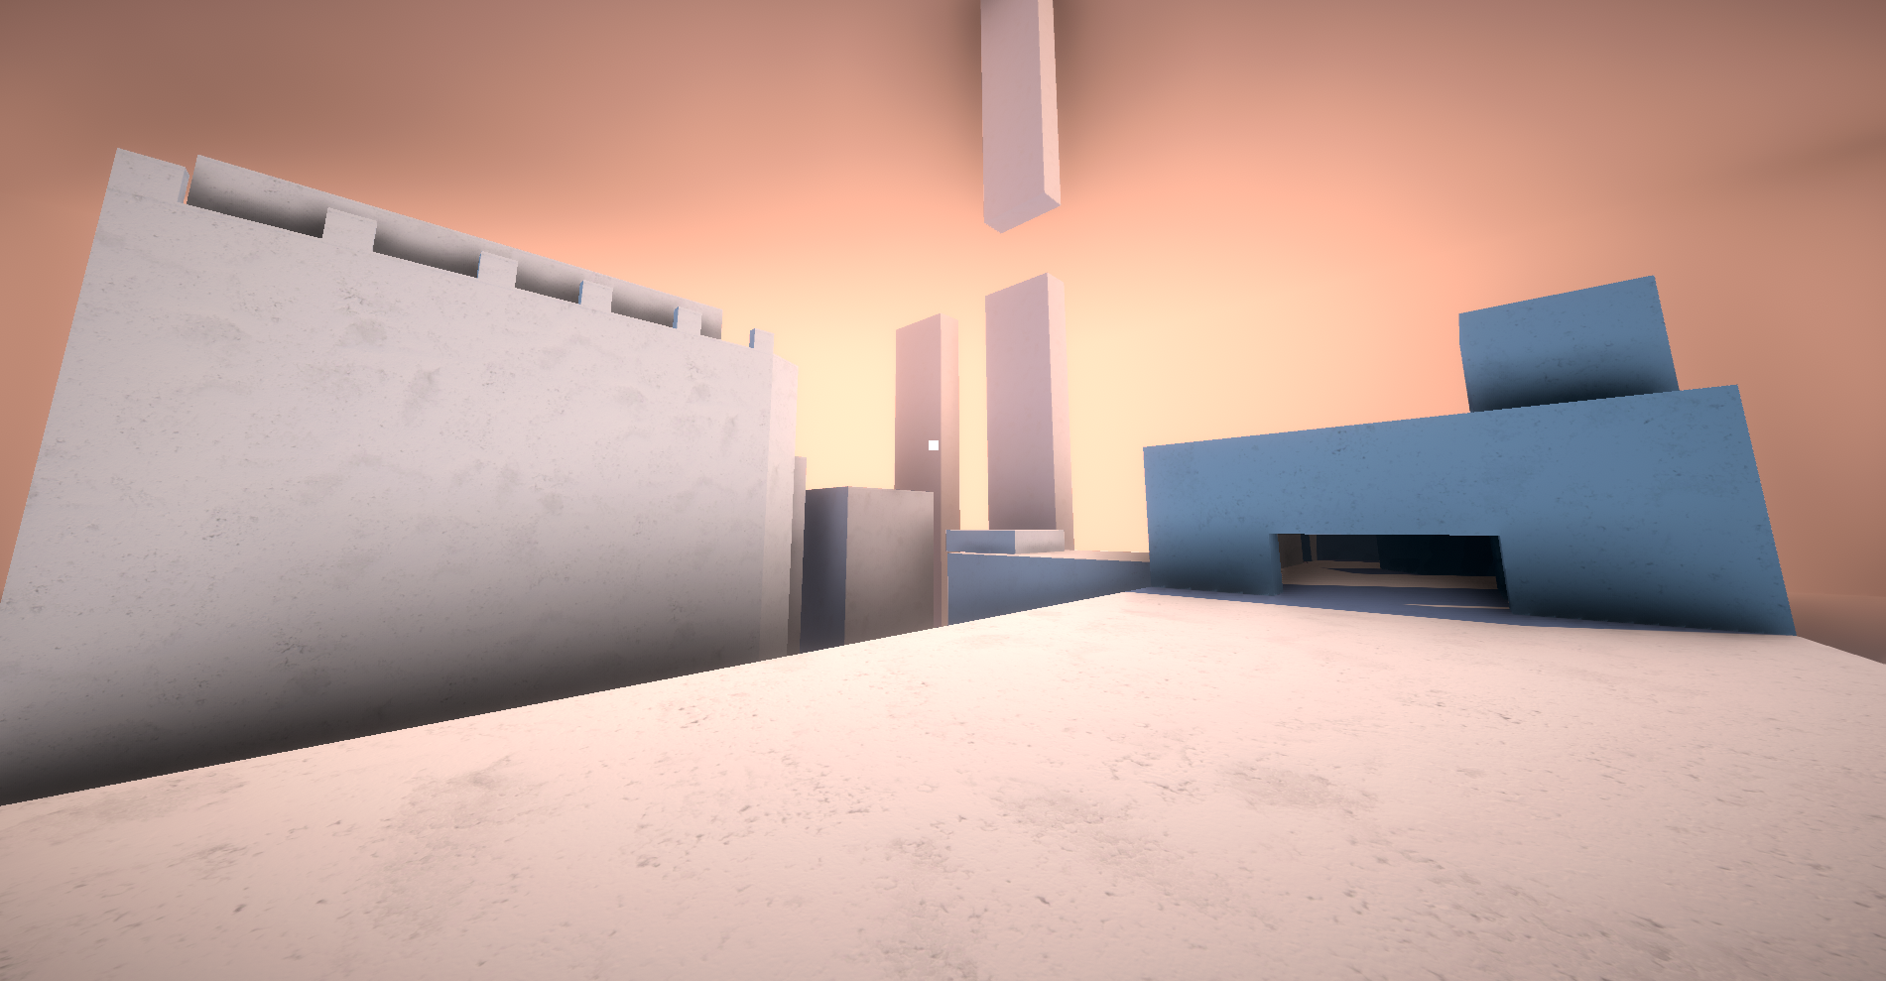

# Level Design

 Level consists of platforms where enemies, buttons, doors are placed. Goal is to reach a rainbow bridge. Platforms are separated by an abyss.

# Balance

|  |  |  |
| --- | --- | --- |
| Name | Value | Comment |
| Player movement speed | 1 |  |
| Player jump height | 1 |  |
| Hammer speed | 2 |  |
| Hammer range | 10 |  |
| Player crouch speed | 1.2 |  |
| Hammer repulsion Force | 1.2 |  |

# Artificial Intelligence

*Example: NPC follows*

Mobs can:

* Aim and shoot the Player
* Follow Player when on one platform

# History

 Game’s history absent