2019

CAPSTONE PROJECT

The Battle of Neighborhoods of Kharkiv

Aleksandr Vershkov

Contents
Executive summary / Introduction 3
Data 3
Methodology 3
Problem Statement 4
Results and Discussion 4
Conclusion 5

Executive summary / Introduction

This final project explores the best locations for restaurants throughout the city of Kharkiv, Ukraine (https://en.wikipedia.org/wiki/Kharkiv). Kharkiv is the second-largest city in in Ukraine, with more than 2 million people living within city limits. This report explores neighborhoods of Kharkiv and tries to answer which neighborhoods and boroughs of Kharkiv have the most as well as the best restaurants. Additionally, I will attempt to answer the questions “Where should I open an Restaurant?” and “Where should I stay If I want great food?”

Data
In order to answer the above questions, data on Kharkiv neighborhoods, boroughs to include boundaries, latitude, longitude, restaurants, and restaurant ratings and tips are required.
Kharkiv data containing the boroughs will be obtained from the data source: "https://www.city.kharkov.ua/ru/gorodskaya-vlast/ispolnitelnyie-organyi/rajonnyie-administraczii.html", latitudes and longitudes of borough's administrations will be obtained by geocoding.
All data related to locations and quality of restaurants will be obtained via the FourSquare API utilized via the Request library in Python.

Methodology
Data will be collected from internet and cleaned and processed into a dataframe.
FourSquare be used to locate all venues and then filtered by restaurants. Ratings, tips, and likes by users will be counted and added to the dataframe.
Data will be sorted based on rankings
Finally, the data be will be visually assessed using graphing from various Python libraries.

Problem Statement
- What is / are the best location(s) for restaurant in Kharkiv?
- In what Neighborhood and/or borough should I open an restaurant to have the best chance of being successful?
- Where would I go in Kharkiv have the best food?

Results and Discussion
From the data we see that Kievskyi and Shevchenkivskyi neighborhoods have the largest amount of restaurants.
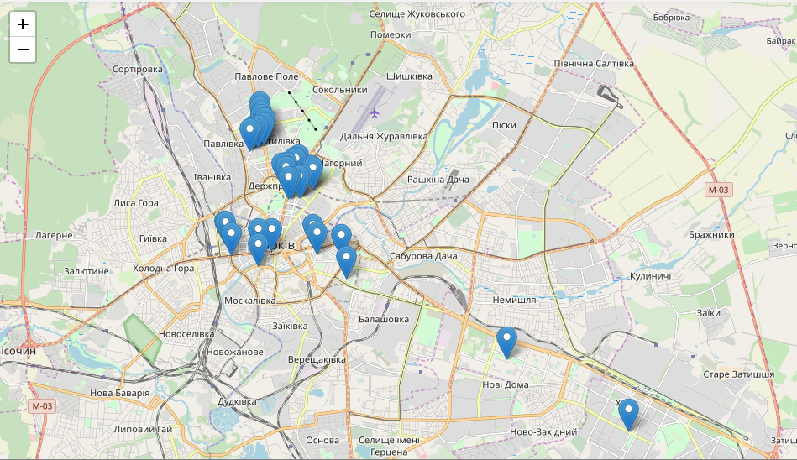
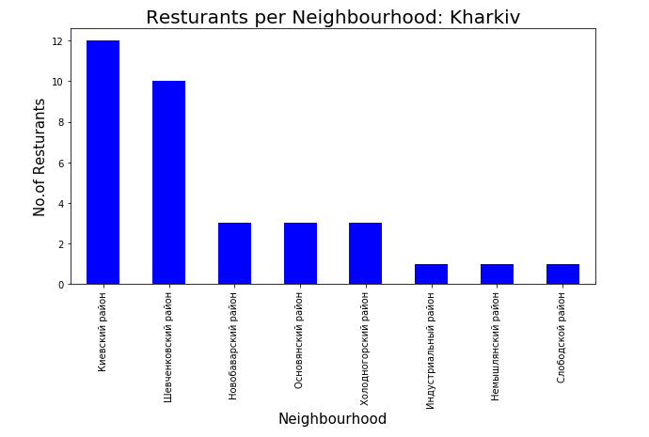
The Nemyshlianskyi and Kievskyi neighborhoods have the highest average restaurant rating 8.0 and 7.8, respectively.
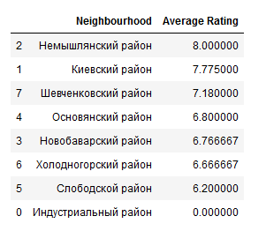
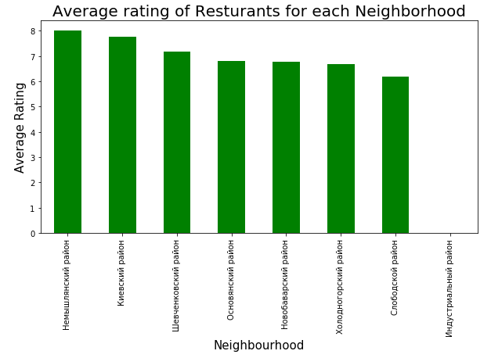

Kievskyi and Shevchenkivskyi are clearly the most dense neighborhoods making competition high. Neighborhoods like Novobavarskyi, Osnovianskyi and Nemyshlianskyi provide less competition based on restaurant density while maintaining high average ratings.

Conclusion
Nemyshlianskyi and Shevchenkivskyi neighborhoods have the best rated restaurants on average. Kievskyi and Shevchenkivskyi neighborhoods have the largest amount of restaurants per borough. Based on this information, I would state that Nemyshlianskyi, Osnovianskyi and Novobavarskyi neighborhoods are the best locations for new restaurants.
As a final note, all of the above analysis is depended on the adequacy and accuracy of Four Square data. A more comprehensive analysis and future work would need to incorporate data from other external databases.

