Getting started in console C#

1. Before doing anything else, create a *Computer Science* folder in your *Documents* folder in your *OneDrive* folder and inside that create a folder called *Code*
2. Open Visual Studio 2017
3. Set the default location to save your projects by clicking **Tools**…**Options**…**Projects** **and Solutions**…**Locations**. The location should be the Code folder that you just created.

**Note:** You will only need to do this once and I would suggest that you repeat this process on your home version of Visual Studio

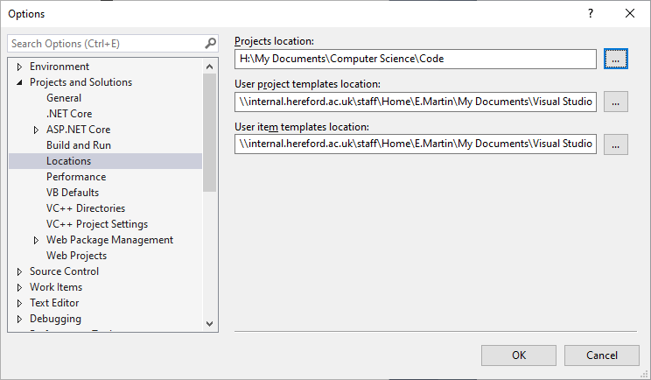

1. Click *File*… *New*… *Project*…

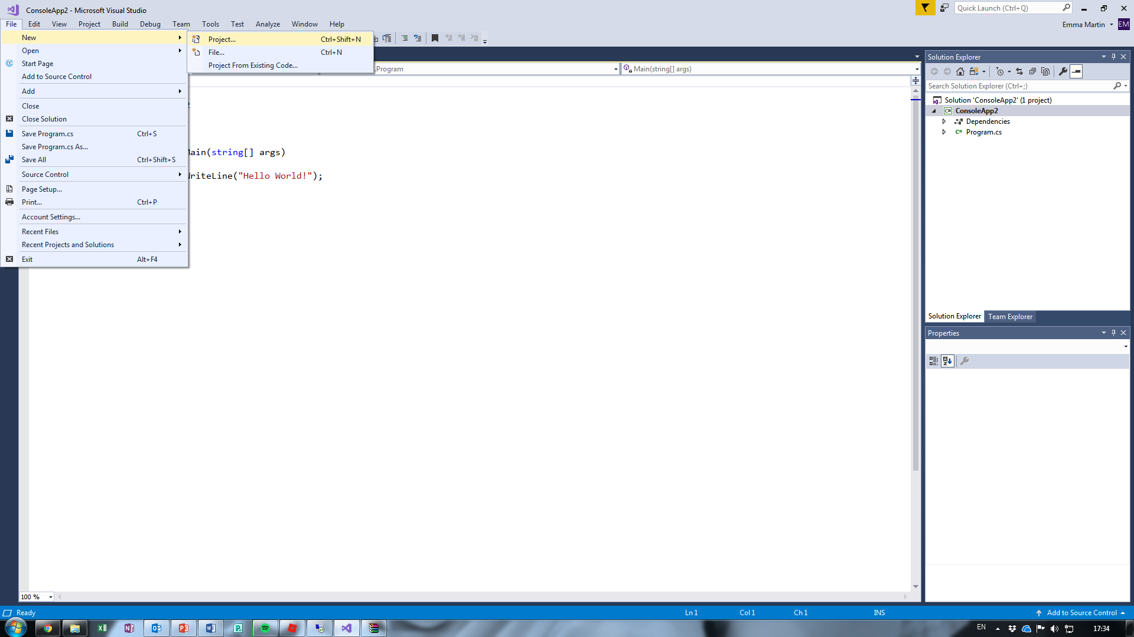

1. Select ***Visual C#*… *Console App(.net Core*)**
2. **DO NOT JUST CLICK OK!**

Make sure you name your program appropriately, e.g. “Conversation” and check that it is saving to your chosen location.

***Note:*** *Visual C# programs consist of many individual files grouped into a solution and therefore you should enable ‘Create directory for solution’ (default).*

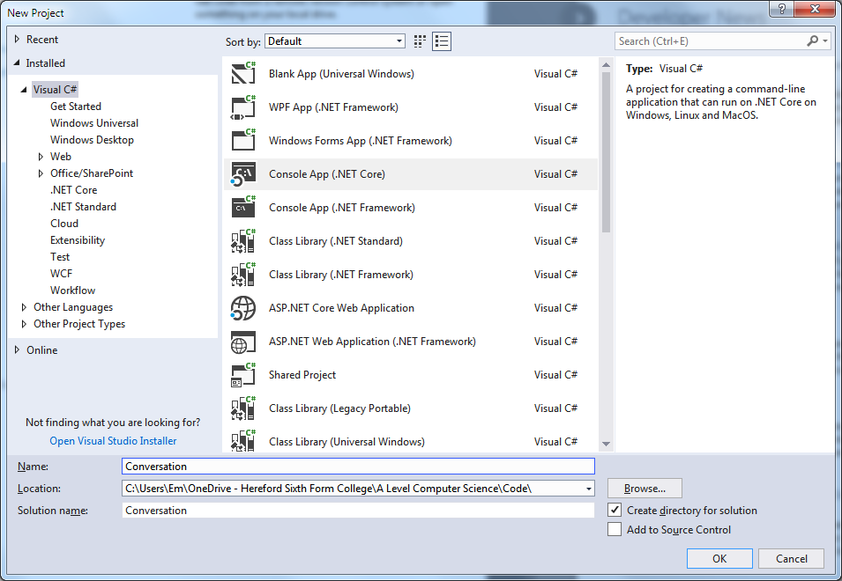

1. To run your program, press F5. It won’t do much at the moment, but that will change!

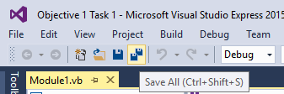

1. When you save your work, make sure you choose Save All
2. When you want to open your work again, choose Open Project…, **not** Open File. Find the **.sln** file.

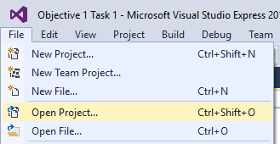

Conversation Program

The IDE (**I**ntegrated **D**evelopment **E**nvironment) is shown below:

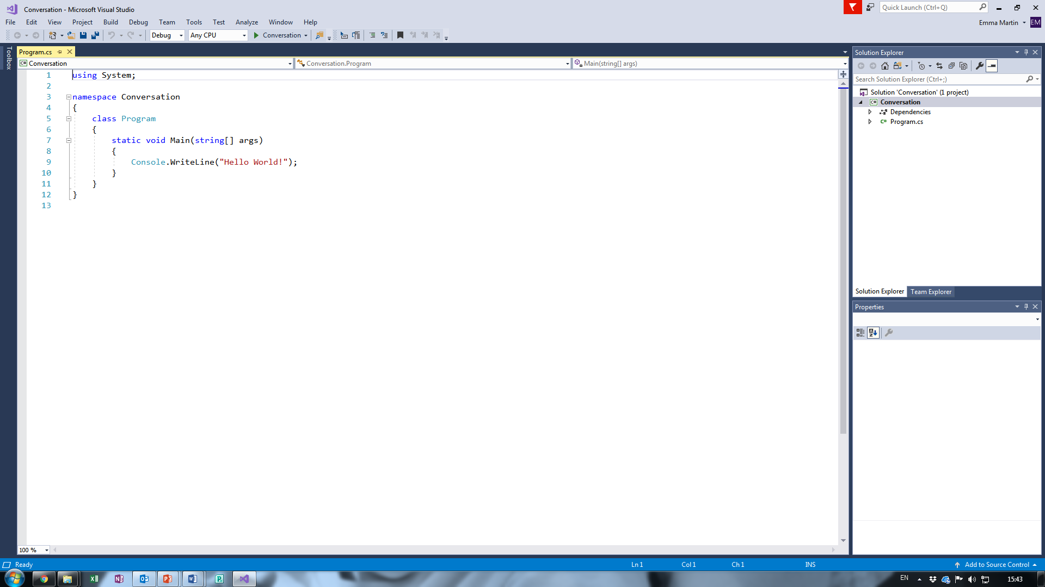

On the left hand side of the screen is the code window, which is where you type your programs.

On the right hand side is the solution explorer. This shows see all of the files that make up your project.

Change the code in the Main procedure to match the program below

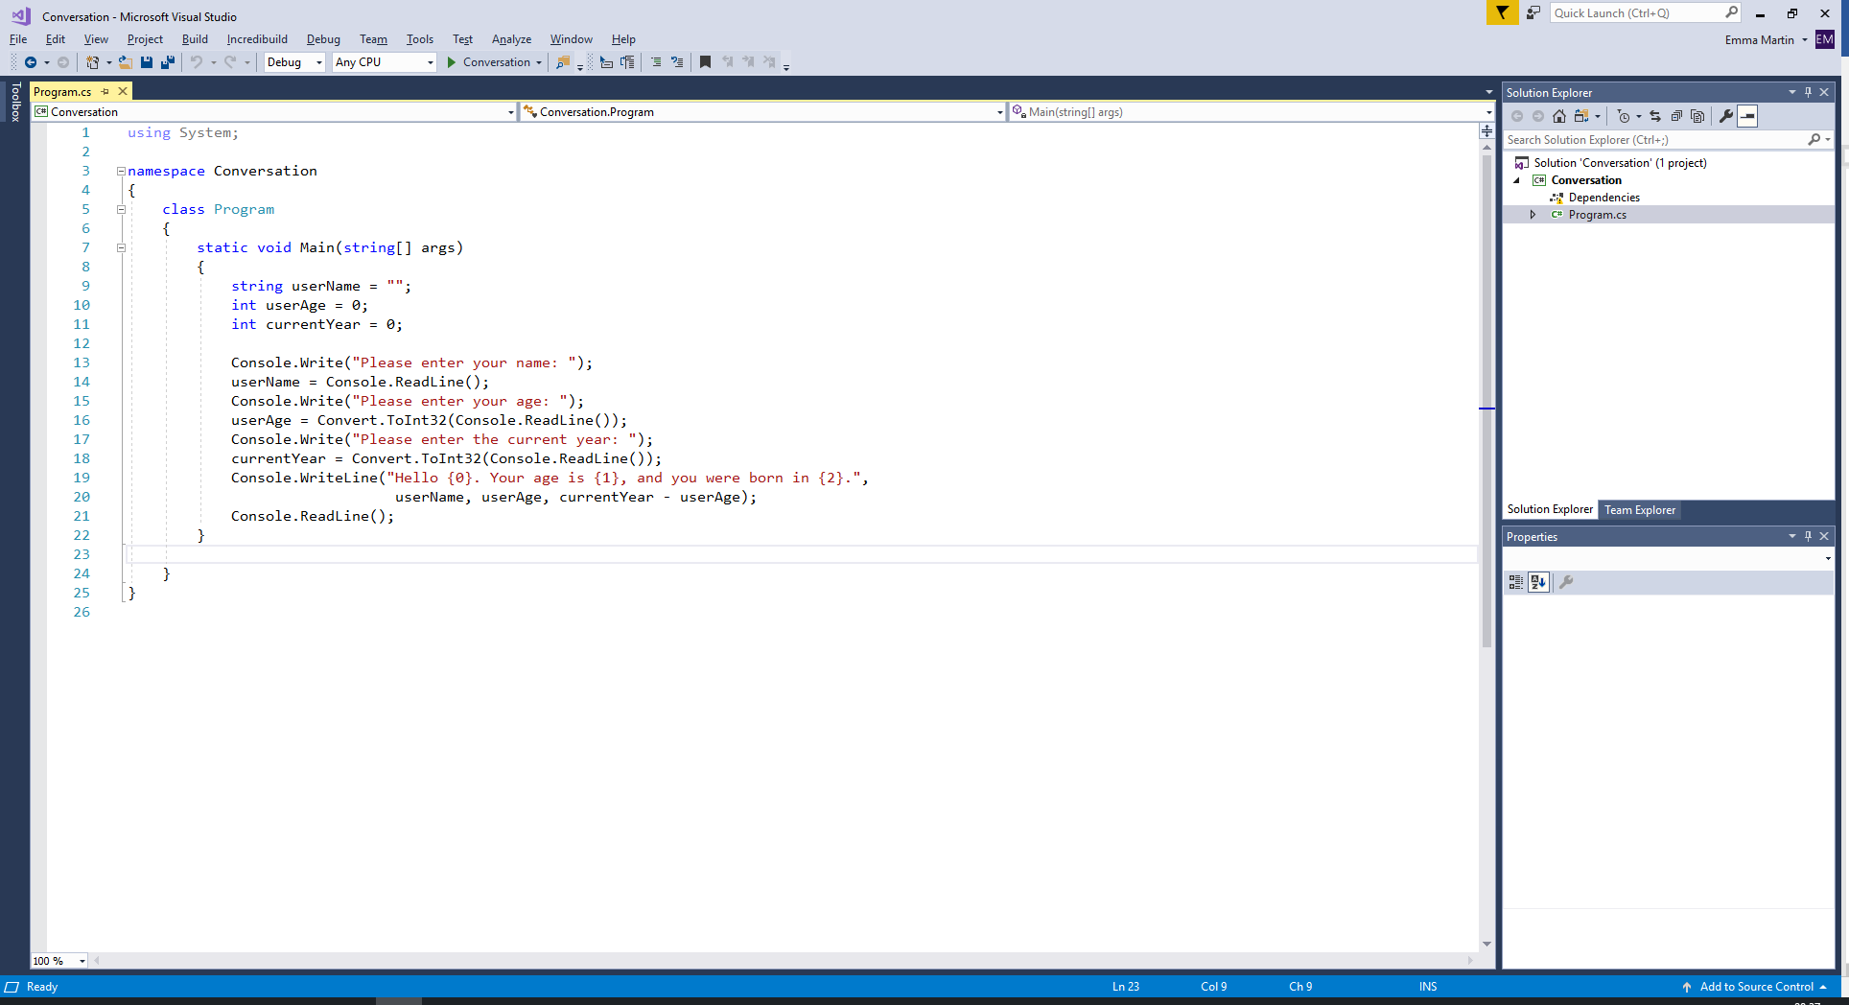

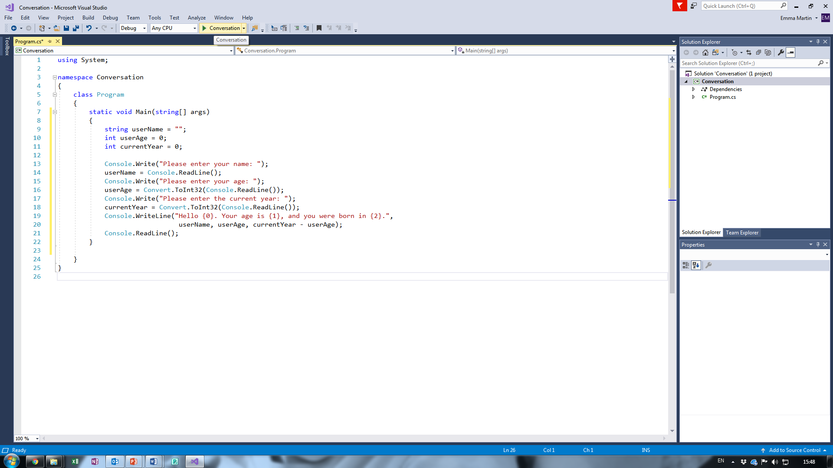Press F5 to run your program or click the play button in the top toolbar (you might be asked to save)

Questions

1. State the data type of the variables below, an example of data that might be input by the user and describe why the **data type** is appropriate:

|  |  |  |  |
| --- | --- | --- | --- |
| **Variable** | **Data Type** | **Example of Data** | **Why is data type appropriate?** |
| userName | String | bob | Because a string holds multiple charactors. |
| userAge | Integer | 420 | Because Mathematical equations can be used. |
| currentYear | Date and Time | 2022 | Because it is perpose made to contain the currrent date. |

1. Run the program and input **invalid** data in to each of the variables. What happens?

|  |  |  |  |
| --- | --- | --- | --- |
| **Variable** | **Invalid Data** | **Why invalid?** | **What happens?** |
| userName | 9 | Because the number 9 isnt a name | The program works |
| userAge | cat | Because its not a number | The program breaks |
| currentYear |  |  |  |

1. What is the difference between Console.Write() and Console.WriteLine()?

|  |
| --- |
| Console.Write() doesn’t create a new line where as Console.Writeline() creates a new line |
|  |

1. What is the difference between Console.Read() and Console.ReadLine()?

*Hint: Try changing the code and see what happens!*

|  |
| --- |
| Console.Read() Only reads a single character. Console.ReadLine() Reads the entire line |
|  |

1. Why do you think it is necessary to use Convert.ToInt32() when storing the users age?

|  |
| --- |
| Because it was originally a string value that cant be used in maths equations |
|  |

1. What code would you use to convert the input to a fraction?

*Hint: Remove the .ToInt32() from after Convert then type a . – you should be provided with a list of suggestions.*

|  |
| --- |
|  |
|  |

1. Why do you think the numbers in curly brackets {} are used in the final Console.WriteLine()?

|  |
| --- |
| To add extra data into the equation. |
|  |