Component 3 (Project)

## Contents

Component 3 (Project) 1

Contents 2

Analysis 5

Project Identification 5

Summary of my project 5

Characters 5

Sounds 5

Sprites 6

Computational Methods 6

Thinking Abstractly 6

Thinking Ahead 6

Thinking Procedurally 7

Thinking Logically 7

Thinking Concurrently 7

Stakeholders 8

Research 9

Games 9

Moto X3M 9

www.coolmathgames.com 9

Controls 9

Aesthetics 9

Competition and High Scores 9

The Chrome Dino Game (Build into The Chromium Project) https://source.chromium.org/chromium/chromium/src/+/main:components/neterror/resources/offline.js 10

Controls 11

Competition and High Scores 11

Settings and Customisation 11

Mountain Biking 1.0 12

Aesthetics 12

Controls 12

Controllers 14

Xbox Wireless Controller (RRP £54.99) 14

Included Input Methods 14

Accessibility 14

Miscellaneous Buttons 15

Xbox Adaptive Controller (RRP £74.99) 15

Included Inputs 15

Additional Input Methods 16

Much like a bespoke system this controller allows for other buttons and switches to be added helping to create a bespoke method of controlling the game. 16

https://www.xbox.com/en-GB/accessories/controllers/xbox-adaptive-controller 16

Additional buttons, triggers, joysticks and switches can be added to the Adaptive Controller. This adds the benefits of a truly individualised control scheme with the simplicity and standardisation of the original Xbox Wireless Controller. 16

16

Stakeholder research 17

Rate how engaging the Dino Game was 17

Explain your rating to the previous question 17

Rate how engaging Moto 3XM was 18

Explain your rating to the previous question 18

Rate how engaging Mountain Biking 1.0 was 19

Explain your rating to the previous question 19

Rate the controls in the Dino Game 19

Explain your rating to the previous question 20

Rate the controls in Moto 3XM 20

Explain your rating to the previous question 20

Rate the controls in Mountain Biking 1.0 21

Explain your rating to the previous question 21

Rate the aesthetics of the Dino Game 21

Explain your rating to the previous question 21

Rate the aesthetics of Moto 3XM 22

Explain your rating to the previous question 22

Rate the aesthetics of Mountain Biking 1.0 22

Explain your rating to the previous question. 23

Did you like the infinitely scrolling nature of the Dino Game and Moto 3XM? 23

Rank the games on how much you liked them overall. 23

Explain your ranking. 23

Name 3 things you liked about the Dino Game 23

Name 3 things you liked about Moto 3XM. 24

Name 3 things you liked about Mountain Biking 1.0 24

Essential Features and Limitations 25

Essential Features: 25

Hardware and Software Specification 26

Success Criteria 27

ID 27

Description 27

Justification 27

# Analysis

## Project Identification

### Summary of my project

The project that I intend to complete is an infinite running game. Games like these can be played by a single player at a time. The player navigates through the game using the space key to jump, navigating along the infinitely scrolling level and manoeuvring themselves around a constantly changing environment. A high score is calculated from the distance that the player completed. This high score can then be compared with others scores to enable competition between players. The gameplay gets progressively harder with a higher speeds and more complicated level design.

I aim to make this game accessible, allowing anybody to play regardless of age, ability, and income, etc. Although many infinite running games do exist there is a gap in the market for accessible games in this genre.



chrome://dino

<https://assets.xboxservices.com/assets/87/c0/87c08868-ad8f-408a-9e90-977fcd02d7e5.jpg?n=Assistive-Tech_Feature-0_Strengthened-Community_1040x585.jpg>

### Characters

The game includes a single playing character. This character is controlled by the player through the keyboard or other input device. To play the game this character is moved through the infinitely scrolling game by jumping / ducking. If the player comes into contact with a cactus or Pterodactyl, the score is reset and the game begins from scratch.

### Sounds

I want the game to have an arcade like feel. Therefore, I will implement simple sounds to create this impression. To emphasise when the player jumps and dies I will add optional sounds corresponding to these events. I will have an optional theme tune that plays continuously, speeding up as the game gets faster, this will increase the adrenaline response of the player increasing the excitement about the game. However I am aware that this needs to be optional to prevent people becoming overstimulated.

### Sprites

Much like my inspiration I aim to use pixel art for my sprites. This will add to the arcade feel of the game. The main playing character will be an animated pixel art bicycle. Although the monochrome aspect of the original game is visually interesting, I believe that sprites with a wide range of vibrant colours will be more entertaining for younger audiences. Again I am aware that the colour scheme needs to be customisable as for some people high contrast monochrome graphics are easier to interpretate than colourful graphics.

## Computational Methods

The game is suitable for a digital solution as it has principles / physics that can be easily enforced by simple algorithms. A non-computational version of my project would lack immersion as in game objects would not be able to be individually controlled. Due to the fundamental lack of refreshing controllable graphics in non-computational situations it is imperative that my program uses a computer.

For example, an algorithm needed to run the game is collision detection. The algorithm checks whether the player has collided with any other game objects (Cactus, pterodactyl). If the player has collided with anything the program stops the game play and shows the user their final score.

Another benefit of creating this game computationally is the potential for networked gameplay. In a future version of this game networked gameplay would allow players to play the game socially, creating an element of competition.

### Thinking Abstractly

In order to simplify the gameplay and the production of the project many unnecessary aspects of reality are discarded.

The main example of this is the 2D nature of the game, although in reality the world is seen in 3D a 3D game would overcomplicate the design / ease of gameplay.

Another example of abstraction in my design process is the blocky graphics used, the need to make the game photo-realistic is diminished allowing me to focus on creating an engaging playing experience as well as making the playing experience easier.

### Thinking Ahead

My games gameplay will be controlled using the space bar (To Jump) / arrow keys (^:To jump).

As the game needs to be as accessible as possible, I will research more types of controller aiming make as many types of controller compatible with the final project. Allowing people to use their desired input method to control the game.

In order to navigate through the menu screens / settings and to pause the game a mouse cursor will be used once again this can be substituted for arrow keys or another method of input (Joystick, Eye-Gase).

### Thinking Procedurally

I will make use of object oriented programming in order to maximise efficiency of my program. All moving objects will share a class with more specific sub classes being employed for each specific character. This will allow for the

I will also break my program down into subroutines. This is imperative as I want parts of my code to be called on demand. For example, when the player inputs a jump command i need the program to run the code making the sprite jump.

### Thinking Logically

For collision detection the program will continuously check to ensure that the character hasn't collided with the platforms. When the player collides with a in game object a decision should be made on what the necessary response is.

### Thinking Concurrently

The program will use event driven programming meaning that when the user triggers an event code will be executed. This is a form of parallel processing.

## Stakeholders

I want my game to be accessible to everybody regardless of age, computer literacy, and ability.

As the game uses simple assets I expect the game to appeal especially to younger audiences and people with a disability that makes traditional games harder to access. However I want the the game to be both playable and entertaining for everybody, I will achieve this by adding lots of customisable setting allowing users to set-up the game bespokely to their own requirements / desires.

I will use a diverse range of named and unnamed stakeholders in order to collate a wide-range of opinions on how best to implement the features of my game.

My named stakeholders include:

* Iustin Tamasanu (An A Level Computer Science Student that enjoys playing computer games casually)
* Esme (A palliative paediatric physiotherapist working in a Children's Hospice)
* Dora Turner (A young occasional gamer that enjoys simple games with bright colourful graphics).

I will collect regular feedback from these named stakeholders while sending out opinion polls to collect data from a wider range of my target audience.

## Research

### Games

In order to develop my ideas more thoroughly I will look into four similar games made by other developers. This will help me decide what features I want to include in this game and how best to implement them.

Moto X3M

[www.coolmathgames.com](http://www.coolmathgames.com)

This fast-paced online 2d driving game provides an immersive experience with its bold graphics and clever controls.

The levels become more difficult as the game is played through, with more complex level design. This provides a good feeling of progression however most of the levels can be passed with little skill.

#### Controls

The user uses the arrow keys to control the motorbikes speed and tilt. They use these controls to navigate through the constantly changing terrain. This provides great control over the bike throughout the game for people with good fine motor skills and coordination.

This opposes my aim of making the game assessable, some people may have trouble with the complex fine motor skills required to control the bike.

#### Aesthetics

Although the style of the game is coherent throughout the levels I dislike how many assets are on screen at any given time. This can make gameplay feel overcomplicated and confusing for players.

I like how the animations make the game feel polished adding more visual interest. My stakeholders suggest that these should be optional as they be overstimulating for some users.

My stakeholders have also suggested that the art style in my game is more simplified than Moto 3XM with boosted contrast between the sprites and the backdrop. This will further reduce visual overstimulation helping players with reduced processing time and visual impairments.

#### Competition and High Scores

The aim of the game is to complete the levels as quickly as possible, a star based scoring system is used to quantify the speed of the level completion. Many players enjoy speed-running the game with a record completion time of 13 minutes and 11 seconds.

Time deductions are offered when players flip the bike (0.5 sec for 1 flip, 1 sec for 2 flips, ect). This provides an interesting high risk / high reward aspect to the game.

Scores based on speed are exhilarating for some users however in my final solution a high score based on distance would be more appropriate as I am going to to make the game infinitely scrolling.

The game ends when the users body touches the course, this is animated through a fireball explosion, insinuating a crash.

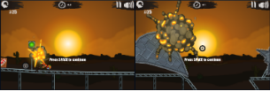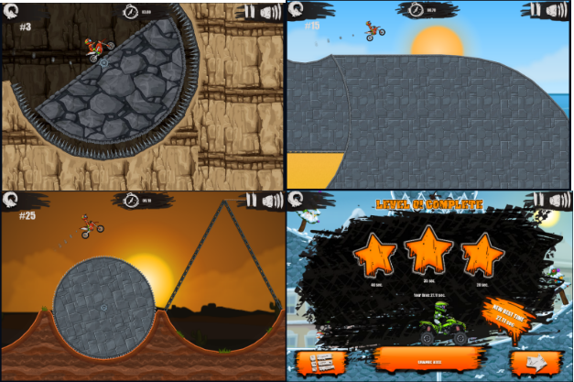

### The Chrome Dino Game (Build into The Chromium Project) <https://source.chromium.org/chromium/chromium/src/+/main:components/neterror/resources/offline.js>

<chrome://dino>

The Chrome Dino game is a simple infinitely scrolling 2d game. The user navigates through a desert environment by jumping over cactus / other objects as the game speeds up / more objects to avoid are added.

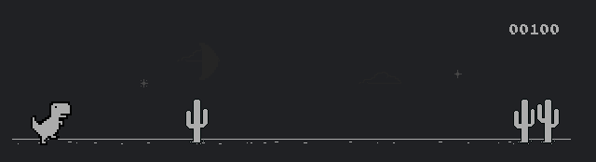

#### Controls

For more experienced gamers the controls may seem limited, the space bar is the main control (Allowing the dinosaur to jump), however this is perfect for people with reduced coordination such as young children, elderly people, and people with coordination difficulties. I like the idea of implementing a similar control layout in order to maximise accessibility. As the game progresses the player is required to duck using the down arrow to avoid objects flying above them. This adds another dimension to the game.

#### Competition and High Scores

The Dino game has a high score system based on how far through the game you progress. Although this is a simple implementation I like how it is easy to compare against other players. The game doesn't have any built in multiplayer / competition features however as these scores are an objective measure of a players skill level they can be shared and compared easily. An indicator showing the high score along with the current score is found in the top right hand side of the screen.



#### Settings and Customisation

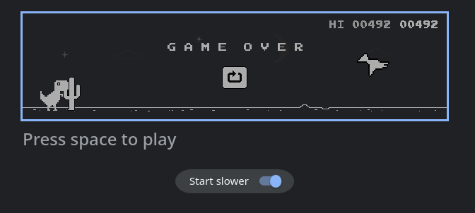

The game isn't particularly customisable, the controls and styling are all pre-programmed. It has one setting option. This setting allows the user to make the game easier if necessary, by starting the game at an even slower pace than usual. Although I do admire the simplicity of the game I have realized that my game should be more customisable than the Dino game to allow users to personalize it to their own specifications.



### Mountain Biking 1.0

<https://scratch.mit.edu/projects/270299035>

Mountain Biking 1.0 is a basic 2d platform game. The player needs to reach the end of each level without falling off the platforms, extra points are awarded to players that collect the spanner adding an extra challenge for intrepid players.

The game isn't a infinite scrolling platformer and the screen resets to a new level after each level has been completed. A positive of this is that much like Moto 3XM the level design can become more complex as the game progresses. However I dislike how the game feels disjointed.

#### Aesthetics

The game uses basic pixel art sprites and a basic single coloured backdrop. I like the overall theming however it feels unpolished due to a lack of consistency in the later levels. In my game i want to use animations to make that game feel more realistic.

The bright colours help to distinguish the foreground from the background. To extenuate this i will ensure that i keep the background neutral

#### Controls

The game works with either WASD or arrow keys to control the movement of the sprite, the space bar can also be used as an additional jump key. The use of standard / intuitive controls makes the game easier to pick up for people that play other games .

However the controls feel unnatural as the bike moves in ways that are impossible in the real world.

By themselves theses methods of control might not seem usable for people with complex motor skills imparements. However a separate controller with large buttons can be easily mapped to the controls of the game to allow for easier .

Ideally my game will implement more accessible controls out of the box with a control scheme more similar to the dino game.

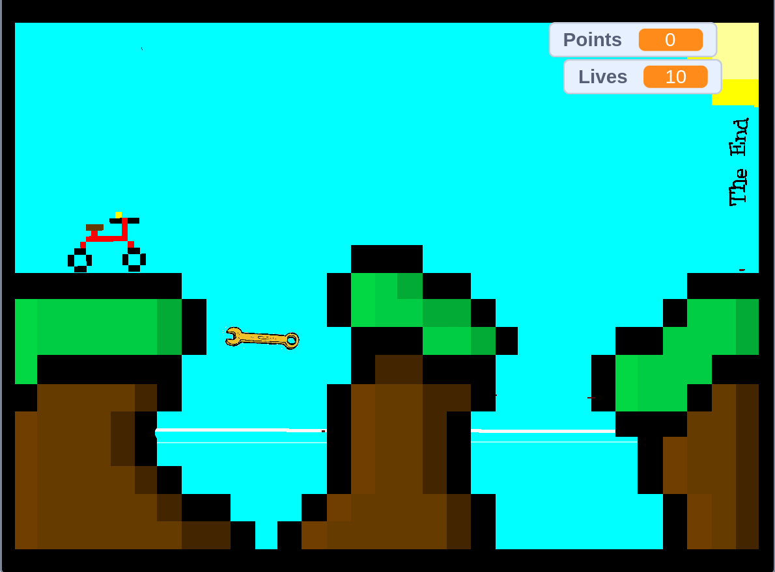

## Controllers

I also wanted to explore the market for dedicated controllers. This will guide me in both how to make the keyboard centric controls easier to use, as I can draw similarities from dedicated controllers as well as helping me to identify control schemes that I can make compatible with my final project.

### Xbox Wireless Controller (RRP £54.99)

The Xbox Wireless Controller is the default game-pad on Microsoft Xbox devices. This means that it will be familiar to a wide subset of my target audience. It can connect to Windows PC’s through Bluetooth allowing my clients to play without being tethered to their computer.

#### Included Input Methods

The Xbox controller has a wide range of inputs that can be used.

* Textured Bumpers and Triggers
  + These allow for tactile digital input.
* Analogue control sticks
  + These sticks allow for precise analogue control.
* D pad and Lettered buttons
  + These are basic button inputs. They provide more tactile experience than a keyboard.

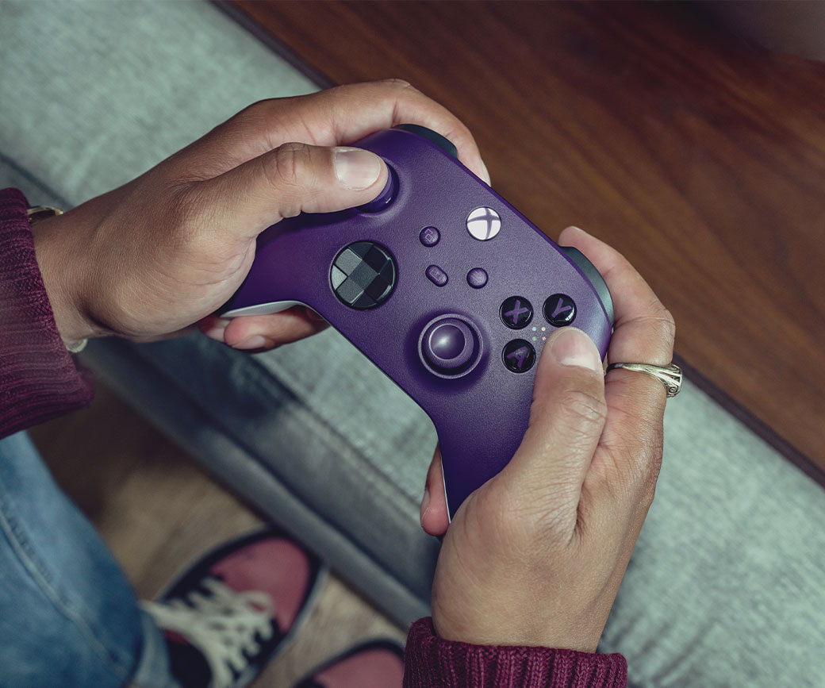

<https://www.xbox.com/en-GB/accessories/controllers/xbox-wireless-controller>

#### Accessibility

This controller will be familiar to most people and is synonymous with video games. For many people using a standard Xbox controller will be easier and more intuitive than a mouse and keyboard. However the controller doesn't implement any ground-breaking benefits for accessibility. After a consultation with my expert stakeholder, Esme Turner, I have come to the conclusion that the controls in my final solution must improve on the Xbox wireless controller in these key ways:

* Buttons should be enlarged.
* The controller should not be solely handheld
* The analogue controls will be challenging to use with limited motor control
* The controller should be able to be used by other body parts rather than limited to handheld use.

Overall the Xbox controller has a negligible improvement in accessibility compared to a mouse and keyboard. However it can be more comfortable and intuitive for some users. It would be good to implement compatibility with the standard Xbox controller within my final project to allow all users a wider choice.

### Miscellaneous Buttons

A wide range of Bluetooth and USB controllers exist. These can be connected to a computer and then mapped to key presses allowing the user to interact with games with basic controls.

Almost any mode of input that can be interfaced with a computer can be made to work with games without much work from the developer. However this puts the burden of work on the user making the game harder to set-up as they need to individually key-map each input to a keyboard control.

Benefits of a Totally Modular system:

* Total control over each component of the system

Drawbacks to a totally modular system:

* Can be very expensive as users have to purchase many different parts
* Hard and time consuming to setup

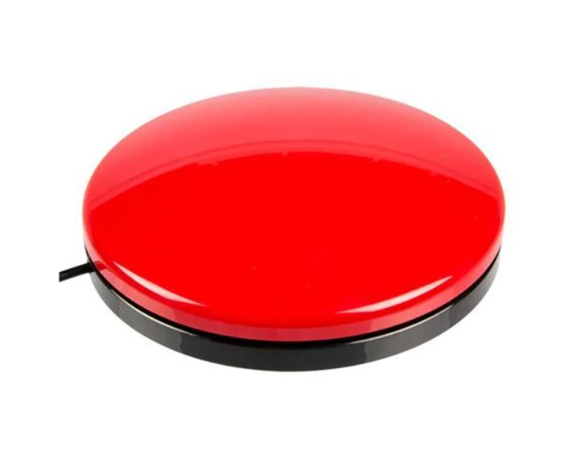

### Xbox Adaptive Controller (RRP £74.99)

Many people that struggle to use a mouse and keyboard have their own personalised set-up to enable them to access computers easily. However as concluded on the previous section they are often not standardised making it hard to implement for developers.

The Xbox Adaptive controller allows users to connect the individual components of their set-ups and interface them in a standard manner to their computers.

#### Included Inputs

* Large Tactile Buttons
  + These are much easier to actuate than the buttons on the Xbox Wireless controller
* A D-pad
  + This is made to provide control over the game interface

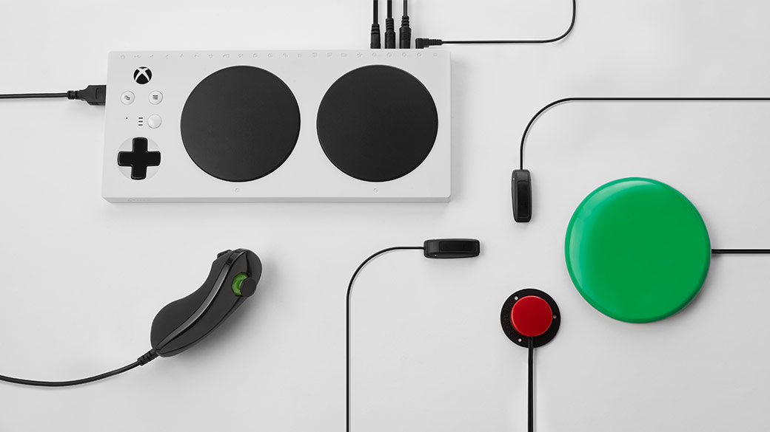

<https://www.xbox.com/en-GB/accessories/controllers/xbox-adaptive-controller>

#### Additional Input Methods

Much like a bespoke system this controller allows for other buttons and switches to be added helping to create a bespoke method of controlling the game.

<https://www.xbox.com/en-GB/accessories/controllers/xbox-adaptive-controller>

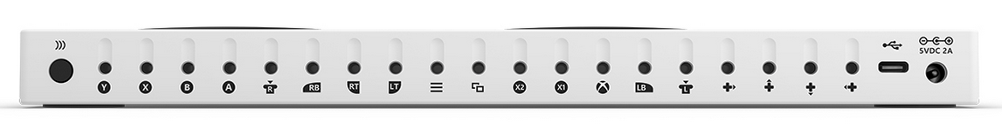

Additional buttons, triggers, joysticks and switches can be added to the Adaptive Controller. This adds the benefits of a truly individualised control scheme with the simplicity and standardisation of the original Xbox Wireless Controller.



https://assets.xboxservices.com/assets/87/c0/87c08868-ad8f-408a-9e90-977fcd02d7e5.jpg?n=Assistive-Tech_Feature-0_Strengthened-Community_1040x585.jpg

## Stakeholder research

I gave my stakeholders the 3 games that are similar to my proposed project and already on the market.

I asked them to rate the game from multiple different standpoints. Including the controls, how engaging the game was, and how much they enjoyed the visuals / sound effects.

In addition I have spoken to an expert in the field of paediatric palliative care in order to better understand how I can tailor my game to be playable by children with a range of different levels of mobility / sight / coordination. This will help to further increase my understanding of the requirements of a large portion of my target market.

#### Rate how engaging the Dino Game was

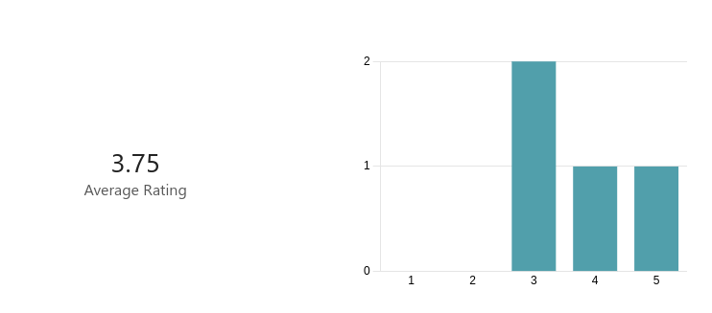

#### Explain your rating to the previous question

|  |  |
| --- | --- |
| 1 | Boring graphics. Game gets repetitive overtime |
| 2 | I was instantly bored by the graphics. I love how it gets faster so its harder. |
| 3 | The intention of the game is simple entertainment with an infinite scroller. It isn't meant to have any progression, however I would enjoy this game more for it provided some customisation. An example may be the mobile game Dune!, although game mechanics are different, you unlock different background and different skins. Competition to defeat your and other people's high scores is definitely the most engaging about this game. |
| 4 | Although the game was simple the way the level of difficulty slowly increased kept me engaged for long periods of time |

Analysis: From this question I have come to the conclusion that my stakeholders like the simple nature of the game despite the fact it might seem initially too basic to allow for long play times.

To make the game more engaging i should add a way for players to easily compete by sharing their scores as well as achievements for reaching high scores.

To make the game less boring for more experienced players i will also implement a checkpoint system allowing players to start at a position that is challenging regardless of their skill level.

#### Rate how engaging Moto 3XM was

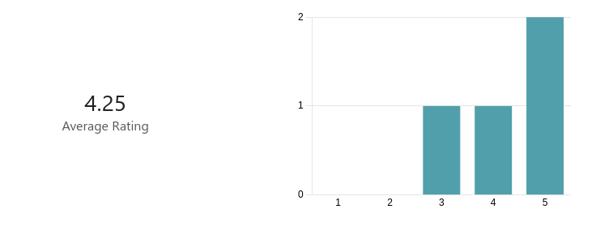

#### Explain your rating to the previous question

|  |  |
| --- | --- |
| 1 | Exiting fast paced game. The difficulty should increase more overtime to maintain engagement. |
| 2 | I dont like the difficulty progression |
| 3 | The game had progression and and interactive environment with a variety of challenges which are built very robust. The animations are great and overall the game is very playable. |
| 4 | I love the visuals. Game play was fluid and fun. |

From these responses I have determined that my stakeholders desire a game with fluid animations however it is important that these animations can be controlled by the user and disabled if they become too visually distracting.

The stakeholders thought that although the game did have some progression the majority of stake holders would like to see a wider range of difficulties (both easier and more complex).

#### Rate how engaging Mountain Biking 1.0 was

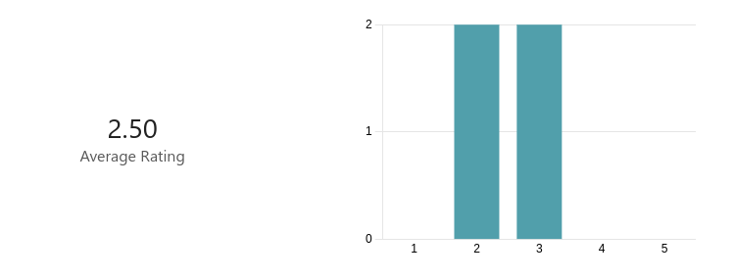

#### Explain your rating to the previous question

|  |  |
| --- | --- |
| 1 | Enjoyable but due to the lack of scrolling the game feels clunky. |
| 2 | Its far too easy |
| 3 | The game is extremely simple with no GUI and introduces some game mechanics which are very strange. There very little animation. For example, I cannot use numbers and arrow keys on my 60% keyboard. I do however believe the game has potential with its blocky aesthetics, which are fairly consistent throughout the game. |
| 4 | The visuals were lacking in quality. Overall the game seemed unpolished. |

From this question i have discovered that my game should be a smooth infinite scoller without individual levels. My project should also have a well designed gui to allow for custimisable settings.

#### Rate the controls in the Dino Game

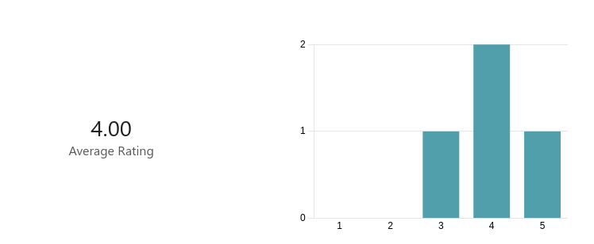

#### Explain your rating to the previous question

|  |  |
| --- | --- |
| 1 | Easy to understand. Limited control. |
| 2 | Easy but boring |
| 3 | It may be as simple as pressing space. I'm giving it four stars as it is extremely responsive and the jump height depends on the duration of time the user has pressed space for which is very nice, as you want to press space for longer if you have to clear a high jump and press space shorter if you have too consecutively jump quickly. |
| 4 | Great for use one handed (I have a broken wrist). Really accessible. |

Although some users found the controls boring they are simple and accessible. I am planning to implement a dino style control layout before adding more granular control later down the line

#### Rate the controls in Moto 3XM

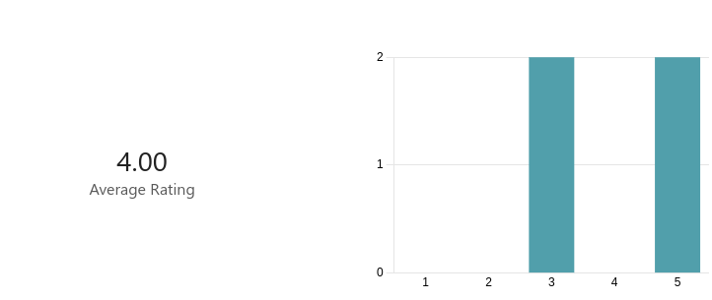

#### Explain your rating to the previous question

|  |  |
| --- | --- |
| 1 | Great life like control. |
| 2 | Easy and fun |
| 3 | Controls allow me to use WASD which I love. I have full control of the motorbike to turn it how I like which makes the controls of this game satisfactory. |
| 4 | Much more control than the dino game however this comes at the cost the adaptability of the controls. |

#### Rate the controls in Mountain Biking 1.0

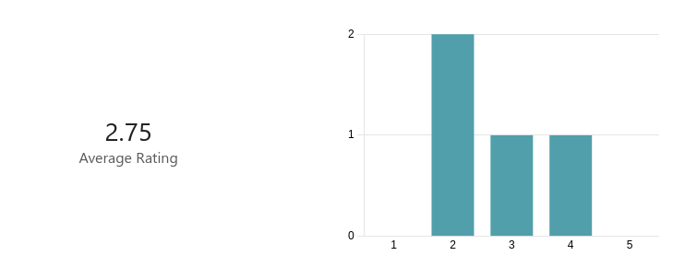

#### Explain your rating to the previous question

|  |  |
| --- | --- |
| 1 | Easy to controll however it lacks life like movement |
| 2 | Unrealistic |
| 3 | I cannot use WASD and using arrow keys on my keyboard is extremely uncomfortable. Jumping and moving is responsive. |
| 4 | Poor. Unlifelike. Suffers from the same problems as Moto 3XM without bring anything more to the table. |

#### Rate the aesthetics of the Dino Game

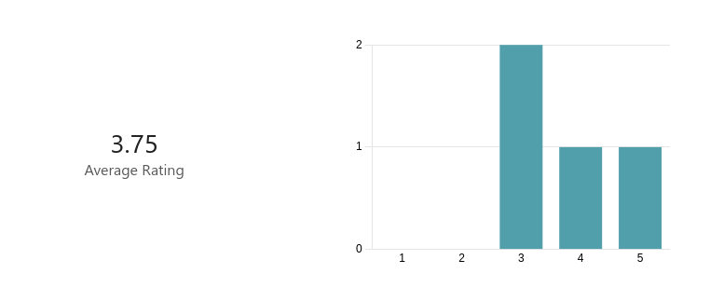

#### Explain your rating to the previous question

|  |  |
| --- | --- |
| 1 | Interesting on the first play. Due to the monochrome nature of the game it gets boring quickly. |
| 2 | I like the pixel art but don't like the monochrome |
| 3 | Very simple, but that's how it's supposed to be. I enjoy the 4 bit colour palette. I very much enjoy how the game alters between day and night time, which gives a simple game like this an immersive feeling. |
| 4 | I love how the simple visuals make the game simple to play, This will also result in better performance on very slow hardware. |

#### Rate the aesthetics of Moto 3XM

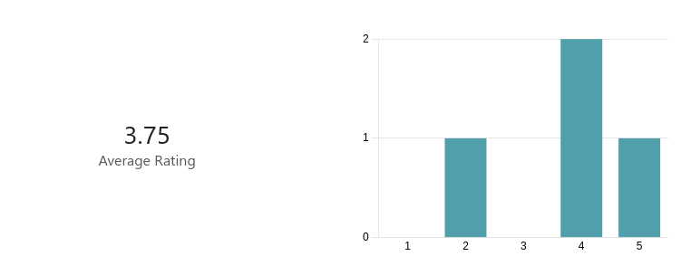

#### Explain your rating to the previous question

|  |  |
| --- | --- |
| 1 | Cartoony graphics provide an imersive experience without needing to look photo-realistic. |
| 2 | Too cartoony for me |
| 3 | Extremely nice game aesthetics. I particularly enjoy the 3 areas the game cycles through: the beach, the caves and the badlands which makes the game enjoyable. Sound effects of the bike and character are very entertaining and fit in perfectly. Animation of the bike as you are pressing the WASD is very smooth. |
| 4 | Great visuals. Might be problematic on slow hardware. |

#### Rate the aesthetics of Mountain Biking 1.0

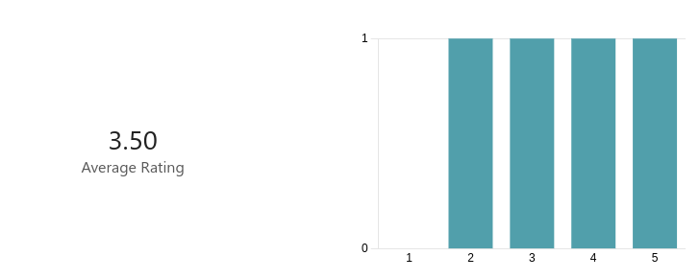

#### Explain your rating to the previous question.

|  |  |
| --- | --- |
| 1 | I like the pixel art aesthetic |
| 2 | Looks great. |
| 3 | Extremely simple with no animation, but as I have mentioned above, there is potential with the blocky theme of the game, and I really like how the terrain looks. |
| 4 | Simple and unfinished. |

#### Did you like the infinitely scrolling nature of the Dino Game and Moto 3XM?

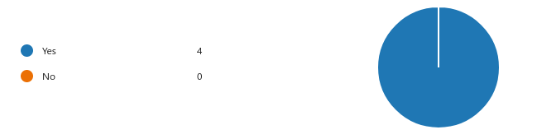

#### Rank the games on how much you liked them overall.

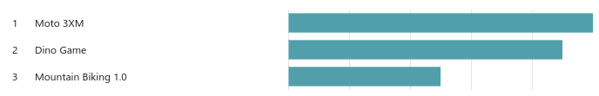

#### Explain your ranking.

|  |  |
| --- | --- |
| 1 | I liked the Moto 3XM games controls and the fact it was infinitely scrolling. I didn't like how boring the Dino game became. |
| 2 | Dino game had best difficulty progression |
| 3 | Moto 3XM is definitely a game I can play start to finish as it fairly simple and provides different challenges, like going through boulders that are launched at you by some explosives and driving over rotating spikes. The Dino Game is very simplistic, which is okay, but it's not a game you could come back to every once in a while. Mountain Biking 1.0 is last due to it's controls and overall functionality. Controls are simple but do not conform to every level, such as jumping up to platform that is too high. |
| 4 | The dino game had the most going for it for such a simple game |

#### Name 3 things you liked about the Dino Game

|  |  |
| --- | --- |
| 1 | The simple controls. How the difficulty increases overtime with speed. The pixel graphics |
| 2 | Difficulty progression. Pixel art Easy controls |
| 3 | Simplistic presentation. The change in background from night to day after a period of time. The repetitive nature of beating your old high score. |
| 4 | Visuals Accessible controls Progression |

#### Name 3 things you liked about Moto 3XM.

|  |  |
| --- | --- |
| 1 | The controls. The scrolling. The sound effects. |
| 2 | Controls Level Design Animations used |
| 3 | I like how the challenges are not repetitive. It delivered exactly what I expected. A relaxing, not difficult experience which was very enjoyable. I enjoyed the -0.5 seconds for a flip (implements a higher risk, higher reward game mechanic) I also liked the progression the levels take through the three different areas. |
| 4 | Fast paced nature Levels provided some change in difficulty Racing against the clock |

#### Name 3 things you liked about Mountain Biking 1.0

|  |  |
| --- | --- |
| 1 | The graphics. The simple level designs. The upgrades. |
| 2 | Graphics Levelling up Ease of play |
| 3 | I enjoyed the overall style the game went for, which blocky and has a lot of potential. I also like how the hitbox of the bike interacts with the hit-box of the environment vertically, allowing you to jump up walls. I like how it introduces different challenges, like the sky being deadly, adding a bit more variety, as every level is different. |

## Essential Features and Limitations

From my own research and the responses, I have received from my stakeholders I have collated a list of Essential Features as well as some notable features that are not required. This will help me to create my success criteria allowing for testing once a solution has been created.

### Essential Features:

1. The game must put accessibility first. This should mean that the game can be played by people regardless of health conditions or impairments.
2. The game should be visually pleasing with a simple interface. This interface should contain settings that allow users to alter aspects of the gameplay in order to customise it to their specific use case.
3. The game should have basic controls that are easy to learn and intuitive. These controls should be customisable. To allow users with differing requirements / desires to all have an intuitive playing experience.
4. A wide range of hardware should be supported so that the game can be played regardless of the performance of the computer available.
5. The game must become more difficult over time. The progression through the game should be marked by checkpoints meaning that uses do not have to replay easy sections after becoming proficient at the game.
6. The game should have an on-boarding experience / tour. This should guide the user around the GUI as well as showing them basic technique.

Limitations

1. My stake holders have suggested that online connectivity is not a priority. This is due to time constraints as well as concerns about making the game age appropriate. They are content with the manual sharing of the high scores.
2. My stake holders do not wish for the game to be 3D this is due to the desire for the game to run on low powered hardware as well as in an attempt to improve the accessibility of the game .
3. It is not a priority to port the game to other platforms apart from windows as windows is a well-used OS running on most personal computers. Any other operating system can run the program through a compatibility layer.

## Hardware and Software Specification

The game needs to be able to run on a wide range of different personal computer systems to make the game usable for as many people as possible. To achieve this, I will provide my users with a windows executable file, this file can be run on any windows-based machine with dot net installed. However, I have included an outline of what is needed to run my game and what is necessary in order to have the best experience possible below for clarification.

|  |  |  |
| --- | --- | --- |
| **Specification** | **Required** | **Recommended** |
| Operating system | 64bit Windows 7 and Above | Windows 10 - 11 |
| RAM | 2GB | >4GB |
| Processor | X86 64 Bit 1GHZ Dual Core CPU | X86 64 Bit >1GHZ Multi Core CPU |
| Disk Space | 20GB | 64GB |
| Graphics | Inbuilt GPU running Direct x9 | Dedicated GPU running >Direct x9 |
| Display | Any functioning display compatible with your computer | >60HRZ HD LCD/ OLED screen |
| Controls | Keyboard + Mouse / Equivalent | Keyboard + Mouse + Any other control needed to make accessing the game easier |

To create the game, I used 2 main computers. This is because I created this project both at home and within college. To develop this game you need a computer running windows with the Dot Net framework installed.

|  |  |  |
| --- | --- | --- |
| **Specification** | **Home PC** | **College PC** |
| Operating system | Windows 10 | Windows 10 |
| RAM | 4GB | 8GB |
| Processor | 1.3 GHz 2 core CPU | 3.10GHz 6 Core CPU |
| Disk Space | 150GB | 237GB |
| Graphics | Integrated GPU | Integrated GPU |
| Display | Remote Desktop through Laptop | 1080p LCD Screen |
| IDE | Visual Studio | Visual Studio |

## Success Criteria

My stake holders have provided a criteria that they want the game to fulfil before it is ready to ship. I can test my project against the criteria as I complete it. This will help me know when the project is at a standard that it can be submitted to the stakeholders.

|  |  |  |
| --- | --- | --- |
| **ID** | **Description** | **Justification** |
| 1 | The user must be able to move the main sprite intuitively using a keyboard. | For the game to work the user must be able to control the movement of the sprite. The keyboard is the most basic implementation of this control. |
| 2 | The user must be able to control the main sprite with alternative controls. (A game-pad) | To maximise the accessibility of the game adapted controllers are important to allow all users to play the game with as few barriers to entry as possible. |
| 3 | The game must run smoothly on low end hardware | I want the game to be as accessible as possible. Not everybody can afford an expensive gaming computer. |
| 4 | The game must become more difficult as it progresses. This should be implemented through a gradual increase in speed. | If no change in difficulty occurs the game will get boring. It is important that the game progresses to keep players engaged. |
| 5 | The game must have customisable graphics allowing the user to choose between styles. | People have different tastes regarding graphics. I want to appeal to as many people as possible. Additionally for some people simplified, high contrast graphics are easier to interpretate. |
| 6 | The game should have optional fun arcade sounds showing a user when an event occurs. (Death, A jump) | These sounds will make the game more immersive adding auditory ques when something happens in game.  It is important that these are optional as it can be overstimulating for some users to have both visual and auditory inputs. |
| 7 | The game should have a customisable start speed. | Some people might need the game to be run more slowly than other players. This should be an easily accessible option. |
| 8 | The game should show a window with the high score and an option to restart when the user collides with a ‘enemy’ sprite. | This will allow the user to restart the game and preview their high score. |
| 9 | The game should store the high scores over time. | This will allow people to attempt to beat previously set high scores. |
| 10 | The game should have a checkpoint system allowing the user to start in a position close to where they last died | This will allow the user to avoid playing through gameplay that they find easy, providing a challenging experience on each session. |
| 11 | The game should have a splash screen | This will allow the user to edit options, start, and exit the game. |
| 12 | The default main sprite should be a pixel art bicycle but other characters should be available showing a wide range of people in different situations. | My stakeholders have suggested that a diverse set of sprites can help people feel included as they are represented within the game. |
| 13 | A wide variety of objects to avoid should be available. The user should be able to choose what type of object they wish to avoid. | My stakeholders suggested that it would be entertaining to choose the objects that they are trying to avoid. |

## Requirement Specification

|  |  |  |
| --- | --- | --- |
| **ID** | **Requirement** | **Justification** |
| 1 | User can move the sprite with keyboard | SC1 |
| 2 | Compatibility with external controllers must be implemented. The controller must move the sprite. | SC2 |
| 3 | The game must be 2d | SC3 |
| 4 | The game must use subroutines where possible | SC3 |
| 5 | The game should be tested on a range of hardware | SC3 |
| 6 | The game should speed up as the user progresses | SC4 |
| 7 | There must be an option in settings to change the graphical style of the application | SC5 |
| 8 | The program should start by displaying a splash screen with basic instructions on how to play |  |
| 9 | The splash screen should have a button to allow the user to open other forms including a settings page and the game itself |  |
| 10 | The game should launch full screen. | This will stop the interface / game from becoming cramped |

# Iterative Development

## Stylistic Choices

### Main Character Ideas

The game should have a coherent aesthetic style. To help determine the style of the sprites that I will use, I created a mood board and shared it with my stakeholders.

|  |  |  |  |
| --- | --- | --- | --- |
| Title | Image | Stakeholder Feedback | My Feedback |
| Hand Drawn Style |  | The hand drawn pencil style is visually interesting. An animated version of this would be amazing. It isn’t great for accessibility as it could be hard to make out. | Great concept visually and artistically. Not a great default option for widening participation due to accessibility concerns. |
|  |  | The retro style is intriguing, and the asset would work well animated. | Great and easy to achieve. Less artistically impressive than the pencil drawing but still aesthetically pleasing. |
|  |  | A very basic drawing of a bike. Boring but great for readability and accessibility | A boring and basic sprite that can be easily interperated. |
|  |  | This has the potential of looking tacky and unpolished. Poor for accessibility due to the complex shape of the bicycle. | Too realistic, the game will look unfinished if this sprite is used with non-photo-realistic sprites. |
|  |  |  |  |

### Rock Styles

|  |  |  |  |
| --- | --- | --- | --- |
| Title | Image / Example | Stakeholder feedback |  |
|  |  |  |  |
|  |  |  |  |
|  |  |  |  |
|  |  |  |  |

## Decomposing the Problem