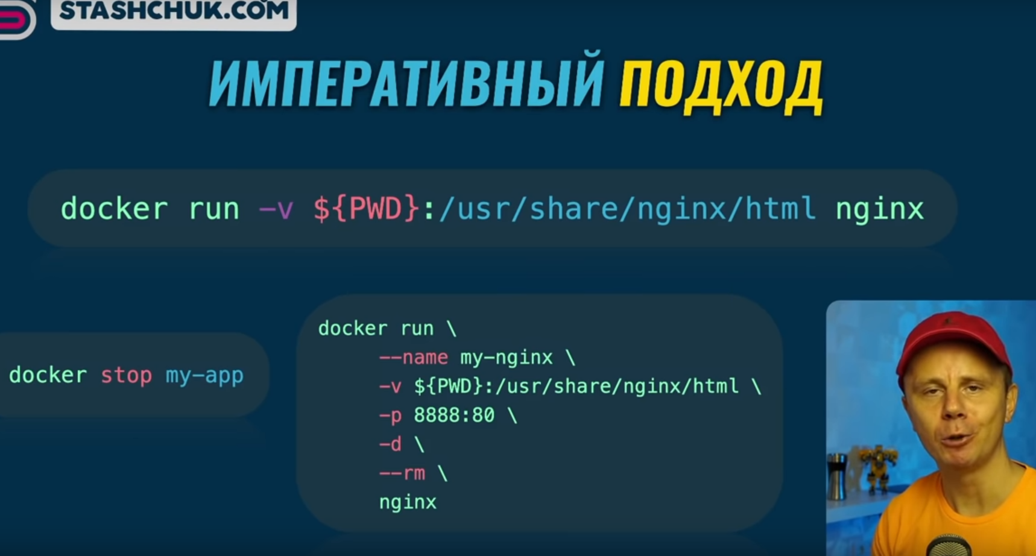

docker build . -t my-file-writer

Dockerfile

FROM  node:alpine

WORKDIR /app

COPY . .

CMD ["node","index.mjs"]

Index.mjs

import fs from 'fs'

fs.appendFile('my-file.txt', 'File created by Node.js', (err) => {

    if (err) throw err

    console.log('File created')

})

setTimeout(()  => console.log('The end'), 60000 )