建立HTML 及 JSP頁面
- Tomcat9.X已成功安裝。
步驟
1. 使用記事本建立 myfavorite.html 內容如下:

<html>
<head>
<meta http-equiv="Content-Type" content="text/html; charset=UTF-8">
<title>JSP Page</title>
</head>
<body>
<form action="simple.jsp">
Please enter your favorite animal:&nbsp;
<input type="text" name="favoriteAnimal" value="Rabbit"/>
<input type="submit" />
</form>
</body>
</html>

2. 檔案儲存於 C:\apache-tomcat-9.0.24\webapps\ROOT\ myfavorite.html
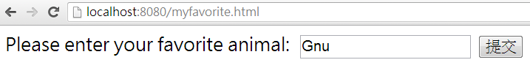
3. 使用記事本建立 simple.jsp 內容如下:
<%@page contentType="text/html" pageEncoding="UTF-8"%>
<!DOCTYPE html>
<html>
<head>
<meta http-equiv="Content-Type" content="text/html; charset=UTF-8">
<title>JSP Page</title>
</head>
<body>
<p>Your favorite animal is a
<%= request.getParameter("favoriteAnimal") %>
Wow, mine is too!
</p>
</body>
</html>
4. 檔案儲存於 C:\apache-tomcat-0.0.24\webapps\ROOT\ simple.jsp
5. 開啟IE連結網址 http://localhost:8080/myfavorite.html
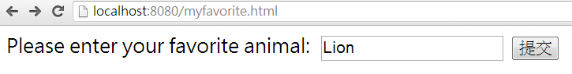

6. 再建立一個檔案儲存於 C:\apache-tomcat-9.0.24\webapps\ROOT\numberTable.jsp
<html>
<head>
<title>Example JSP Page</title>
</head>
<body bgcolor="white">
<b>Table of numbers squared:</b>
<table border="1" cellspacing="0" cellpadding="5">
<tr><th>number</th><th>squared</th></tr>
<% for ( int i=0; i<10; i++ ) { %>
<tr><td><%= i %></td><td><%= (i * i) %></td></tr>
<% } %>
</table>
</body>
</html>
