Servlet接收Form資料
1. C:\apache-tomcat-9.0.24\webapps\ROOT 加入ServletForm.html
<!DOCTYPE html>
<html>
<head>
<title></title>
<meta http-equiv="Content-Type" content="text/html; charset=UTF-8">
</head>
<body>
<form action="GetDataServlet" method="post">
<input type="text" name="user" value="張小明"/>
<input type="text" name="pass" value="pass"/>
<input type="submit"/>
</form>
</body>
</html>
2. C:\apache-tomcat-9.0.24\webapps\ROOT\WEB-INF\classes 加入 GetDataServlet.java並編譯

import java.io.IOException;
import java.io.PrintWriter;
import javax.servlet.ServletException;
import javax.servlet.annotation.WebServlet;
import javax.servlet.http.HttpServlet;
import javax.servlet.http.HttpServletRequest;
import javax.servlet.http.HttpServletResponse;

@WebServlet(urlPatterns = {"/GetDataServlet"})
public class GetDataServlet extends HttpServlet {

protected void processRequest(HttpServletRequest request, HttpServletResponse response)
throws ServletException, IOException {
response.setContentType("text/html;charset=UTF-8");
request.setCharacterEncoding("UTF-8");
PrintWriter out = response.getWriter();
try {
/* TODO output your page here. You may use following sample code. */
out.println("<!DOCTYPE html>");
out.println("<html>");
out.println("<head>");
out.println("<title>Servlet GetDataServlet</title>");
out.println("</head>");
out.println("<body>");
out.println("<h1><font color='blue'>" +request.getParameter("user") + "</font></h1>");
out.println("<h1><font color='red'>" +request.getParameter("pass") + "</font></h1>");
out.println("</body>");
out.println("</html>");
} finally {
out.close();
}
}
@Override
protected void doGet(HttpServletRequest request, HttpServletResponse response)
throws ServletException, IOException {
processRequest(request, response);
}
@Override
protected void doPost(HttpServletRequest request, HttpServletResponse response)
throws ServletException, IOException {
processRequest(request, response);
}
@Override
public String getServletInfo() {
return "Short description";
}// </editor-fold>
}
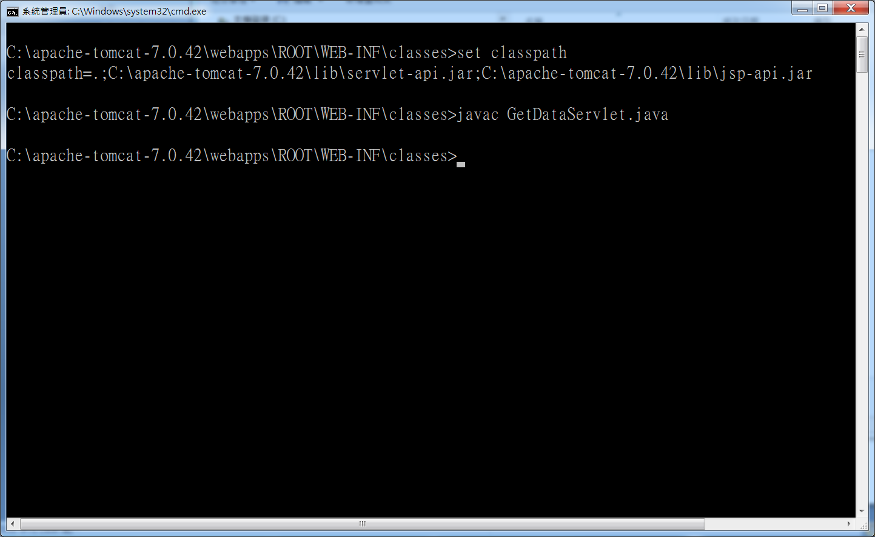

3. 編輯C:\apache-tomcat-9.0.24\webapps\ROOT\WEB-INF\web.xml
<servlet>
<servlet-name>GetServ</servlet-name>
<servlet-class>GetDataServlet</servlet-class>
</servlet>
<servlet-mapping>
<servlet-name>GetServ</servlet-name>
<url-pattern>/GetDataServlet</url-pattern>
</servlet-mapping>
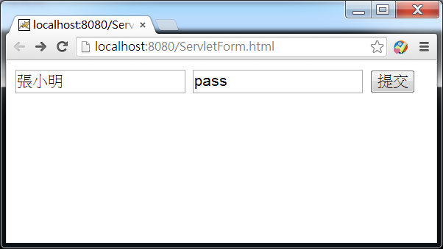
4. C:\apache-tomcat-7.0.42\webapps\ROOT 加入 GetELData.jsp
<%@page contentType="text/html" pageEncoding="UTF-8"%>
<!DOCTYPE html>
<html>
<head>
<title>JSP Page</title>
<% request.setCharacterEncoding("UTF-8");%>
</head>
<body>
<h1>Hello World!</h1>
User: ${param.user}<br/>
Pass: ${param.pass}
</body>
</html>

