建立JPQL操作(查詢/新增/修改/刪除)。
我們將在下面建立資料表中使用這兩種查詢來執行一些基本的JPQL操作。
在這個例子中，我們將使用createQuery()方法從資料庫中獲取資料。
DROP TABLE IF EXISTS student;
CREATE TABLE student (
SID int(11) NOT NULL,
SNAME varchar(255) DEFAULT NULL,
AGE int(11) DEFAULT NULL,
PRIMARY KEY (SID)
) ENGINE=InnoDB DEFAULT CHARSET=utf8;

-- ----------------------------
-- Records of student
-- ----------------------------
INSERT INTO student VALUES ('101', 'Gaurav', '24');
INSERT INTO student VALUES ('102', 'Rahul', '22');
INSERT INTO student VALUES ('103', 'Chris', '20');
INSERT INTO student VALUES ('104', 'Ronit', '26');
INSERT INTO student VALUES ('105', 'Roy', '21');
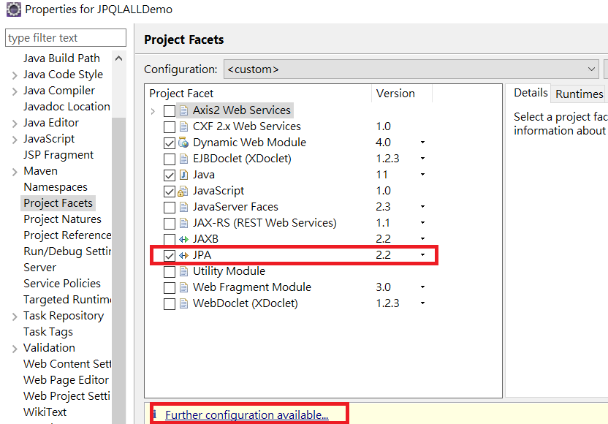

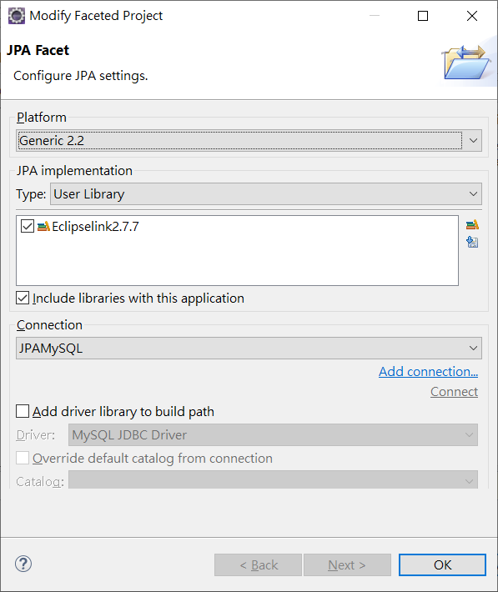
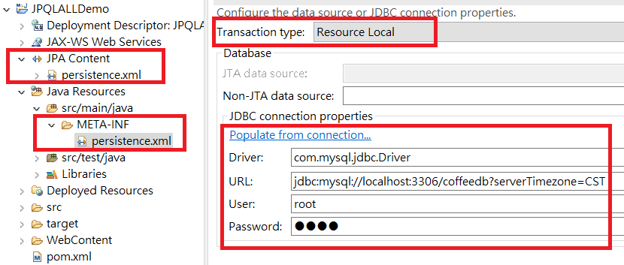

<?xml version="1.0" encoding="UTF-8"?>
<persistence version="2.2" xmlns="http://xmlns.jcp.org/xml/ns/persistence" xmlns:xsi="http://www.w3.org/2001/XMLSchema-instance" xsi:schemaLocation="http://xmlns.jcp.org/xml/ns/persistence http://xmlns.jcp.org/xml/ns/persistence/persistence_2_2.xsd">
<persistence-unit name="JPQLALLDemo" transaction-type="RESOURCE_LOCAL">
<class>model.Student</class>
<properties>
<property name="javax.persistence.jdbc.url" value="jdbc:mysql://localhost:3306/coffeedb?serverTimezone=CST"/>
<property name="javax.persistence.jdbc.user" value="root"/>
<property name="javax.persistence.jdbc.password" value="1234"/>
<property name="javax.persistence.jdbc.driver" value="com.mysql.cj.jdbc.Driver"/>
</properties>
</persistence-unit>
</persistence>

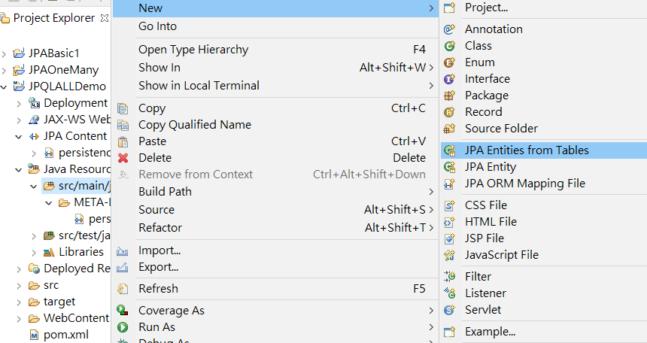
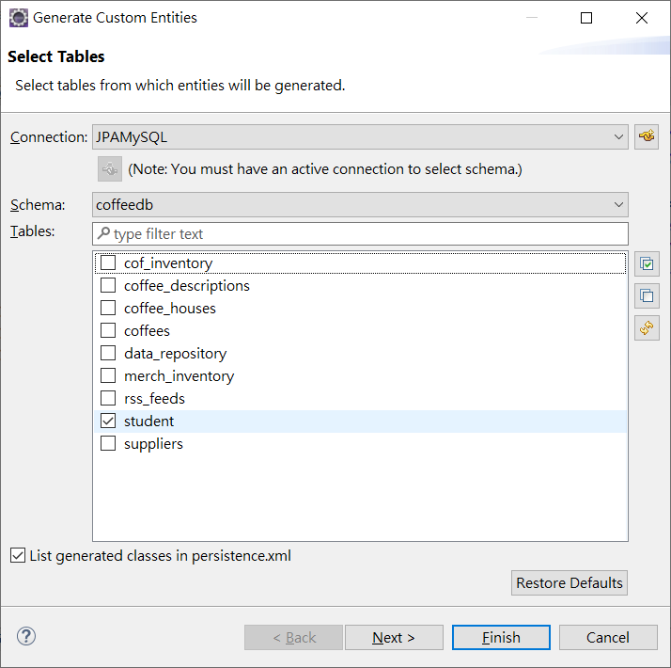

package model;

import java.io.Serializable;
import javax.persistence.*;

@Entity
@NamedQuery(name="Student.findAll", query="SELECT s FROM Student s")
public class Student implements Serializable {
private static final long serialVersionUID = 1L;

private int age;
@Id
private int sid;

private String sname;

public Student() {
}
public int getAge() {
return this.age;
}
public void setAge(int age) {
this.age = age;
}
public int getSid() {
return this.sid;
}
public void setSid(int sid) {
this.sid = sid;
}
public String getSname() {
return this.sname;
}
public void setSname(String sname) {
this.sname = sname;
}
}
JPQL提取記錄
在這裡我們將從資料庫中提取所有記錄。
protected void doGet(HttpServletRequest request, HttpServletResponse response) throws ServletException, IOException {
EntityManagerFactory emf = Persistence.createEntityManagerFactory("JPQLALLDemo");
EntityManager em = emf.createEntityManager();
em.getTransaction().begin();
Query query = em.createQuery("Select s from Student s ");
@SuppressWarnings("unchecked")
List<Student> list = (List<Student>) query.getResultList();
System.out.print("sid");
System.out.print("\t sname");
System.out.println("\t age");
for (Student s : list) {
System.out.print(s.getSid());
System.out.print("\t" + s.getSname());
System.out.print("\t" + s.getAge());
System.out.println();
}
em.getTransaction().commit();
em.close();
emf.close();
response.getWriter().append("See Tomcat Console Student Data");
}
JPQL更新記錄
在這裡我們將更新資料庫中的記錄。
void updateQuery(HttpServletResponse response)throws ServletException, IOException {
EntityManagerFactory emf = Persistence.createEntityManagerFactory("JPQLALLDemo");
EntityManager em = emf.createEntityManager();
em.getTransaction().begin();

Query query = em.createQuery("update Student SET age=19 where sid=103");
int r=query.executeUpdate();
if(r>0)
System.out.println("update successfully");
else
System.out.println("update failed");
em.getTransaction().commit();
em.close();
emf.close();
response.getWriter().append("See Tomcat Console Student Data");
}
protected void doGet(HttpServletRequest request, HttpServletResponse response) throws ServletException, IOException {
updateQuery(response);
}

JPQL 資料新增
void insertQuery(HttpServletResponse response)throws ServletException, IOException {
EntityManagerFactory emf = Persistence.createEntityManagerFactory("JPQLALLDemo");
EntityManager em = emf.createEntityManager();

em.getTransaction().begin();

Student s1 = new Student();
s1.setSid(1001);
s1.setSname("Max");
s1.setAge(27);

Student s2 = new Student();
s2.setSid(1102);
s2.setSname("Yen");
s2.setAge(21);

em.persist(s1);
em.persist(s2);

em.getTransaction().commit();
em.close();
emf.close();
response.getWriter().append("See Tomcat Console Student Data");
}
protected void doGet(HttpServletRequest request, HttpServletResponse response) throws ServletException, IOException {
//updateQuery(response);
insertQuery(response);
}

JPQL刪除記錄
我們將從資料庫中刪除特定的資料列。
void deleteQuery(HttpServletResponse response)throws ServletException, IOException {
EntityManagerFactory emf = Persistence.createEntityManagerFactory("JPQLALLDemo");
EntityManager em = emf.createEntityManager();

em.getTransaction().begin();

Query query = em.createQuery("delete from Student where sid=1102");

int r=query.executeUpdate();
if(r>0)
System.out.println("delete successfully");
else
System.out.println("delete failed");

em.getTransaction().commit();

em.close();
emf.close();

response.getWriter().append("See Tomcat Console Student Data");
}

自行練習JPQL語法
Query q1 = em.createQuery("Select s from Student s where s.age between 22 and 28");

Query q2 = em.createQuery("Select s from Student s where s.age IN(20,22,23)");

Query q3 = em.createQuery("Select s from Student s where s.sname like '%a%'");

Query q4 = em.createQuery("Select s from Student s order by s.age desc");

