Eclipse_Spring_Hibernate 環境設定與範例
- 在Eclipse 先建立一個Dynamic Web Project 樣板提供給maven使用
- 建立Maven 專案
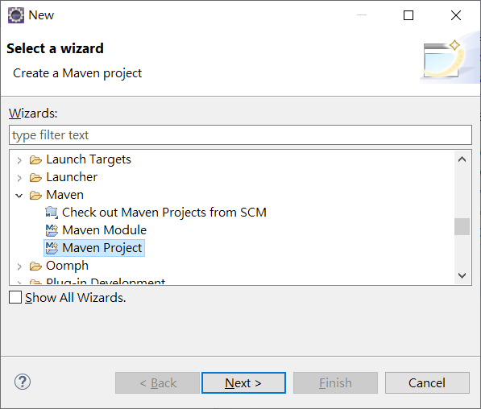
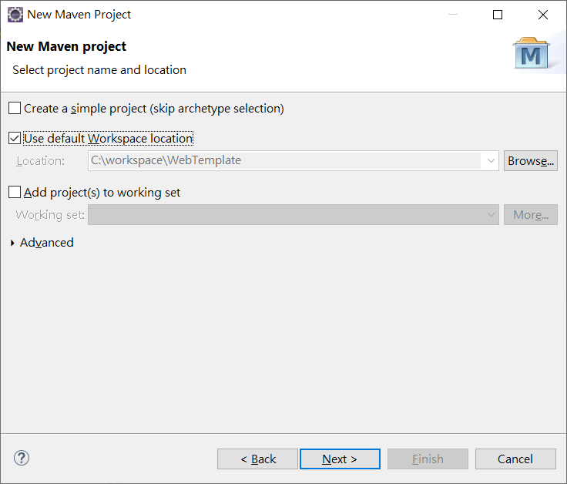
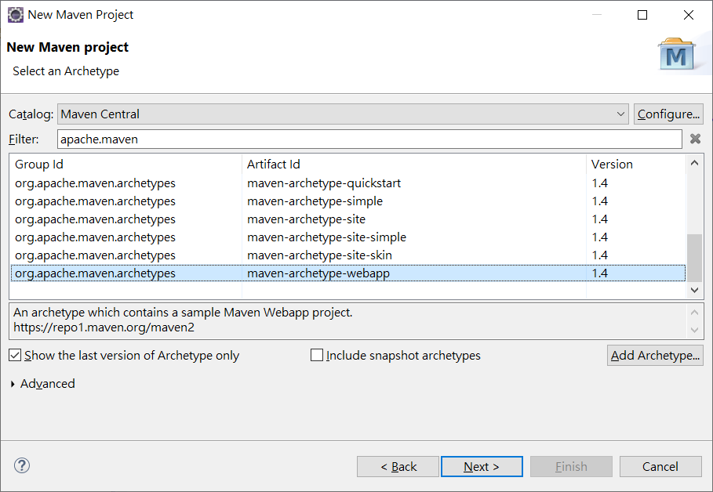
建好此maven樣板的時候會有錯誤原因是:
- Jdk 版本不對
- Tomcat 版本不對
所以我們必須到 Build Path->修改 Project Facets
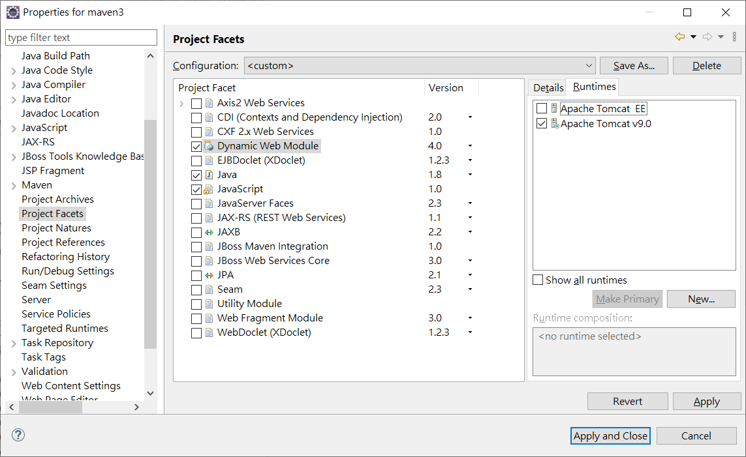
- src/main 下面漏了一個java 資料夾請建立
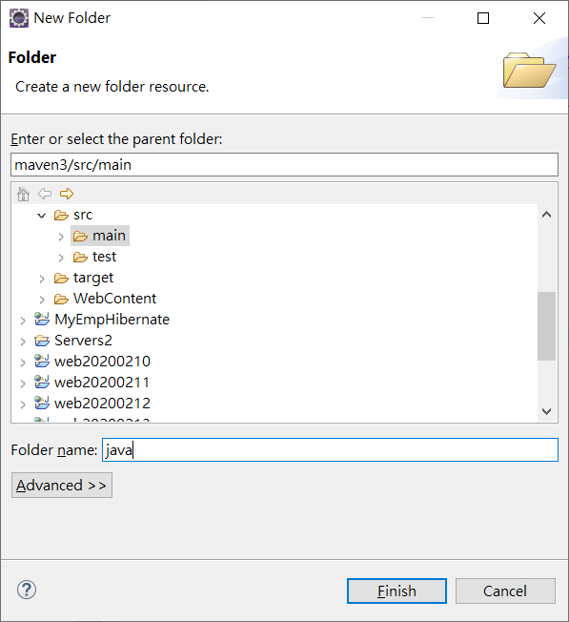
- maven 系統所產生的web.xml是舊版請複製樣板的web.xml
- 接下來加入 spring-webmvc , jstl , mysql , hibernate
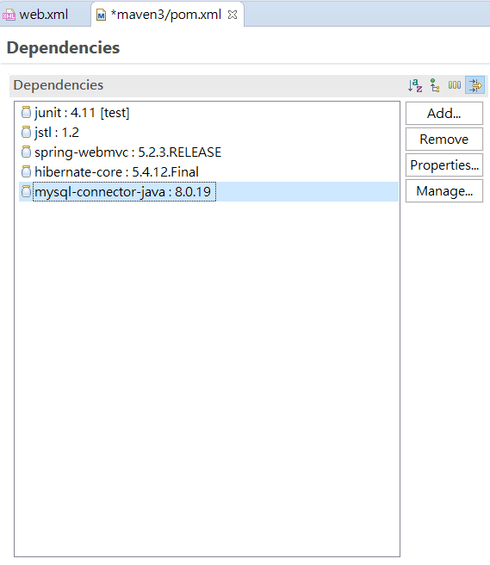

- 加入Maven Deployment Assembly
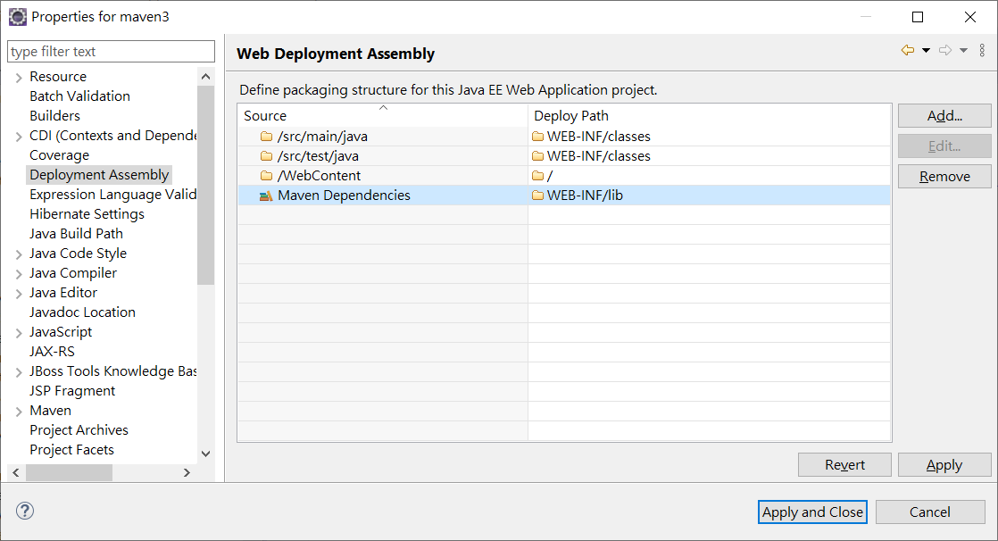
接下來建立Spring 作業環境
<?xml version="1.0" encoding="UTF-8"?>
<web-app xmlns:xsi="http://www.w3.org/2001/XMLSchema-instance"
xmlns="http://xmlns.jcp.org/xml/ns/javaee"
xsi:schemaLocation="http://xmlns.jcp.org/xml/ns/javaee http://xmlns.jcp.org/xml/ns/javaee/web-app_4_0.xsd" id="WebApp_ID" version="4.0">
<display-name>Archetype Created Web Application</display-name>
<servlet>
<servlet-name>dispatcher</servlet-name>
<servlet-class>org.springframework.web.servlet.DispatcherServlet</servlet-class>
<load-on-startup>1</load-on-startup>
</servlet>
<servlet-mapping>
<servlet-name> dispatcher </servlet-name>
<url-pattern>/</url-pattern>
</servlet-mapping>
</web-app>

建立 dispatcher-servlet.xml

<?xml version='1.0' encoding='UTF-8' ?>
<!-- was: <?xml version="1.0" encoding="UTF-8"?> -->
<beans xmlns="http://www.springframework.org/schema/beans"
xmlns:xsi="http://www.w3.org/2001/XMLSchema-instance"
xmlns:p="http://www.springframework.org/schema/p"
xmlns:aop="http://www.springframework.org/schema/aop"
xmlns:mvc="http://www.springframework.org/schema/mvc"
xmlns:context="http://www.springframework.org/schema/context"
xmlns:tx="http://www.springframework.org/schema/tx"
xsi:schemaLocation="http://www.springframework.org/schema/beans http://www.springframework.org/schema/beans/spring-beans-4.0.xsd
http://www.springframework.org/schema/aop http://www.springframework.org/schema/aop/spring-aop-4.0.xsd
http://www.springframework.org/schema/mvc
http://www.springframework.org/schema/mvc/spring-mvc-4.0.xsd
http://www.springframework.org/schema/context http://www.springframework.org/schema/context/spring-context-4.0.xsd
http://www.springframework.org/schema/tx http://www.springframework.org/schema/tx/spring-tx-4.0.xsd">
<mvc:annotation-driven />
<context:component-scan base-package="com.controller"></context:component-scan>
<bean id="viewResolver" class="org.springframework.web.servlet.view.InternalResourceViewResolver"
p:prefix="/WEB-INF/jsp/"
p:suffix=".jsp" />
</beans>
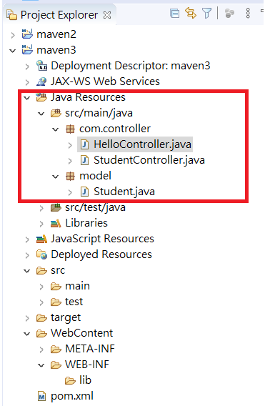
public class Student {
private Integer age;
private String name;
private Integer id;

public void setAge(Integer age) {
this.age = age;
}
public Integer getAge() {
return age;
}
public void setName(String name) {
this.name = name;
}
public String getName() {
return name;
}
public void setId(Integer id) {
this.id = id;
}
public Integer getId() {
return id;
}
}

import org.springframework.stereotype.Controller;
import org.springframework.ui.ModelMap;
import org.springframework.web.bind.annotation.RequestMapping;
import org.springframework.web.bind.annotation.RequestMethod;

@Controller
@RequestMapping("/hello")
public class HelloController {
@RequestMapping(method = RequestMethod.GET)
public String printHello(ModelMap model) {
model.addAttribute("message", "Hello Spring MVC Framework!");
return "demo";
}
}

import org.springframework.stereotype.Controller;
import org.springframework.web.bind.annotation.ModelAttribute;
import org.springframework.web.bind.annotation.RequestMapping;
import org.springframework.web.bind.annotation.RequestMethod;
import org.springframework.web.servlet.ModelAndView;
import org.springframework.ui.ModelMap;
import model.Student;

@Controller
public class StudentController {

@RequestMapping(value = "/student", method = RequestMethod.GET)
public ModelAndView student() {
Student temp=new Student();
temp.setId(1);
temp.setName("John");
temp.setAge(20);
return new ModelAndView("jqStudent", "command", temp);
}

@RequestMapping(value = "/addStudent", method = RequestMethod.POST)
public String addStudent(@ModelAttribute("student") Student student, ModelMap model) {
model.addAttribute("name", student.getName());
model.addAttribute("age", student.getAge());
model.addAttribute("id", student.getId());

return "result";
}
}

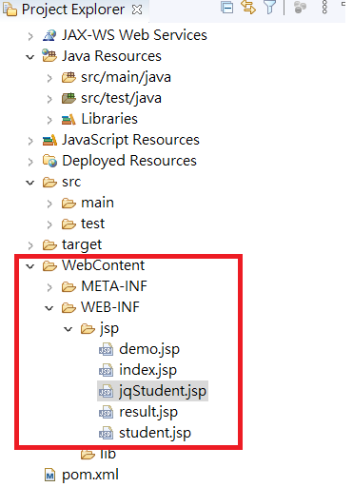
jqStudent.jsp

<%@page contentType="text/html" pageEncoding="UTF-8"%>
<%@taglib uri = "http://www.springframework.org/tags/form" prefix = "form"%>
<html>
<head>
<title>Spring MVC Form Handling</title>
</head>

<body>
<script src="https://ajax.googleapis.com/ajax/libs/jquery/3.4.1/jquery.min.js"></script>
<h2>Student Information</h2>
<form:form method = "post" action = "" onclick="return false">
<table>
<tr>
<td><form:label path = "name">Name</form:label></td>
<td><form:input path = "name" id="name"/></td>
</tr>
<tr>
<td><form:label path = "age">Age</form:label></td>
<td><form:input path = "age" id="age"/></td>
</tr>
<tr>
<td><form:label path = "id">id</form:label></td>
<td><form:input path = "id" id="id"/></td>
</tr>
<tr>
<td colspan = "2">
<input type = "submit" value = "Submit" onclick="send()" />
</td>
</tr>
</table>
</form:form>
<div id="div1"></div>
<script>
function send(){
$.post("addStudent",{"age":$("#age").val() , "name":$("#name").val(),"id":$("#id").val()},function(data){
$("#div1").html(data);
});
}
</script>
</body>

</html>

student.jsp
<%@page contentType="text/html" pageEncoding="UTF-8"%>
<%@taglib uri = "http://www.springframework.org/tags/form" prefix = "form"%>
<html>
<head>
<title>Spring MVC Form Handling</title>
</head>

<body>
<h2>Student Information</h2>
<form:form method = "post" action = "addStudent">
<table>
<tr>
<td><form:label path = "name">Name</form:label></td>
<td><form:input path = "name" /></td>
</tr>
<tr>
<td><form:label path = "age">Age</form:label></td>
<td><form:input path = "age" /></td>
</tr>
<tr>
<td><form:label path = "id">id</form:label></td>
<td><form:input path = "id" /></td>
</tr>
<tr>
<td colspan = "2">
<input type = "submit" value = "Submit"/>
</td>
</tr>
</table>
</form:form>
</body>

</html>
result.jsp
<%@page contentType="text/html" pageEncoding="UTF-8"%>
<!DOCTYPE html>
<html>
<head>
<meta http-equiv="Content-Type" content="text/html; charset=UTF-8">
<title>JSP Page</title>
</head>
<body>
<h2>Submitted Student Information</h2>
<table>
<tr>
<td>Name</td>
<td>${name}</td>
</tr>
<tr>
<td>Age</td>
<td>${age}</td>
</tr>
<tr>
<td>ID</td>
<td>${id}</td>
</tr>
</table>

</body>
</html>

demo.jsp
<%@page contentType="text/html" pageEncoding="UTF-8"%>
<!DOCTYPE html>
<html>
<head>
<meta http-equiv="Content-Type" content="text/html; charset=UTF-8">
<title>Hello Spring MVC</title>
</head>
<body>

<h2>${message}</h2>
</body>
</html>
最後複製web.xml dispatch-servlet.xml 到Webcontent下
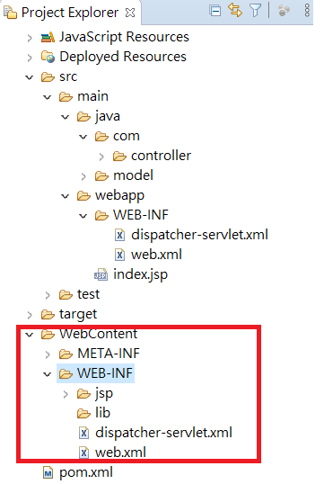

CREATE TABLE student (
studentID varchar(12) NOT NULL,
name varchar(60) NOT NULL,
address varchar(80) NOT NULL,
PRIMARY KEY (studentID)
) ENGINE=InnoDB DEFAULT CHARSET=utf8;
Hibernate 設定:
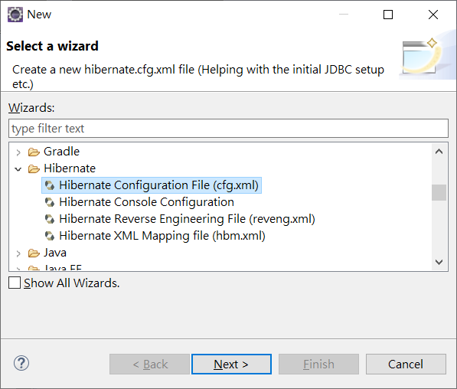
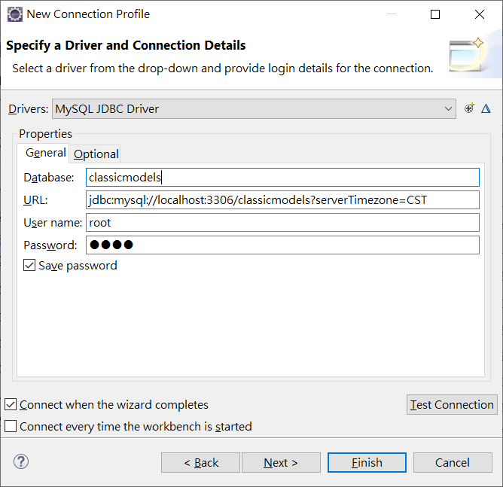
<?xml version="1.0" encoding="UTF-8"?>
<!DOCTYPE hibernate-configuration PUBLIC
"-//Hibernate/Hibernate Configuration DTD 3.0//EN"
"http://www.hibernate.org/dtd/hibernate-configuration-3.0.dtd">
<hibernate-configuration>
<session-factory>
<property name="hibernate.connection.driver_class">com.mysql.cj.jdbc.Driver</property>
<property name="hibernate.connection.password">1234</property>
<property name="hibernate.connection.url">jdbc:mysql://localhost:3306/classicmodels?serverTimezone=CST</property>
<property name="hibernate.connection.username">root</property>
</session-factory>
</hibernate-configuration>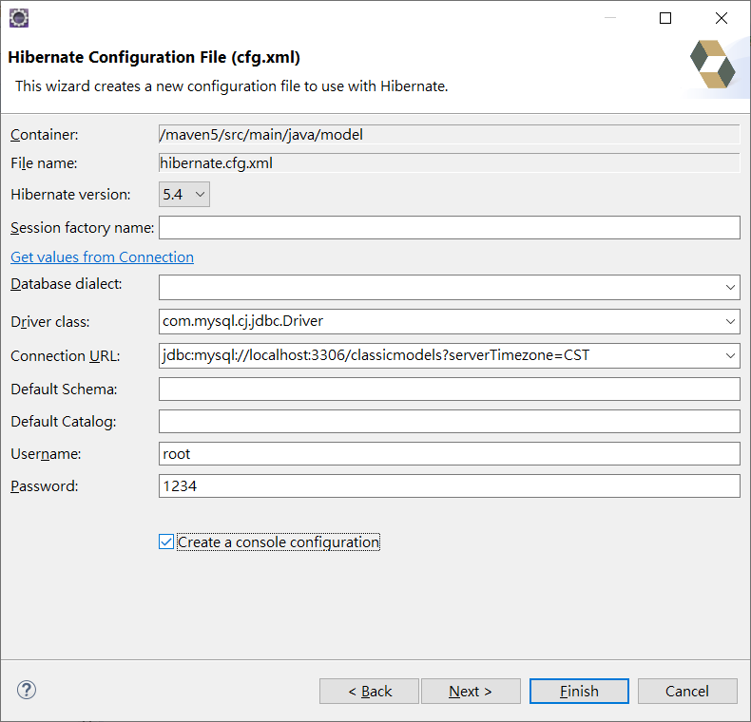
- 建逆向工程設定檔案:
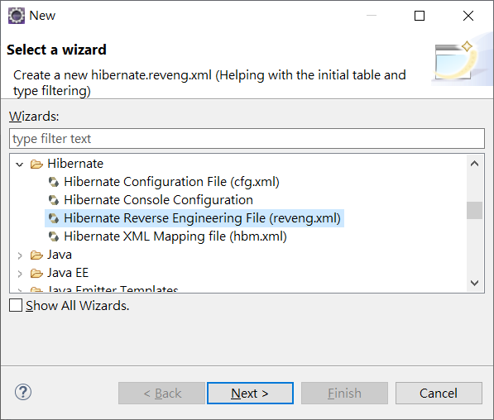
<?xml version="1.0" encoding="UTF-8"?>
<!DOCTYPE hibernate-reverse-engineering PUBLIC "-//Hibernate/Hibernate Reverse Engineering DTD 3.0//EN" "http://hibernate.org/dtd/hibernate-reverse-engineering-3.0.dtd" >

<hibernate-reverse-engineering>
<table-filter match-catalog="classicmodels" match-name="student"/>
</hibernate-reverse-engineering>
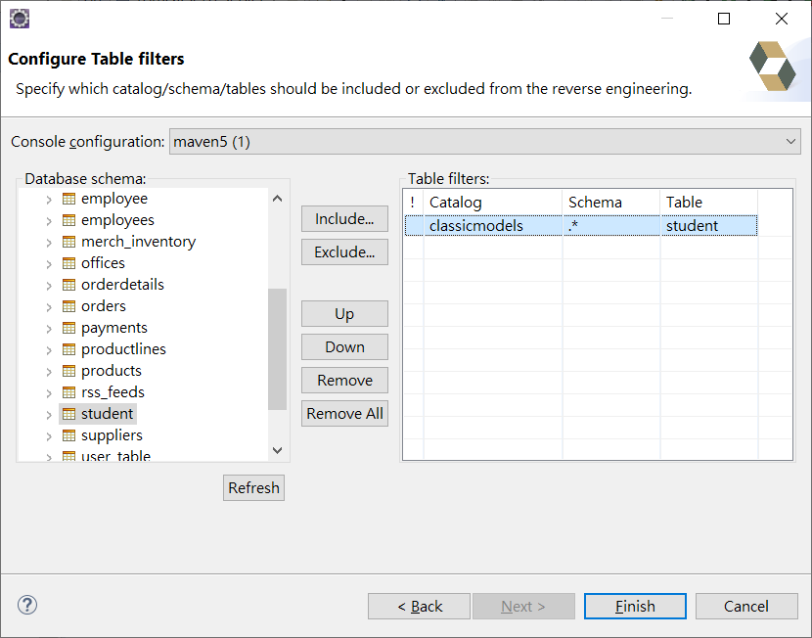
- 建立表格類別程式
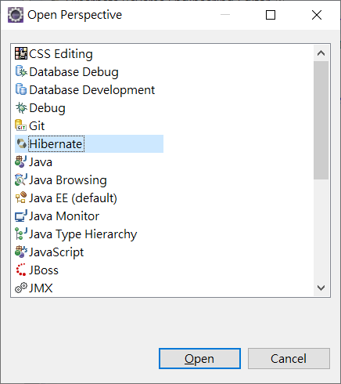
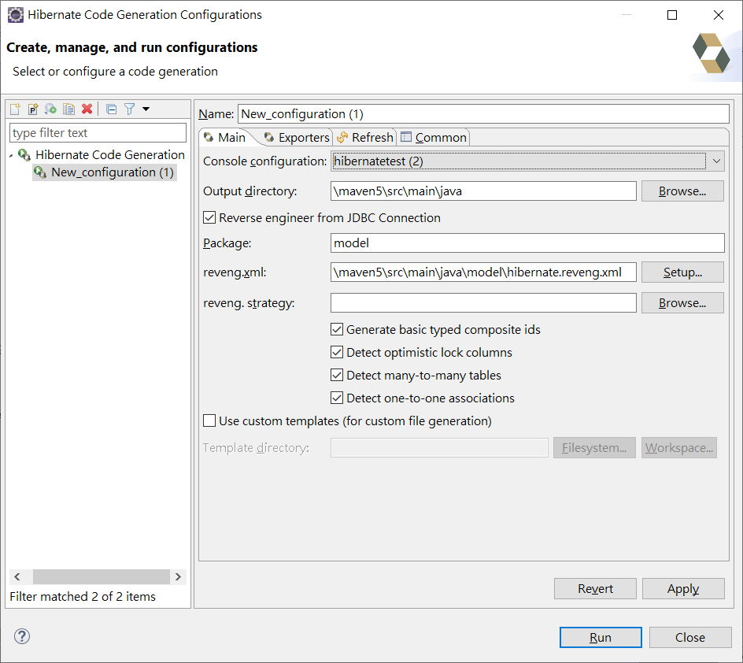
package model;

public class Student implements java.io.Serializable {

private String studentId;
private String name;
private String address;

public Student() {
}

public Student(String studentId, String name, String address) {
this.studentId = studentId;
this.name = name;
this.address = address;
}

public String getStudentId() {
return this.studentId;
}

public void setStudentId(String studentId) {
this.studentId = studentId;
}

public String getName() {
return this.name;
}

public void setName(String name) {
this.name = name;
}

public String getAddress() {
return this.address;
}

public void setAddress(String address) {
this.address = address;
}

}
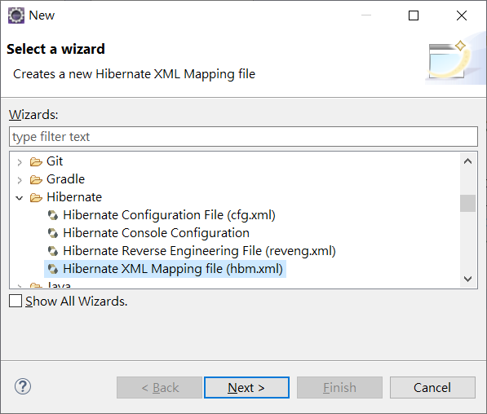
Entity class 產生xml設定檔案
<?xml version="1.0"?>
<!DOCTYPE hibernate-mapping PUBLIC "-//Hibernate/Hibernate Mapping DTD 3.0//EN"
"http://hibernate.sourceforge.net/hibernate-mapping-3.0.dtd">
<!-- Generated 2020/2/26 ?W?? 11:36:46 by Hibernate Tools 3.5.0.Final -->
<hibernate-mapping>
<class name="model.Student" table="STUDENT">
<id name="studentId" type="java.lang.String">
<column name="STUDENTID" />
<generator class="assigned" />
</id>
<property name="name" type="java.lang.String">
<column name="NAME" />
</property>
<property name="address" type="java.lang.String">
<column name="ADDRESS" />
</property>
</class>
</hibernate-mapping>
最後建立設定檔案之表格對應檔案
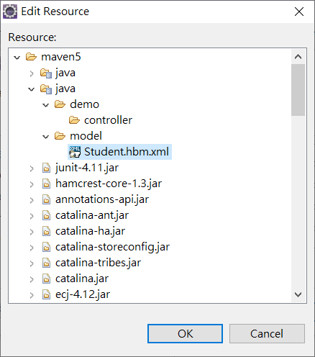
<?xml version="1.0" encoding="UTF-8"?>
<!DOCTYPE hibernate-configuration PUBLIC "-//Hibernate/Hibernate Configuration DTD 3.0//EN"
"http://www.hibernate.org/dtd/hibernate-configuration-3.0.dtd">
<hibernate-configuration>
<session-factory name="">
<property name="hibernate.connection.driver_class">com.mysql.cj.jdbc.Driver</property>
<property name="hibernate.connection.password">1234</property>
<property name="hibernate.connection.url">jdbc:mysql://localhost:3306/classicmodels?serverTimezone=CST</property>
<property name="hibernate.connection.username">root</property>
<mapping resource="model/Student.hbm.xml"/>
</session-factory>
</hibernate-configuration>

建立StudentController
package demo.controller;

import org.hibernate.HibernateException;
import org.hibernate.Session;
import org.hibernate.SessionFactory;
import org.hibernate.Transaction;
import org.hibernate.cfg.Configuration;
import org.springframework.stereotype.Controller;
import org.springframework.ui.ModelMap;
import org.springframework.web.bind.annotation.RequestMapping;
import org.springframework.web.bind.annotation.RequestMethod;

import java.util.*;
import model.Student;

@Controller
@RequestMapping("/student")
public class StudentController {
@RequestMapping(method = RequestMethod.GET)
public String listStudent(ModelMap model) {
List<Student> data=getAll();
System.out.println(data);
model.addAttribute("message", data);
return "showStudent";
}
List<Student> getAll(){
SessionFactory factory=null;
try {
factory = new Configuration().configure("/model/hibernate.cfg.xml").buildSessionFactory();
} catch (Throwable ex) {
System.err.println("Failed to create sessionFactory object." + ex);
throw new ExceptionInInitializerError(ex);
}

Session session = factory.openSession();
Transaction tx = null;

try {
tx = session.beginTransaction();
List data = session.createQuery("FROM Student").list();
for (Iterator iterator = data.iterator(); iterator.hasNext();){
Student st = (Student) iterator.next();
System.out.print("Student ID: " + st.getStudentId());
System.out.print(" Last Name: " + st.getName());
System.out.println(" Address: " + st.getAddress());
}
tx.commit();
return data;
} catch (HibernateException e) {
if (tx!=null) tx.rollback();
e.printStackTrace();
} finally {
session.close();
}

return null;
}
}

建立showStudent view
<%@ page language="java" contentType="text/html; charset=UTF-8"
pageEncoding="UTF-8"%>
<%@taglib prefix="c" uri="http://java.sun.com/jsp/jstl/core" %>
<!DOCTYPE html>
<html>
<head>
<meta charset="UTF-8">
<title>Students</title>
</head>
<body>
<table border="1">
<th>Student ID</th>
<th>Student Name</th>
<th>Address</th>
<c:forEach items="${message}" var="student">
<tr>
<td>${student.studentId}</td>
<td>${student.name}</td>
<td>${student.address}</td>
</tr>
</c:forEach>
</table>
</body>
</html>

