Spring Form JSON
以下範例編寫一個簡單的maven基於Web的應用程式，它使用Spring Web MVC框架使用HTML表單。 首先使用Eclipse IDE，並按照以下步驟使用Spring Web Framework開發基於maven動態表單的Web應用程式：
- 建立的 SpringJSON 來建立一個新的名稱為：SpringJSON，並建立一個套件名稱為 com.springformmvc。
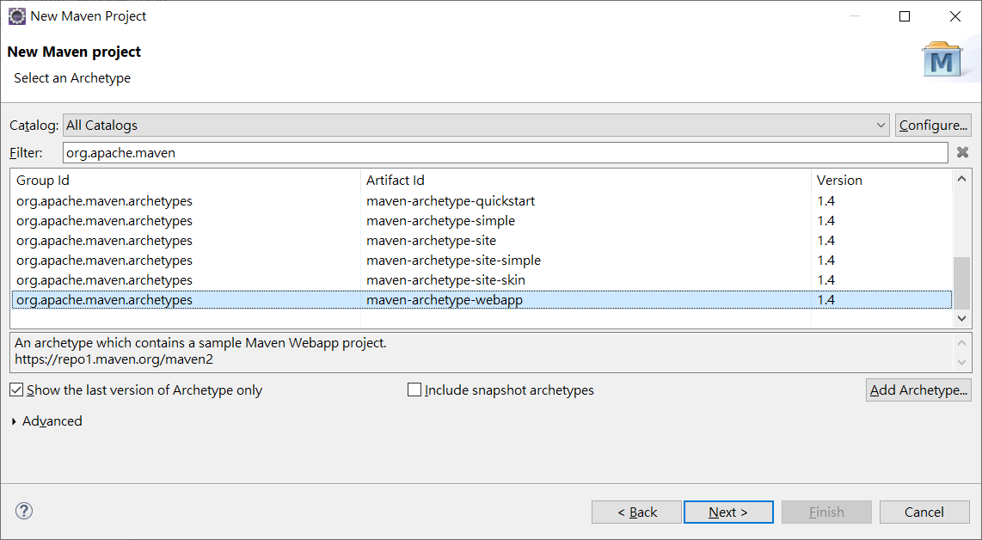

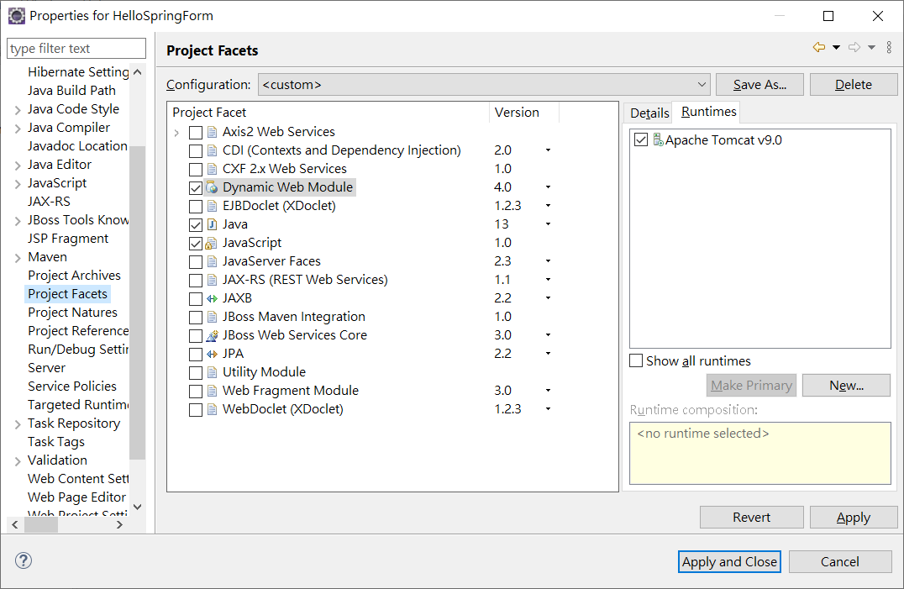
- 在com.springformmvc套件下建立Java類別 SupplierCoffeeController。
- 建立model 套件 加入 Supplier.java Coffee.java
- 在jsp子檔案夾下建立兩個檢視檔案home.jsp，showCoffee.jsp。
- 最後一步是建立所有組態檔案的內容並執行應用程式，如下所述。
完整的專案檔案結構如下所示 -
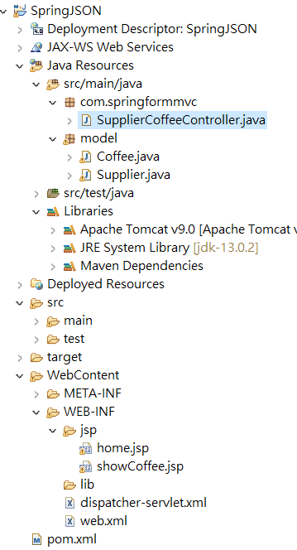
pom.xml
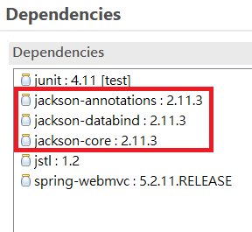
pom.xml 加入
<dependency>
<groupId>com.fasterxml.jackson.core</groupId>
<artifactId>jackson-annotations</artifactId>
<version>2.11.3</version>
</dependency>
<dependency>
<groupId>com.fasterxml.jackson.core</groupId>
<artifactId>jackson-databind</artifactId>
<version>2.11.3</version>
</dependency>
<dependency>
<groupId>com.fasterxml.jackson.core</groupId>
<artifactId>jackson-core</artifactId>
<version>2.11.3</version>
</dependency>
<dependency>
<groupId>org.springframework</groupId>
<artifactId>spring-webmvc</artifactId>
<version>5.2.12.RELEASE</version>
</dependency>
<dependency>
<groupId>jstl</groupId>
<artifactId>jstl</artifactId>
<version>1.2</version>
</dependency>

web.xml 加入:
<servlet>
<servlet-name>dispatcher</servlet-name>
<servlet-class>
org.springframework.web.servlet.DispatcherServlet
</servlet-class>
<load-on-startup>1</load-on-startup>
</servlet>
<servlet-mapping>
<servlet-name>dispatcher</servlet-name>
<url-pattern>/</url-pattern>
</servlet-mapping>

dispatcher-servlet.xml
<?xml version="1.0" encoding="UTF-8"?>
<beans xmlns="http://www.springframework.org/schema/beans"
xmlns:xsi="http://www.w3.org/2001/XMLSchema-instance"
xmlns:p="http://www.springframework.org/schema/p"
xmlns:context="http://www.springframework.org/schema/context"
xmlns:mvc="http://www.springframework.org/schema/mvc"
xsi:schemaLocation="http://www.springframework.org/schema/beans
http://www.springframework.org/schema/beans/spring-beans-4.1.xsd
http://www.springframework.org/schema/context
http://www.springframework.org/schema/context/spring-context-4.1.xsd
http://www.springframework.org/schema/mvc
http://www.springframework.org/schema/mvc/spring-mvc-4.1.xsd">

<context:component-scan base-package="com.springformmvc"/>
<mvc:annotation-driven />
<context:annotation-config/>
<bean class="org.springframework.web.servlet.view.InternalResourceViewResolver">
<property name="prefix">
<value>/WEB-INF/jsp/</value>
</property>
<property name="suffix">
<value>.jsp</value>
</property>
</bean>
</beans>

Coffee.java檔案中的程式碼內容 -
package model;
public class Coffee implements java.io.Serializable {
private String cofName;
private Supplier suppliers;
private double price;
private int sales;
private int total;
public Coffee() {
}
public Coffee(String cofName, Supplier suppliers, double price, int sales, int total) {
this.cofName = cofName;
this.suppliers = suppliers;
this.price = price;
this.sales = sales;
this.total = total;
}
public String getCofName() {
return this.cofName;
}
public void setCofName(String cofName) {
this.cofName = cofName;
}
public Supplier getSuppliers() {
return this.suppliers;
}

public void setSuppliers(Supplier suppliers) {
this.suppliers = suppliers;
}

public double getPrice() {
return this.price;
}

public void setPrice(double price) {
this.price = price;
}

public int getSales() {
return this.sales;
}

public void setSales(int sales) {
this.sales = sales;
}

public int getTotal() {
return this.total;
}

public void setTotal(int total) {
this.total = total;
}

}
Supplier.java 檔案中的程式碼內容 -
package model;
import java.util.*;
public class Supplier implements java.io.Serializable {
private int supId;
private String supName;
private String street;
private String city;
private String state;
private String zip;
private List<Coffee> coffeeses = new ArrayList<>();

public Supplier() {
}
public Supplier(int supId, String supName, String street, String city, String state) {
this.supId = supId;
this.supName = supName;
this.street = street;
this.city = city;
this.state = state;
}
public Supplier(int supId, String supName, String street, String city, String state, String zip, List<Coffee> coffeeses) {
this.supId = supId;
this.supName = supName;
this.street = street;
this.city = city;
this.state = state;
this.zip = zip;
this.coffeeses = coffeeses;
}
public int getSupId() {
return this.supId;
}
public void setSupId(int supId) {
this.supId = supId;
}
public String getSupName() {
return this.supName;
}
public void setSupName(String supName) {
this.supName = supName;
}
public String getStreet() {
return this.street;
}
public void setStreet(String street) {
this.street = street;
}

public String getCity() {
return this.city;
}

public void setCity(String city) {
this.city = city;
}

public String getState() {
return this.state;
}

public void setState(String state) {
this.state = state;
}

public String getZip() {
return this.zip;
}

public void setZip(String zip) {
this.zip = zip;
}

public List<Coffee> getCoffeeses() {
return this.coffeeses;
}

public void setCoffees(List<Coffee> coffeeses) {
this.coffeeses = coffeeses;
}

}
SupplierCoffeeController.java
package com.springformmvc;
import org.springframework.stereotype.Controller;
import org.springframework.ui.ModelMap;

import java.util.*;
import org.springframework.web.bind.annotation.RequestBody;
import org.springframework.web.bind.annotation.RequestMapping;
import org.springframework.web.bind.annotation.RequestMethod;
import org.springframework.web.servlet.ModelAndView;

import model.*;

@Controller
@RequestMapping("/")
public class SupplierCoffeeController {
List<Coffee> coffees = new ArrayList<>();

@RequestMapping(value="/supplier" ,method = RequestMethod.GET)
public String getSupplierView() {
return "supplier";
}
@RequestMapping(value = "/addSupplier", method = RequestMethod.POST )
public ModelAndView addSupplier(@RequestBody Supplier sup, ModelMap modelMap) {

modelMap.addAttribute("sups", sup);
return new ModelAndView("showSupplier");

}

@RequestMapping(value="/home" ,method = RequestMethod.GET)
public String getFirstView() {
return "home";
}

@RequestMapping(value = "/addOrder", method = RequestMethod.POST )
public ModelAndView addOrder(@RequestBody Coffee coffee, ModelMap modelMap) {
Supplier sup = coffee.getSuppliers();
coffees.add(coffee);
modelMap.addAttribute("coffees", coffees);
modelMap.addAttribute("sups", sup);
return new ModelAndView("showCoffee");

}
}
http://localhost:8080/SpringJSON/supplier
supplier.jsp 單一表單資料接收
<%@ page language="java" contentType="text/html; charset=UTF-8"
pageEncoding="UTF-8"%>
<!DOCTYPE html>
<html>
<head>
<meta charset="UTF-8">
<title>Supplier</title>
<style>
fieldset {
margin: 1.5em 0 0 0;
padding: 0;
border: 1px solid #CCC;
}

legend {
margin-left: 1em;
color: #009;
font-weight: bold;
}
</style>
</head>
<body>
<script
src="http://ajax.googleapis.com/ajax/libs/jquery/3.5.1/jquery.min.js"></script>
<fieldset>
<legend>Supplier Info</legend>
Supplier ID :<input type="text" id="supId" value="1" /><br />
Supplier Name :<input type="text" id="supName"
value="Gjun Coffee Inc.," /><br /> Street :<input type="text"
id="street" value="Kung Yuan 30" /><br /> City :<input type="text"
id="city" value="Taipei" /><br /> zip :<input type="text" id="zip"
value="100" /><br /> state :<input type="text" id="state"
value="TW" /><br />
</fieldset>
<button id="send">Send</button>
<div id="msg"></div>
<script>
function send() {
var supobj=new Object();
supobj.supId=$("#supId").val();
supobj.supName=$("#supName").val();
supobj.street=$("#street").val();
supobj.city=$("#city").val();
supobj.state=$("#state").val();
supobj.zip=$("#zip").val();

var value=JSON.stringify(supobj);

$.ajax("addSupplier",{
type:"post",
data: value,
contentType:"application/json", // 要送到server的資料型態
dataType:"html" , // 預期從server接收的資料型態
success: function (data, status, jqXhr) {
$("#msg").html(data);
},
error : function (data, status, errormsg) {
$("#msg").html(errormsg);
}
});

}
$(document).ready(function() {
$("#send").click(send);
});
</script>
</body>
</html>
showSupplier.jsp
<%@ page language="java" contentType="text/html; charset=UTF-8"
pageEncoding="UTF-8"%>
<%@taglib prefix="c" uri="http://java.sun.com/jsp/jstl/core"%>
<!DOCTYPE html>
<html>
<head>
<meta charset="UTF-8">
<title>Tables</title>
</head>
<body>
Supplier ID : ${sups.supId}<br>
Supplier Name:${sups.supName}<br>
Supplier city:${sups.city}<br>
Supplier state:${sups.state} <br>
Supplier zip:${sups.zip}
</body>
</html>
http://localhost:8080/SpringJSON/home
關聯表格資料新增
這裡的第一個服務方法 getFirstView ()，我們傳回home.jsp 表單畫面。
第二個服務方法addOrder ()將在 URL SpringJSON/addOrder上的POST方法提交時呼叫。傳入引數@RequestBody將根據傳入的資訊準備JSON模型物件。最後，將從服務方法返回「showCoffee」檢視，這將最終渲染showCoffee.jsp檢視。
home.jsp檔案的內容如下所示 -
<%@ page language="java" contentType="text/html; charset=UTF-8"
pageEncoding="UTF-8"%>
<!DOCTYPE html>
<html>
<head>
<meta charset="UTF-8">
<title>Supplier Coffee</title>
</head>
<body>
<style>
fieldset {
margin: 1.5em 0 0 0;
padding: 0;
border: 1px solid #CCC;
}

legend {
margin-left: 1em;
color: #009;
font-weight: bold;
}
</style>
<script
src="http://ajax.googleapis.com/ajax/libs/jquery/3.5.1/jquery.min.js"></script>
<fieldset>
<legend>Supplier Info</legend>
Supplier ID :<input type="text" id="supId" value="1" /><br />
Supplier Name :<input type="text" id="supName"
value="Gjun Coffee Inc.," /><br /> Street :<input type="text"
id="street" value="Kung Yuan 30" /><br /> City :<input type="text"
id="city" value="Taipei" /><br /> zip :<input type="text" id="zip"
value="100" /><br /> state :<input type="text" id="state"
value="TW" /><br />
</fieldset>
<p>
<fieldset>
<legend>Coffee Info</legend>
Coffee Name :<input type="text" id="cofName" value="Gjun Gold Brand" /><br />
Sale :<input type="text" id="sales" value="300" /><br /> total :<input
type="text" id="total" value="99" /><br /> price :<input
type="text" id="price" value="250" /><br />
<button id="send">Send</button>
</fieldset>
<div id="msg"></div>
<script>
function send() {
var supobj=new Object();
supobj.supId=$("#supId").val();
supobj.supName=$("#supName").val();
supobj.street=$("#street").val();
supobj.city=$("#city").val();
supobj.state=$("#state").val();
supobj.zip=$("#zip").val();
var cofObj=new Object();
cofObj.cofName=$("#cofName").val();
cofObj.suppliers=supobj;
cofObj.sales=$("#sales").val();
cofObj.total=$("#total").val();
cofObj.price=$("#price").val();
var value=JSON.stringify(cofObj);

$.ajax("addOrder",{
type:"post",
data: value,
contentType:"application/json", // 要送到server的資料型態 dataType:"html" , // 預期從server接收的資料型態 success: function (data, status, jqXhr) {
$("#msg").html(data);
},
error : function (data, status, errormsg) {
$("#msg").html(errormsg);
}
});

}
$(document).ready(function() {
$("#send").click(send);
});
</script>
</body>
</html>

showCoffee.jsp

<%@ page language="java" contentType="text/html; charset=UTF-8"
pageEncoding="UTF-8"%>
<%@taglib prefix="c" uri="http://java.sun.com/jsp/jstl/core"%>
<!DOCTYPE html>
<html>
<head>
<meta charset="UTF-8">
<title>Tables</title>
</head>
<body>
Supplier ID : ${sups.supId}<br>
Supplier Name:${sups.supName}
<table border="1" width="70%">
<tr>
<th>Coffee Name</th>
<th>Sales</th>
<th>Total</th>
<th>Price</th>

</tr>
<c:forEach var="current" items="${coffees}" >
<tr>
<td><c:out value="${current.cofName}" /></td>
<td><c:out value="${current.sales}" /></td>
<td><c:out value="${current.total}" /></td>
<td><c:out value="${current.price}" /></td>
</tr>
</c:forEach>
</table>

</body>
</html>
