Spring WebMVC Form DropDown List
以下範例編寫一個簡單的maven基於Web的應用程式，它使用Spring Web MVC框架使用HTML表單。 首先使用Eclipse IDE，並按照以下步驟使用Spring Web Framework開發基於maven動態表單的Web應用程式：
- 建立的 FormSelect來建立一個新的名稱為： FormSelect，並建立一個套件名稱為 com.springformmvc。
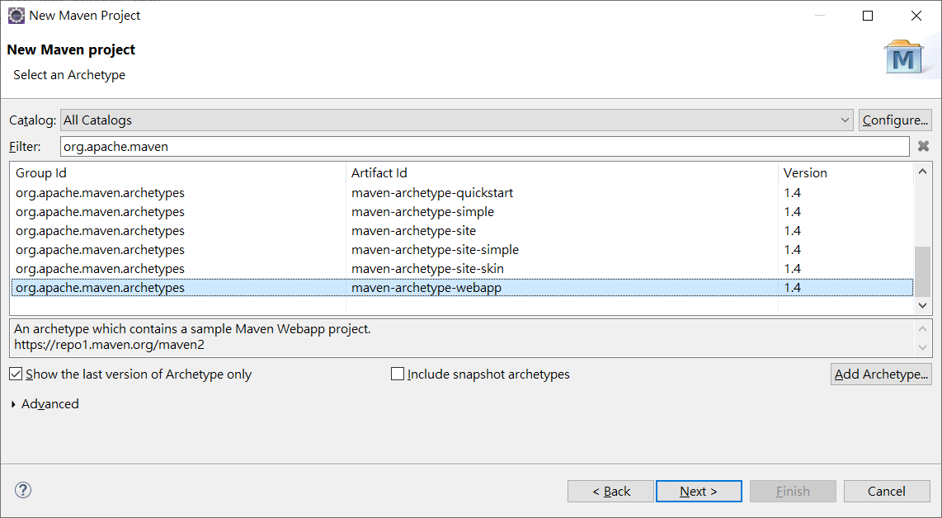

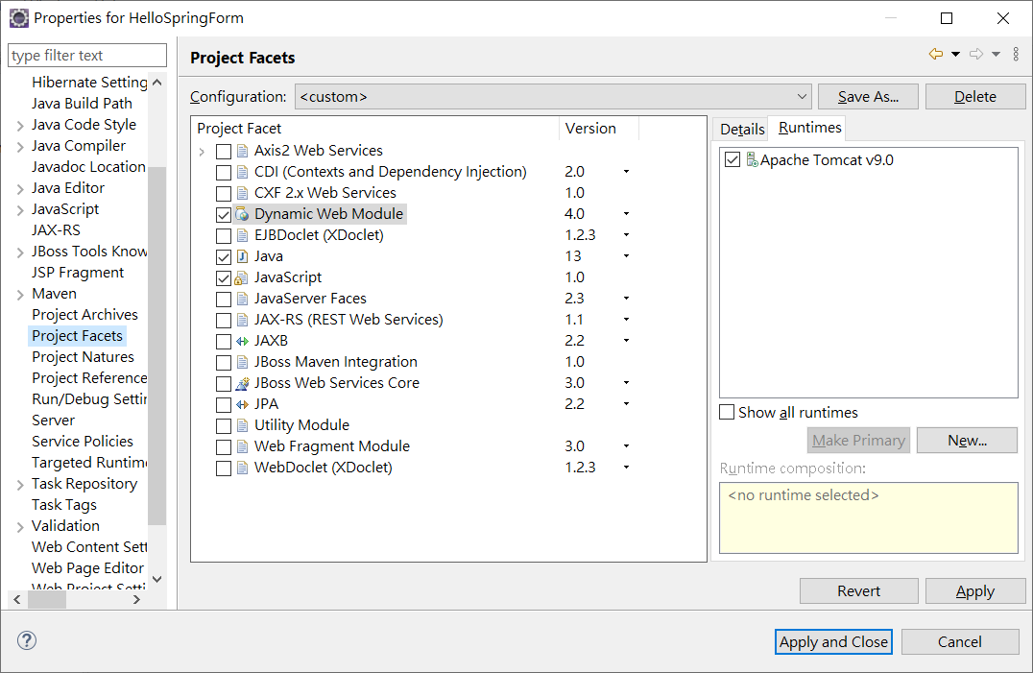
- 在com.springformmvc套件下建立兩個Java類別User，UserController。
- 在jsp子檔案夾下建立兩個檢視檔案user.jsp，userlist.jsp。
- 最後一步是建立所有組態檔案的內容並執行應用程式，如下所述。
完整的專案檔案結構如下所示 -
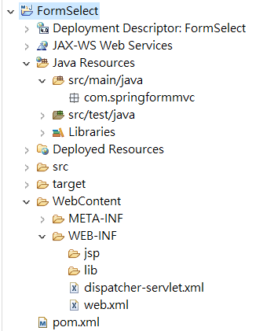
pom.xml
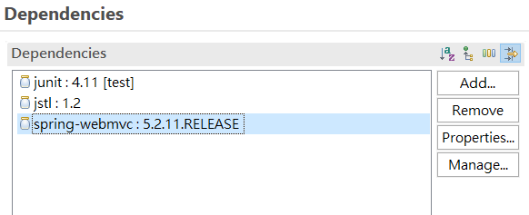
web.xml 加入:
<servlet>
<servlet-name>dispatcher</servlet-name>
<servlet-class>
org.springframework.web.servlet.DispatcherServlet
</servlet-class>
<load-on-startup>1</load-on-startup>
</servlet>
<servlet-mapping>
<servlet-name>dispatcher</servlet-name>
<url-pattern>/</url-pattern>
</servlet-mapping>

dispatcher-servlet.xml
<?xml version="1.0" encoding="UTF-8"?>
<beans xmlns="http://www.springframework.org/schema/beans"
xmlns:xsi="http://www.w3.org/2001/XMLSchema-instance"
xmlns:p="http://www.springframework.org/schema/p"
xmlns:context="http://www.springframework.org/schema/context"
xmlns:mvc="http://www.springframework.org/schema/mvc"
xsi:schemaLocation="http://www.springframework.org/schema/beans
http://www.springframework.org/schema/beans/spring-beans-4.1.xsd
http://www.springframework.org/schema/context
http://www.springframework.org/schema/context/spring-context-4.1.xsd
http://www.springframework.org/schema/mvc
http://www.springframework.org/schema/mvc/spring-mvc-4.1.xsd">

<context:component-scan base-package="com.springformmvc"/>
<context:annotation-config/>
<bean class="org.springframework.web.servlet.view.InternalResourceViewResolver">
<property name="prefix">
<value>/WEB-INF/jsp/</value>
</property>
<property name="suffix">
<value>.jsp</value>
</property>
</bean>
</beans>
User.java 的程式碼如下所示

package com.springformmvc;
public class User {
private String username;
private String password;
private String address;
private boolean receivePaper;
private String [] favoriteFrameworks;
private String gender;
private String favoriteNumber;
private String country;
public String getUsername() {
return username;
}
public void setUsername(String username) {
this.username = username;
}

public String getPassword() {
return password;
}
public void setPassword(String password) {
this.password = password;
}
public String getAddress() {
return address;
}
public void setAddress(String address) {
this.address = address;
}
public boolean isReceivePaper() {
return receivePaper;
}
public void setReceivePaper(boolean receivePaper) {
this.receivePaper = receivePaper;
}
public String[] getFavoriteFrameworks() {
return favoriteFrameworks;
}
public void setFavoriteFrameworks(String[] favoriteFrameworks) {
this.favoriteFrameworks = favoriteFrameworks;
}
public String getGender() {
return gender;
}
public void setGender(String gender) {
this.gender = gender;
}
public String getFavoriteNumber() {
return favoriteNumber;
}
public void setFavoriteNumber(String favoriteNumber) {
this.favoriteNumber = favoriteNumber;
}
public String getCountry() {
return country;
}
public void setCountry(String country) {
this.country = country;
}
}

UserController.java 的程式碼如下所示 -
package com.springformmvc;
import java.util.ArrayList;
import java.util.HashMap;
import java.util.List;
import java.util.Map;

import org.springframework.stereotype.Controller;
import org.springframework.web.bind.annotation.ModelAttribute;
import org.springframework.web.bind.annotation.RequestMapping;
import org.springframework.web.bind.annotation.RequestMethod;
import org.springframework.web.servlet.ModelAndView;
import org.springframework.ui.ModelMap;

@Controller
public class UserController {

@RequestMapping(value = "/user", method = RequestMethod.GET)
public ModelAndView user() {
User user = new User();
user.setFavoriteFrameworks((new String []{"Spring MVC","Struts 2"}));
user.setGender("M");
ModelAndView modelAndView = new ModelAndView("user", "command", user);
return modelAndView;
}

@RequestMapping(value = "/addUser", method = RequestMethod.POST)
public String addUser(@ModelAttribute("SpringWeb")User user,
ModelMap model) {
model.addAttribute("username", user.getUsername());
model.addAttribute("password", user.getPassword());
model.addAttribute("address", user.getAddress());
model.addAttribute("receivePaper", user.isReceivePaper());
model.addAttribute("favoriteFrameworks", getWebFrameworkList());
model.addAttribute("gender", user.getGender());
model.addAttribute("favoriteNumber", user.getFavoriteNumber());
model.addAttribute("country", user.getCountry());
return "userlist";
}

@ModelAttribute("webFrameworkList")
public List<String> getWebFrameworkList()
{
List<String> webFrameworkList = new ArrayList<String>();
webFrameworkList.add("Spring MVC");
webFrameworkList.add("Struts 1");
webFrameworkList.add("Struts 2");
webFrameworkList.add("Apache Wicket");
return webFrameworkList;
}

@ModelAttribute("numbersList")
public List<String> getNumbersList()
{
List<String> numbersList = new ArrayList<String>();
numbersList.add("1");
numbersList.add("2");
numbersList.add("3");
numbersList.add("4");
return numbersList;
}

@ModelAttribute("countryList")
public Map<String, String> getCountryList()
{
Map<String, String> countryList = new HashMap<String, String>();
countryList.put("US", "United States");
countryList.put("CH", "China");
countryList.put("SG", "Singapore");
countryList.put("MY", "Malaysia");
return countryList;
}
}

這裡的第一個服務方法user()，我們已經在ModelAndView物件中傳遞了一個名稱為「command」的空User物件，因為如果在JSP檔案中使用<form:form>標籤，spring框架需要一個名稱為「command」的物件。 所以當呼叫user()方法時，它返回user.jsp檢視。

第二個服務方法addUser()將根據URL => Dropdown/addUser 上的POST方法請求時呼叫。根據提交的資訊準備模型物件。 最後從服務方法返回「userlist」檢視，這將呈現userlist.jsp檢視。

user.jsp 的程式碼如下所示 -
<%@ page contentType="text/html; charset=UTF-8"%>
<%@taglib uri="http://www.springframework.org/tags/form" prefix="form"%>
<html>
<head>
<title>Spring MVC表單處理(下拉選擇)</title>
</head>
<body>

<h2>使用者資訊</h2>
<form:form method="POST" action="/FormSelect/addUser">
<table>
<tr>
<td><form:label path="username">使用者名：</form:label></td>
<td><form:input path="username" /></td>
</tr>
<tr>
<td><form:label path="password">密碼：</form:label></td>
<td><form:password path="password" /></td>
</tr>
<tr>
<td><form:label path="address">地址：</form:label></td>
<td><form:textarea path="address" rows="5" cols="30" /></td>
</tr>
<tr>
<td><form:label path="receivePaper">是否訂閱：</form:label></td>
<td><form:checkbox path="receivePaper" /></td>
</tr>
<tr>
<td><form:label path="favoriteFrameworks">喜歡的框架/技術：</form:label></td>
<td><form:checkboxes items="${webFrameworkList}"
path="favoriteFrameworks" /></td>
</tr>
<tr>
<td><form:label path="gender">性別：</form:label></td>
<td><form:radiobutton path="gender" value="M" label="男" />
<form:radiobutton path="gender" value="F" label="女" /></td>
</tr>
<tr>
<td><form:label path="favoriteNumber">喜歡的數字：</form:label></td>
<td><form:radiobuttons path="favoriteNumber" items="${numbersList}" /></td>
</tr>
<tr>
<td><form:label path="country">所在國家：</form:label></td>
<td><form:select path="country">
<form:option value="NONE" label="請選擇..." />
<form:options items="${countryList}" />
</form:select></td>
</tr>

<tr>
<td colspan="2"><input type="submit" value="提交" /></td>
</tr>
</table>
</form:form>
</body>
</html>

這裡使用<form:select /> , <form:option /> 和 <form:options />標籤來呈現HTML密碼框。 例如 -
<form:select path="country">
<form:option value="NONE" label="Select"/>
<form:options items="${countryList}" />
</form:select>
它將呈現以下HTML內容。
<select id="country" name="country">
<option value="NONE">請選擇...</option>
<option value="US">United States</option>
<option value="CH">China</option>
<option value="MY">Malaysia</option>
<option value="SG">Singapore</option>
</select>

userlist.jsp 的程式碼如下所示
<%@ page contentType="text/html; charset=UTF-8"%>
<%@taglib uri="http://www.springframework.org/tags/form" prefix="form"%>
<%@taglib prefix="c" uri="http://java.sun.com/jsp/jstl/core"%>
<html>
<head>
<title>Spring MVC表單處理(下拉選擇)</title>
</head>
<body>

<h2>提交使用者資訊 -</h2>
<table>
<tr>
<td>使用者名：</td>
<td>${username}</td>
</tr>
<tr>
<td>密碼：</td>
<td>${password}</td>
</tr>
<tr>
<td>地址：</td>
<td>${address}</td>
</tr>
<tr>
<td>是否訂閱：</td>
<td>${receivePaper}</td>
</tr>
<tr>
<td>喜歡的技術/框架：</td>
<c:forEach var="current" items="${webFrameworkList}" >
<td><c:out value="${current}" /></td>
</c:forEach>
</tr>
<tr>
<td>性別：</td>
<td>${(gender=="M"? "男" : "女")}</td>
</tr>
<tr>
<td>喜歡的數字：</td>
<td>${favoriteNumber}</td>
</tr>
<tr>
<td>國家：</td>
<td>${country}</td>
</tr>
</table>
</body>
</html>
完成建立源和組態檔案後，發布應用程式到Tomcat伺服器。
