Hibernate One-Many Table Web程式
- 建立 Maven Web 應用程式
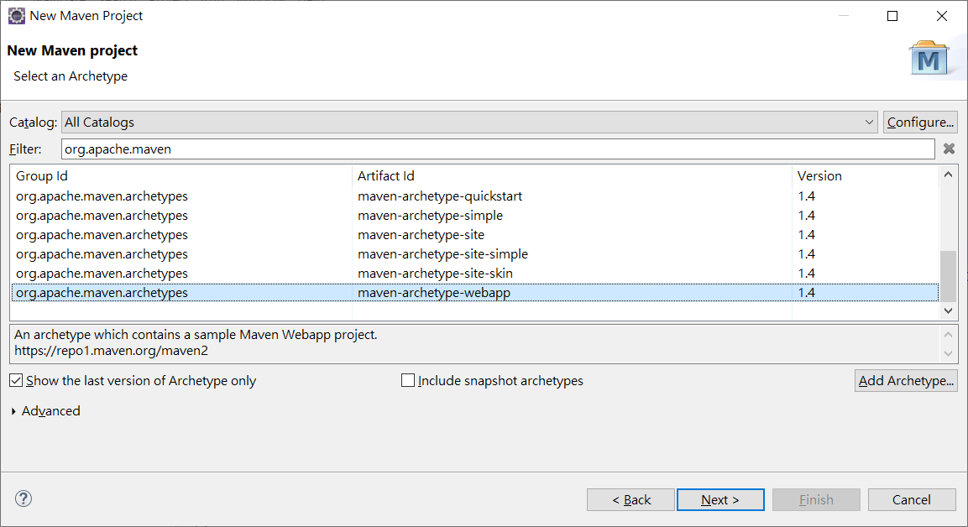
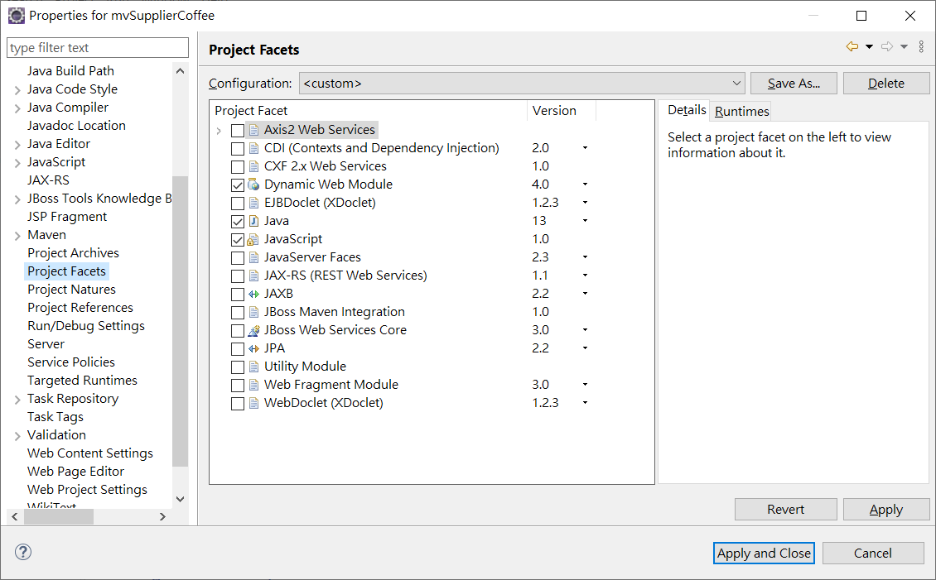
專案 Properties 下設定 Project Facets\Dynamic Web Module -> 4.0
並設定Java 到最新版本(這裡是JDK 13)
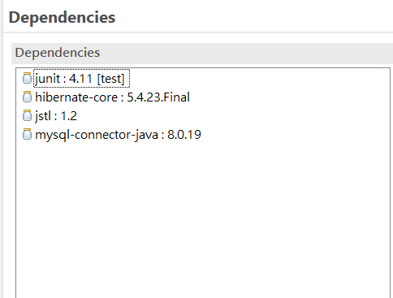
- 緊接著將資料表 Coffees , Suppliers 關聯表格的 xml 檔案設定完成

CREATE TABLE suppliers (
SUP_ID int(11) NOT NULL,
SUP_NAME varchar(40) NOT NULL,
STREET varchar(40) NOT NULL,
CITY varchar(20) NOT NULL,
STATE char(2) NOT NULL,
ZIP char(5) DEFAULT NULL,
PRIMARY KEY (SUP_ID)
) ENGINE=InnoDB DEFAULT CHARSET=utf8;

CREATE TABLE coffees (
COF_NAME varchar(32) NOT NULL,
SUP_ID int(11) NOT NULL,
PRICE decimal(10,2) NOT NULL,
SALES int(11) NOT NULL,
TOTAL int(11) NOT NULL,
PRIMARY KEY (COF_NAME),
KEY SUP_ID (SUP_ID),
CONSTRAINT coffees_ibfk_1 FOREIGN KEY (SUP_ID) REFERENCES suppliers (SUP_ID)
) ENGINE=InnoDB DEFAULT CHARSET=utf8;

insert into SUPPLIERS values(49, 'Superior Coffee', '1 Party Place', 'Mendocino', 'CA', '95460');
insert into SUPPLIERS values(101, 'Acme, Inc.', '99 Market Street', 'Groundsville', 'CA', '95199');
insert into SUPPLIERS values(150, 'The High Ground', '100 Coffee Lane', 'Meadows', 'CA', '93966');
insert into SUPPLIERS values(456, 'Restaurant Supplies, Inc.', '200 Magnolia Street', 'Meadows', 'CA', '93966');
insert into SUPPLIERS values(927, 'Professional Kitchen', '300 Daisy Avenue', 'Groundsville', 'CA', '95199');
insert into COFFEES values('Colombian', 101, 7.99, 0, 0);
insert into COFFEES values('French_Roast', 49, 8.99, 0, 0);
insert into COFFEES values('Espresso', 150, 9.99, 0, 0);
insert into COFFEES values('Colombian_Decaf', 101, 8.99, 0, 0);
insert into COFFEES values('French_Roast_Decaf', 049, 9.99, 0, 0);

pom.xml
<dependencies>
<dependency>
<groupId>com.google.code.gson</groupId>
<artifactId>gson</artifactId>
<version>2.9.0</version>
</dependency>
<dependency>
<groupId>org.hibernate</groupId>
<artifactId>hibernate-core</artifactId>
<version>5.6.15.Final</version>
</dependency>
<dependency>
<groupId>mysql</groupId>
<artifactId>mysql-connector-java</artifactId>
<version>8.0.33</version>
</dependency>
<dependency>
<groupId>javax.servlet</groupId>
<artifactId>jstl</artifactId>
<version>1.2</version>
</dependency>
<dependency>
<groupId>org.springframework</groupId>
<artifactId>spring-webmvc</artifactId>
<version>5.2.25.RELEASE</version>
</dependency>

hibernate.cfg.xml 資料庫連接設定檔案
<?xml version="1.0" encoding="UTF-8"?>
<!DOCTYPE hibernate-configuration PUBLIC "-//Hibernate/Hibernate Configuration DTD 3.0//EN"
"http://www.hibernate.org/dtd/hibernate-configuration-3.0.dtd">
<hibernate-configuration>
<session-factory name="mydbclassicmodels">
<property name="hibernate.connection.driver_class">com.mysql.cj.jdbc.Driver</property>
<property name="hibernate.connection.password">1234</property>
<property name="hibernate.connection.url">jdbc:mysql://localhost:3306/classicmodels</property>
<property name="hibernate.connection.username">root</property>
<property name="hibernate.dialect">org.hibernate.dialect.MySQLDialect</property>
<mapping class="model.Coffee"/>
<mapping class="model.Supplier"/>
</session-factory>
</hibernate-configuration>

package model;

import java.io.Serializable;
import javax.persistence.*;
import java.math.BigDecimal;

@Entity
@Table(name="coffees")
public class Coffee implements Serializable {
private static final long serialVersionUID = 1L;
@Id
@Column(name="COF_NAME")
private String cofName;
private BigDecimal price;
private int sales;
private int total;

//bi-directional many-to-one association to Supplier
@ManyToOne
@JoinColumn(name="SUP_ID")
private Supplier suppliers;

public Coffee() {
}

public String getCofName() {
return this.cofName;
}

public void setCofName(String cofName) {
this.cofName = cofName;
}

public BigDecimal getPrice() {
return this.price;
}

public void setPrice(BigDecimal price) {
this.price = price;
}
public int getSales() {
return this.sales;
}
public void setSales(int sales) {
this.sales = sales;
}
public int getTotal() {
return this.total;
}
public void setTotal(int total) {
this.total = total;
}
public Supplier getSuppliers() {
return this.suppliers;
}
public void setSuppliers(Supplier supplier) {
this.suppliers = supplier;
}
@Override
public String toString() {
return "Coffee [cofName=" + cofName + ", price=" + price + ", sales=" + sales + ", total=" + total + "]";
}

}

import java.io.Serializable;
import javax.persistence.*;
import java.util.List;

@Entity
@Table(name="suppliers")
public class Supplier implements Serializable {
private static final long serialVersionUID = 1L;

@Id
@Column(name="SUP_ID")
private int supId;
private String city;
private String state;
private String street;
@Column(name="SUP_NAME")
private String supName;

private String zip;

//bi-directional many-to-one association to Coffee
@OneToMany(mappedBy="suppliers" , targetEntity=Coffees.class, cascade = CascadeType.PERSIST)
private List<Coffee> coffees;

public Supplier() {
}

public int getSupId() {
return this.supId;
}

public void setSupId(int supId) {
this.supId = supId;
}

public String getCity() {
return this.city;
}

public void setCity(String city) {
this.city = city;
}

public String getState() {
return this.state;
}

public void setState(String state) {
this.state = state;
}

public String getStreet() {
return this.street;
}

public void setStreet(String street) {
this.street = street;
}

public String getSupName() {
return this.supName;
}

public void setSupName(String supName) {
this.supName = supName;
}

public String getZip() {
return this.zip;
}

public void setZip(String zip) {
this.zip = zip;
}
public List<Coffee> getCoffees() {
return this.coffees;
}

public void setCoffees(List<Coffee> coffees) {
this.coffees = coffees;
}
public Coffee addCoffee(Coffee coffee) {
getCoffees().add(coffee);
coffee.setSuppliers(this);
return coffee;
}
public Coffee removeCoffee(Coffee coffee) {
getCoffees().remove(coffee);
coffee.setSuppliers(null);

return coffee;
}
@Override
public String toString() {
return "Supplier [supId=" + supId + ", city=" + city + ", state=" + state + ", street=" + street + ", supName="
+ supName + ", zip=" + zip + "]";
}
}

import javax.persistence.TypedQuery;
import org.hibernate.Session;
import org.hibernate.SessionFactory;
import org.hibernate.cfg.Configuration;
import java.util.*;

public class SupplierCoffeeDAO {
public Supplier getSupplier(int sid) {
SessionFactory factory = null;
try {
factory = new Configuration().configure("hibernate.cfg.xml").buildSessionFactory();
} catch (Throwable ex) {
System.err.println("Failed to create sessionFactory object." + ex);
throw new ExceptionInInitializerError(ex);
}
Session session = factory.openSession();
System.out.println("Session created");
session.getTransaction().begin();
TypedQuery<Supplier> query = session.createQuery("from Supplier a where a.supId= :sup_id", Supplier.class);
query.setParameter("sup_id", sid);
List<Supplier> sups = query.getResultList();
return sups.get(0);
}
}

- 建立一支Spring Controller 程式輸入下述程式:
import org.springframework.stereotype.Controller;
import org.springframework.ui.ModelMap;
import org.springframework.web.bind.annotation.RequestBody;
import org.springframework.web.bind.annotation.RequestMapping;
import org.springframework.web.bind.annotation.RequestMethod;
import org.springframework.web.bind.annotation.ResponseBody;
import org.springframework.web.servlet.ModelAndView;

import java.math.BigDecimal;
import java.util.*;
import model.*;

@Controller
@RequestMapping("/coffee")
public class SupplierCoffeeController {
List<Coffee> coffees = new ArrayList<>();

@RequestMapping(value = "/create", method = RequestMethod.GET )
public @ResponseBody Coffee getCoffee() {
Supplier s1=new Supplier();
Coffee c1=new Coffee();
s1.setSupId(101); s1.setSupName("Brand Coffee");
s1.setCity("Taipei");
c1.setSuppliers(s1);
c1.setCofName("Gjun Coffee");
c1.setPrice(new BigDecimal(200));
c1.setSales(100);
c1.setTotal(300);
return c1;
}

@RequestMapping(value = "/addorder", method = RequestMethod.POST )
public ModelAndView addOrder(@RequestBody Coffee coffee, ModelMap modelMap) {
Supplier sup = coffee.getSuppliers();
coffees.add(coffee);
modelMap.addAttribute("coffees", coffees);
modelMap.addAttribute("sups", sup);
return new ModelAndView("showcoffee");

}

@RequestMapping(value = "/supcof", method = RequestMethod.GET )
public ModelAndView tableSupCof(ModelMap modelMap) {
SupplierCoffeeDAO dao=new SupplierCoffeeDAO();
Supplier sp=dao.getSupplier(49);
modelMap.addAttribute("coffees", sp.getCoffees());
modelMap.addAttribute("sups", sp);
return new ModelAndView("viewtables");

}
}

viewTables.jsp

<%@ page language="java" contentType="text/html; charset=UTF-8"
pageEncoding="UTF-8"%>
<%@taglib prefix="c" uri="http://java.sun.com/jsp/jstl/core"%>
<!DOCTYPE html>
<html>
<head>
<meta charset="UTF-8">
<title>Tables</title>
</head>
<body>
Supplier ID : ${sups.get(0).supId}<br>
Supplier Name:${sups.get(0).supName}
<table border="1" width="70%">
<tr>
<th>Coffee Name</th>
<th>Sales</th>
<th>Total</th>
<th>Price</th>
</tr>
<c:forEach var="current" items="${coffees}" >
<tr>
<td><c:out value="${current.cofName}" /></td>
<td><c:out value="${current.sales}" /></td>
<td><c:out value="${current.total}" /></td>
<td><c:out value="${current.price}" /></td>
</tr>
</c:forEach>
</table>

</body>
</html>

以下是透過Code Generation 產生 Coffees.hbm.xml Suppliers.hbm.xml
系統產出的資料是按照資料庫表格產生對應檔名
hibernate.reveng.xml
<?xml version="1.0" encoding="UTF-8"?>
<!DOCTYPE hibernate-reverse-engineering PUBLIC "-//Hibernate/Hibernate Reverse Engineering DTD 3.0//EN" "http://hibernate.org/dtd/hibernate-reverse-engineering-3.0.dtd" >

<hibernate-reverse-engineering>
<table-filter match-catalog="classicmodels" match-name="coffees"/>
<table-filter match-catalog="classicmodels" match-name="suppliers"/>
</hibernate-reverse-engineering>

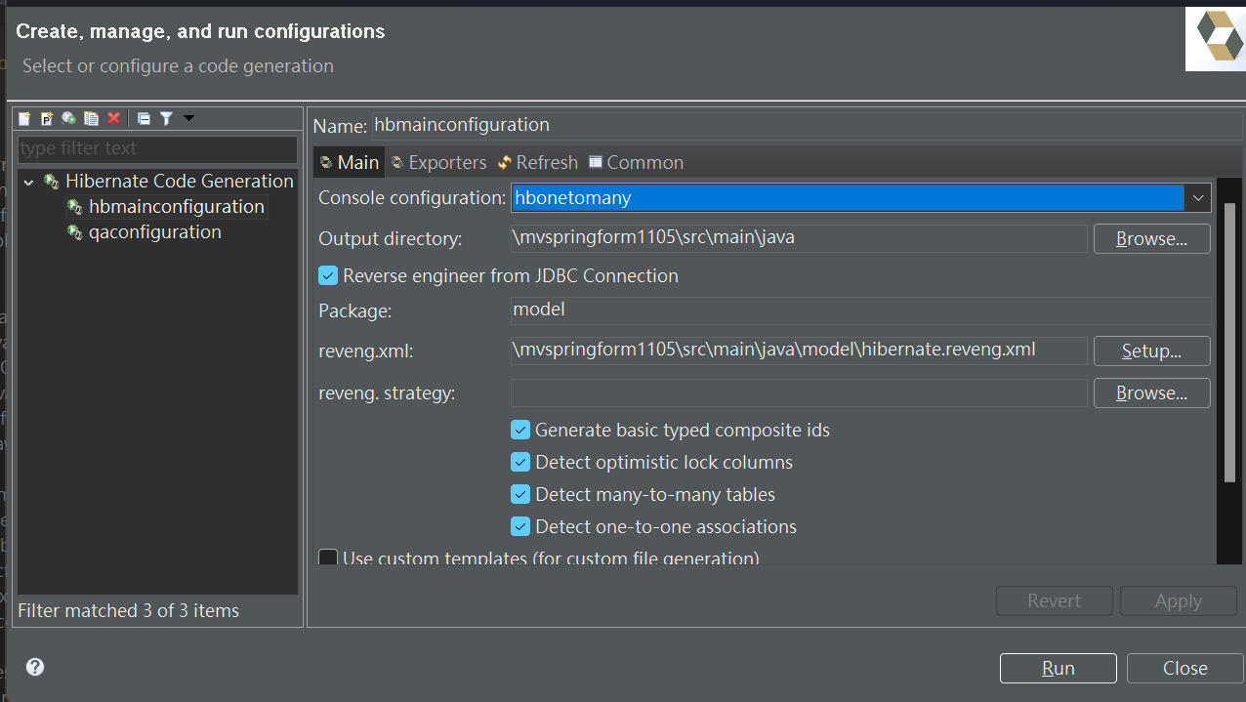

Coffees.hbm.xml
<?xml version="1.0"?>
<!DOCTYPE hibernate-mapping PUBLIC "-//Hibernate/Hibernate Mapping DTD 3.0//EN"
"http://www.hibernate.org/dtd/hibernate-mapping-3.0.dtd">
<!-- Generated by Hibernate Tools 4.3.6.Final -->
<hibernate-mapping>
<class name="model.Coffees" table="coffees" catalog="classicmodels" optimistic-lock="version">
<id name="cofName" type="string">
<column name="COF_NAME" length="32" />
<generator class="assigned" />
</id>
<many-to-one name="suppliers" class="model.Suppliers" fetch="select">
<column name="SUP_ID" not-null="true" />
</many-to-one>
<property name="price" type="big_decimal">
<column name="PRICE" precision="10" not-null="true" />
</property>
<property name="sales" type="int">
<column name="SALES" not-null="true" />
</property>
<property name="total" type="int">
<column name="TOTAL" not-null="true" />
</property>
</class>
</hibernate-mapping>

Suppliers.hbm.xml
<?xml version="1.0"?>
<!DOCTYPE hibernate-mapping PUBLIC "-//Hibernate/Hibernate Mapping DTD 3.0//EN"
"http://www.hibernate.org/dtd/hibernate-mapping-3.0.dtd">
<hibernate-mapping>
<class name="model.Suppliers" table="suppliers" catalog="classicmodels" optimistic-lock="version">
<id name="supId" type="int">
<column name="SUP_ID" />
<generator class="assigned" />
</id>
<property name="supName" type="string">
<column name="SUP_NAME" length="40" not-null="true" />
</property>
<property name="street" type="string">
<column name="STREET" length="40" not-null="true" />
</property>
<property name="city" type="string">
<column name="CITY" length="20" not-null="true" />
</property>
<property name="state" type="string">
<column name="STATE" length="2" not-null="true" />
</property>
<property name="zip" type="string">
<column name="ZIP" length="5" />
</property>
<set name="coffeeses" table="coffees" inverse="true" lazy="true" fetch="select">
<key>
<column name="SUP_ID" not-null="true" />
</key>
<one-to-many class="model.Coffees" />
</set>
</class>
</hibernate-mapping>

Coffees.java
package model;
// Generated 2023 by Hibernate Tools 4.3.6.Final
import java.math.BigDecimal;
import javax.persistence.Column;
import javax.persistence.Entity;
import javax.persistence.FetchType;
import javax.persistence.Id;
import javax.persistence.JoinColumn;
import javax.persistence.ManyToOne;
import javax.persistence.Table;

@Entity
@Table(name = "coffees", catalog = "classicmodels")
public class Coffees implements java.io.Serializable {

private String cofName;
private Suppliers suppliers;
private BigDecimal price;
private int sales;
private int total;

public Coffees() {
}

public Coffees(String cofName, Suppliers suppliers, BigDecimal price, int sales, int total) {
this.cofName = cofName;
this.suppliers = suppliers;
this.price = price;
this.sales = sales;
this.total = total;
}

@Id
@Column(name = "COF_NAME", unique = true, nullable = false, length = 32)
public String getCofName() {
return this.cofName;
}

public void setCofName(String cofName) {
this.cofName = cofName;
}

@ManyToOne(fetch = FetchType.LAZY)
@JoinColumn(name = "SUP_ID", nullable = false)
public Suppliers getSuppliers() {
return this.suppliers;
}

public void setSuppliers(Suppliers suppliers) {
this.suppliers = suppliers;
}

@Column(name = "PRICE", nullable = false, precision = 10)
public BigDecimal getPrice() {
return this.price;
}

public void setPrice(BigDecimal price) {
this.price = price;
}

@Column(name = "SALES", nullable = false)
public int getSales() {
return this.sales;
}

public void setSales(int sales) {
this.sales = sales;
}

@Column(name = "TOTAL", nullable = false)
public int getTotal() {
return this.total;
}

public void setTotal(int total) {
this.total = total;
}

}
Suppliers.java

package model;
// Generated 2023 by Hibernate Tools 4.3.6.Final

import java.util.HashSet;
import java.util.Set;
import javax.persistence.Column;
import javax.persistence.Entity;
import javax.persistence.FetchType;
import javax.persistence.Id;
import javax.persistence.OneToMany;
import javax.persistence.Table;

@Entity
@Table(name = "suppliers", catalog = "classicmodels")
public class Suppliers implements java.io.Serializable {

private int supId;
private String supName;
private String street;
private String city;
private String state;
private String zip;
private Set coffeeses = new HashSet(0);

public Suppliers() {
}

public Suppliers(int supId, String supName, String street, String city, String state) {
this.supId = supId;
this.supName = supName;
this.street = street;
this.city = city;
this.state = state;
}

public Suppliers(int supId, String supName, String street, String city, String state, String zip, Set coffeeses) {
this.supId = supId;
this.supName = supName;
this.street = street;
this.city = city;
this.state = state;
this.zip = zip;
this.coffeeses = coffeeses;
}

@Id

@Column(name = "SUP_ID", unique = true, nullable = false)
public int getSupId() {
return this.supId;
}

public void setSupId(int supId) {
this.supId = supId;
}

@Column(name = "SUP_NAME", nullable = false, length = 40)
public String getSupName() {
return this.supName;
}

public void setSupName(String supName) {
this.supName = supName;
}

@Column(name = "STREET", nullable = false, length = 40)
public String getStreet() {
return this.street;
}

public void setStreet(String street) {
this.street = street;
}

@Column(name = "CITY", nullable = false, length = 20)
public String getCity() {
return this.city;
}

public void setCity(String city) {
this.city = city;
}

@Column(name = "STATE", nullable = false, length = 2)
public String getState() {
return this.state;
}

public void setState(String state) {
this.state = state;
}

@Column(name = "ZIP", length = 5)
public String getZip() {
return this.zip;
}

public void setZip(String zip) {
this.zip = zip;
}
@OneToMany(fetch = FetchType.LAZY, mappedBy = "suppliers")
public Set getCoffeeses() {
return this.coffeeses;
}
public void setCoffeeses(Set coffeeses) {
this.coffeeses = coffeeses;
}

}

Suppliers Coffees DAO
public Suppliers getSupplier(int sid) {
SessionFactory factory = null;
try {
factory = new Configuration().configure("classicmodel.cfg.xml").buildSessionFactory();
} catch (Throwable ex) {
System.err.println("Failed to create sessionFactory object." + ex);
throw new ExceptionInInitializerError(ex);
}
Session session = factory.openSession();
System.out.println("Session created");
session.getTransaction().begin();
TypedQuery<Suppliers> query = session.createQuery("from Suppliers a where a.supId= :sup_id", Suppliers.class);
query.setParameter("sup_id", sid);
List<Suppliers> sups =new ArrayList<Suppliers>( query.getResultList());
return sups.get(0);
}

Controller:
@RequestMapping(value = "/supcof", method = RequestMethod.GET )
public ModelAndView tableSupCof(ModelMap modelMap) {
SupplierCoffeeDAO dao=new SupplierCoffeeDAO();
Suppliers sp=dao.getSupplier(101);
modelMap.addAttribute("coffees", sp.getCoffeeses());
modelMap.addAttribute("sups", sp);
return new ModelAndView("viewtables");

}

