SpringBean Ioc
基於 XML 的Spring Bean配置
我的Bean是一個簡單的Java POJO類別。
package demo.beans;
public class MyBean {
private String name="NA";
public String getName() {
return name;
}
public void setName(String name) {
this.name = name;
}
@Override
public String toString() {
return "MyBean [name=" + name + "]";
}
}

web.xml

<?xml version="1.0" encoding="UTF-8"?>
<web-app xmlns:xsi="http://www.w3.org/2001/XMLSchema-instance"
xmlns="http://xmlns.jcp.org/xml/ns/javaee"
xsi:schemaLocation="http://xmlns.jcp.org/xml/ns/javaee http://xmlns.jcp.org/xml/ns/javaee/web-app_4_0.xsd"
id="WebApp_ID" version="4.0">
<display-name>mvspringIOC</display-name>
<welcome-file-list>
<welcome-file>index.html</welcome-file>
<welcome-file>index.jsp</welcome-file>
<welcome-file>index.htm</welcome-file>
<welcome-file>default.html</welcome-file>
<welcome-file>default.jsp</welcome-file>
<welcome-file>default.htm</welcome-file>
</welcome-file-list>
<filter>
<filter-name>characterEncodingFilter</filter-name>
<filter-class>org.springframework.web.filter.CharacterEncodingFilter</filter-class>
<init-param>
<param-name>encoding</param-name>
<param-value>UTF-8</param-value>
</init-param>
<init-param>
<param-name>forceEncoding</param-name>
<param-value>true</param-value>
</init-param>
</filter>
<filter-mapping>
<filter-name>characterEncodingFilter</filter-name>
<url-pattern>/*</url-pattern>
</filter-mapping>

<!-- Processes application requests -->
<servlet>
<servlet-name>appServlet</servlet-name>
<servlet-class>org.springframework.web.servlet.DispatcherServlet</servlet-class>
<load-on-startup>1</load-on-startup>
</servlet>

<servlet-mapping>
<servlet-name>appServlet</servlet-name>
<url-pattern>/</url-pattern>
</servlet-mapping>

</web-app>

appServlet-servlet.xml

<beans xmlns="http://www.springframework.org/schema/beans"
xmlns:xsi="http://www.w3.org/2001/XMLSchema-instance"
xmlns:p="http://www.springframework.org/schema/p"
xmlns:context="http://www.springframework.org/schema/context"
xmlns:mvc="http://www.springframework.org/schema/mvc"
xsi:schemaLocation="http://www.springframework.org/schema/beans
http://www.springframework.org/schema/beans/spring-beans-4.1.xsd
http://www.springframework.org/schema/context
http://www.springframework.org/schema/context/spring-context-4.1.xsd
http://www.springframework.org/schema/mvc
http://www.springframework.org/schema/mvc/spring-mvc-4.1.xsd">

<context:annotation-config/>
<mvc:annotation-driven />

<!-- Handles HTTP GET requests for /resources/** by efficiently serving up static resources in the ${webappRoot}/resources directory
<resources mapping="/resources/**" location="/resources/" />
-->
<!-- Resolves views selected for rendering by @Controllers to .jsp resources in the /WEB-INF/views directory -->
<bean class="org.springframework.web.servlet.view.InternalResourceViewResolver">
<property name="prefix" value="/WEB-INF/views/" />
<property name="suffix" value=".jsp" />
</bean>

<context:component-scan base-package="demo" />
<bean name="myBean" class="demo.beans.MyBean"></bean>

</beans>
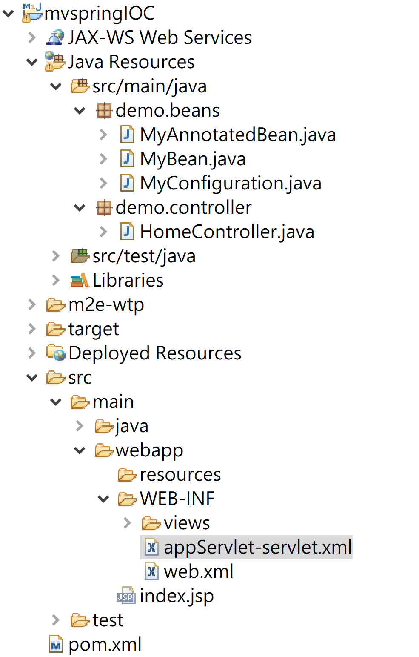
<dependency>
<groupId>org.springframework</groupId>
<artifactId>spring-webmvc</artifactId>
<version>5.2.22.RELEASE</version>
</dependency>
<dependency>
<groupId>javax.servlet</groupId>
<artifactId>jstl</artifactId>
<version>1.2</version>
</dependency>

基於註釋的Spring Bean配置
package demo.beans;

import org.springframework.context.annotation.Scope;
import org.springframework.stereotype.Service;
import org.springframework.web.context.WebApplicationContext;

@Service
@Scope(WebApplicationContext.SCOPE_REQUEST)
public class MyAnnotatedBean {

private int empId;

public int getEmpId() {
return empId;
}

public void setEmpId(int empId) {
this.empId = empId;
}

@Override
public String toString() {
return "MyAnnotatedBean [empId=" + empId + "]";
}
}

package demo.beans;

import org.springframework.context.annotation.Bean;
import org.springframework.context.annotation.ComponentScan;
import org.springframework.context.annotation.Configuration;

@Configuration
@ComponentScan(value="com.beans")
public class MyConfiguration {

@Bean
public MyBean getService(){
MyBean m=new MyBean();
m.setName("Just Test");
return m;
}
}

控制器類別
控制器類別將處理應用程式主頁的 HTTP 請求。我們將通過 Web 應用程式上下文容器將我們的Spring Bean注入到此控制器類別中。

package demo.controller;

import java.text.DateFormat;
import java.util.Date;
import java.util.Locale;

import org.springframework.beans.factory.annotation.Autowired;
import org.springframework.context.annotation.AnnotationConfigApplicationContext;
import org.springframework.context.annotation.Scope;
import org.springframework.stereotype.Controller;
import org.springframework.ui.Model;
import org.springframework.web.bind.annotation.RequestMapping;
import org.springframework.web.bind.annotation.RequestMethod;

import demo.beans.MyAnnotatedBean;
import demo.beans.MyBean;
import demo.beans.MyConfiguration;

@Controller
@Scope("request")
public class HomeController {

private MyBean myBean;

private MyAnnotatedBean myAnnotatedBean;

@Autowired
public void setMyBean(MyBean myBean) {
this.myBean = myBean;
}

@Autowired
public void setMyAnnotatedBean(MyAnnotatedBean obj) {
this.myAnnotatedBean = obj;
}

/**
* Simply selects the home view to render by returning its name.
*/
@RequestMapping(value = {"/","/home"}, method = RequestMethod.GET)
public String home(Locale locale, Model model) {
System.out.println("MyBean ="+myBean.toString());
System.out.println("MyAnnotatedBean ="+myAnnotatedBean.toString());

Date date = new Date();
DateFormat dateFormat = DateFormat.getDateTimeInstance(DateFormat.LONG, DateFormat.LONG, locale);

String formattedDate = dateFormat.format(date);

model.addAttribute("serverTime", formattedDate );

AnnotationConfigApplicationContext ctx = new AnnotationConfigApplicationContext(
MyConfiguration.class);
MyBean service = ctx.getBean(MyBean.class);

MyBean newService = ctx.getBean(MyBean.class);
System.out.println("service ="+service.toString());
System.out.println("newService ="+newService.toString());
ctx.close();

return "home";
}

}

home.jsp
<%@ page language="java" contentType="text/html; charset=UTF-8"
pageEncoding="UTF-8"%>
<!DOCTYPE html>
<html>
<head>
<meta charset="UTF-8">
<title>Insert title here</title>
</head>
<body>
Server Time:${serverTime}
</body>
</html>

運行Spring IoC Bean類別範例應用程式
現在，當您啟動 Web 應用程式時，主頁將被載入，並且在控制台中
