使用集合的建構函數注入範例

我們可以在 spring 框架中通過建構函數注入集合值。可以在建構函數參數元素中使用三種元素。

它可以是：
- list
- set
- map
每個集合可以具有基於字串和非基於字串的值。
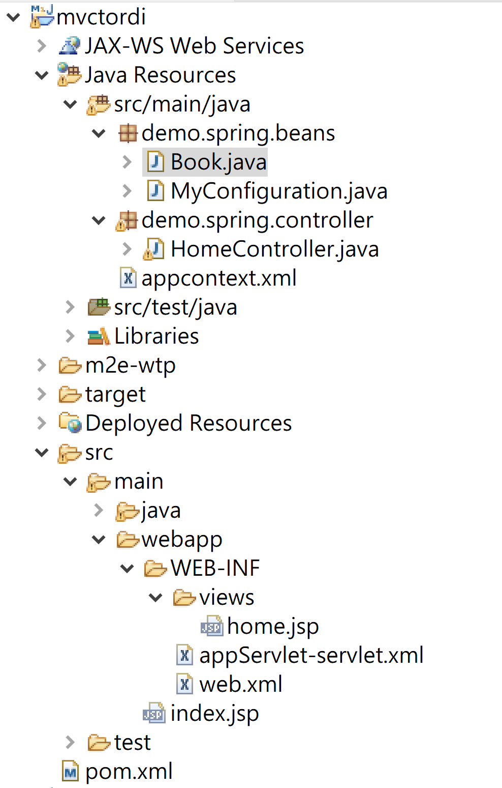
web.xml
<?xml version="1.0" encoding="UTF-8"?>
<web-app xmlns:xsi="http://www.w3.org/2001/XMLSchema-instance"
xmlns="http://xmlns.jcp.org/xml/ns/javaee"
xsi:schemaLocation="http://xmlns.jcp.org/xml/ns/javaee http://xmlns.jcp.org/xml/ns/javaee/web-app_4_0.xsd"
id="WebApp_ID" version="4.0">
<display-name>mvctordi</display-name>
<welcome-file-list>
<welcome-file>index.html</welcome-file>
<welcome-file>index.jsp</welcome-file>
<welcome-file>index.htm</welcome-file>
<welcome-file>default.html</welcome-file>
<welcome-file>default.jsp</welcome-file>
<welcome-file>default.htm</welcome-file>
</welcome-file-list>
<filter>
<filter-name>characterEncodingFilter</filter-name>
<filter-class>org.springframework.web.filter.CharacterEncodingFilter</filter-class>
<init-param>
<param-name>encoding</param-name>
<param-value>UTF-8</param-value>
</init-param>
<init-param>
<param-name>forceEncoding</param-name>
<param-value>true</param-value>
</init-param>
</filter>
<filter-mapping>
<filter-name>characterEncodingFilter</filter-name>
<url-pattern>/*</url-pattern>
</filter-mapping>
<!-- Processes application requests -->
<servlet>
<servlet-name>appServlet</servlet-name>
<servlet-class>org.springframework.web.servlet.DispatcherServlet</servlet-class>
<load-on-startup>1</load-on-startup>
</servlet>
<servlet-mapping>
<servlet-name>appServlet</servlet-name>
<url-pattern>/</url-pattern>
</servlet-mapping>
</web-app>

appServlet-servlet.xml

<beans xmlns="http://www.springframework.org/schema/beans"
xmlns:xsi="http://www.w3.org/2001/XMLSchema-instance"
xmlns:p="http://www.springframework.org/schema/p"
xmlns:context="http://www.springframework.org/schema/context"
xmlns:mvc="http://www.springframework.org/schema/mvc"
xsi:schemaLocation="http://www.springframework.org/schema/beans
http://www.springframework.org/schema/beans/spring-beans-4.1.xsd
http://www.springframework.org/schema/context
http://www.springframework.org/schema/context/spring-context-4.1.xsd
http://www.springframework.org/schema/mvc
http://www.springframework.org/schema/mvc/spring-mvc-4.1.xsd">

<context:annotation-config />
<mvc:annotation-driven />
<context:component-scan base-package="demo.spring" />

<!-- Handles HTTP GET requests for /resources/** by efficiently serving
up static resources in the ${webappRoot}/resources directory -->
<mvc:resources mapping="/resources/**"
location="/resources/" />

<!-- Resolves views selected for rendering by @Controllers to .jsp resources
in the /WEB-INF/views directory -->
<bean
class="org.springframework.web.servlet.view.InternalResourceViewResolver">
<property name="prefix" value="/WEB-INF/views/" />
<property name="suffix" value=".jsp" />
</bean>
</beans>

pom.xml
<dependency>
<groupId>org.springframework</groupId>
<artifactId>spring-webmvc</artifactId>
<version>5.2.22.RELEASE</version>
</dependency>
<dependency>
<groupId>javax.servlet</groupId>
<artifactId>jstl</artifactId>
<version>1.2</version>
</dependency>

Book.java
package demo.spring.beans;

import java.util.Iterator;
import java.util.List;

public class Book {
private int id;
private String name;
private List<String> bookStore;
public int getId() {
return id;
}

public void setId(int id) {
this.id = id;
}

public String getName() {
return name;
}

public void setName(String name) {
this.name = name;
}

public List<String> getBookStore() {
return bookStore;
}
public void setBookStore(List<String> bookStore) {
this.bookStore = bookStore;
}
public Book() {
}

public Book(int id, String name, List<String> bookStore) {
super();
this.id = id;
this.name = name;
this.bookStore = bookStore;
}

public void displayInfo() {
System.out.println(id + " " + name);
System.out.println("Stores are:");
Iterator<String> itr = bookStore.iterator();
while (itr.hasNext()) {
System.out.println(itr.next());
}
}

@Override
public String toString() {
return "Book [id=" + id + ", name=" + name + ", bookStore=" + bookStore + "]";
}

}
MyConfiguration.java

package demo.spring.beans;

import java.util.Arrays;
import org.springframework.context.annotation.Bean;
import org.springframework.context.annotation.ComponentScan;
import org.springframework.context.annotation.Configuration;

@Configuration
@ComponentScan(value="demo.spring.beans")
public class MyConfiguration {
@Bean
public Book getService(){
Book m=new Book(102,"C# .Net",Arrays.asList("Store1","Store2"));
return m;
}
}
appcontext.xml
<?xml version="1.0" encoding="UTF-8"?>
<beans xmlns="http://www.springframework.org/schema/beans"
xmlns:xsi="http://www.w3.org/2001/XMLSchema-instance"
xmlns:p="http://www.springframework.org/schema/p"
xsi:schemaLocation="http://www.springframework.org/schema/beans
http://www.springframework.org/schema/beans/spring-beans-4.0.xsd">

<bean id="bk1" class="demo.spring.beans.Book">
<constructor-arg value="101"></constructor-arg>
<constructor-arg value="java spring programming"></constructor-arg>
<constructor-arg>
<list>
<value>Taipei Store I</value>
<value>Kaohsiung Store II</value>
<value>Keelung Store III</value>
</list>
</constructor-arg>
</bean>
</beans>

HomeController.java

package demo.spring.controller;
import org.springframework.beans.factory.annotation.Autowired;
import org.springframework.context.ApplicationContext;
import org.springframework.context.support.ClassPathXmlApplicationContext;
import org.springframework.stereotype.Controller;
import org.springframework.ui.Model;
import org.springframework.web.bind.annotation.RequestMapping;
import org.springframework.web.bind.annotation.RequestMethod;

import demo.spring.beans.*;

@Controller
public class HomeController {

private Book bk;

@Autowired
public void setBook(Book myBean) {
this.bk = myBean;
}

@RequestMapping(value = {"/","/home"}, method = RequestMethod.GET)
public String home(Model model) {

System.out.println("Autowired Book="+bk.toString());

ApplicationContext context =
new ClassPathXmlApplicationContext("appcontext.xml");
Book book = (Book)context.getBean("bk1");

model.addAttribute("book", book);
return "home";
}

}
home.jsp
<%@ page language="java" contentType="text/html; charset=UTF-8"
pageEncoding="UTF-8"%>
<!DOCTYPE html>
<html>
<head>
<meta charset="UTF-8">
<title>Book View</title>
</head>
<body>
Book : ${book}
</body>
</html>

