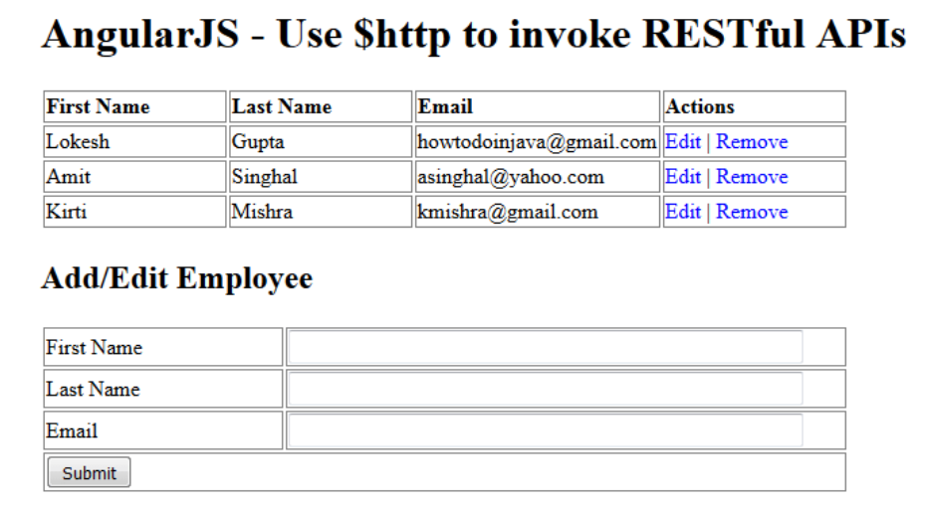
- 建立 mvngemployee專案
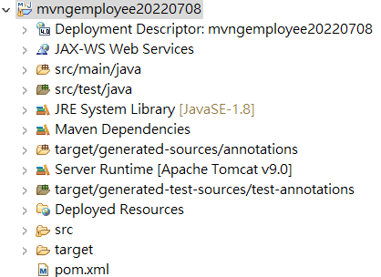
pom.xml
<dependency>
<groupId>javax.servlet</groupId>
<artifactId>jstl</artifactId>
<version>1.2</version>
</dependency>
<dependency>
<groupId>mysql</groupId>
<artifactId>mysql-connector-java</artifactId>
<version>8.0.29</version>
</dependency>
<dependency>
<groupId>org.hibernate</groupId>
<artifactId>hibernate-core</artifactId>
<version>5.4.30.Final</version>
</dependency>
<dependency>
<groupId>org.springframework</groupId>
<artifactId>spring-webmvc</artifactId>
<version>5.2.22.RELEASE</version>
</dependency>
<dependency>
<groupId>com.google.code.gson</groupId>
<artifactId>gson</artifactId>
<version>2.9.0</version>
</dependency>

web.xml
<servlet>
<servlet-name>dispatcher</servlet-name> <servlet-class>org.springframework.web.servlet.DispatcherServlet</servlet-class>
<load-on-startup>1</load-on-startup>
</servlet>
<servlet-mapping>
<servlet-name> dispatcher </servlet-name>
<url-pattern>/</url-pattern>
</servlet-mapping>

dispatcher-servlet.xml
<?xml version='1.0' encoding='UTF-8' ?>
<!-- was: <?xml version="1.0" encoding="UTF-8"?> -->
<beans xmlns="http://www.springframework.org/schema/beans"
xmlns:xsi="http://www.w3.org/2001/XMLSchema-instance"
xmlns:p="http://www.springframework.org/schema/p"
xmlns:aop="http://www.springframework.org/schema/aop"
xmlns:mvc="http://www.springframework.org/schema/mvc"
xmlns:context="http://www.springframework.org/schema/context"
xmlns:tx="http://www.springframework.org/schema/tx"
xsi:schemaLocation="http://www.springframework.org/schema/beans http://www.springframework.org/schema/beans/spring-beans-4.0.xsd
http://www.springframework.org/schema/aop http://www.springframework.org/schema/aop/spring-aop-4.0.xsd
http://www.springframework.org/schema/mvc
http://www.springframework.org/schema/mvc/spring-mvc-4.0.xsd
http://www.springframework.org/schema/context http://www.springframework.org/schema/context/spring-context-4.0.xsd
http://www.springframework.org/schema/tx http://www.springframework.org/schema/tx/spring-tx-4.0.xsd">

<mvc:annotation-driven />
<context:annotation-config/>
<mvc:resources location="/images/" mapping="/images/**" />
<mvc:resources location="/css/" mapping="/css/**" />
<mvc:resources location="/js/" mapping="/js/**" />
<mvc:resources location="/html/" mapping="/html/**" />
<context:component-scan base-package="demo.controller">
</context:component-scan>
<bean id="viewResolver"
class="org.springframework.web.servlet.view.InternalResourceViewResolver"
p:prefix="/WEB-INF/jsp/"
p:suffix=".jsp" />
</beans>

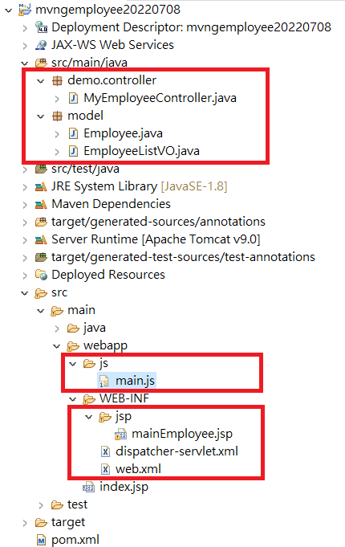
- 建立資料模型: Employee.java EmployeeListVO.java
- 將angularJS 語法移動到 js/main.js 並建立檢視畫面 mainEmployee.jsp
- 建立控制器 MyEmployeeController.java 取得 employees 所有資料
Model:
Employee.java

public class Employee {
int id;
String firstName,lastName,email;

public Employee() {}
public Employee(int id, String firstName, String lastName, String email) {
this.id = id;
this.firstName = firstName;
this.lastName = lastName;
this.email = email;
}
public int getId() {
return id;
}
public void setId(int id) {
this.id = id;
}
public String getFirstName() {
return firstName;
}
public void setFirstName(String firstName) {
this.firstName = firstName;
}
public String getLastName() {
return lastName;
}
public void setLastName(String lastName) {
this.lastName = lastName;
}
public String getEmail() {
return email;
}
public void setEmail(String email) {
this.email = email;
}

}

EmployeeListVO.java

import java.util.*;
public class EmployeeListVO {
List<Employee> employees;

public EmployeeListVO() {}
public EmployeeListVO(List<Employee> employees) {
this.employees = employees;
}

public List<Employee> getEmployees() {
return employees;
}

public void setEmployees(List<Employee> employees) {
this.employees = employees;
}

}

js/main.js

var app = angular.module("UserManagement", []);

//Controller Part
app.controller("UserManagementController", function($scope, $http) {

//Initialize page with default data which is blank in this example
$scope.employees = [];
$scope.form = {
id : -1,
firstName : "",
lastName : "",
email : ""
};

//Now load the data from server
_refreshPageData();

//HTTP POST/PUT methods for add/edit employee
$scope.submitEmployee = function() {

var method = "";
var url = "";
if ($scope.form.id == -1) {
//Id is absent so add employee - POST operation
method = "POST";
url = 'employees';
} else {
//If Id is present, it's edit operation - PUT operation
method = "PUT";
url = 'employees/' + $scope.form.id;
}

$http({
method : method,
url : url,
data : angular.toJson($scope.form),
headers : {
'Content-Type' : 'application/json'
}
}).then( _success, _error );
};

//HTTP DELETE- delete employee by Id
$scope.removeEmployee = function(employee) {
$http({
method : 'DELETE',
url : 'employees/' + employee.id
}).then(_success, _error);
};

//In case of edit employee, populate form with employee data
$scope.editEmployee = function(employee) {
$scope.form.firstName = employee.firstName;
$scope.form.lastName = employee.lastName;
$scope.form.email = employee.email;
$scope.form.id = employee.id;
};

/* Private Methods */
//HTTP GET- get all employees collection
function _refreshPageData() {
$http({
method : 'GET',
url : 'employees'
}).then(function successCallback(response) {
$scope.employees = response.data.employees;
}, function errorCallback(response) {
console.log(response.statusText);
});
}

function _success(response) {
_refreshPageData();
_clearForm()
}

function _error(response) {
console.log(response.statusText);
}

//Clear the form
function _clearForm() {
$scope.form.firstName = "";
$scope.form.lastName = "";
$scope.form.email = "";
$scope.form.id = -1;
};
});

jsp/mainEmployee.jsp

<%@ page language="java" contentType="text/html; charset=UTF-8"
pageEncoding="UTF-8"%>
<!doctype html>
<html>
<head>
<meta charset="utf-8" />
<title>
AngularJS - REST Demo using $http service
</title>
<script src="http://ajax.googleapis.com/ajax/libs/angularjs/1.8.2/angular.min.js"></script>
<!-- Load AngularJS -->
<script src="../js/main.js"></script>
<style>
.button {
cursor: pointer;
color: blue;
}
td,th{
border: 1px solid gray;
width: 25%;
text-align: left;
}
table {
width: 600px;
}
</style>
<head>
<body ng-app="UserManagement" ng-controller="UserManagementController">
<h1>
AngularJS - Use $http to invoke RESTful APIs
</h1>

<table>
<tr>
<th>First Name</th>
<th>Last Name</th>
<th>Email</th>
<th>Actions</th>
</tr>

<tr ng-repeat="employee in employees">
<td>{{ employee.firstName }}</td>
<td>{{ employee.lastName }}</td>
<td>{{ employee.email }}</td>
<td><a ng-click="editEmployee( employee )" class="button">Edit</a> | <a ng-click="removeEmployee( employee )" class="button">Remove</a></td>
</tr>

</table>

<h2>Add/Edit Employee</h2>

<form ng-submit="submitEmployee()">
<table>
<tr>
<td>First Name</td>
<td><input type="text" ng-model="form.firstName" size="60" /></td>
</tr>
<tr>
<td>Last Name</td>
<td><input type="text" ng-model="form.lastName" size="60" /></td>
</tr>
<tr>
<td>Email</td>
<td><input type="text" ng-model="form.email" size="60" /></td>
</tr>
<tr>
<td colspan="2"><input type="submit" value="Submit" /></td>
</tr>
</table>
</form>

</body>
</html>

Controller MyEmployeeController.java

import org.springframework.http.HttpStatus;
import org.springframework.http.MediaType;
import org.springframework.http.ResponseEntity;
import org.springframework.stereotype.Controller;
import org.springframework.ui.ModelMap;
import org.springframework.web.bind.annotation.PathVariable;
import org.springframework.web.bind.annotation.RequestBody;
import org.springframework.web.bind.annotation.RequestMapping;
import org.springframework.web.bind.annotation.RequestMethod;
import org.springframework.web.bind.annotation.ResponseBody;

import model.*;
import java.util.*;
@Controller
@RequestMapping("/ngemployee")
public class MyEmployeeController {
EmployeeListVO vo;
public MyEmployeeController() {
Employee empOne = new Employee(1,"Lokesh","Gupta","howtodoinjava@gmail.com");
Employee empTwo = new Employee(2,"Amit","Singhal","asinghal@yahoo.com");
Employee empThree = new Employee(3,"Kirti","Mishra","kmishra@gmail.com");
List<Employee> data=new ArrayList<>();
data.add(empOne);data.add(empTwo);data.add(empThree);
vo=new EmployeeListVO(data);
}
@RequestMapping(value="/home",method = RequestMethod.GET)
public String mainEmployee(ModelMap model) {
return "mainEmployee";
}
@RequestMapping(value="/employees",method = RequestMethod.GET)
public @ResponseBody EmployeeListVO getAllEmployee(ModelMap model) {

return vo;
}

@RequestMapping(value = "/employees/{id}",consumes = MediaType.APPLICATION_JSON_VALUE, method = RequestMethod.PUT)
public ResponseEntity<Employee> updateEmployee(@PathVariable("id") int id, @RequestBody Employee employee)
{
System.out.println("updateemployees id "+id);
System.out.println("employee "+ employee);
List<Employee> data=vo.getEmployees();
int index=-1;
for(int i=0;i<data.size();i++) {
if(data.get(i).getId()==id) {
index=i;
break;
}
}
if(index>=0) {
data.set(index, employee);
return new ResponseEntity<Employee>(employee, HttpStatus.OK);
}
return new ResponseEntity<Employee>(employee, HttpStatus.NOT_FOUND);
}

@RequestMapping(value = "/employees", consumes = MediaType.APPLICATION_JSON_VALUE, method = RequestMethod.POST)
public ResponseEntity<String> createEmployee(@RequestBody Employee employee)
{
employee.setId(vo.getEmployees().size() + 1);
vo.getEmployees().add(employee);
return new ResponseEntity<String>(HttpStatus.CREATED);
}
@RequestMapping(value = "/employees/{id}", method = RequestMethod.DELETE)
public ResponseEntity<String> deleteEmployee(@PathVariable("id") int id)
{
List<Employee> data=vo.getEmployees();
int index=-1;
for(int i=0;i<data.size();i++) {
if(data.get(i).getId()==id) {
index=i;
break;
}
}

if(index>=0){
vo.getEmployees().remove(index);
return new ResponseEntity<String>(HttpStatus.OK);
}
return new ResponseEntity<String>(HttpStatus.NOT_FOUND);
}

}

接下加入新增修改方法:
前端javascript:
$scope.submitEmployee = function() {
var method = "";
var url = "";
if ($scope.form.id == -1) {
//Id is absent so add employee - POST operation
method = "POST";
url = 'employees';
} else {
//If Id is present, it's edit operation - PUT operation
method = "PUT";
url = 'employees/' + $scope.form.id;
}

$http({
method : method,
url : url,
data : JSON.stringify($scope.form) ,
headers : {
'Content-Type' : 'application/json'
}
}).then( _success, _error );
};
後端控制器:
@RequestMapping(value = "/employees/{id}",consumes = MediaType.APPLICATION_JSON_VALUE, method = RequestMethod.PUT)
public ResponseEntity<Employee> updateEmployee(@PathVariable("id") int id, @RequestBody Employee employee)
{
System.out.println("updateemployees id "+id);
System.out.println("employee "+ employee);
List<Employee> data=vo.getEmployees();
int index=-1;
for(int i=0;i<data.size();i++) {
if(data.get(i).getId()==id) {
index=i;
break;
}
}
if(index>=0) {
data.set(index, employee);
return new ResponseEntity<Employee>(employee, HttpStatus.OK);
}
return new ResponseEntity<Employee>(employee, HttpStatus.NOT_FOUND);
}
要回傳 new ResponseEntity<Employee>(employee, HttpStatus.OK) 通知瀏覽器執行是否成功

最後兩個方法 新增 移除
@RequestMapping(value = "/employees", consumes = MediaType.APPLICATION_JSON_VALUE, method = RequestMethod.POST)
public ResponseEntity<String> createEmployee(@RequestBody Employee employee)
{
employee.setId(vo.getEmployees().size() + 1);
vo.getEmployees().add(employee);
return new ResponseEntity<String>(HttpStatus.CREATED);
}
@RequestMapping(value = "/employees/{id}", method = RequestMethod.DELETE)
public ResponseEntity<String> deleteEmployee(@PathVariable("id") int id)
{
List<Employee> data=vo.getEmployees();
int index=-1;
for(int i=0;i<data.size();i++) {
if(data.get(i).getId()==id) {
index=i;
break;
}
}

if(index>=0){
vo.getEmployees().remove(index);
return new ResponseEntity<String>(HttpStatus.OK);
}
return new ResponseEntity<String>(HttpStatus.NOT_FOUND);
}

