<!doctype html>
<html>
<head>
<meta charset="utf-8" />
<title>
AngularJS - REST Demo using $http service
</title>
<!-- Load AngularJS -->
<script src="http://ajax.googleapis.com/ajax/libs/angularjs/1.4.8/angular.min.js"></script>
<script type="text/javascript">
var app = angular.module("UserManagement", []);

//Controller Part
app.controller("UserManagementController", function($scope, $http) {

//Initialize page with default data which is blank in this example
$scope.employees = [];
$scope.form = {
id : -1,
firstName : "",
lastName : "",
email : ""
};

//Now load the data from server
_refreshPageData();

//HTTP POST/PUT methods for add/edit employee
$scope.submitEmployee = function() {

var method = "";
var url = "";
if ($scope.form.id == -1) {
//Id is absent so add employee - POST operation
method = "POST";
url = 'employees';
} else {
//If Id is present, it's edit operation - PUT operation
method = "PUT";
url = 'employees/' + $scope.form.id;
}

$http({
method : method,
url : url,
data : angular.toJson($scope.form),
headers : {
'Content-Type' : 'application/json'
}
}).then( _success, _error );
};

//HTTP DELETE- delete employee by Id
$scope.removeEmployee = function(employee) {
$http({
method : 'DELETE',
url : 'employees/' + employee.id
}).then(_success, _error);
};

//In case of edit employee, populate form with employee data
$scope.editEmployee = function(employee) {
$scope.form.firstName = employee.firstName;
$scope.form.lastName = employee.lastName;
$scope.form.email = employee.email;
$scope.form.id = employee.id;
};

/* Private Methods */
//HTTP GET- get all employees collection
function _refreshPageData() {
$http({
method : 'GET',
url : 'employees'
}).then(function successCallback(response) {
$scope.employees = response.data.employees;
}, function errorCallback(response) {
console.log(response.statusText);
});
}

function _success(response) {
_refreshPageData();
_clearForm()
}

function _error(response) {
console.log(response.statusText);
}

//Clear the form
function _clearForm() {
$scope.form.firstName = "";
$scope.form.lastName = "";
$scope.form.email = "";
$scope.form.id = -1;
};
});
</script>
<style>
.button {
cursor: pointer;
color: blue;
}
td,th{
border: 1px solid gray;
width: 25%;
text-align: left;
}
table {
width: 600px;
}
</style>
<head>
<body ng-app="UserManagement" ng-controller="UserManagementController">
<h1>
AngularJS - Use $http to invoke RESTful APIs
</h1>

<table>
<tr>
<th>First Name</th>
<th>Last Name</th>
<th>Email</th>
<th>Actions</th>
</tr>

<tr ng-repeat="employee in employees">
<td>{{ employee.firstName }}</td>
<td>{{ employee.lastName }}</td>
<td>{{ employee.email }}</td>
<td><a ng-click="editEmployee( employee )" class="button">Edit</a> | <a ng-click="removeEmployee( employee )" class="button">Remove</a></td>
</tr>

</table>

<h2>Add/Edit Employee</h2>

<form ng-submit="submitEmployee()">
<table>
<tr>
<td>First Name</td>
<td><input type="text" ng-model="form.firstName" size="60" /></td>
</tr>
<tr>
<td>Last Name</td>
<td><input type="text" ng-model="form.lastName" size="60" /></td>
</tr>
<tr>
<td>Email</td>
<td><input type="text" ng-model="form.email" size="60" /></td>
</tr>
<tr>
<td colspan="2"><input type="submit" value="Submit" /></td>
</tr>
</table>
</form>

</body>
</html>

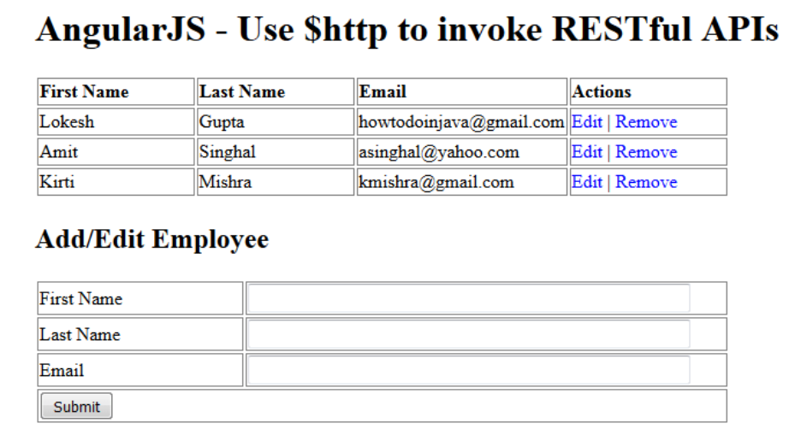

HTTP GET operation
Angular $http can be used to invoke HTTP GET api in below manner. In this example, this code is used to get all employees from server.

$http({
method : 'GET',
url : 'employees'
}).then(function successCallback(response) {
$scope.employees = response.data.employees;
}, function errorCallback(response) {
console.log(response.statusText);
});

HTTP POST operation
Angular $http can be used to invoke HTTP POST api in below manner. In this example, this code is used to add an employee into the system.

$http({
method : "POST",
url : "employees",
data : angular.toJson($scope.form),
headers : {
'Content-Type' : 'application/json'
}
}).then( _success, _error );
HTTP PUT operation
Angular $http can be used to invoke HTTP PUT api in below manner. In this example, this code is used to update an employee into the system.

$http({
method : "PUT",
url : "employees/" + $scope.form.id,
data : angular.toJson($scope.form),
headers : {
'Content-Type' : 'application/json'
}
}).then( _success, _error );

HTTP DELETE operation
Angular $http can be used to invoke HTTP DETELE api in below manner. In this example, this code is used to delete an employee into the system.

$http({
method : "DELETE",
url : "employees/" + employee.id
}).then( _success, _error );

import org.springframework.http.HttpStatus;
import org.springframework.http.MediaType;
import org.springframework.http.ResponseEntity;
import org.springframework.stereotype.Controller;
import org.springframework.web.bind.annotation.PathVariable;
import org.springframework.web.bind.annotation.RequestBody;
import org.springframework.web.bind.annotation.RequestMapping;
import org.springframework.web.bind.annotation.RequestMethod;

import com.howtodoinjava.demo.model.EmployeeListVO;
import com.howtodoinjava.demo.model.EmployeeVO;

@Controller
public class EmployeeRESTController
{
//Local storage of employees for demo; You will use database here
private static EmployeeListVO employees = new EmployeeListVO();

//add some employees here
public EmployeeRESTController()
{
EmployeeVO empOne = new EmployeeVO(1,"Lokesh","Gupta","howtodoinjava@gmail.com");
EmployeeVO empTwo = new EmployeeVO(2,"Amit","Singhal","asinghal@yahoo.com");
EmployeeVO empThree = new EmployeeVO(3,"Kirti","Mishra","kmishra@gmail.com");

employees.getEmployees().add(empOne);
employees.getEmployees().add(empTwo);
employees.getEmployees().add(empThree);
}

//Utility methods for getting employee by id
private EmployeeVO _getEmployeeById(int id){
for(EmployeeVO e : employees.getEmployees()){
if(e.getId() == id){
return e;
}
}
return null;
}

/**
* HTTP GET - Get all employees
* */
@RequestMapping(value = "/employees", produces = MediaType.APPLICATION_JSON_VALUE, method = RequestMethod.GET)
public ResponseEntity<EmployeeListVO> getAllEmployeesJSON()
{
return new ResponseEntity<EmployeeListVO>(employees, HttpStatus.OK);
}

/**
* HTTP POST - Create new Employee
* */
@RequestMapping(value = "/employees", consumes = MediaType.APPLICATION_JSON_VALUE, method = RequestMethod.POST)
public ResponseEntity<String> createEmployee(@RequestBody EmployeeVO employee)
{
employee.setId(employees.getEmployees().size() + 1);
employees.getEmployees().add(employee);
return new ResponseEntity<String>(HttpStatus.CREATED);
}

/**
* HTTP PUT - Update employee
* */
@RequestMapping(value = "/employees/{id}", consumes = MediaType.APPLICATION_JSON_VALUE, method = RequestMethod.PUT)
public ResponseEntity<EmployeeVO> updateEmployee(@PathVariable("id") int id, @RequestBody EmployeeVO employee)
{
EmployeeVO emp = _getEmployeeById(id);
if(emp != null){
emp.setFirstName(employee.getFirstName());
emp.setLastName(employee.getLastName());
emp.setEmail(employee.getEmail());
return new ResponseEntity<EmployeeVO>(emp, HttpStatus.OK);
}
return new ResponseEntity<EmployeeVO>(HttpStatus.NOT_FOUND);
}

/**
* HTTP DELETE - Delete employee
* */
@RequestMapping(value = "/employees/{id}", method = RequestMethod.DELETE)
public ResponseEntity<String> deleteEmployee(@PathVariable("id") int id)
{
EmployeeVO employee = _getEmployeeById(id);
if(employee != null){
employees.getEmployees().remove(employee);
return new ResponseEntity<String>(HttpStatus.OK);
}
return new ResponseEntity<String>(HttpStatus.NOT_FOUND);
}
}

