Spring MVC Hibernate驗證器
下面範例將展示如何使用Spring Web MVC框架在表單中使用錯誤處理和驗證器。 首先使用Eclipse IDE，並按照以下步驟使用Spring Web Framework開發動態表單的Web Maven應用程式：

- 建立一個名稱為SpHBValidatorDemo的Maven WEB專案。
- 在 com.springmvc.controller , com.springmvc.model 套件建立 2個Java類：Student和StudentController 。
- 在jsp子檔案夾下建立兩個檢視檔案：addStudent.jsp, result.jsp。
- 下載SpHBValidatorDemo程式庫 - Hibernate Validator。
- 在src檔案夾下建立屬性檔案messages.properties。
- 最後一步是建立所有源和組態檔案的內容並執行應用程式

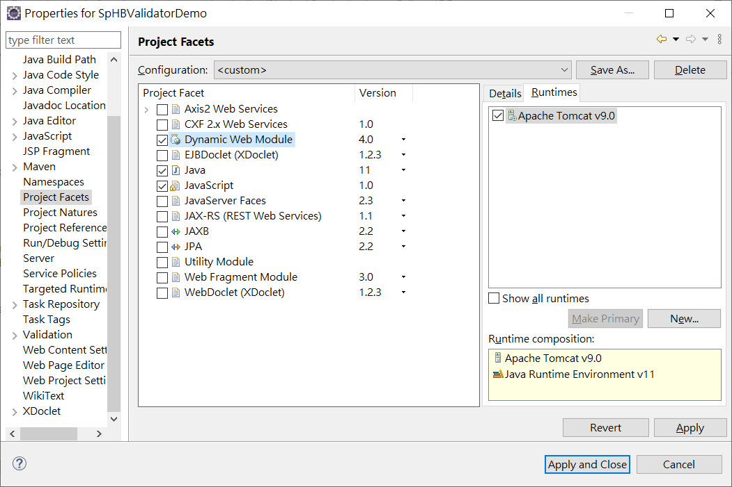
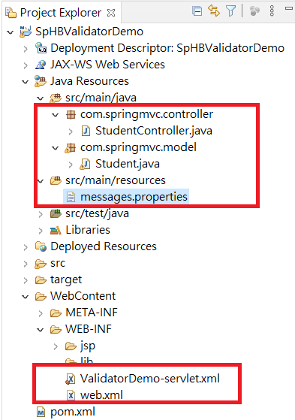
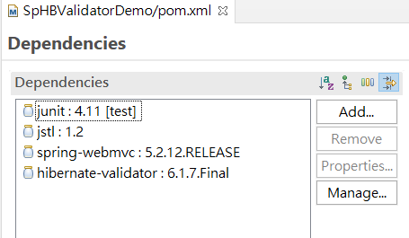
<?xml version="1.0" encoding="UTF-8"?>

<project xmlns="http://maven.apache.org/POM/4.0.0" xmlns:xsi="http://www.w3.org/2001/XMLSchema-instance"
xsi:schemaLocation="http://maven.apache.org/POM/4.0.0 http://maven.apache.org/xsd/maven-4.0.0.xsd">
<modelVersion>4.0.0</modelVersion>

<groupId>SpHBValidatorDemo</groupId>
<artifactId>SpHBValidatorDemo</artifactId>
<version>0.0.1-SNAPSHOT</version>
<packaging>war</packaging>

<name>SpHBValidatorDemo Maven Webapp</name>
<!-- FIXME change it to the project's website -->
<url>http://www.example.com</url>

<properties>
<project.build.sourceEncoding>UTF-8</project.build.sourceEncoding>
<maven.compiler.source>1.8</maven.compiler.source>
<maven.compiler.target>1.8</maven.compiler.target>
</properties>

<dependencies>
<dependency>
<groupId>junit</groupId>
<artifactId>junit</artifactId>
<version>4.11</version>
<scope>test</scope>
</dependency>
<dependency>
<groupId>javax.servlet</groupId>
<artifactId>jstl</artifactId>
<version>1.2</version>
</dependency>
<dependency>
<groupId>org.springframework</groupId>
<artifactId>spring-webmvc</artifactId>
<version>5.2.12.RELEASE</version>
</dependency>
<dependency>
<groupId>org.hibernate</groupId>
<artifactId>hibernate-validator</artifactId>
<version>6.1.7.Final</version>
</dependency>
</dependencies>

<build>
<finalName>SpHBValidatorDemo</finalName>
<pluginManagement><!-- lock down plugins versions to avoid using Maven defaults (may be moved to parent pom) -->
<plugins>
<plugin>
<artifactId>maven-clean-plugin</artifactId>
<version>3.1.0</version>
</plugin>
<!-- see http://maven.apache.org/ref/current/maven-core/default-bindings.html#Plugin_bindings_for_war_packaging -->
<plugin>
<artifactId>maven-resources-plugin</artifactId>
<version>3.0.2</version>
</plugin>
<plugin>
<artifactId>maven-compiler-plugin</artifactId>
<version>3.8.0</version>
</plugin>
<plugin>
<artifactId>maven-surefire-plugin</artifactId>
<version>2.22.1</version>
</plugin>
<plugin>
<artifactId>maven-war-plugin</artifactId>
<version>3.2.2</version>
</plugin>
<plugin>
<artifactId>maven-install-plugin</artifactId>
<version>2.5.2</version>
</plugin>
<plugin>
<artifactId>maven-deploy-plugin</artifactId>
<version>2.8.2</version>
</plugin>
</plugins>
</pluginManagement>
</build>
</project>

web.xml
<?xml version="1.0" encoding="UTF-8"?>
<web-app xmlns:xsi="http://www.w3.org/2001/XMLSchema-instance" xmlns="http://xmlns.jcp.org/xml/ns/javaee" xsi:schemaLocation="http://xmlns.jcp.org/xml/ns/javaee http://xmlns.jcp.org/xml/ns/javaee/web-app_4_0.xsd" id="WebApp_ID" version="4.0">
<display-name>SpHBValidatorDemo</display-name>
<welcome-file-list>
<welcome-file>index.html</welcome-file>
<welcome-file>index.htm</welcome-file>
<welcome-file>index.jsp</welcome-file>
<welcome-file>default.html</welcome-file>
<welcome-file>default.htm</welcome-file>
<welcome-file>default.jsp</welcome-file>
</welcome-file-list>
<servlet>
<servlet-name>ValidatorDemo</servlet-name>
<servlet-class>
org.springframework.web.servlet.DispatcherServlet
</servlet-class>
<load-on-startup>1</load-on-startup>
</servlet>

<servlet-mapping>
<servlet-name>ValidatorDemo</servlet-name>
<url-pattern>/</url-pattern>
</servlet-mapping>
</web-app>

ValidatorDemo-servlet.xml
<beans xmlns="http://www.springframework.org/schema/beans"
xmlns:context="http://www.springframework.org/schema/context"
xmlns:mvc="http://www.springframework.org/schema/mvc"
xmlns:xsi="http://www.w3.org/2001/XMLSchema-instance"
xsi:schemaLocation="
http://www.springframework.org/schema/beans
http://www.springframework.org/schema/beans/spring-beans-4.0.xsd
http://www.springframework.org/schema/context
http://www.springframework.org/schema/context/spring-context-4.0.xsd
http://www.springframework.org/schema/mvc
http://www.springframework.org/schema/mvc/spring-mvc-4.0.xsd">

<context:component-scan base-package="com.springmvc" />
<mvc:annotation-driven />
<bean class="org.springframework.context.support.ResourceBundleMessageSource"
id="messageSource">
<property name="basename" value="messages" />
</bean>
<bean class="org.springframework.web.servlet.view.InternalResourceViewResolver">
<property name="prefix" value="/WEB-INF/jsp/" />
<property name="suffix" value=".jsp" />
</bean>
</beans>

src/main/resources
messages.properties

NotEmpty.student.name = Name is required!
Range.student.age = Age value must be between 1 and 150!

Student.java
package com.springmvc.model;

import org.hibernate.validator.constraints.NotEmpty;
import org.hibernate.validator.constraints.Range;

public class Student {

@Range(min = 1, max = 150)
private Integer age;
@NotEmpty
private String name;
private Integer id;

public void setAge(Integer age) {
this.age = age;
}
public Integer getAge() {
return age;
}

public void setName(String name) {
this.name = name;
}
public String getName() {
return name;
}

public void setId(Integer id) {
this.id = id;
}
public Integer getId() {
return id;
}
}

StudentController.java
package com.springmvc.controller;
import org.springframework.stereotype.Controller;
import org.springframework.ui.Model;
import org.springframework.validation.BindingResult;
import org.springframework.validation.annotation.Validated;
import org.springframework.web.bind.annotation.ModelAttribute;
import org.springframework.web.bind.annotation.RequestMapping;
import org.springframework.web.bind.annotation.RequestMethod;
import org.springframework.web.servlet.ModelAndView;
import com.springmvc.model.*;
@Controller
public class StudentController {

@RequestMapping(value = "/", method = RequestMethod.GET)
public ModelAndView student(Model model) {
return new ModelAndView("addStudent", "command", new Student());
}

@ModelAttribute("student")
public Student createStudentModel() {
return new Student();
}

@RequestMapping(value = "/addStudent", method = RequestMethod.POST)
public String addStudent(@ModelAttribute("student") @Validated Student student,
BindingResult bindingResult, Model model) {
if (bindingResult.hasErrors()) {
return "addStudent";
}
model.addAttribute("name", student.getName());
model.addAttribute("age", student.getAge());
model.addAttribute("id", student.getId());

return "result";
}
}

addStudent.jsp
<%@ page contentType="text/html; charset=UTF-8" %>
<%@taglib uri="http://www.springframework.org/tags/form" prefix="form"%>
<html>
<head>
<title>Spring MVC Form Handling</title>
</head>
<style>
.error {
color: #ff0000;
}

.errorblock {
color: #000;
background-color: #ffEEEE;
border: 3px solid #ff0000;
padding: 8px;
margin: 16px;
}
</style>
<body>

<h2>學生資訊</h2>
<form:form method="POST" action="addStudent" modelAttribute="student">
<form:errors path="*" cssClass="errorblock" element="div" />
<table>
<tr>
<td><form:label path="name">姓名：</form:label></td>
<td><form:input path="name" /></td>
<td><form:errors path="name" cssClass="error" /></td>
</tr>
<tr>
<td><form:label path="age">年齡：</form:label></td>
<td><form:input path="age" /></td>
<td><form:errors path="age" cssClass="error" /></td>
</tr>
<tr>
<td><form:label path="id">編號：</form:label></td>
<td><form:input path="id" /></td>
</tr>
<tr>
<td colspan="2">
<input type="submit" value="提交"/>
</td>
</tr>
</table>
</form:form>
</body>
</html>

result.jsp

<%@ page contentType="text/html; charset=UTF-8" %>
<%@taglib uri="http://www.springframework.org/tags/form" prefix="form"%>
<html>
<head>
<title>Spring MVC Form Handling</title>
</head>
<body>

<h2>提交的學生資訊如下 -</h2>
<table>
<tr>
<td>姓名：</td>
<td>${name}</td>
</tr>
<tr>
<td>年齡：</td>
<td>${age}</td>
</tr>
<tr>
<td>編號：</td>
<td>${id}</td>
</tr>
</table>
</body>
</html>

